Outdoor Space Accessibility Project
Final Report
Syed Haider Ali
Jess Herman
Brent McNeil
Teddy Sin
Ben White

June 24, 2013

Memorandum
To: Dr. Paul Winkelman, APSC 461 Instructor
CC: Diana Buric, Director Recreation Therapy, Volunteer & Building Services
From: Ben White, Syed Haider Ali, Brent McNeil, Teddy Sin, Jess Herman BW,SA,BM,TS,JH
Date: June 20th, 2013
Subject: Final Report: Haro Park Centre - Outdoor Space Accessibility
________________________________________________________________________
As requested, enclosed with this memorandum is the final report for Haro Park Centre - outdoor space accessibility project as well as the final designs for the outdoor space. The final report includes the requested information required upon completion of the project. The report further explains the details of the project as well as the methodology, research findings, recommendations, significance and final design.

This report is adapted with consideration to the recommendations and critiques given to the primary proposal. This project meets the requirements for the Community Based Experiential Learning (CBEL) aspect of the APSC 461 course. Further explanation of all of methods taken, findings, and recommendations for improvement are provided within.

Working with Haro Park administration and residents has been a good learning experience. The CBEL component drew on the team’s diverse engineering knowledge and allowed the opportunity to work with a community partner. The learning taken from this project will not be forgotten, and will be incorporated into future projects.

We are looking forward to receiving feedback on the report, and if you have any questions or concerns please feel free to contact us.

Sincerely,

The UBC APSC Team #5

Abstract
Our team worked on developing a redesign of the outdoor spaces at Haro Park Center to improve its accessibility to the residents of the centre. The design incorporated the wishes and needs of the community at Haro Park which includes the elderly residents and their visitors, the staff of the centre as well as the surrounding community. In order to ensure that we meet the objective of this project, our team adopted a strategy which translated input from all stakeholders involved to a two design for the outdoor spaces which can be implemented in two stages. The first part of the proposal involves restructuring of the current outdoor spaces and can be implemented immediately and requires few resources and infrastructural changes. The second part of the solution involves a more rigorous reconstruction of the facility, requiring more resources and further professional planning. In the course of this project, we gathered input from the Haro Park community and attempted to find a common ground which best reflected the needs of all the stakeholders.. We hope that the proposals we present in this report will meet the wishes of the community at Haro Park.
Table of Contents
Abstract ii
List of Figures iv
1.0 Introduction 1
2.0 Purpose of the Project 3
3.0 Partner Organization, Participants and Community 3
4.0 Goals and Objectives of the Project 4
5.0 Approach and Methods 5
6.0 Results 6
6.1 Accessibility 6
6.2 Layout & Appearance 6
6.3 Weather 7
6.4 Smoking 7
6.5 Families 7
7.0 Recommendations for Design 8
7.1 Preliminary Design Option: Stage I 8
7.1.1 Back Outdoor Area (Lane) 8
7.1.2 Front Outdoor Area (Haro St.) 10
7.2 Secondary Design Option: Stage II 11
8.0 Discussion 13
9.0 Conclusion 14
10.0 References 15

List of Figures
Figure 1: Current Front Area at Haro Park 2
Figure 2: Current Back Area at Haro Park 2
Figure 3: Layout of the Current Back Outdoor Area 8
Figure 4: Proposed Back Outdoor Area 9
Figure 5: Layout of the Current Front Area 10
Figure 6: Proposed Front Area – Stage I 11
Figure 7: Proposed Front Area – Stage II

1.0 Introduction

Today, seniors are one of the fastest growing groups in Canada. Between 2005 and 2036, the senior population is expected to increase from 4.2 million to 9.8 million (Statistics Canada, 2006). This means that, in the future, a growing number of seniors will also moving into residential care and assisted living facilities. One of the challenges that our society faces is making these facilities healthy and enjoyable places to live in. The University of British (UBC) provides an opportunity to make a difference in senior’s lives through the Community Service Learning (CSL) program. For the CSL project, our team was paired with the Haro Park Centre, a seniors residence in downtown Vancouver that provides assisted living, independent housing and complex care. The organization has raised concerns over the amount of outdoor space accessible and available to the residents of the center. Our team was assigned the task of making the already available outdoor spaces more accessible to the residents. The details of the methodology as well as the final proposed design are further explained in this report.
Currently, there are two main outdoor spaces on the property of Haro Park. The front area, along Haro street which serves as a the main point of entry and exit for most of the staff, visitors and complex care residents. A section of the front area is depicted below in Figure 1. It has a small courtyard containing numerous large potted-plants in its center and some benches lining the walls as well as a wheel chair ramp leading from the entrance to Haro street. In the back of the center there is a small, rectangular area that is the only enclosed and secure outside space within the center, which is shown in Figure 2 below. Aside from the Haro street entrance, there is another entrance through Bute street at the east of the building. Residents in the assisted living and independent housing units, who do not require a high a level of care, are the main users of this entrance.
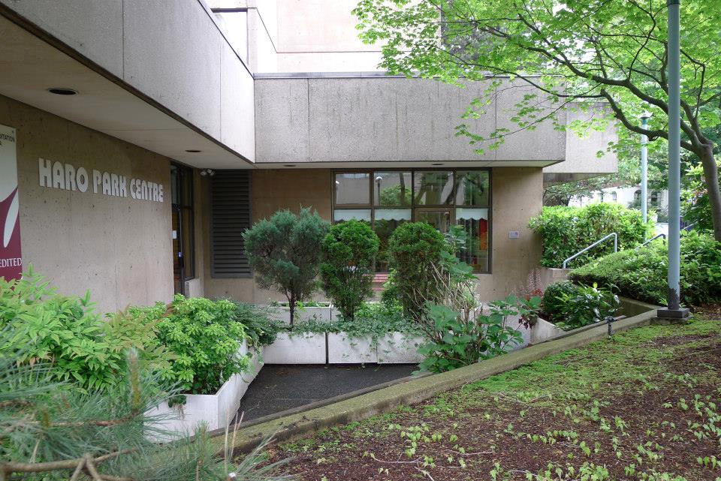
Figure 1: Current front area at Haro Park
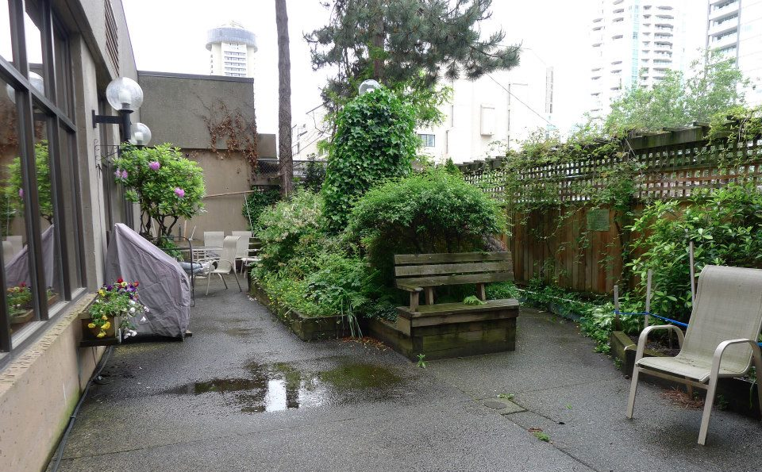
Figure 2: Current back area at Haro park
Presently, very few residents use the outdoor spaces. Our team has been tasked with finding out the reasons for this and uncovering the topics that influence outdoor usage. These findings were incorporated into creating a new design for Haro Park’s outdoor space. This report explores the issues facing Haro Park with regards to outdoor space and proposes a course of action that would resolve the problems and needs that we discovered.

2.0 Purpose of the Project
The focus of this project is to develop a plan for exterior renovations of the outdoor areas at Haro Park Centre based on the input and desires of the residents, staff, and family members of the residents. The renovation plans incorporate the needs of the stakeholders, which include accessibility, security, and usability. The proposed plans should encourage residents to use the areas by improving the atmosphere, making it more liveable, and tailoring the design to minimize the challenges senior residents face when using these spaces. Overall the essential necessity for this project is to ensure Haro Park Centre continues to be an enjoyable facility that provides a warming and suitable environment for its senior residents.
The major challenges faced by this project are to develop a clear understanding of what the stakeholders’ needs are, and what they hope to see from the design. Obtaining input can be difficult when working with senior citizens at a care facility due to certain issues, such as illnesses, attentiveness, and the desire to participate. The approach we designed as well our findings will be further discussed.
3.0 Partner Organization, Participants, and Community
Identifying potential stakeholders is an important step in our design process. We identified the stakeholders of our project as follows:
- Residents and their families
- Staff
- Surrounding community
We identified the main stakeholder for this project as the senior residents’ at the Haro Park Center. Our design of the outdoor space is incorporates needs and demands to attempt to create a more enjoyable, accessible and safe outdoor space. Furthermore, the outdoor space will provide family members and visitors a more useable space to spend time with the Haro park residents.
Another stakeholder for our project is the staff of Haro Park Center. Both management and floor staff of the facility will be able to experience lesser workloads and conveniences with the improved security system designed to improve the safety of the residents.
Lastly, the surrounding community of the care center will also affected by our project design. The improved outdoor space aims to increase the willingness of the seniors to stay in the facility; thus, increasing the safety and decreasing accident rate in the neighborhood

4.0 Goals and Objectives of the Project

Outlined below are our main objectives and goals for the project.
- To improve and continue to improve the quality of life of everyone in the center, including staff, residents and families.
- For any changes to the outdoors spaces to be safe and able to be managed by the facility’s staff. Many of the residents of Haro Park have some form of mental illness. This means that it is not safe for them to freely leave the center, which is monitored by the Watchmate security system. Any new outdoor space must also continue to protect residents and staff from outside threats.
- For our design outcomes to be beneficial for the residents. These areas need to be redesigned so that all, including those with physical and mental disabilities, can readily take advantage of them. These areas need to be comfortable and useable in a variety of weather situations.
- For our design to reflect the wishes and values of the staff, residents and families. Our improvements have to foster and encourage relationships between these groups, creating a calming and courteous environment.

5.0 Approach and Methods
In this section we discuss the approach we used to generate ideas for our designs of the outside space. Since our primary goal of the project was to best reflect the wishes of the stakeholders in the final design, our methodology was designed to help us better understand the needs, values and beliefs of the Haro Park community.
Our first meeting was conducted with the administrative staff at Haro Park. During this meeting we outlined the purpose scope of our project and briefly discussed what deliverables we were expected to complete. We then conducted multiple observations at Haro Park where we took notes on how the space was currently being used. During these site visits, we also conducted casual interviews with residents and staff about the use of the space. Furthermore, we facilitated several focus groups at Haro Park. Each focus group comprised of roughly 10 residents or staff. We choose to separate the groups into groups of residents or groups of staff to reduce any tensions and encourage more participation from the stakeholders. Finally, we conducted a questionnaire with staff members, as they were more capable of responding to the questions in written form.
As mentioned previously, our main purpose of this approach was to gain a deeper understanding of the needs, beliefs and wants of the stakeholders. Our goal was to focus on the social implications of the outdoor space before developing technical solutions to incorporate in the design. We drew upon suggestions presented in Robert Yin’s “Case Study Research: Methods and Approach”. In this article, Yin discusses the proper usage and design of the case study approach in social science research. We designed our approach to address some of the concepts covered in Yin’s article. For example, we choose to incorporate focus groups to not only gain input from selected stakeholders but also to remove biases from preconceived notions from our group. In the focus group, we acted as facilitators and prompted participants with questions attempting to eliminate any of our own judgments. We looked for commonalities mentioned in each group to develop a sense of the main challenges in improving the accessibility of the space. Our team decided to conduct preliminary observations prior to the focus groups to develop a sense of how many people used the space and also where they would sit. In addition, the questionnaire was used as a tool to determine how often the back and front spaces were being used as well as initiate the flow of ideas prior to the discussion in the focus groups. The findings of are approach are discussed further in the next section.

6.0 Results

6.1 Accessibility
As we worked in our focus groups and made observations around the center, it became clear to us that a majority of the residents were using walkers or wheelchairs. This underlined the importance of improving the accessibility for these individuals into the new design. Opinions towards the entrance were negative in general. Staff pointed out that the access ramp to Haro Street was very steep in gradient, making it a challenge for residents in walkers and wheelchairs to use it properly. Staff thought that an open, more welcoming space in the front would create a nicer atmosphere for entering and leaving the complex. Wheelchair users pointed out the inconvenience of the abrupt doorway ledges leading to the back space.

6.2 Layout & Appearance
The lack of space on the property instantly stood out to us during our initial site visits. As Haro Park is located in downtown Vancouver, the area is densely populated, with tight streets and small outdoor spaces. The city of Vancouver has done very well in handling the large population in the small downtown corridor region (Boddy, pg. 19) but much of the outdoor space at Haro Park is mismanaged or misused. The layouts of the two main outdoors areas create crammed and congested spaces. Both areas contain elaborate garden arrangements, which are visually pleasing, but their placement creates inaccessible spaces. This resulted in few residents using and enjoying the surrounding space. Staff commented on the dullness of the garden section adjacent to the access ramp, saying they would like to see a more lively vegetated area. Staff also thought that residents needed better ways to visit with their families in the outdoor areas.

6.3 Weather
The front outdoor space is facing south and receives a lot of sunlight. Though dominated by a large tree and overgrown vegetation, it usually remains warm and inviting. The back area, however, is darker and cooler during the day. Along with this, the grimy surface and overgrown vegetation in the back (also found in the front) creates a damp, bitter environment. During one of our visits, on a typical Vancouver day with moderate rain and overcast skies, both environments looked somber and were not being used by any residents.

6.4 Smoking
Staff voiced many concerns over the interaction between smokers and non-smokers in the outdoor environment. Until recently, there was an isolated smoking room, but recently it was shut down due to city bylaws and is currently awaiting a new purpose. Non-smoking signs are clearly visible along the front wall of the building, and while residents have been directed to smoke further away on Haro Street, this option is relatively inaccessible due to steep ramp and rough weather conditions. As a result some residents still chose to smoke right outside the entrance. Speaking with residents yielded some of the most unforeseeable and useful information. Some of their concerns were not addressed or considered in either our other focus groups or observations. It was revealed that the problem of outdoor use was creating some underlying friction among residents. In the focus groups, many non-smokers were frustrated with smoking disrupting the environment, while smoking residents were frustrated with the others’ intolerance and their poor access to the street. This further emphasized that not only was smoking a health issue for everyone living and working at Haro Park, it was also the reason of a substantial social issue that needed to be considered.

6.5 Families
Unfortunately we had the chance to speak with only one family member of a resident, the husband of a woman staying in Haro Park. It was still very useful to converse with him, as the two of them gave a good example of what was important in the relationships of residents with non-residents. It also came to our attention that another family member had proposed a new fenced design for the front entrance area. This proved that family members are concerned in the wellbeing of the residents at Haro Park and interested in changes to the centre. This is very important to recognize and consider moving forward with any technical and social solution.

7.0 Recommendations for Design
Following observations, focus groups, and consultations with staff, a recommendation for the renovation plans of Haro Park Centre have been drafted. The design options take into account the findings attained throughout the inquiry process, and try to meet the needs and desires of all the stakeholders involved. A two stage design process has been suggested in which a preliminary design could be implemented in the near future, and a second stage design could be implemented further down the road. Please note that further explanations of why these design options are appropriate for the stakeholders are detailed in the discussion section.

7.1 Preliminary Design Option: Stage I
The preliminary design option is a plan that is easier to implement and requires less excavation of the current outdoor areas. It incorporates changes to both the front and back areas.

7.1.1 Back Outdoor Area (Lane)
Below in Figure 3 is the layout of the current backdoor space at Haro Park. Please note that the plan drawings are not to scale.
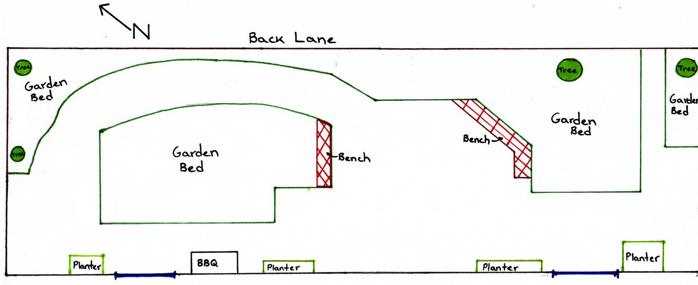Figure 3: Layout of the Current Back Outdoor Area
The preliminary renovation plan for the back outdoor area includes several structural changes which can be seen in Figure 4 below. These entail replacing the current pebble concrete surface with a non-slippery smooth concrete surface with good drainage, in order to provide a safe, durable platform for the residents. Next, a key accessibility point is the doorframes, marked in blue in Figure 3 & 4, which are tripping hazards and difficult to navigate over on a wheelchair. New doorframes that are smooth and at a level grade must be installed to provide an easy transition between indoors and outdoors. Lastly, the structural design changes propose the installation of a glass veranda as shown in Figure 4 by the yellow dashed lined, to allow for the outdoor area to be comfortable on foul weather days.
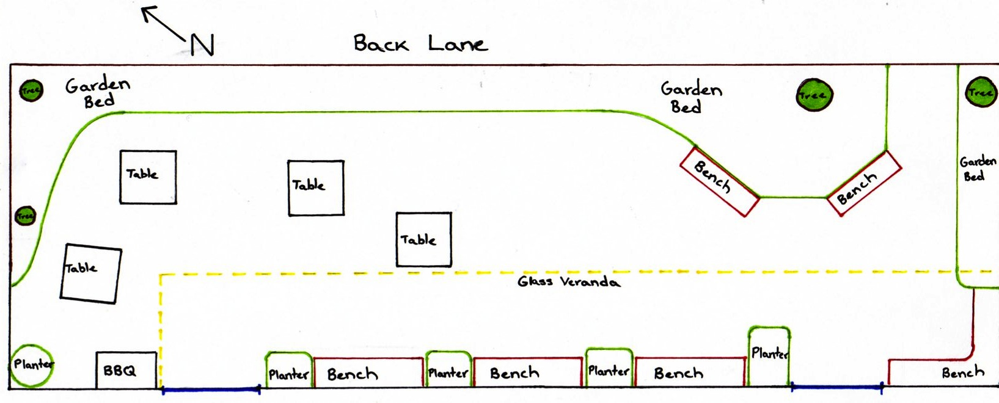
Figure 4: Proposed Back Outdoor Area
Furthermore, the design changes include removing the island garden bed, and reducing the size of the garden peninsula on the northeast corner. These changes will create a more spacious and accessible area. The majority of the garden fixtures will be along the outside fenced edges as depicted above, with more planters along the building. Additionally, the four large trees marked on the figures should remain enclosed by the garden beds to provide natural beauty. However, they should be trimmed appropriately to maximize sunlight during the morning hours while the sun rises in the East. The gap between garden beds in the East corner, that leads to an emergency exit gate should be widened to provide more space for people to walk in that area.
Finally, several outdoor furnishings, including wooden benches located along the building and garden beds should be incorporated into the space. For safety reasons, there should be space for the barbeque outside of the veranda cover. Lastly, several moveable tables with appropriate chairs should be placed in the open space, ensuring that there is sufficient space for residents to navigate the area and also a provide a place to eat outdoors.

7.1.2 Front Outdoor Area (Haro St.)
The current front outdoor area is shown schematically in Figure 5, it is visible that the area is quite cramped and adjustments need to be made to improve its accessibility.
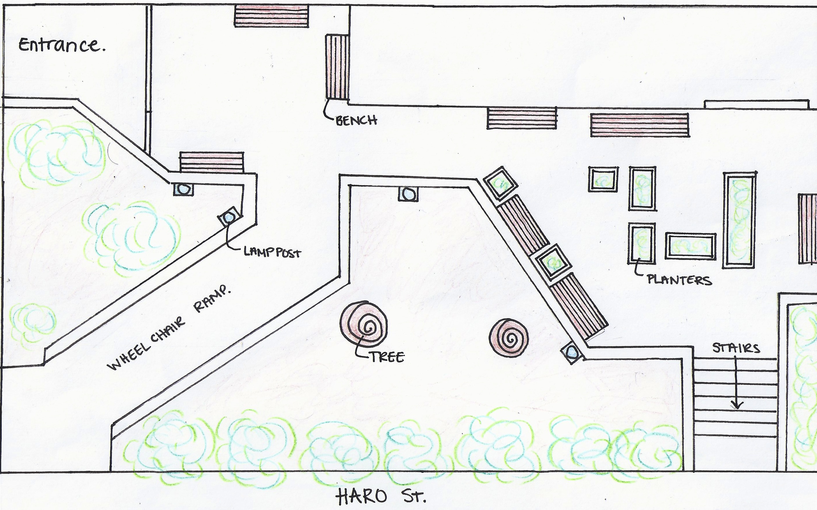
Figure 5: Layout of the Current Front Area
A potential layout for the first stage of the design is depicted schematically in Figure 6. The main design change for Stage I is installing a fence to section off the east corner, which is shown by a dashed black line in Figure 6. This will provide a safer area for residents to enjoy while not being worried about outsiders, and will make the outdoor areas easier to monitor for staff. The fence should be lined or surrounded by hedges or bushes to provide a friendly atmosphere that does not feel restricting. The access to the outdoor area will be from the entrance located on the southeast corner that connects to the common and dining area. The doorframe at this entrance must be replaced with a door that provides a level surface for an easy transition between indoors and outdoors. Additionally, as desired by the residents, a glass veranda that does not restrict sunlight should be installed over the entrance towards the north fence as shown in blue on Figure 6 to provide rain coverage.
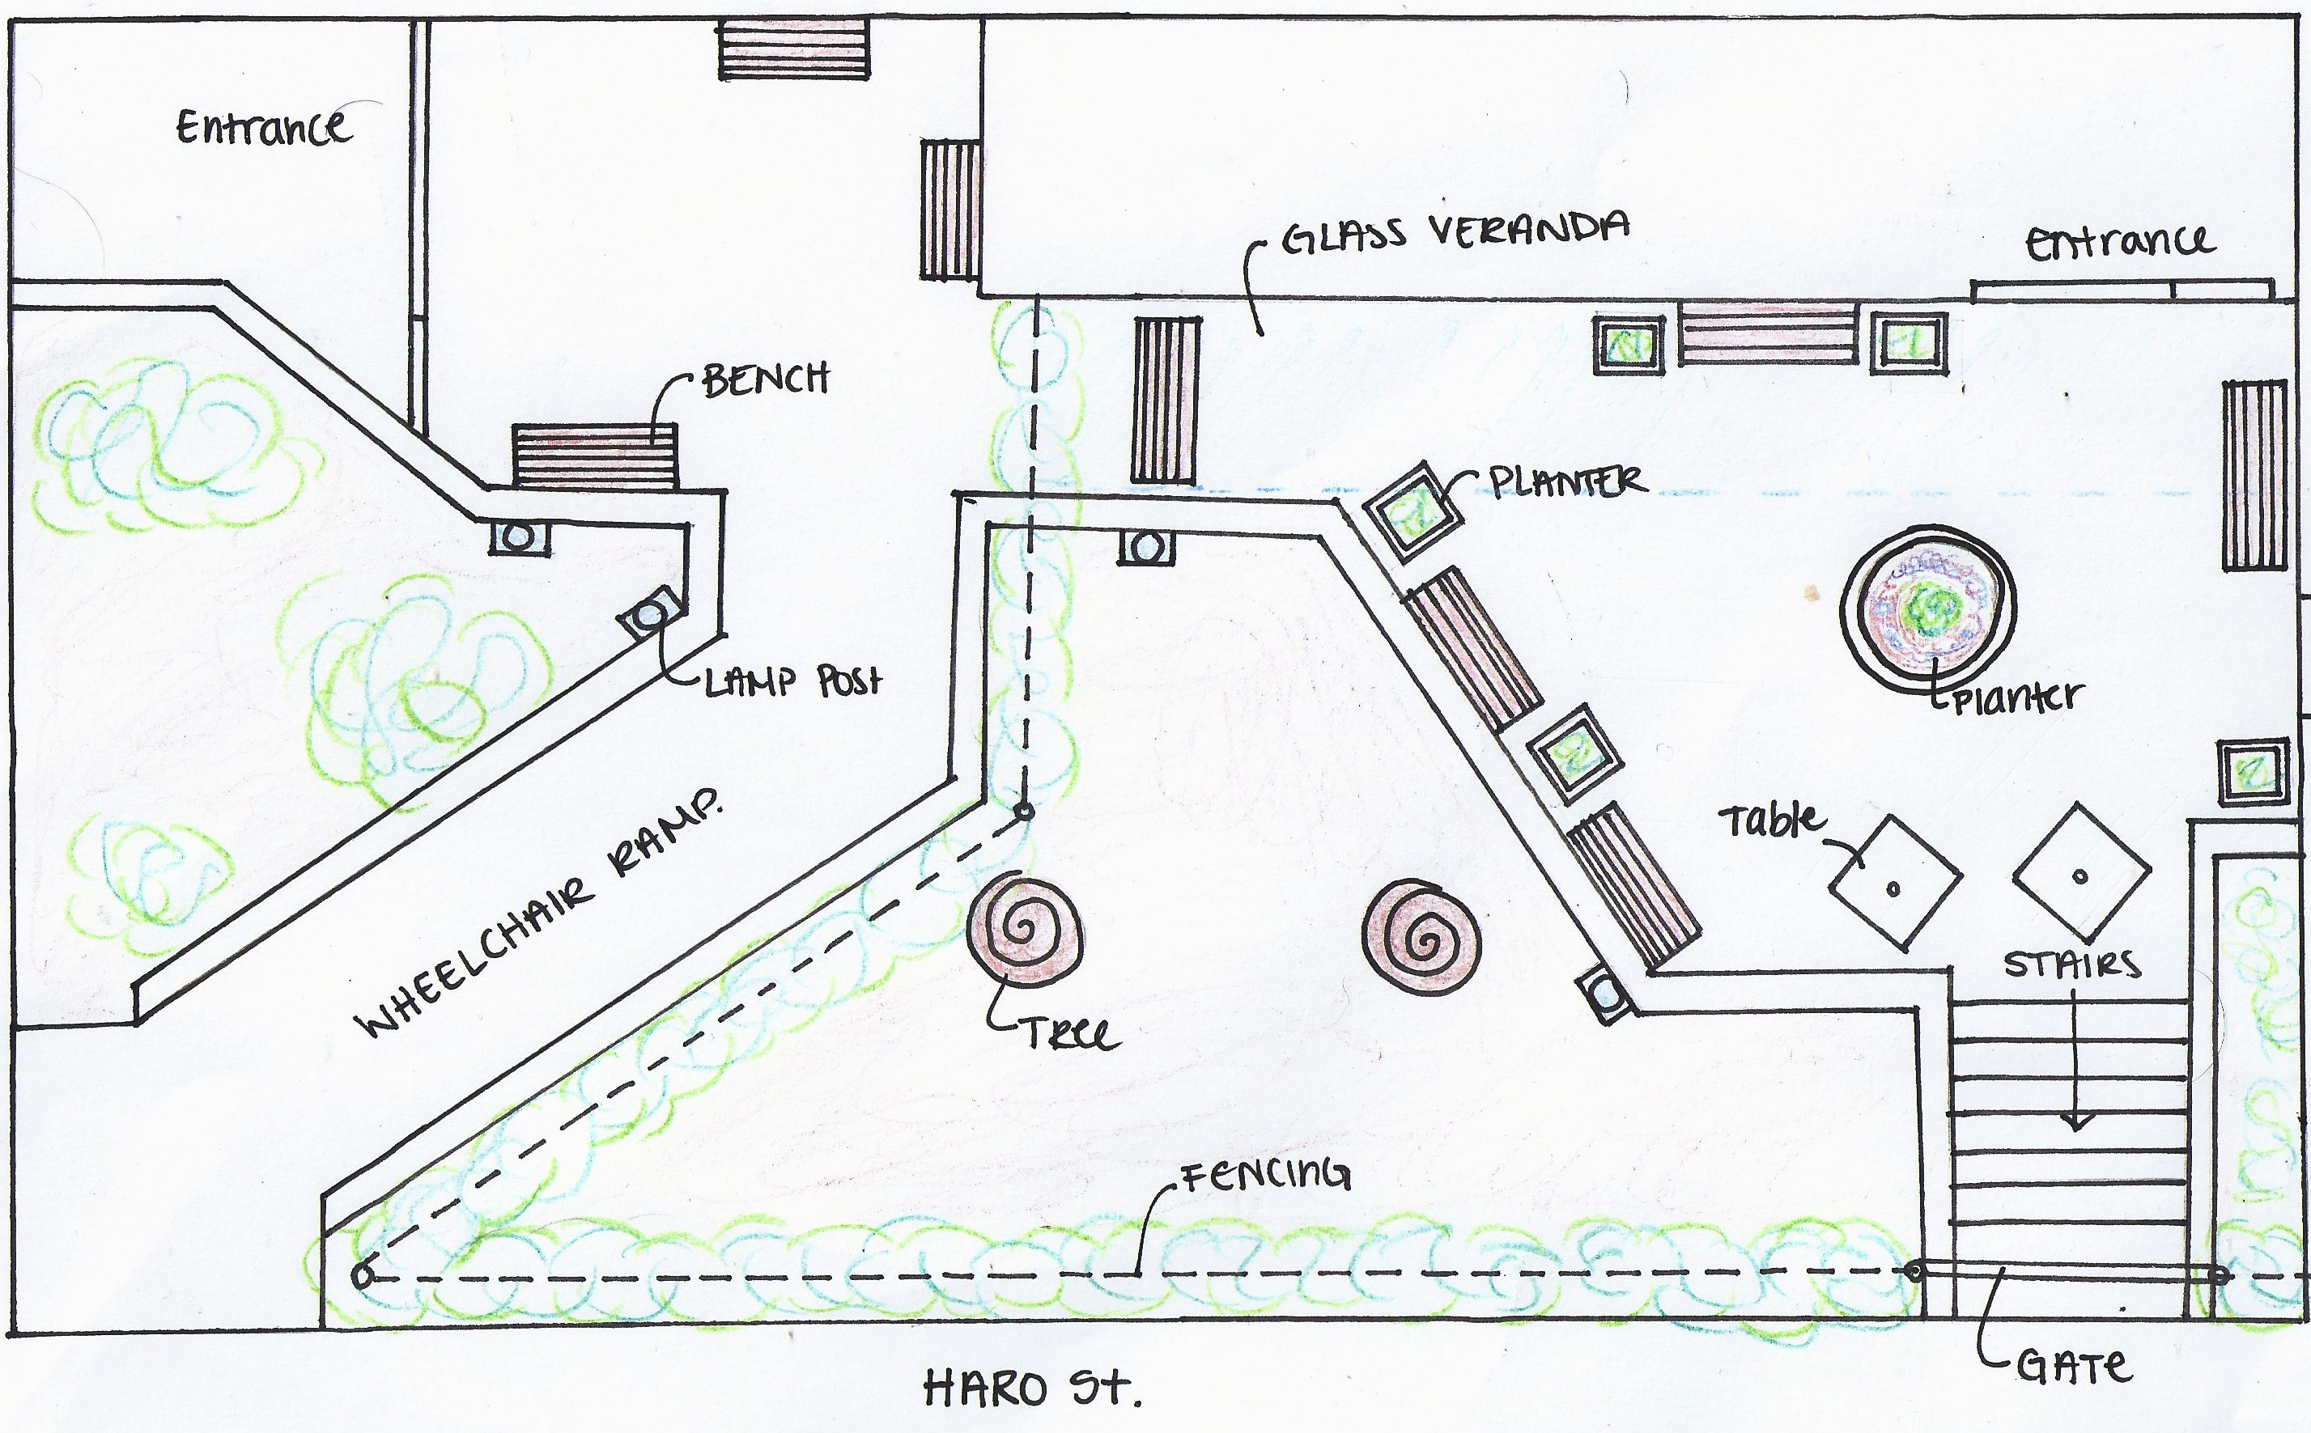
Figure 6: Proposed Front Area – Stage I
Furthermore, the outdoor fixtures including the planters located in the middle of the open area (Figure 5) should be removed as they lead to cramped space, which is difficult for residents to navigate. In this area, a single planter or fixture should be installed, as well as a few of tables, as this will provide a more open area where residents, family members and friends can socialize in an enjoyable setting.

7.2 Secondary Design Option: Stage II
The secondary design approach is an extensive design in which much more excavation and changes will be necessary. A layout of the design is provided below in Figure 7. The main component of this design is to move the main entrance of Haro Park Centre to Bute Street in order to create a significantly larger outdoor area on Haro St.
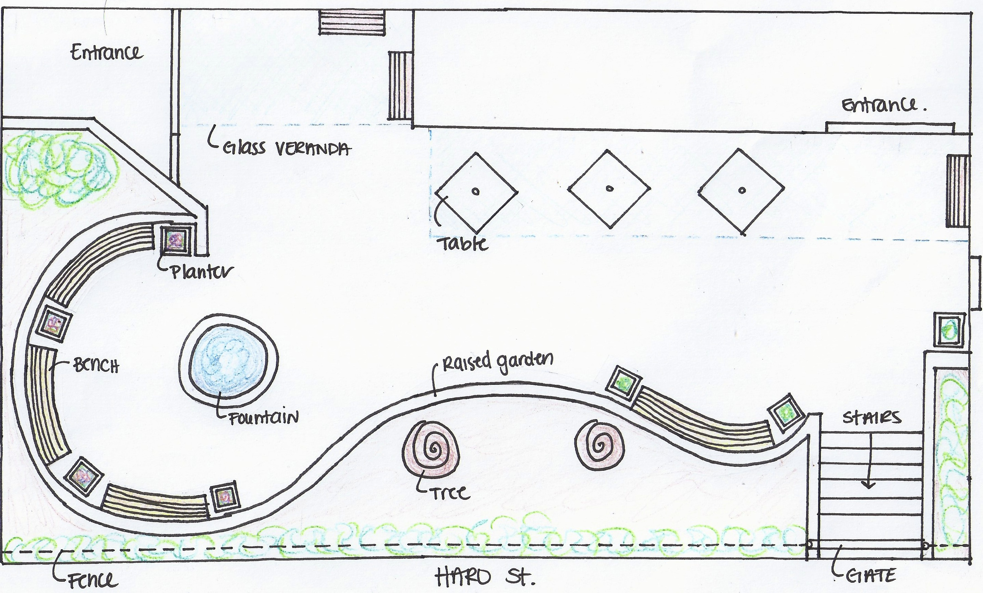
Figure 7: Proposed Front Area – Stage II
This will help to solve the current issue of the cramped entrance area as the Bute Street entrance opens into a larger hallway. Please note that interior design changes will have to be made in order to perform this stage, such as moving the receptionist office near the Bute street entrance which is currently occupied by a barber shop.
With this approach, the front outdoor area will require the excavation of the raised garden beds as well as the wheel chair ramp. This will create a much nicer sitting area with more sun exposure and an overall open area that will be easier to navigate. The proposed design leaves the large trees in the front untouched within an exterior garden bed. Tables, bench seating, and a water feature are included as an option for this space as this will help provide a friendly outdoor area that can be enjoyed by the residents, staff and family members.

8.0 Discussion
All of the issues that our team discovered relate to the quality of life and well being of seniors. Each issue is affecting not only the senior residents, but the staff working with them, their families, and the surrounding community. Senior citizens have unique needs and desires with regards to health and recreation. The results we have gathered need to be analyzed with a different mindset, one that puts aside our own values and focuses on seniors’ needs and values.
Implementing better outdoor designs in senior homes, including Haro Park, could encourage seniors to consider assisted care as an option. Many seniors who can benefit from assisted living are very hesitant to leave the comfort of their own homes. For many, the potential move would mean living in closer proximity to other people, with less personal space and a smaller living area. Effective outdoor spaces can help attract seniors to elderly homes and can make the transition to this new form of living easier. The loss of personal yards could be combated to some extent by a clean, enjoyable outdoor environment.
Smoking was a factor that our team didn’t consider going into the project, but in most situations it was a prevalent issue. In the end, our phase 1 design didn’t provide as complete a solution as we would have liked that accommodated both smokers and non-smokers alike. It was very hard to come up with a moderate design that did this, especially since we couldn’t recommend allowing smoking within 6 meters of the front entrance, as this would violate Vancouver City Health Bylaw No. 9535. However, we believe that if our design is met with an increased enforcement of the bylaw by Haro Park staff, then all groups of residents can be accommodated. We regret that this report does not suggest an appropriate solution the problem of the steep access ramp which is hinders smokers from leaving the facility to smoke, but this compromise is preferable over smoking occurring within an illegal range.
Another interesting social factor that played a large role in our design was security. From many angles, security is important to everyone at Haro Park. Unwanted intruders must be kept out, and all residents, especially those with mental illness, must be provided with an adequate level of safety within the residence. Any technical solution short of a complete security overhaul had to be able to operate fluidly with the current Watchmate system. In our designs these needs influenced the application of fences, as well as the continued implementation of auto-unlocking gates. This was a very good illustration of the technical and social links that occur in design.

9.0 Conclusion
The purpose of this project is to make the outdoor spaces of the Haro Park facility more accessible. We aimed to do this my taking into consideration the wishes of all the stakeholders involved in this project. However, we realized earlier on in the project that any proposals we make need to be centered on the senior residents and other stakeholders of Haro Park. We held talks with all the stakeholders of the project and were able to bring about a consensus within the Haro Community on how the outdoor spaces can be used more effectively. Based on the consensus we have made the proposals given in this report which we hope meets all the needs of the stakeholders.

10.0 References
Boddy, T. (2004). New Urbanism:" The Vancouver Model"[Speaking of Places]. Places, 16(2).
Haro Park. (n.d.). About us. In Haro Park Centre. Retrieved on June 19th, 2013. From http://www.haropark.org/about-us.html
Statistics Canada (2006). A Portrait of Seniors in Canada. (Catalogue no. 89-519-XIE). Retrieved from the Statistics Canada website http://www.statcan.gc.ca/ads-annonces/89-519-x/index-eng.htm
Yin, Robert K. (2003). Case Study Research: Design and Methods. Sage Publications: Thousand Oaks, CA.

