Wimba Classroom Setup Wizard



Prepared By:

Henry Lo

# ABSTRACT

Wimba Classroom is a live, virtual classroom environment with robust features that include audio, video, application sharing, and content display. Its design and ease-of-use ensures that educators and students alike are able to engage as if they were meeting face-to-face. The Wimba Classroom Setup Wizard is a verification test of the required software needed to run the virtual classroom. It includes a series of tests to ensure that you computer is ready.

Table of Contents

ABSTRACT 2

1.0 INTRODUCTION 5

2.0 BACKGROUND 5

3.0 TESTS 6

3.1 POPUP WINDOWS 6

3.2 JAVA 7

3.3 TEXT CHAT 8

3.4 SIGNED APPLET 8

3.5 PLAYBACK 9

3.6 RECORDING 10

4.0 CONCLUSION 12

**Table of Figures**

Figure 1. Wimba Setup Wizard 5

Figure 2. Pop-up Blocker 6

Figure 3. Allow Pop-ups for Wimba Setup Wizard 6

Figure 4. Java Update 7

Figure 5. Installing Java Update 7

Figure 6. Testing Text Chat 8

Figure 7. Allow Signed Applet 9

Figure 8. WimbaMedia Bar 10

Figure 9. Testing Audio Recording 11

Figure 10. Wimba Setup Wizrd Complete 12

# INTRODUCTION

The Wimba Classroom Setup Wizard assists you in preparing your computer for a Wimba session. The Wimba wizard will detect difficulties as part of the setup process.

The requirements to run Wimba Classroom are as follows:

* Operating System: Windows XP or Vista, Mac OSX 10.4++
* Memory: 256 MB RAM
* Browser: Internet Explorer 7.0+, Safari 3.0+, Firefox 3.0+ (Browser must be Java and JavaScript enabled)
* Internet Connection: 56k or above

This report is aimed to help you better understand the steps taken by the Wimba Classroom Wizard in ensuring your computer is able to run the virtual classroom. Each section will be devoted to the tests that the wizard performs, starting from Popup Windows.



Figure 1. Wimba Setup Wizard

# BACKGROUND

All tests run by the wizard are developed in JavaScript, hence the requirement for browser able to run Java and JavaScript.

JavaScript is an [object-oriented](http://en.wikipedia.org/wiki/Object-oriented)[scripting language](http://en.wikipedia.org/wiki/Scripting_language) used to enable [programmatic](http://en.wikipedia.org/wiki/Computer_programming) access to objects within both the [client application](http://en.wikipedia.org/wiki/Client_%28computing%29) and other [applications](http://en.wikipedia.org/wiki/Application_software). It is primarily used as an integrated component of the [web browser](http://en.wikipedia.org/wiki/Web_browser), allowing the development of enhanced [user interfaces](http://en.wikipedia.org/wiki/User_interface) and dynamic [websites](http://en.wikipedia.org/wiki/Website). The tests that Wimba Classroom Setup Wizard implements are developed in JavaScript. The WimbaMedia toolbar, for example, is developed using JavaScript as an integrated components of the setup. Other tests like scanning your browser setting to ensure that popups, text chat, etc. are all developed using JavaScript to ensure the capabilities of your internet browser.

# TESTS

## 3.1 POPUP WINDOWS

The first test Wimba Classroom Wizard runs is the popup window. This test utilizes JavaScript code to check if any pop-up blockers exist. Wimba behaves within your browser as a pop-up, so a new window will appear when you first run Wimba. This test ensures that the pop-up blocker found in many internet browsers allows Wimba to appear. If you are also using a pop-up blocker, Wimba will not function properly.

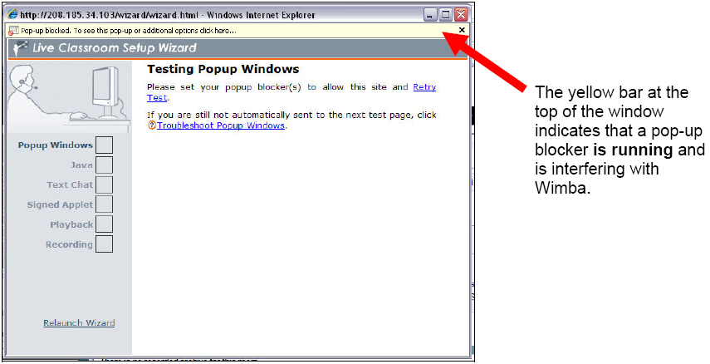

Figure 2. Pop-up Blocker

For example, many popular browsers contain an application called Google Toolbar. It is designed to add additional features to your browser. However, the pop-up blocker feature contained in the Google Toolbar can interfere with Wimba. Therefore it is recommended for Wimba users to uninstall any pop-up blocker software before starting the virtual classroom. After successfully completing this test, a check will appear in the Popup Windows box.

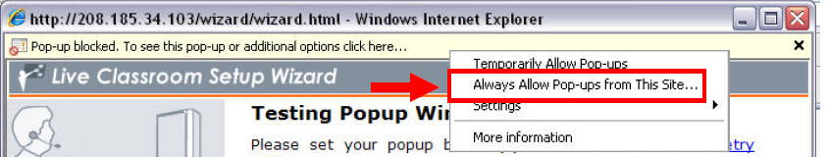

Figure 3. Allow Pop-ups for Wimba Setup Wizard

## 3.2 JAVA

The second test is the Java test. Java is a computer programming language. Many helpful programs that you find online such as chat messengers, online games, etc. are written using Java. These applications, written in the Java programming language and accessible from your browser are called “applets”. Many features contained in Wimba require Java, and this test will ensure that your computer has the required java updates to run the applets in Wimba. The test takes a few seconds to complete. If this portion of the wizard fails, you will need to visit the Sun Microsystems Java website to download and install Java.

Downloading Java™ SE Runtime Environment 6 Update 3 will ensure that you have the required java update to run Wimba Classroom.

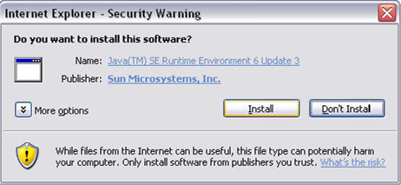

Figure 4. Java Update

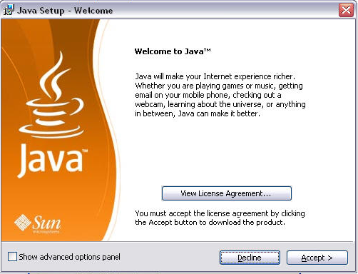

Figure 5. Installing Java Update

## 3.3 TEXT CHAT

This test is a simple and quick evaluation of your browser’s text capability. All browsers should contain a text feature for users to enter in websites addresses, etc. As long as the user is using one of the required internet browsers listed above, this test should not be a problem.

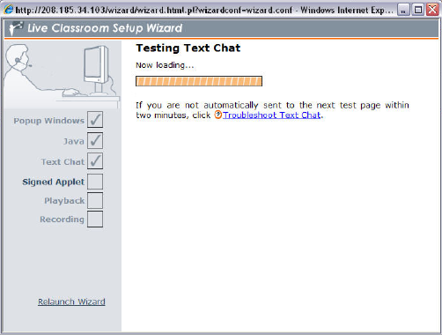

Figure 6. Testing Text Chat

## 3.4 SIGNED APPLET

Whenever you are surfing the web and you want to execute an applet, you want to be sure a person/company you trust has approved the applet. In order to realize this, the applet is signed by its publisher. The Signed Applet section of the Wimba Classroom Setup Wizard stops the test and waits for the user to verify/allow Wimba Classroom audio to run on the computer. The Signed Applet section of the Wimba setup wizard warns the user that a pop-up window is to appear and instructs him/her to continue and run the signed applet approved by Wimba.

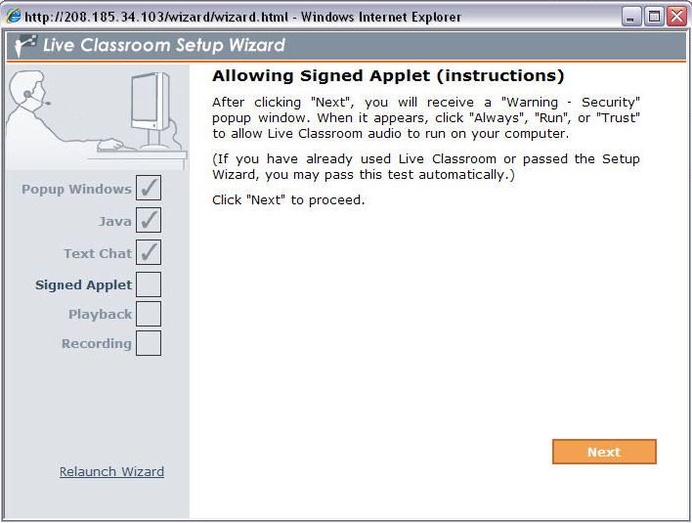

Figure 7. Allow Signed Applet

## 3.5 PLAYBACK

This portion of the wizard will test if the system is ready to receive and let you hear audio signals. You will notice on the page that a new toolbar appears on screen. This is identical in appearance to features that are part of the Wimba Classroom, called WimbaMedia. It is developed using Javascript. If you have speakers (or headphones) correctly attached, you will hear a women’s voice talking, verifying that the audio function of your system is working.

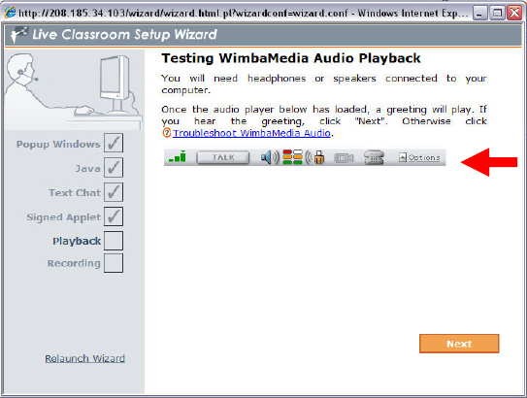

Figure 8. WimbaMedia Bar

## 3.6 RECORDING

The last portion on the Wimba Classroom Setup Wizard is audio recording. This test requires both speakers and a microphone and will verify if your system is ready to send audio signals, so that you can send your voice for others to hear you talking during Wimba sessions. After three beeps, click and hold down the “Talk” button and speak into the microphone. If you can hear your own voice after a delay, your system is prepared for audio recording.

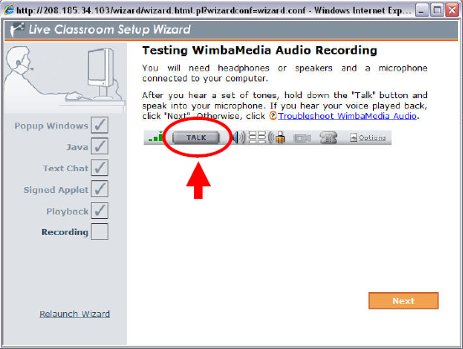

Figure 9. Testing Audio Recording

# CONCLUSION

Once you have successfully passed all the tests, your system will be fully prepared to start your first Wimba session.

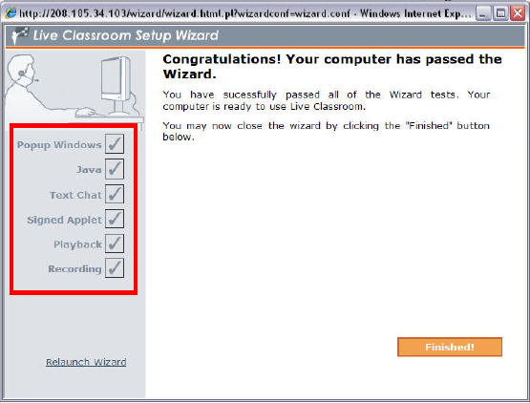

Figure 10. Wimba Setup Wizard Complete