The criteria of this assignment is to comprehend and apply the importance of definitions in technical writing, while educating an audience who may not have prior knowledge of the defined area. The objection of this assignment is to construct a definition appropriately and professionally as to provide as much detail as possible while keeping the definition informative.

Parenthetical Definition- Recidivism (Repeating similar offences requiring punishment multiple times)
Sentence Definition- When an individual repeatedly performs a negative, often illegal, action even after followed by a punishment or consequence.
Expanded Definition- Recidivism is a term which is used in the criminal justice system for individuals who commit crimes and are arrested, charged, and incarcerated repeatedly for similar offenses. The recidivist individual has previously received punishment and often treatment in an attempt to correct their deviant behaviors.
Etymology- The word recidivism stems from “Latin recidivus “recurring”, from re-“back” and cado-”I fall” (“Recidivism,” n.d.).
Comparison and Contrast- Recidivism is also a term used with individuals who struggle with addictions and substance abuse. “Recidivism is a synonym for ‘relapse’, which is more commonly used in medicine and in the disease model of addiction” (“Recidivism,” n.d.). Relapse is when an individual discontinues usage of an addictive substance only to begin using it again shortly after attempting to stop. Here we can see the connection between recidivism and relapse in the sense that individuals participate in a crime or substance abuse, attempts are made to stop this behavior only to continue or reoccur.
Required Conditions- Mental illness is linked to both of these terms, and specifically in the correctional system, such as jail and recidivism with Psychosis, Antisocial Personality Disorder and Borderline Personality Disorder. Often recidivism criminal behavior begins in adolescence, which is called juvenile delinquency. Individuals who end up incarcerated (in jail) multiple times tend to become what is called “institutionalized”. When a recidivist individual becomes institutionalized they become accustomed to the lifestyle of being in jail and being taken care of, therefore when released into society they do not know how to take care of themselves which often bringing the individual to reoffend as a way to stay in jail.
Proposed procedures to minimize recidivism:
- Continuing the current incarceration process;
- Increasing pre-release support and preparation, such as educational and vocational training and mental health and addictions counselling;
- Increasing and enriching community-based support and programs in facilitation integration effectively into society.

Examples- An example of a recidivist individual is a young juvenile delinquent female. This youth has a family history of multiple severe mental illnesses (due to this she is termed as “at-risk”), as well she was born into a neglectful and violent environment. Due to this home environment she was taken into the care of Ministry of Child and Family Development where she was adopted and later returned into care. Due to the combination of biological and environmental affect this youth became extremely violent and rebellious and has spent the majority of her youth in-and-out of youth correctional facility (jail) for assaults. This youth is a juvenile delinquent recidivist individual who suffers from multiple mental illness diagnosis. Consequently she is housed in a public residence with staff and an integrated team who spend all day with her guiding her with social skills, anger management and personal support in hopes to discontinue her recidivist behavior and patterns.
Visuals-
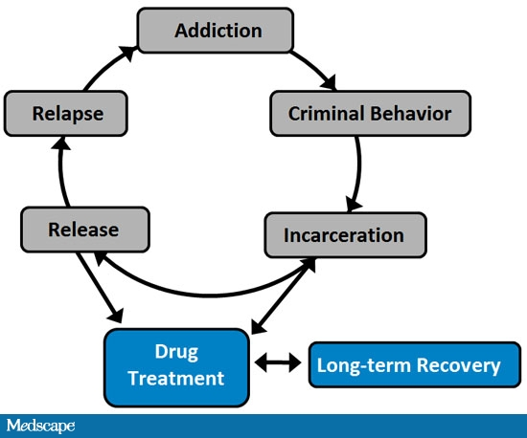
Figure 1. Feedback loop of the recidivism cycle. This diagram applies to addictions however also applies to mental illnesses.
Source: Medscape Education [online image].

References
Medscape Education [Online Image]. (2009). Retrieved May 27, 2015
from http://www.medscape.org/viewarticle/712637.
Recidivism. (n.d.). Retrieved May 27, 2015, from the Recidivism
Wiki: http://en.wikipedia.org/wiki/Recidivism#Alternative_policies

