**EDCP 305: Digital Media in Arts Education**

**LESSON ON INTRODUCTION TO PHOTOSHOP TOOLS**

**BY: Hyesun (Judy) Kim & Hyejin (Jeanelle) Kim**

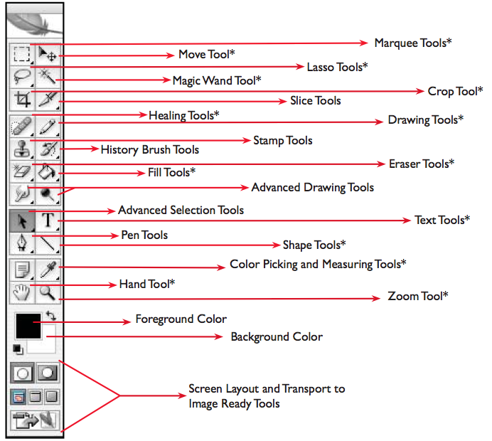

= This little black arrows in the bottom of right corner of the tools indicate a tool group. When you click the black arrows, you will see the alternate tools.

Next! We will see **toolbox in detail!**

First tool: **Marquee Tools**

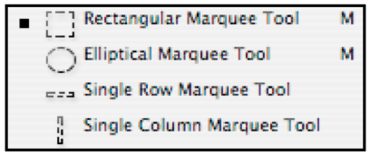

* The Marquee Tool makes rectangular selections.
* The Elliptical Marquee Tool makes elliptical selections.
* Single Row Marquee Tool & Single Column Marquee Tool selects a section of the document based on the shape of the chosen tool.

Second tool: **Move Tool**

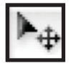

* The Move Tool moves selections, layers, and guides.

Third tool: **Lasso Tools**

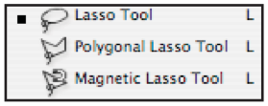

* The Lasso Tools allow you to select a section of the document either by freehand, polygonal, or magnetic selections.

★ When the mouse is unclicked, the Lasso Tool selection will close.

Fourth tool: **Magic Wand Tool**

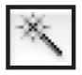

* Magic Wand Tool selects similarly colored areas.

Fifth tool: **Crop Tool**

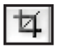

* The Crop Tool trims images.

★ When you want to expand or contract the area, you just have to drag on one of the 9 points of the box.

Sixth tool: **Healing Tools**

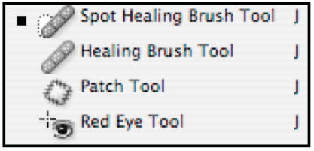

* The Healing Tools fix up the issues in the document such as red eye and blemishes.

★ The Spot Healing Brush removes blemishes and objects.

★ The Red Eye tool removes the red reflection in the eyes which is caused by the flash.

Seventh tool: **Drawing Tools**

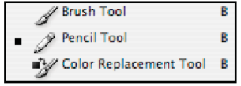

* The Drawing Tools let you draw in your document.

★ The Brush Tool paints brush strokes.

★ The Pencil Tool paints hard edged strokes.

★ The Color Replacement Tool replaces a selected color with a new color.

Eighth tool: **Eraser Tools**

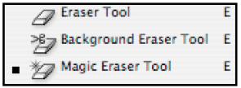

* The Eraser Tool erases pixels and restores parts of an image to a previously saved state.

★ The Eraser Tool will restore parts of an image to a previously state or will display the background color.

★The Background Eraser Tool will turn the erased areas into a transparency.

★ Magic Eraser Tool will erase everything of the same color into a transparency.

Ninth tool: **Fill Tools**

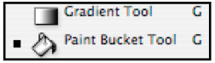

* The Fill Tools fill color into areas of the document

★ The Gradient Tool creates a smooth straight line change from the foreground color to the background color.

★ The Paint Bucket Tool fills in areas of similar color with the foreground color.

Tenth tool: **Text Tools**

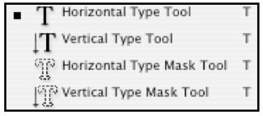

* The Text Tools create type on an image.

★ The Type Mask Tools make a selection of the document in the shape of type.

Eleventh tool: **Shape Tools**

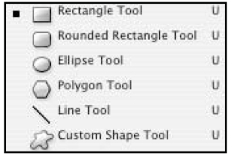

* The Shape Tools draw shapes and lines in a normal layer or a shape layer.

★ The Shape Tools will create solid color shape of their type.

★ The Line Tool will create a solid color line.

★ The Custom Shape Tool makes customized shapes selected from a custom shape list.

Twelfth tool: **Color Picking and Measuring Tools**

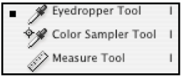

* The Eyedropper tool changes the foreground color to the color that is clicked and picked on.
* The Color Sampler Tool is an advanced tool.
* The Measure Tool measures the distance, location, and angle between two points in the document.

Thirteenth tool: **Hand Tool**

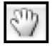

* The Hand Tool moves an image within its window

Fourteenth tool: **Zoom Tool**



* The Zoom Tool magnifies and reduces the view of an image.