Using your Teaching Portfolio to Showcase your Educational Leadership
Winter Institute 2016
UBC Centre for Teaching, Learning and Technology

Facilitators: Dr. Isabeau Iqbal (Centre for Teaching, Learning and Technology [CTLT]),
Dr. Simon Albon (Faculty of Pharmaceutical Sciences), and Dr. Simon Bates (CTLT)

Teaching Portfolio

Some definitions

“a purposeful collection of evidence, consisting of descriptions, documents and examples of what is good teaching for the teacher.” (De Rijdt, Tiquet, Dochy & Devolder, 2006, p.1086)

“...a personal document where the teacher presents his or her teaching philosophy (reflections about teaching and student learning), together with integrated examples from their teaching practice.” (Olsson & Roxå, 2013, p.43)

Elements of a teaching portfolio

Teaching philosophy statement
Approach to course design
Teaching activities
teaching responsibilities
supervising and advising students
activities to improve teaching and learning
contributions to the teaching profession/institution
evidence of student learning
committee service
Demonstrations of teaching effectiveness
Educational leadership

Educational leadership in 5 questions

- What did you do?
- What are the outputs from doing it?
- What impact has it had on people, processes and products?
- How do you know?
- How is it documented in your CV and teaching dossier?

Educational Leadership Mapping (ELM) Framework

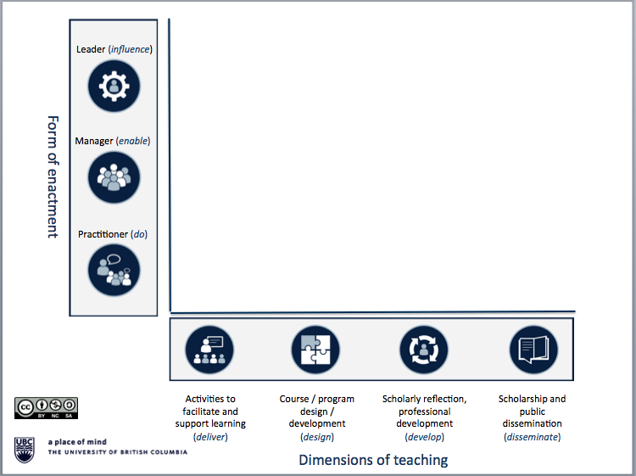

To access a (readable) version of the map above and to read more information about the framework, please see: http://ctlt.ubc.ca/programs/all-our-programs/teaching-and-educational-leadership/ (download the map as a PPT slide)
Or contact: Dr. Simon Bates at simon.bates@ubc.ca

Categories of Impact

People
practice (our own/colleagues’/disciplinary)
student success (learning, program outcomes, engagement, well-being)

Processes
priorities (departmental/Faculty/institutional)
capacity (provision of support for teaching and learning activities)

Products
curriculum (course/program offerings/accreditation)
literature (scholarly literature, wider publishing venues, media)

References

De Rijdt, C., Tiquet, E., Dochy, F., & Devolder, M. (2006). Teaching portfolios in higher education and their effects: An explorative study. Teaching and Teacher Education, 22(8), 1084-1093.

Olsson, T. & Roxå, T. (2013) Assessing and rewarding excellent academic teachers for the benefit of an organization, European Journal of Higher Education, 3(1), 40-61. DOI: 10.1080/21568235.2013.778041

