Information Package

Southwest University

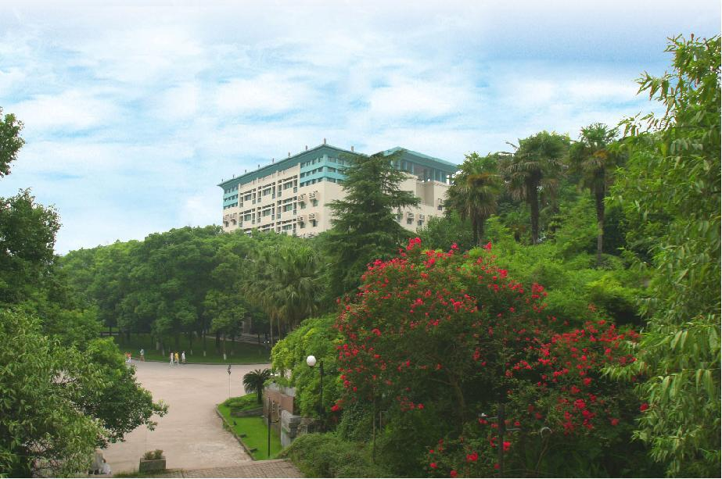

Faculty of Education at Southwest University, Chongqing, China
中国·重庆 西南大学教育学部

About Southwest University
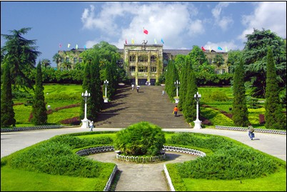
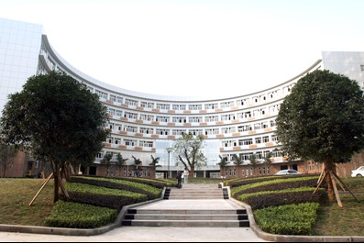
Southwest University (SWU) is a key comprehensive university, under the direct administration of the Ministry of Education. It was newly established in July 2005 through the incorporation of former Southwest China Normal University and Southwest Agricultural University upon the approval of the Ministry of Education. SWU is situated nearby the beautiful Jialing River, and is located at the foot of Jinyun Mountain, a state level scenic spot, in Beibei District, Chongqing Municipality. Southwest University has a variety of students numbering over 50,000. Its scale and levels are ranked ahead of other higher education institutions in the western China. Till now, Southwest University has had close communication and cooperation in research and academic studies with international universities and/or institutes from more than 30 countries and/or regions, including the US, UK, France, Germany, Japan, Australia, Russia and Canada etc., and enjoys long term partnership with over 20 of these universities.

About Faculty of Education
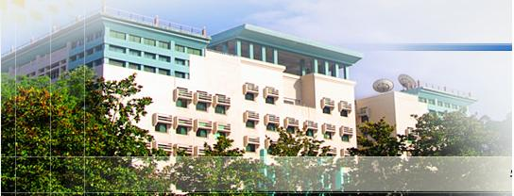
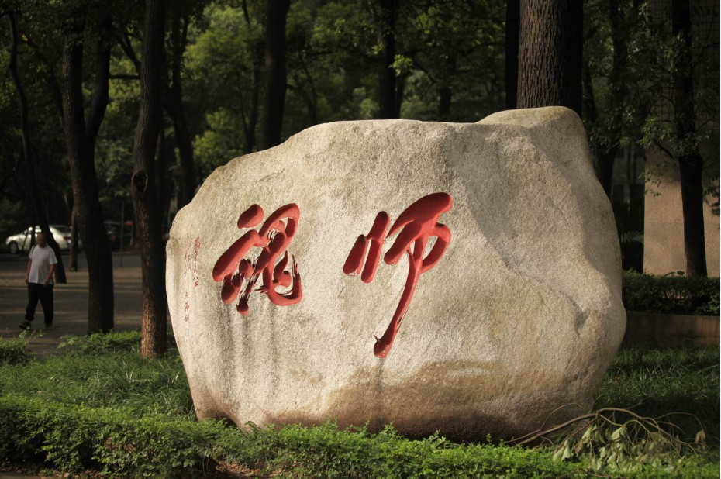
The Faculty of Education at Southwest University has served educational communities of China, especially Western China through its leadership in research, service, and advocacy for more than fifty years. As one of the leading faculties of education in China, it engages in preparing teachers and other educational professionals for practice in a wide range of education-related fields from preschool through adulthood and dedicates to advancing knowledge and improving the practice of teaching and learning experience. Our faculty members are organized for their work in developing, advancing and enacting knowledge and driven by our commitment to educational excellence, equity, and constant pursuit of knowledge. Throughout our about sixty years of history, we have grown and evolved in response to the ever-changing challenges and needs of the society. We follow a rigorous research program to investigate theory and provide innovative leadership in issues of educational pedagogy. The Faculty ranks third in academic research and first in programs for graduate students among the colleges of education in China. With development of Western China, this Faculty will make more contribution to the communities and China.

About Dean, Professor Zhu Dequan
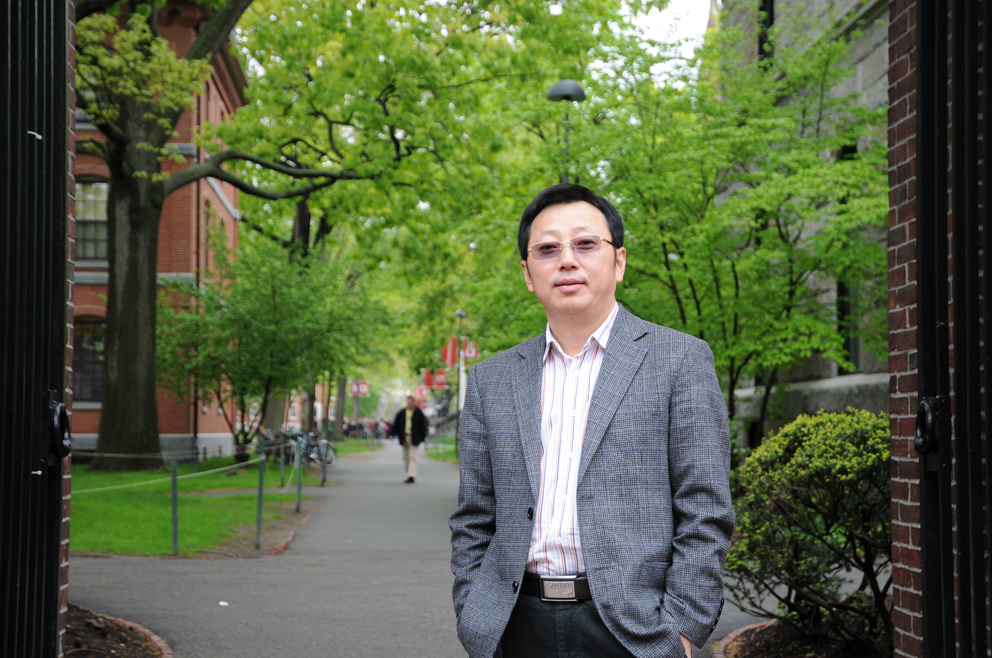
Dr. Zhu Dequan is the Dean of the Faculty of education at SWU. He is a distinguished professor and has chaired over 10 national or provincial level educational research projects, and published more than 200 academic papers in key journals including Higher Education Research and Education Research. Dr. Zhu Dequan has edited more than 10 books and educational textbooks including The Prescription Teaching Principle. He was also involved in edition of three national textbooks which are listed in the national “the 10th Five Year Plan” and “11th Five Year Plan”.

Our Programs
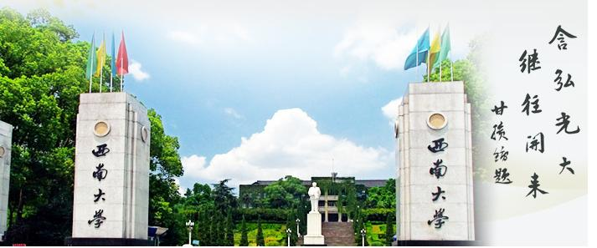
We are conscious of the needs of our students and the expectations of our society. To provide the most intimate and responsive programs, we have offered the following programs areas, each with its own unique organizational structure:
Undergraduate Program
Graduate Program
Certificate Program
Diploma Program
International Program
More details at http://jyxb.swu.edu.cn/jyxben/index.jsp

