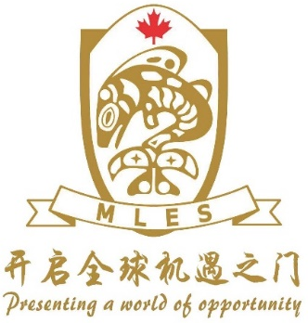

Date
Pre-practicum information for a Maple Leaf placement
UBC Field Experience Required Information
Name:
Bachelor Degree:
Major:
Minor:
B. Ed Focus- grade level:
Travel dates planned:
Travelling alone or with a partner:
School location requested: 1.
(not required) 2.
3.

Wish to be considered for a placement in a community with (provide name of other individual):
Travelling with a partner who will also require accommodation:
Will live as a roommate with an existing Maple Leaf teacher during the practicum:
Would prefer to be housed on my own or with a University Colleague, if housing is available:
Passport is valid for more than 6 months after the planned travel dates:
Passport Photo Page returned to Maple Leaf to: humanresources@mapleleafedu.com
Profile/Letter of Introduction returned to Maple Leaf to: humanresources@mapleleafedu.com
Skype or WeChat contact necessary for an interview with one of the school administrators:
Project or Inquiry focus (if you have one):
Objective (what you hope to gain from this experience):

