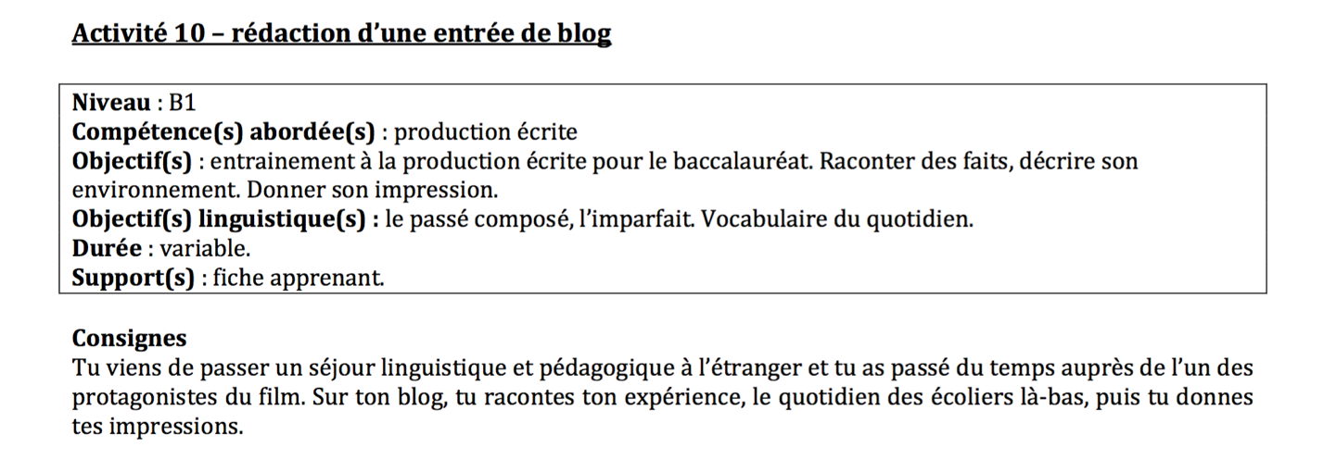

Date: ___________________

Titre: __________________________________________

