GENERAL NOTES FOR ALL FINALE PARTICIPANTS
- This is the last dance project to be included in “Hands Down, We Did It!”, Handsworth’s first virtual dance showcase.
- Every dancer in the dance program is encouraged to learn this finale. All the files you will need to learn the dance can be found HERE.
- The dance was choreographed by Tayla Doyle & Holly Tarves (G12 Studio).
- The video montage will be created by Megan Hingson & Felix Soong who created our video of “La La Land”. It includes 3 parts where we need student participation:
  - Dancers performing the 64 counts of choreography to the chorus.
  - A picture of each dancer holding a message of hope or encouragement to our dance community to spread positivity.
  - A picture of each dancer pretending to hold hands with others for the final image of the video montage.

PART ONE – CHOREOGRAPHY (Required)

CHOREOGRAPHY
- The video including the breakdown of the movements, plus the counts can be found here:
- The choreography can be learnt on your preferred side as the video can be flipped during the editing process. Meaning, you can:
  - Do the right if the choreographer does their right, or
  - Do the left if the choreographer does their right as you are mirroring them.
- There is only one choreography for all the different dance classes.
- The chorus is 64 counts and can be divide in two parts:
  - Part one (the first 32 counts)
    - Music track from 0:46-1:00
    - There is a part one video (explained, slow motion, regular tempo)
  - Part two (the last 32 counts)
    - Music track from 1:01-1:15
    - There is a part two video (explained, slow motion, regular tempo)
- The goal is to give 110% of energy, fun, and smile when performing this.

COSTUME & HAIR
- It must follow the same requirements as a “Hands Up” performance.
  - Follow these costume guidelines:
    - Wear a white or bright coloured t-shirt. Female dancers should wear a white tank top under their white top. Logos OK
    - Blue jeans shorts, pants, or overalls.
    - Sneakers that go well with your outfit.
      - Absolutely NO booty shorts, no crop tops, no stomach showing, no spaghetti straps.
  - Hair must be tied up somehow, not in your face, neat and tidy.

FILMING REQUIREMENTS
Read the file entitled “Filming Requirements” on the shared OneDrive folder I gave you access to, to learn how you must film your video. It is crucial that you follow these guidelines to make it easier on Megan & Felix who will have A LOT OF FOOTAGE to manage and a very short time frame to produce the video for performance night.
- Make sure to start the music at 0:41 and hold still until you start dancing to help with the editing.

Send film to your teacher. Due June 10, 2020 by 11:59pm
- For Ms. Isabelle, please place your video under your 4th assignment (first option), the large files dropbox (second option), email (third option).
- For Ms. Brodie, ask her directly what she prefers.

PART TWO – PICTURE OF YOU WITH A MESSAGE OF HOPE (Bonus points)

CONCEPT
- During the video, there will be sections where we would like to get students to be photographed, in the position of their choice (it doesn’t have to be dancing, but just being), holding a message of hope for the other dancers to spread some positivity and make us feel connected as a community before heading our individual ways to summer.
  - Original idea inspired from this video.

WHAT TO DO
- Choose your message. Access the Google Doc here to see what others have written and to choose what you will write. Read the submissions before you and then add yours. First come first serve.
  - 1 sentence maximum. It can be a quote with name of the person who originally said it.
  - Ms. Isabelle & Ms. Brodie will then look through them and approve them.
    - Highlighted green: approved
    - Highlighted yellow: review
    - Highlighted red: change
  - Once your message has been approved and highlighted in green by one of us, go ahead and create your sign.

- Make a sign.
  - The paper must be at least 8 ½ x 11 (Letter Size) so the audience can read it easily.
  - White paper is best.
  - Check your spelling before writing your message.
  - Write in bold BLACK letters for everyone to read easily.
  - Decorate the rest of the paper as you wish!

- Take a picture with your sign.
  - Take the picture horizontally/landscape ONLY! No vertical pictures please.
  - Smile while holding your message of hope.
  - Position yourself in front of a tidy background. Outside is highly encouraged.
  - The message should be in the middle of the frame.
  - We need to see your face well, but it is not necessary to see your entire body.

- Send your picture to your teacher. Due June 10, 2020 by 11:59pm
  - For Ms. Isabelle, please place your picture under your 4th assignment (not in the large files dropbox).
  - For Ms. Brodie, ask her directly what she prefers.

PART THREE – PICTURE OF YOU HOLDING HANDS (Required)

CONCEPT
- For the final image, we would like everyone to take a picture of themselves as if they were holding hands down with other people in a circle… It will make sense with the video montage…we put some examples below…
  - Original idea taken from this video.

Take a picture of yourself pretending to hold hands.
- Stand straight. Smile. Put your arms out. Look straight on.
  - Take the picture vertically/portrait from straight on.
  - Cut out just the wrists.
  - Take it from knees up so the dimensions are similar (like the guy in the centre)

This example is not perfect, but it gives you the idea.
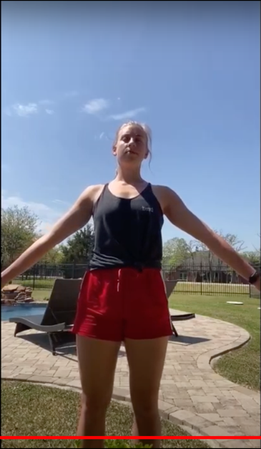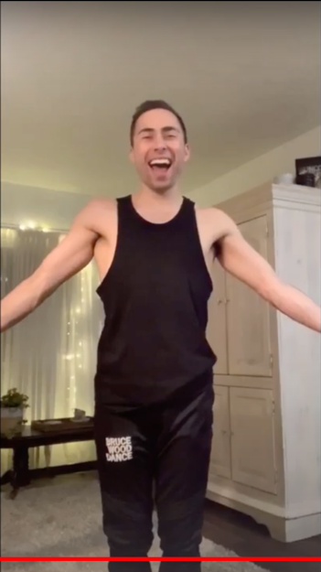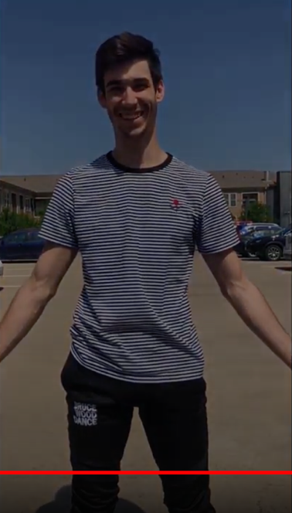
He’s the best example!

- Send your picture to your teacher. Due June 10, 2020 by 11:59pm
  - For Ms. Isabelle, please place your picture under your 4th assignment (not in the large files dropbox).
  - For Ms. Brodie, ask her directly what she prefers.

