English 301 99A - Ishaan Vora 54165600 - Assignment 1-3

Objective & Criteria:
This assignment is a practice for students to define a relatively complex term in three ways: a parenthetical definition, a sentence definition, and an expanded definition. The nature of these definitions are to make an audience, with no prior knowledge about the term and it’s context, comprehensively understand the meaning and subject of the term.

Situation & Audience:
A marketing strategist explaining the term “Brand Extension” to a marketing intern

Term:
Brand Extension

Parenthetical Definition:
Brand extension refers to the use of the same brand name in a different product line.

Sentenced Definition:
Brand extension is a marketing strategy where an established company uses its name and starts a new product line. This new line can be related or unrelated to the existing product the company is known for and help the company grow its product portfolio in various industries. Brand extension can be used in a company’s marketing mix and expand their customer reach.

Expanded Definition:
Brand extension is a common marketing strategy for a company that wants to increase its business portfolio. It either strategizes on providing complementary goods (products that are needed with other products, i.e cars and petrol) or diversify into another industry and increase its consumer base.

Rather than having only one product whose product life will come to and end at some point, companies create extensions within their Marketing Mix (elements of Product, Price, Place, & Promotion) and make expansions in these domains to increase their business activity and maximize profit.

Brand extension is often used by companies having a well-established image in society with intentions to branch out into new product areas. Therefore to see this through, the company would have to identify another gap in the market that they can fulfil in an appealing manner. There are several advantages in doing so. By using the same brand name that has an established reputation, the company can spend less of its time and finances on developing customer brand awareness and brand associations for the new product.

Colgate has branched out from a simple toothpaste company and has expanded into making toothbrushes, mouthwashes, and more. Its strategy of branding the corporate name into the
product name has allowed it to introduce new products quicker and more easily.
Figure 1: Colgate and it’s diverse product range

Another instance is of Virgin Group which has diversified in varied industries.
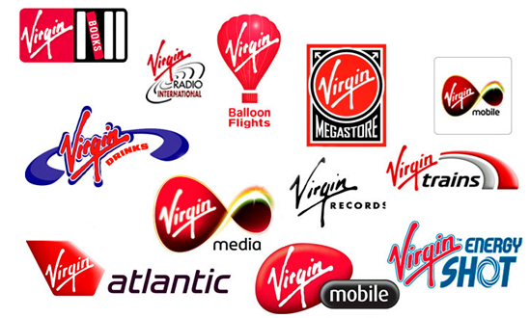
As a multinational corporation, this company has taken advantage of its pre-existing global image and has entered different markets. Successful in the aviation industry Virgin Atlantic, the company has used brand extension to further its consumer reach in the radio, beverage, and smartphone industries.

Figure 2: Virgin Group and it’s diverse product range
Works Cited:

- Grewal, Dhruv, and Michael Levy. Marketing. Boston: McGraw-Hill Irwin, 2010. Print.
- “MSG Management Study Guide.” Brand Extension - Meaning, Advantages and Disadvantages, www.managementstudyguide.com/brand-extension.htm.
- “Stretching Success: Do You Need A Brand Extension Strategy?” Fabrik Brands, 2 Aug. 2018, fabrikbrands.com/brand-extension-strategy/.
- Branding. (n.d.). Retrieved October 10, 2020, from https://www.ludu.co/course/principles-marketing/branding

