Measures of Democracy
Post-Soviet Europe
Justin Abrioux - 66140088

A Conceptualization of Democracy
In creating a definition of democracy to use for the analysis of Post-Soviet Europe, one ought to consider the history of the region. This zone is noteworthy as each of these countries has undergone transformation at a similar time. The fall of the Berlin Wall in 1989 and subsequent collapse of the Soviet Union meant that these states each transitioned to an institutional form of democracy during a similar time period. This minimalist definition, however, is not able to capture the full range of transition that these states have undergone since then. Each would likely qualify as a democracy on paper, but in practice this is constantly evolving. The type of transition to democracy one ought to examine in Post-Soviet Europe is one which focuses on the contestation of free and fair elections, the rule of law, human rights, political and social freedoms, and participation. The vestiges of Soviet rule still linger in the social and political spheres. The one party system and neglect of human rights and the rule of law were all a part of the political status quo under Soviet Rule. Examining if and how these aspects have declined over time is the way to fully appreciate the transitions of Post-Soviet European States.
The operational definition of democracy used to analyze Post Soviet Europe should therefore be as follows: “The existence of free and fair multiparty elections where all citizens are able to fully exercise their social and political rights under a system which has respect for the rule of law and human rights.” This definition is undoubtedly the antithesis of what Soviet rule may have been conceptualized as. The objective with a definition such as this is to properly capture the range of evolution between the two eras of governance.

Categorical Measures
Democracy and Dictatorship CGV Regime Type
Reich’s Political Regime Change
Freedom House Electoral Democracy

The key question which democracy reports try to answer is simply whether or not a certain state can be considered a democracy. If a simple dummy variable does not accurately capture the reality, or is too imprecise for a certain use, then a categorical measurement which names the specific type of democracy may be more appropriate. Using a scale or range of numerical statistics is often too unwieldy for inclusion in a summary. For a concise statement reflecting the condition of a country’s democracy, categorical measures are particularly useful. Among these are the Freedom House Electoral Democracy Score, Riech’s extended Political Regime Change Dataset, and the Democracy and Dictatorship CGV Regime measure.
As discussed in the conceptualization section, the important measures to consider for Post-Soviet Europe are those which take into account non-institutional factors as well as the minimalist ones. The CGV regime type measure is particularly apt at capturing the range of available categories as it divides democracy into the parliamentary, mixed, or presidential subtypes, as well as reducing dictatorship into civilian, military, or royal. Both the CGV regime type and Reich’s categories focus mostly on institutional factors, leaving out many of the rights considerations important for an analysis of this region. As can be seen in figure 1, both categorical measures are apt at capturing the post-Berlin wall increase in political rights as this was the period where democratic systems were being implemented for the first time. They are not, however, as good at noticing the general trend of decreasing political rights following the mid-1990s as can be observed through the Freedom House dataset. Belarus, for instance, is uniformly categorized as an Authoritarian state or Civilian Dictatorship at one time while having the same high political rights scores as Moldova as a Parliamentary Democracy. Freedom House’s political rights score has a more comprehensive scope than the categorical measures, taking into account extra-institutional data such as corruption and the political rights of a minority. This is important to examine due to the complexities of democratization in this region, especially considering its communist history. This is also why the Freedom House Electoral Democracy measure is inappropriate. The fact that it is structured as a dichotomous measure does not accurately portray the range of possible conditions on the ground, instead it lumps data into two categories.
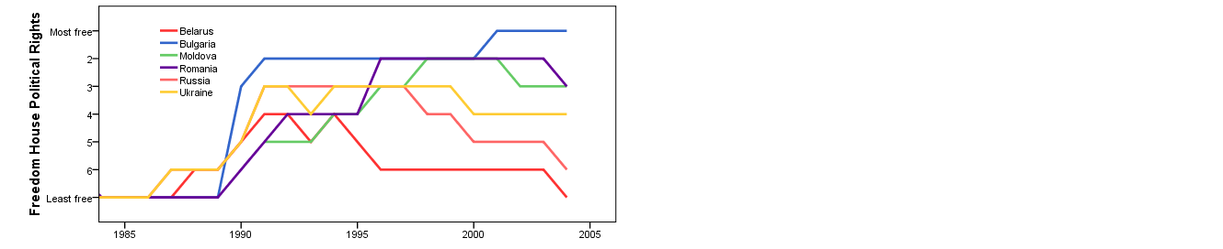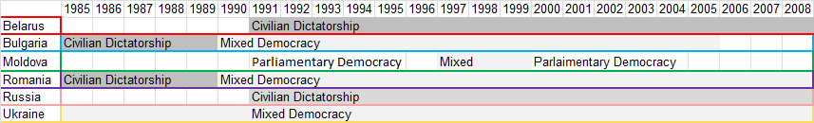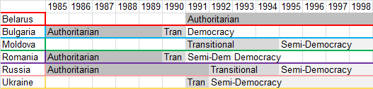
CGV Regime Type
Reich’s Political Regime Change
Figure 1

Ordinal Measures
Freedom House
Polity IV

Given the constantly changing state of democracy and the relative stability of government structure in Post-Soviet Europe, it is important to use measurements which are able to demonstrate subtler changes over time. Categorical measures are unable to do this as effectively as ordinal ones. A rating scale for the condition of a country’s democracy is more appropriate when subtle changes can affect this without changing the institutional structure. Post-Soviet Europe lends itself to this type of rating scheme. Since democratization after the fall of the Berlin Wall, these states have undergone various increases in government repression, several have had ‘colour revolutions’, and many have received democracy assistance from western powers. Each of these has a palpable effect but does not dramatically change the structure of government.
The Polity IV data would suggest that after 1990, with the exception of Belarus, these post-Soviet European states all increased the quality of their democracy. This clashes with some of the Freedom House Political Rights data previously presented. The difference is the result of a different operationalization of what democracy is. The Polity IV data collection method favours a more institutional approach, focusing on a more minimalist definition of democracy. In fact, the two measures which are aggregated together for the Polity score are ‘institutionalized democracy’ and ‘institutionalized autocracy’. The components which go into this score involve executive recruitment and constraints, and the degree of possible participation.
The Freedom House data, on the other hand, has a much wider scope than the Polity data. In aggregating a 7 point rating of democracy, the average between political rights and civil liberties is derived. Freedom House has a more grassroots, societal concept of democracy, and therefore considers civil liberties to be of equal importance to political rights and institutional factors. Issues such as freedom of expression and belief, organizational rights, and the rule of law are all combined to make up the civil liberties score.
Figure 2 compares the 20 year trends for both these measures of democracy. There is a considerable amount of agreement between the two in that there seems to be a general rise in the condition of democracy, and a sharp decline in the case of Belarus. The main subject of disagreement, however, seems to be Russia. Polity IV contends that Russia improved the state of its democracy around 2000 and is sitting at a comparable level to the Ukraine and Moldova as of 2005. Freedom House on the other hand shows a pattern more like that of Belarus, whereby the late 1990s began a process of considerable democratic decline, resting just above that country in 2005.
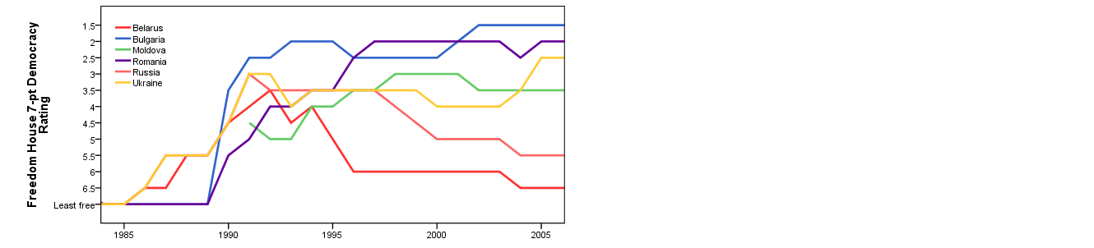
Figure 2
The Russian case demonstrates why the Freedom House data is superior for a true understanding of the condition of democracy in Post-Soviet Europe. Figure 3 shows that there existed a steady decline in Russian civil liberties since the early 1990s. Several events attest to this. One obvious example is the behaviour of the Russian government during the Second Chechen War, beginning in 1999. Summary executions and forced disappearances of civilians were among some of the authoritarian measures exacted upon the citizenry to maintain order. Similarly, the press in Russia is notorious for being under the thumb of the government. Reporters without Borders has ranked Russia at 147th out of 168 countries for freedom of the press, citing several instances of journalists being killed or bribed. These are just a few examples of the downward spiral of civil liberties in Russia. Other issues include the use of torture, intolerance of minorities, and manipulation of the judicial system.
Figure 3
The Soviet legacy in Post-Soviet Europe is something which is not easily caught by institutional measures. The Polity score did not capture the decline of civil liberties in Russia. The definition of democracy which is of particular importance to this region is one which takes these factors into account. As is obvious in Russia, it is not sufficient to label a country as a democracy due to its institutional features. Other regions which are less prone to abusing their citizens may prefer this minimalist definition, however the Soviet influence makes Freedom House’s averaged democracy score superior to that of Polity IV.

Measures Regarding Contestation
Coppedge and Reinecke
Vanhanen

The Vanhanen method of scoring a country is far different than the others presented thus far. It is an entirely behavioural measure, being simply the product of participation and competition as percentages. This, however, suffers from the same downfall as the institutional measures such as Polity IV in that it does not take the government’s regulation of civil liberties into account. The Vanhanen trend for Russia looks much like that of Polity IV’s. It rises steadily, resting near the level of unanimously proclaimed democracies such as Romania despite its civil rights abuses. Vanhanen is able to reflect the operation of elections, but has little data to examine what happens in between.
The Coppedge and Reineke scoring method is a fairly reasonable way to evaluate democracy. It takes both political and civil liberties into account and aggregates them in such a way as to make the categories themselves meaningful instead of just ordinal. The main flaw in this dataset, however, is that it only has two sampling dates, 1985 and 2000. Just one glance at the changes which occur on the previous figures during this time period reveals this method’s uselessness. It misses entirely the fall of the Berlin wall, the democratization of Eastern Europe, and picks back up at the end of some countries’ gradual erosion of civil liberties. In addition, data is absent for the 1985 sample of Belarus, Moldova, and Ukraine.

Conclusions

In sum, the data has painted a picture of rapid democratization following the collapse of the Soviet Union. No measure has failed to capture this dramatic event, however, the following 20 years has revealed a systematic difference in the way some datasets perceive history. The main point of contention has been between a minimalist and a maximalist definition of democracy. Those which preferred the minimalist, institutional variety witnessed this remarkable increase in democratic measures, and for the most part they stayed high. This is all with the exception of the dismal performance of Belarus. No dataset was in disagreement in that regard. Polity IV was the main example of this institutional focus, although the CGV regime type and Reich’s Political Regime Change categories all suffered insensitivity due to this narrow definition.
The shadow cast by the Soviet Union’s history of civil rights abuses makes this an incredibly important aspect to examine. Democracy is the antithesis of the old communist regime, and each aspect of these two political ideologies must be contrasted to ensure that democracy is indeed being practiced in this region. The Freedom House measures do well to encapsulate both the political and civil side of a maximalist definition of democracy. Its scope is wide, and rightly so. Without attention to this aspect, one would be statistically blind to the continuation of Soviet style authoritarianism on the part of the Russian government.
The reality of a transitional region is that there is no clear demarcating line between a democracy and a non-democracy. Dichotomous variables can not express the complexities of transition and categorizations can often lump radically different regimes into the same set. It is important to have an ordinal range to express a precise measurement, and a wide scope to express an accurate one.

Reporters Without Borders. Press Freedom Index. Washington DC: RSF, 2012

