**This passage is created to provide information on OCD: Obsessive Compulsive Disorder for audiences who are not familiar with the term and the disorder. My intended audience is children who have been diagnosed with OCD and their families. The situation would be a family reading this passage on an informational pamphlet.**

**Parenthetical Definition: Obsessive Compulsive Disorder (mental illness) is made up of obsessions (obsessed with certain ideas) and compulsions (an irresistible urge to do something).**

**Sentence Definition: Obsessive Compulsive Disorder is a type of mental disorders which occupy children mind and can cause extreme anxiety that disturbs his/her normal life.**

**Expanded Definition:**

**What is OCD?**

**Obsessive Compulsive Disorder (OCD) is made up of obsessions and compulsions. It occupies children’s mind and can cause extreme anxiety as well as discomfort which disturbs his/her normal life. Children try to reduce the anxiety from obsessive thoughts by engaging in repetitive and ritualistic behaviors or mental acts.** **OCD is no longer classified as an anxiety disorder, but anxiety is still a major part of it.**

**Common Symptoms:**

**Common obsessions include: Contamination (fear of dirtiness); Accidental harm to self or others; Symmetry and exactness (need to have items ordered); A need for perfection; Forbidden thoughts.**

**Common compulsions include: Washing and cleaning; Checking; Counting, tapping, touching, or rubbing; Ordering/arranging; Mental rituals.**

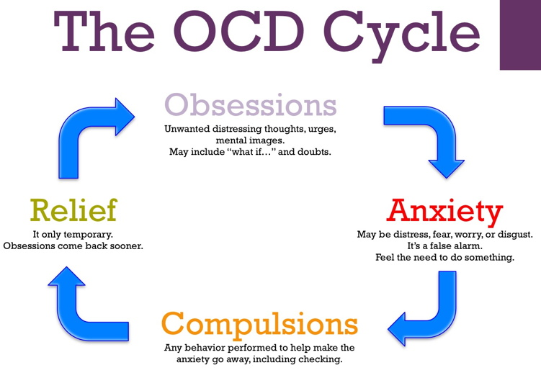

**Figure 1. OCD cycle shows OCD patients’ thoughts and behavior pattern.**

**Source: http://www.louisvilleocdclinic.com/images/OCD-cycle.jpg**

**OCD in children**

**Thoughts of children diagnosed with OCD can vary. These thoughts could lead to extreme anxiety, which eventually causes children to engage in compulsive and repetitive behaviors. Here are some examples of obsessive thoughts:**

* What if I am sick and get my parents sick.
* I am responsible for the accident.
* I have no future because I didn’t get an A.
* I know nothing.

Besides anxiety, other emotions could arise, such as: worry, fear, shame, sadness, guilt, and even anger and rage.

Psychical feelings could also occur because of the excessive thoughts: dizziness, stomachaches, shallow breathing, shortness of breath, headaches, and muscle tension.

Many compulsive behaviors could be used to alleviate anxious emotions listed above, for example:

* Asking parents to buy excess cleaning supplies.
* Washing hands and body excessively.
* Repeating certain phrases in multiples of 2 or 4.
* Avoiding touching doorknobs, handles, etc.

Treatment

Exposure and Response Prevention (ERP) is one of the most effective treatments for children. OCD is best treated by a licensed mental health professional. A professional (psychologist, social worker, or counselor) will guide the kids through the process. Kids will learn to face the fears without giving in to compulsive thoughts and behaviors. If symptoms are severe, medication such as serotonin reuptake inhibitors (SRIs) can help to reduce the symptoms and make EPR more effective. Overall, ERP is considered a “first-line treatment” and 70% of people benefit from it.

Family Involvement is an important part of the treatment and parents can be involved in many ways. Family should know more about OCD and talk with their children. Also, it is very important to talk to the school because OCD might greatly impact on children’s performance due to its interference with their concentration/focus. Hearing experience from other parents could also help to feel supported and understand more!

**Reference:**

Anxiety Disorders - Canadian Mental Health Association. (n.d.). Retrieved November 25, 2015, from <https://www.cmha.ca/mental_health/understanding-anxiety-disorders/>

For Parents & Families. (2015, July 7). Retrieved November 25, 2015, from https://kids.iocdf.org/for-parents/

How is OCD Treated? (2015, July 7). Retrieved November 25, 2015, from https://kids.iocdf.org/what-is-ocd/how-is-ocd-treated/

Obsessive Compulsive Disorder. (2014, November 14). Retrieved November 25, 2015, from http://www.anxietybc.com/parenting/obsessive-compulsive-disorder