Enhancing Participation of Educators in the Greater Vancouver Regional Science Fair Committee

for
Greater Vancouver Regional Science Fair Committee
and
Madeleine Guenette
Executive Director, Science Fair Foundation BC
and
Jessica Zhang
Program Manager, Science Fair Foundation BC

by
Janice Pang
Treasurer & Sponsorship Coordinator, Greater Vancouver Regional Science Fair
English 301 Student, University of British Columbia

November 30, 2019
Table of Contents
I. Introduction 3
Overview of Study 4
Methods 4
Limitations and delimitations 5
Significance 5
II. Results 6
Analysis of Alumni Surveys 6
Profile of alumni respondents 6
Alumni have positive attitudes toward science fairs and believe interest for science drives educator participation on science fair committees 6
Emails and online platforms should be leveraged to promote science fair volunteering opportunities 7
Time and connection to the aims of science fair may influence educator participation on science fair committees 8
Analysis of Educator Surveys 9
Profile of educator respondents 9
Educators have positive attitudes towards science fairs 10
Direct outreach to educators can be an additional method of recruitment of educators to the committee 11
Increasing familiarity with science fairs and gaining school support of science fairs can help attract educators 12
Analysis of Educator Interviews 13
Profile of Educators 13
Composition of NWORSF and VIRSF committee 14
Support of science fairs from school administration and school board is crucial 14
Professional development opportunities attract educators to science fairs 15
Overcoming geographical hurdles through online conferences and virtual science fairs 15
Interviews further support that familiarizing educators with science fairs is crucial in educator recruitment 16
III. Conclusion 16
Summary of Findings 16
Recommendations 17
IV. References 18
V. Appendix 18

List of Figures
Figure 1: Alumni Involvement on Science Fair Committees…………………………………...6
Figure 2: Alumni’s Attitudes Towards Science Fairs and Reasons for Volunteering…......... 7
Figure 3: Recruiting Volunteers to Science Fairs……………………………………………….8
Figure 4: Factors Impacting Educator Participation on Science Fair Committees...…………9
Figure 5: Educators by Grade Level and Involvement in Science Fair Committees………...10
Figure 6: Educator Involvement on Science Fair Committees…………………………...…...11
Figure 7: Recruiting Volunteers to Science Fairs……………………………………………...12
Figure 8: Factors Impacting Educator Participation on Science Fair Committees………….13

Introduction

For over 37 years, the Greater Vancouver Regional Science Fair (GVRSF) has been providing grade 7-12 students in Metro Vancouver an opportunity to showcase their research and innovations related to discovery, energy, health, information, environment, innovation and resources (“History”). All science fair projects at the fair are adjudicated by more than 200 science and technology professionals from industry, research, and academia. The top 17 students selected from GVRSF attend the prestigious Canada-Wide Science Fair (CWSF). Notably, GVRSF is organized by volunteers who are passionate about promoting education in science, technology, engineering and mathematics (STEM).

The GVRSF committee includes approximately 40 volunteers who are dedicated in planning for the annual regional science fair and all associated activities (“The Committee”). The committee includes educators, science fair alumni and science professionals. Educators on the GVRSF committee are pivotal in exposing students to science fairs to help develop science talent within the Greater Vancouver region. By incorporating science fair projects into classrooms, educators expose students to project-based learning and enable students to conduct original experimentations and create novel innovations. In a recent interview at GVRSF 2019, a student stated, “Science fair has been a huge part in the progression of my ideas” (“Why Do a Science Fair Project?”). Another student added that they have learned that “any project is good enough as long as you’re passionate about what you’re working on and as long as you learn something” (“Science Fair Project Advice for Students, from Students”). Over the years, many students have discovered passions for science through GVRSF. Hence, it is important to maintain a network of educators within the GVRSF committee who are passionate about teaching science and aware of science fairs so that students can continuously explore their scientific interests.

In recent years, it became apparent that an increase in educator participation on the committee may lead to a larger network of educators who are aware of science fairs in Greater Vancouver. This could dramatically increase the number of students who gain exposure to the opportunities presented by science fairs. Therefore, investigations are required to identify potential activities that will increase educator participation within regional science fair committees and create strategies to encourage more educators to become involved within the GVRSF committee.

Overview of Study

This report aimed to understand educator participation on science fair committees and to improve educator participation within the GVRSF committee. The following questions were investigated:
- What are the main reasons or activities that will encourage educators to participate in regional science fairs?
- Where do educators likely hear about regional science fairs?
- Will additional science fair resources help educators learn more about GVRSF?
- How are other regions recruiting educators to their science fair committee?

Methods. GVRSF and Science Fair Foundation BC distributed surveys to educators and science fair alumni in Greater Vancouver, as well as other regions in BC and other provinces via e-newsletters and social media posts. Eighty-one survey responses were received. Surveys assessed the respondents’ familiarity with science fairs and ascertain respondents’ attitudes toward potential reasons or activities that may influence educators’ involvement in science fair committees (See Table 1-3 in Appendix). Two interviews were also conducted with educators from the Northwestern Ontario Regional Science Fair (NWORSF) and Vancouver Island Science Fair (VIRSF) committees to understand recruitment strategies both regions have implemented.

The Likert scale, a commonly used methodology in educational research, was used to determine respondent attitudes (Barnette 715). Surveys were analyzed by computing the frequency distribution of the multiple-choice answers and the median of the distribution. The following values were assigned for the Likert scale: one for strongly disagree, two for disagree, three for undecided, four for agree, and five for strongly agree. Median scores were used to conclude respondent attitudes.

Limitations and delimitations. Limitations include low survey response rates. This may be due to insufficient time to complete survey. Since survey questions were distributed via e-newsletters, it could be possible that recipients missed the survey information. In addition, the audience of social media pages of the GVRSF and Science Fair Foundation BC may primarily be student participants. To circumvent the limitations, surveys were distributed to a wider audience, including educators and alumni outside Greater Vancouver.

Significance. Educators enable students in elementary and high school to explore project-based learning. The coming sections highlight the main reasons or activities influencing educators’ participation on science fair committees. This report concludes with recommendations for improving educator participation.

Results

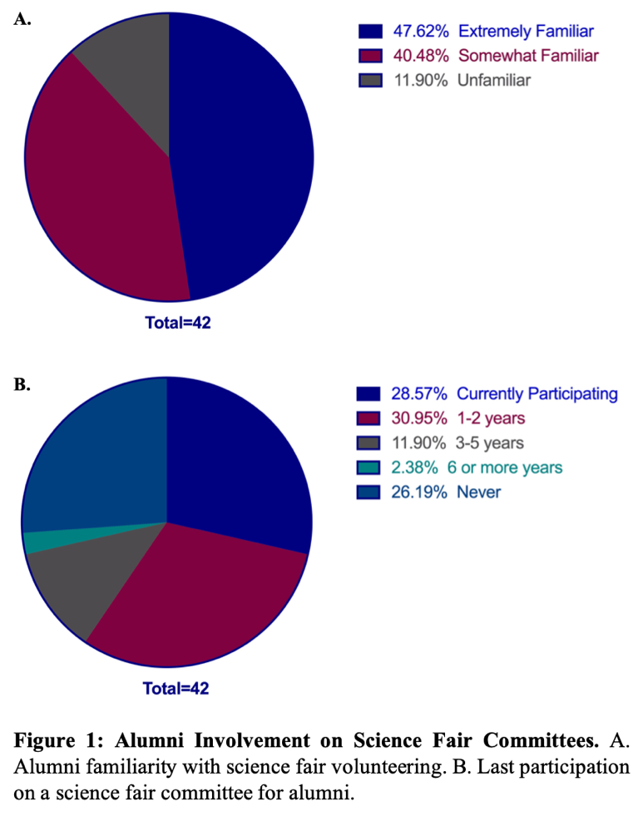
Analysis of Alumni Surveys

Profile of alumni respondents. Respondents represent science fair alumni from British Columbia (40.5%), Ontario (40.5%), Alberta (12%), Quebec (2.4%) and other international locations (5%) (Supplementary Data 1). Amongst alumni, 48% cited an extreme familiarity with volunteering at science fairs, 40% were somewhat familiar and 12% were unfamiliar about volunteering at science fairs (Figure 1A). In addition, 29% are currently involved in a science fair committee (Figure 1B). There are also 31% who have participated in a science fair committee in the last 1-2 years, 12% who have participated in the last 3-5 years and 2.4% at 6 or more years. Furthermore, 26% have not participated in a science fair committee.

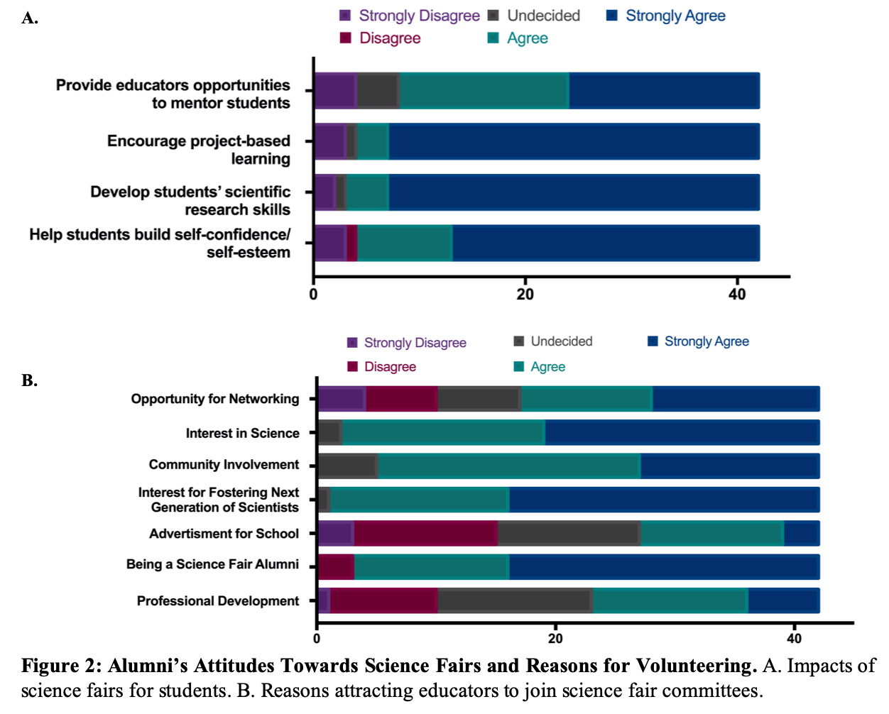
Alumni have positive attitudes toward science fairs and believe interest for science drives educator participation on science fair committees. Results from alumni survey reflect that science fairs have positive impacts on students. Alumni strongly agree that science fairs allow students to build self-confidence and self-esteem, develop students’ scientific research skills and encourage project-based learning (Figure 2A). They agree that science fairs provide educators opportunities to mentor students. In addition, alumni strongly agree that educators are attracted to join a science fair committee if they are a science fair alumnus and have interest in science and fostering the next generation of scientists (Figure 2B). Alumni also agree that community involvement and opportunity of networking could be reasons committee involvement. However, it was undecided whether educators are interested to become involved on a science fair committee because of the opportunity for professional development or advertisement of their school. This reflects an educator-specific designed question and the requirement to survey educators for elucidation.

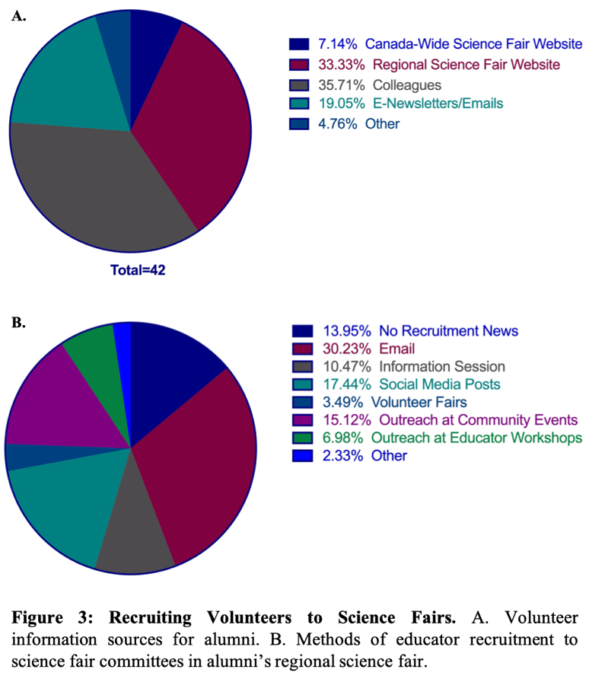
Emails and online platforms should be leveraged to promote science fair volunteering opportunities. Results show that 36% of alumni hear about volunteering opportunities through their colleagues (Figure 3A). It is important to note that the use of regional science fair websites and emails may be as effective as word-of-mouth methods since around 30% of alumni heard about volunteer information through those methods (Figure 3B). Thus, GVRSF committee recruitment information may be most effectively distributed via online methods.
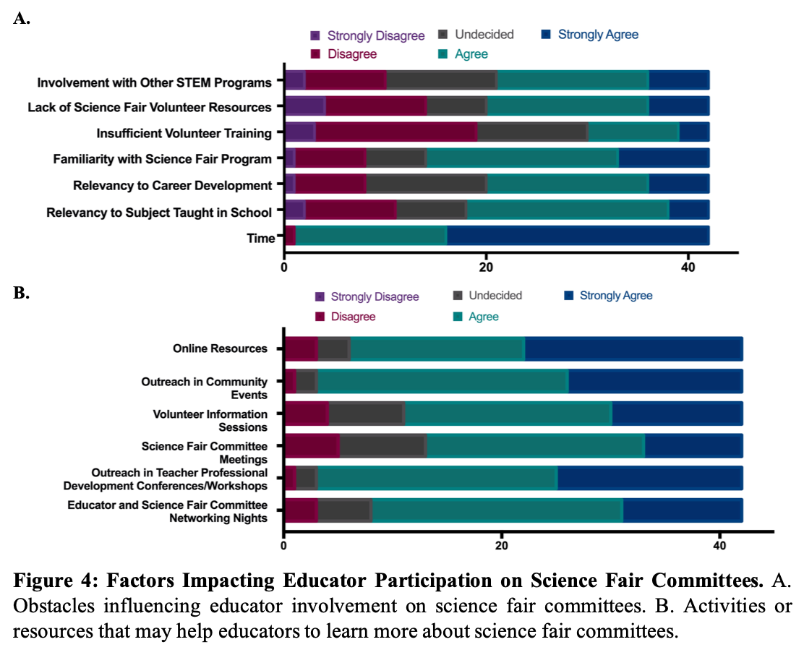
Time and connection to the aims of science fair may influence educator participation on science fair committees. Alumni strongly agree with time as a key obstacle preventing educators from joining science fair committees (Figure 4). Relevancy to subject taught in school and career development, familiarity with science fair program and lack of science fair volunteer resources are other reasons that alumni agreed to be obstacles for educator participation. However, it was undecided whether insufficient volunteer training and involvement with other STEM programs can influence educator participation. This could be further elucidated with the educator surveys. Nonetheless, results indicate that raising awareness of the aims of science fairs could potentially help educators better understand the program and become more interested to join the committee. Networking nights, outreach at teacher conferences and workshops, outreach in community events, science fair committee meetings, volunteer information sessions and online resources are options to explore to help educators learn more about GVRSF (Figure 4). Further increasing the support of science fairs from school administration can potentially overcome the challenge of time.

Analysis of Educator Surveys
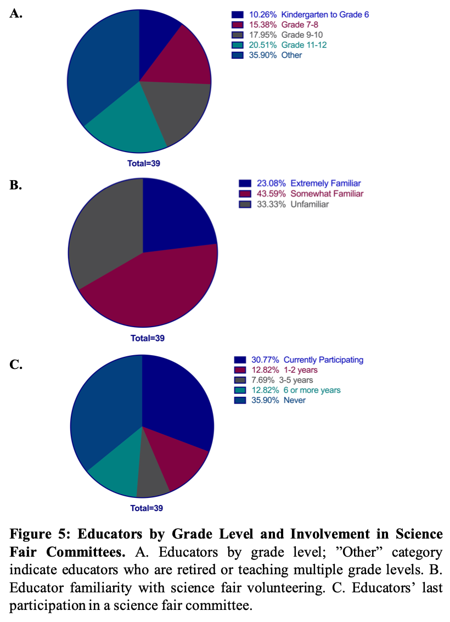
Profile of educator respondents. Respondents represent educators from Greater Vancouver (56%), Vancouver Island (15%), Central Okanagan (8%), Central Interior (8%), Northern BC (3%), Fraser Valley (3%), and Northwestern Ontario (5%) (Supplementary Data 1). Seventy-nine percent of the educators surveyed were formal participants of science fair. The educators surveyed are currently teaching a wide range of students from kindergarten to grade 12 (Figure 5A). Eighty-eight percent of the educators cite that they introduced science fair projects to students before. In terms of educator acquaintance with science fair volunteering, 23% of educators were extremely familiar, 44% were somewhat familiar and 33% were unfamiliar (Figure 5B). In addition, 31% of the educators are currently involved in a science fair committee (Figure 5C). There are also 13% who have participated in a science fair committee in the last 1-2 years, as well as 8% who have participated in the last 3-5 years and 13% at 6 or more years. Notably, 36% have not participated in a science fair committee. Thus, significantly more educators compared to alumni have not heard of volunteer recruitment from science fair committees. While the majority of the educators have introduced science fairs to their students, they may not be familiar with the volunteering opportunities available.

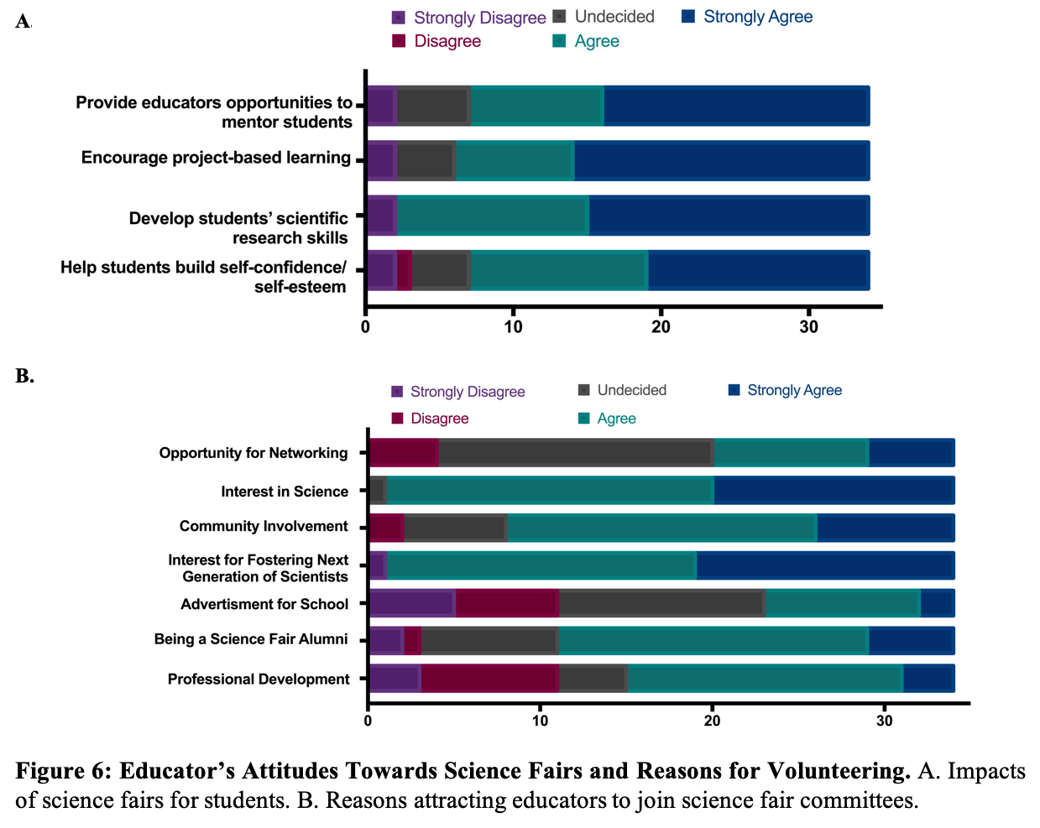
Educators have positive attitudes towards science fairs. Similar to alumni, educators have positive attitudes towards science fairs (Figure 6A). Consistent with the alumni survey, educators agree that educators are attracted to join a science fair committee because of community involvement, being a science fair alumnus, and having interest in science and fostering the next generation of scientists (Figure 6B). However, educators remain undecided for advertisement for schools. In contrast with alumni, educators agree that professional development can attract them to join a science fair committee. Interestingly, educators are undecided about the opportunity of networking. The undecided factors could be due to insufficient information known about science fairs. Notably, results clarify the alumni survey in that professional development is a factor influencing educators’ commitment to volunteering at science fairs.

Direct outreach to educators can be an additional method of recruitment of educators to the committee. To explore recruiting new educators to the GVRSF committee, it appears that direct outreach to educators may be a good method since most educators are likely to hear about volunteering at science fairs via their colleagues (Figure 7A). Since many of the educators have never participated in science fairs, it was not surprising to have a greater proportion of respondents who have not heard about science fair volunteer opportunities. However, among the educators who have heard of recruitment and similar to alumni, email remains to be the predominant method in which information about volunteering is received (Figure 7B). Increasing outreach to educators at schools or professional development conferences as well as through emails could be beneficial.
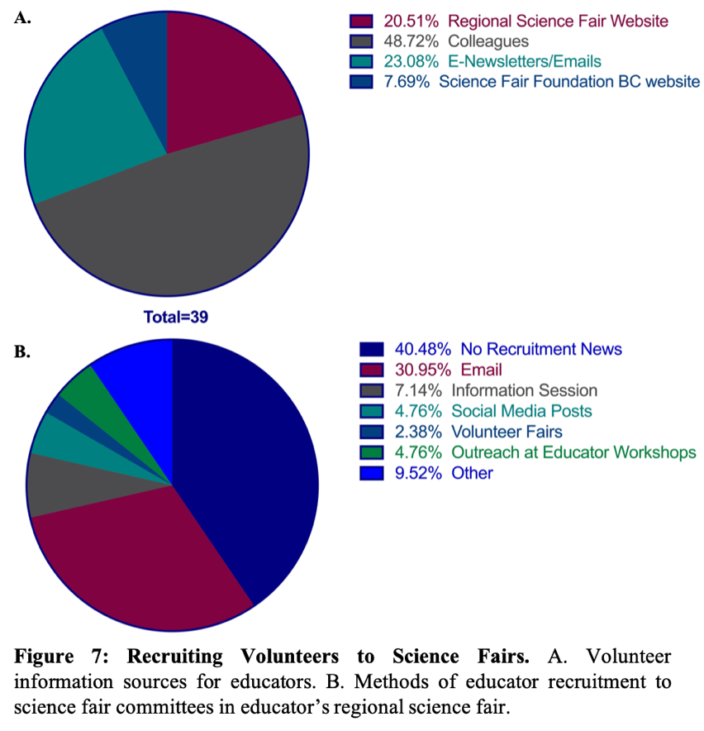
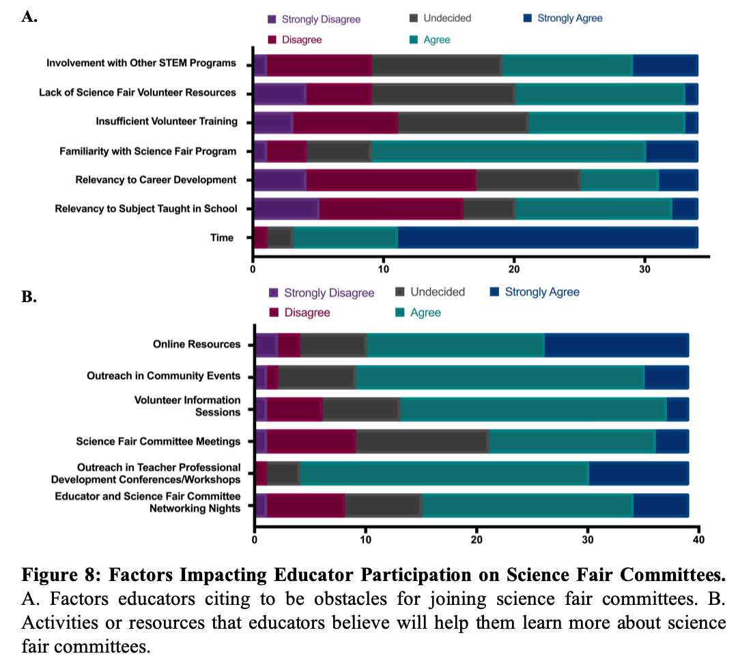
Increasing familiarity with science fairs and gaining school support of science fairs can help attract educators. Consistent with alumni response, educators strongly agree that time pose an obstacle to participate in a science fair committee (Figure 8A). Familiarity with science fairs can also influence whether educators’ commitment to volunteering. However, educators are undecided on relevancy to subject taught in school and career development, insufficient volunteer training, lack of science fair volunteer resources and involvement with other STEM programs. The undecided factors could be explained by educators’ agreement that familiarity with the science fair program is an obstacle. Results continuously highlight that improving educator familiarity with science fairs and increasing school support of science fairs are vital to helping educators better understand the program and become more interested to join the committee. This is further supported by educators agreeing that networking nights, outreach at teacher conferences and workshops, outreach in community events, volunteer information sessions and online resources will help them learn more about science fair committees (Figure 8B).

Analysis of Educator Interviews
Profile of Educators. The first interview was conducted with Rebecca Cross, the Education Liaison from the NWORSF committee. As the Education Liaison, Cross’ responsibilities include outreach to educators and schools, managing online resources, and providing support to teachers and students. The second interview was conducted with Anne-Marie Simard, a general educator volunteer on the VIRSF Committee. Simard is focused on streamlining the special awards program at the regional science fair and conducting project safety checks.
Composition of NWORSF and VIRSF committee. Annually, NWORSF hosts around 120-180 students and the VIRSF hosts around 190 students. Both the regional science fairs have approximately 15 committee members responsible for planning different aspects of the fair, including judging, awards, safety and ethics, outreach and sponsorships. Interestingly, around 50% of the NWORSF committee is composed of educators. Meanwhile, the committee members at VIRSF have more diverse backgrounds with only 10% of the members being educators. While effective strategies for educator outreach is pending for VIRSF, NWORSF have implemented strategies to actively recruit educators to their committees. Overall, there are differences in composition of committee members in these regional science fairs and regions are attracting distinct volunteers.

Support of science fairs from school administration and school board is crucial. Educators in NWORSF and VIRSF faced challenges in getting paid time off to volunteer during the science fair. Notably, many educators feel a disconnect of the science fair program with their teachings because there is limited endorsement of science fairs from the school administration and school board. Hence, educators are reluctant to add science fair involvement to their demanding teaching schedules. It is possible that more educators would be willing to commit to volunteering on a science fair committee if there was a closer alignment of the science fair program with their school curriculum. Of note, the NWORSF recently established a Trustee award with the local school board. This annual award presented at the school board trustee meeting aimed to raise awareness within the school distract about the local science fair program and to recognize successes of science fair students. Evidently, increased support from school administration and school board is pivotal in allowing educators to become involved in science fairs outside of class time. This is further supported by survey findings discussed earlier.
Professional development opportunities attract educators to science fairs. Similar to survey findings, the educators mentioned professional development opportunities to be critical in encouraging more educators to join science fair committees. Annually, student teachers on the NWORSF committee plans for a special science Olympics event for grade 4-6 students. Notably, student teachers were eager to become more involved in the regional science fair following their involvement with the science Olympics since it was a great opportunity for them to diversify their teaching skills. Therefore, promoting professional development opportunities to student teachers from the faculty of education in local institutions could potentially be an avenue by which more educators could be recruited to the committee.

Overcoming geographical hurdles through online conferences and virtual science fairs. Geographical hurdles can be a challenge when organizing meetings for committee members and attracting new members, especially for a fair like NWORSF which spans Thunder Bay and over 28 remote areas in Northern Ontario. As such, NWORSF has routinely held committee meetings via Skype, which allowed members who are in remote places of Northern Ontario or outside the region to continuously be involved in the committee. Furthermore, NWORSF recently established a virtual science fair aimed to overcome geographical hurdles and to provide better science fair support to educators and students in rural communities. Traditionally, students and educators in the remote communities of Northern Ontario traveled long distances to participate at NWORSF. Ultimately, only a select number of educators and students were able to attend. Hence, a virtual science fair committee was subsequently created to plan for a pilot virtual science fair. This initiative was led online by the head judge of the region. NWORSF successfully formed a small organizing committee involving educators from remote communities who planned, managed and executed the fair online. These successes NWORSF have experienced are encouraging strategies for overcoming geographical challenges that may impact educator involvement on science fair committees. In relation to GVRSF, this could be a prudent strategy to consider for increasing involvement of educators from the Sunshine Coast on the committee.

Interviews further support that familiarizing educators with science fairs is crucial in educator recruitment. Both educators noted that witnessing the positive impacts of science fairs on promoting science education and enthusiasm for science amongst youth are the most rewarding aspects of becoming involved with science fairs. For these reasons, familiarizing educators with science fairs is the first step in recruiting new committee members. This may be inviting educators and superintendents of school boards to attend committee meetings and visit the regional fair. Another suggestion would be reserving a spot for educators who may or may not be already involved in a science fair committee to attend CWSF as a delegate for professional development. This week-long exposure to a national science fair could help inspire and show educators the potential of science fairs.

Conclusion

Summary of Findings

Educators and alumni strongly believe that science fairs can develop students’ scientific research skills, promote project-based learning and provide educators an opportunity to mentor students. Findings from this report indicate that despite having 88% of educators introducing science fairs to students, 36% of educators have never been involved on a science fair committee and 77% have limited familiarity or no familiarity with the available volunteer opportunities. Notably, educator participation on the GVRSF committee can strongly be influenced by time and acquaintance with the science fair program.

Increasing support of GVRSF from school administration and the school board is important in allowing educators to learn more about GVRSF and potentially become involved on the committee. Additionally, establishing professional development opportunities can be beneficial in attracting more educators to the committee. Furthermore, this report suggests that direct outreach to educators may be the best method of recruitment. Nonetheless, email communication and postings on the GVRSF website should continuously be utilized to recruit educators to the committee.

Recommendations
This report indicates that the following should be prioritized for enhancing participation of educators in the GVRSF committee:
- Increasing outreach to teachers at schools, educator workshops and conferences to better familiarize educators with volunteer opportunities of GVRSF.
- Establishing stronger connections with school administration and school boards to increase their support of GVRSF so that more educators are encouraged to volunteer.
- Inviting educators to GVRSF committee meetings or host volunteer information sessions to help educators learn more about volunteering at GVRSF.
- Providing educators with more professional development opportunities at GVRSF, such as inviting student teachers to lead student activities at the fair or inviting educators to chaperone Team GVRSF at CWSF.
- Investigating feasibility of piloting a virtual science fair for educators and students on the Sunshine Coast to increase their participation at GVRSF.
As the planning of GVRSF 2020 gets underway, these recommendations should be reviewed and utilized to establish solid educator recruitment strategies at the next committee meeting.

References

Barnette, J. Jackson. “Likert Scaling.” Encyclopedia of Research Design, SAGE Publications,
Inc., 2012, pp. 715–718.
“History.” GVRSF, www.gvrsf.ca/about-the-fair/history/.
“Science Fair Project Advice for Students, from Students” YouTube, uploaded by Science Fair
Foundation BC, 22 Oct 2019, www.youtube.com/watch?v=cB6C1B--SxI&fbclid=IwAR062dl1dQuWhwpgJeo0KM5VWbjzRl-dA5RtaGyIdotRJZnABCYzmob2abY.
“The Committee.” GVRSF, www.gvrsf.ca/about-the-fair/committee/.
“Why Do a Science Fair Project?” YouTube, uploaded by Science Fair Foundation BC, 27 Sept
2019, www.youtube.com/watch?v=tvc4M6yMLX4.

Appendix

Table 1: Correlation of Research Questions with Alumni Survey Questions
Research Question | Survey Question
What are the main reasons or activities that will encourage educators to participate in regional science fairs? | What province/territories are you from?  Which regional science fair did you participate in?  Science fairs...  - Help students build self-confidence and self esteem  - Contribute to developing students' scientific research skills  - Encourage students to pursue project-based learning  - Provide educators an opportunity to mentor students  How many years ago was your last participation on a science fair committee?  Are you familiar with the volunteer opportunities in regional science fairs around BC?  Educators are attracted to join a science fair committee because of:  - Professional development  - Being a science fair alumnus  - Advertisement for their school  - Interest in fostering the next generation of scientists  - Community involvement  - Interest in science  - Opportunity for networking  The following pose a challenge for educators to participate in a science fair committee  - Time  - Relevancy to subject taught in school  - Relevancy to career development  - Familiarity with science fair program  - Insufficient volunteer training  - Lack of science fair volunteer resources  - Involvement with other STEM programs
Where do educators likely hear about regional science fairs? | Where are you most likely to hear about volunteering on a science fair committee?
Will additional science fair resources help educators learn more about GVRSF? | The following will help educators learn more about science fair committees  - Educator and Science Fair Committee Networking Nights  - Outreach in teacher professional development conferences/workshops  - Science fair committee meetings  - Volunteer information sessions  - Outreach in community events  - Online Resources
How are other regions recruiting educators to their science fair committee? | How has your region recruited educator participation on science fair committees?

Table 2: Correlation of Research Questions with Educator Survey Questions
Research Question | Survey Question
What are the main reasons or activities that will encourage educators to participate in regional science fairs? | Which region are you from?  What grade level are you currently teaching?  Have you introduced science fair projects to your students before?  Science fairs...  - Help students build self-confidence and self esteem  - Contribute to developing students' scientific research skills  - Encourage students to pursue project-based learning  - Provide educators an opportunity to mentor students  Are you a formal student participant of science fairs?  How many years ago was your last participation on a science fair committee?  Are you familiar with the volunteer opportunities in regional science fairs around BC?  Educators are attracted to join a science fair committee because of:  - Professional development  - Being a science fair alumnus  - Advertisement for their school  - Interest in fostering the next generation of scientists  - Community involvement  - Interest in science  - Opportunity for networking  The following pose a challenge for educators to participate in a science fair committee  - Time  - Relevancy to subject taught in school  - Relevancy to career development  - Familiarity with science fair program  - Insufficient volunteer training  - Lack of science fair volunteer resources  - Involvement with other STEM programs
Where do educators likely hear about regional science fairs? | Where are you most likely to hear about volunteering on a science fair committee?
Will additional science fair resources help educators learn more about GVRSF? | The following will help educators learn more about science fair committees  - Educator and Science Fair Committee Networking Nights  - Outreach in teacher professional development conferences/workshops  - Science fair committee meetings  - Volunteer information sessions  - Outreach in community events  - Online Resources
How are other regions recruiting educators to their science fair committee? | How has your region recruited educator participation on science fair committees?

Table 3: Correlation of Research Questions with Interview Questions
Research Question | Interview Question
What are the main reasons or activities that will encourage educators to participate in regional science fairs? | What attracts educators the most to join a science fair committee? How has your regional science fair attracted educators to join the committee?  What are some challenges that may deter educators from participating in your regional science fair committee? Has your regional science fair needed to find strategies to overcome these potential obstacles?  What has been the most rewarding aspect of being involved in your regional science fair committee?
Where do educators likely hear about regional science fairs? | Where are educators most likely going to hear about volunteering for your science fair committee?
Will additional science fair resources help educators learn more about GVRSF? | What attracts educators the most to join a science fair committee? How has your regional science fair attracted educators to join the committee?  What are some challenges that may deter educators from participating in your regional science fair committee? Has your regional science fair needed to find strategies to overcome these potential obstacles?  What recommendations do you have for regional science fair looking to increase educator participation within the science fair committee?
How are other regions recruiting educators to their science fair committee? | Which regional science fair are you currently involved with?  What is your current role on the committee? Briefly, what are your responsibilities in that role?  How many educators are involved in your regional science fair committee? Do all educators have similar responsibilities on the committee?  What recommendations do you have for regional science fair looking to increase educator participation within the science fair committee?
