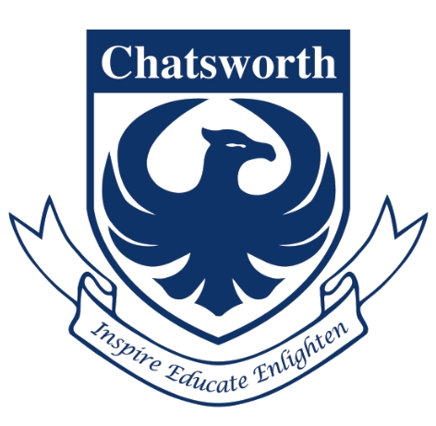

**Chatsworth International School**

MYP Unit Planner

|  |  |
| --- | --- |
| **Unit title** | **Caring for Communities** |
| Teacher(s) | MYP2 / Year 8 teaching team |
| Subject and grade level | English A year 8 / MYP 2 |
| Time frame and duration | 5 weeks plus one week in Cambodia |

**Stage 1: Integrate significant concept, area of interaction and unit question**

|  |  |  |
| --- | --- | --- |
| **Area of interaction focus**  Which area of interaction will be our focus? Why have we chosen this? |  | **Significant concept(s)**  What are the big ideas? What do we want our students to retain for years into the future? |
| Community and Service   * community involvement * understanding the concept of community | People become stronger through adversity |

|  |
| --- |
| **MYP unit question** |
| How has my trip to Cambodia enabled me to see my community in a different light? |

|  |
| --- |
| **Assessment**  What task(s) will allow students the opportunity to respond to the unit question?  What will constitute acceptable evidence of understanding? How will students show what they have understood? |
| Documentary film and journalistic writing on an aspect of history/politics/society in Cambodia - groups of three, length of film 5 - 7 minutes.  Use the AOI questions for Community and Service as an inspiration/way-in to the project. |
| Which specific MYP objectives will be addressed during this unit? |
| **A Content**   * Understand and analyse language, content, structure, meaning and significance of both familiar and previously unseen oral, written and visual texts * Analyse the effects on the authors choice on an audience * Compose pieces that apply appropriate literary and/or non-literary features to serve the context and intention   **B Organisation**   * Create work that employs organisational structures and language specific conventions throughout a variety of text types * Organise ideas and arguments in a sustained, coherent and logical manner * Employ appropriate critical apparatus   **C Style and language mechanics**   * Use language to narrate, describe, analyse, explain, argue, persuade, inform, entertain and express feelings * Use language accurately * Use appropriate and varied register, vocabulary and idiom * Use correct grammar and syntax * Use appropriate and varied sentence structure |
| Which MYP assessment criteria will be used? |
| **A Content**   * Understand and analyse language, content, structure, meaning and significance of both familiar and previously unseen oral, written and visual texts * Compare and contrast works and compare themes accords and within genres * Analyse the effects on the authors choice on an audience * Express an informed and independent response to literary and non-literary texts * Compose pieces that apply appropriate literary and/or non literary features to serve the context and intention   **B Organisation**   * Create work that employs organisational structures and language specific conventions throughout a variety of text types * Organise ideas and arguments in a sustained, coherent and logical manner * Employ appropriate critical apparatus   **C Style and language mechanics**   * Use appropriate and varied register, vocabulary and idiom * Use correct grammar and syntax * Use appropriate and varied sentence structure * Use correct spelling/writing * Use language to narrate, describe, analyse, explain, argue, persuade, inform, entertain and express feelings * Use language accurately |

**Stage 2: Backward planning: from the assessment to the learning activities through inquiry**

|  |  |
| --- | --- |
| **Content**  What knowledge and/or skills (from the course overview) are going to be used to enable the student to respond to the unit question?  What (if any) state, provincial, district, or local standards/skills are to be addressed? How can they be unpacked to develop the significant concept(s) for stage 1? | |
| Students will learn about the history, culture and politics of Cambodia. They will study a novel, the Clay Marble, and they will visit Siem Reap.  Before going, they will have a talk from a documentary film maker briefing them on how to make a good documentary ( | |
| **Approaches to learning**  How will this unit contribute to the overall development of subject-specific and general approaches to learning skills? | |
| Organisation  Collaboration  Communication  Information Literacy  Reflection  Thinking | |
| **Learning experiences**  How will students know what is expected of them? Will they see examples, rubrics, templates?  How will students acquire the knowledge and practise the skills required? How will they practise applying these?  Do the students have enough prior knowledge? How will we know? | **Teaching strategies**  How will we use formative assessment to give students feedback during the unit?  What different teaching methodologies will we employ?  How are we differentiating teaching and learning for all? How have we made provision for those learning in a language other than their mother tongue? How have we considered those with special educational needs? |
| Students to find out about the Ancient and Modern Cambodias. Find out about Khmer Rouge, Killing Fields.  Answer novel questions; writing about the theme of adversity. How does this novel explore the idea of overcoming adversity?  Assign groups and strands:   * arts and culture * temples and religion * children at CFC * the Killing Fields   Prepare themes, questions, topics, plans for filming the documentary  In Cambodia, film and prepare footage for the documentaries.  Reflection  Film Festival in hall showing all the documentaries | We will arrange an introductory talk by Cambodian diplomats, or CFC representatives. This will be an introduction to Cambodia.  Study The Clay Marble.  Guest speaker - documentary film maker to brief on how to make a documentary.  Show short film about Australian Sailor (if available)  Five Day visit to Cambodia  Time given for preparation of films |
| **Resources**  What resources are available to us?  How will our classroom environment, local environment and/or the community be used to facilitate students’ experiences during the unit? | |
| Cambodian staff; art and dance exhibitions locally?  Documentary film maker, available to speak | |

**Ongoing reflections and evaluation**

|  |
| --- |
| **In keeping an ongoing record, consider the following questions. There are further stimulus questions at the end of the “Planning for teaching and learning” section of *MYP: From principles into practice*.**  **Students and teachers**  What did we find compelling? Were our disciplinary knowledge/skills challenged in any way?  What inquiries arose during the learning? What, if any, extension activities arose?  How did we reflect—both on the unit and on our own learning?  Which attributes of the learner profile were encouraged through this unit? What opportunities were there for student-initiated action?  **Possible connections**  How successful was the collaboration with other teachers within my subject group and from other subject groups?  What interdisciplinary understandings were or could be forged through collaboration with other subjects?  **Assessment**  Were students able to demonstrate their learning?  How did the assessment tasks allow students to demonstrate the learning objectives identified for this unit? How did I make sure students were invited to achieve at all levels of the criteria descriptors?  Are we prepared for the next stage?  **Data collection**  How did we decide on the data to collect? Was it useful? |
|  |

**Figure 12**

*MYP unit planner*