**Feasibility of Hands-On Workshop Courses**

**for Psychology Undergraduate Students At UBC**

for

Dr. Geoffrey Hall

Psychology Department Head

University of British Columbia

Vancouver, British Columbia

by

Jenny Li

English 301 Student

November 16, 2021

Contents

Introduction 2

Statement of Problem 2

Objective 3

Scope 3

Sources 4

Data Section 4

Introducing Hands-On Psychology Courses 4

Hands-on courses establishment process. 4

Feasibility 6

Benefits 8

Workplace Transition. 9

Limitations 9

1. Cost and Tuition. 9

2. Does it Work for Everyone? 10

Conclusion 10

Summary of Findings 10

Interpretation of Findings 11

Recommendations 11

**Figures and Tables**

**Figure 1** Hands on courses establishment process 5

**Figure 2** Graph of data for satisfaction level of psychology courses 6

**Figure 3** Graph of data for extent of post-graduate plans 6

**Figure 4** Graph of data for interest in hands-on workshops 7

**Figure 5** Graph of data for whether or not participants believe hands-on workshops would improve learning experiences at UBC 7

**Figure 6** Hands-on learning benefits 8

# Introduction

With nearly 2,000 students, psychology is the most popular major for undergraduate students at UBC. Psychology is an increasingly valuable discipline and many students are drawn to the engaging courses offered at UBC. Additionally, declaring a major in psychology is simple, with no high GPA requirement and no limit to the number of intakes. However, unlike other more traditional disciplines like biology, computer science, or English, many psychology majors do not have a solid career plan. The extensive variety of career options available for psychology graduates can be confusing and psychology majors can feel very lost as to which career path is the right one for them. Despite the prestige of UBC’s psychology program, psychology undergraduate students often feel unprepared and insecure about their future.

## Statement of Problem

There are many psychology subfield courses offered at UBC, from social psychology, clinical psychology, to cognitive psychology. These are introductory courses, based on technical learning that takes place mainly in a classroom. Most psychology courses only consist of lectures, with no accompanying lab or seminar time like many other disciplines at UBC. While course content may be interesting and professors may facilitate enthusiasm in the subject, after the conclusion of a very short introductory course in a psychology subdiscipline, students have only scraped the top layer of knowledge of that subject. This leads to several issues, including:

1. Few opportunities for students to physically demonstrate what they have learned
2. Lack of ability to apply the material outside the classroom
3. Difficulty seeking employment after graduation due to confusion as to which psychology-related career better suits them

Although internships and co-op programs are available, spaces are limited and is gated by cumulative GPA. These programs also require a significant amount of availability outside of class time, which not every student is able to spare. Due to the exclusive nature of internships and co-op programs, they do not benefit the general population of psychology undergraduates. Many psychology majors may graduate feeling very clueless because they lack of relevant work experience.

## Objective

This proposal examines the current learning experience of psychology undergrads at UBC. It then offers the solution of establishing hands-on workshops to better prepare psychology students for their future.

## Scope

To assess the feasibility of establishing workshop courses as apart of UBC’s undergraduate psychology program, the following areas of inquiry are pursued in this proposal:

1. How many psychology students will be willing to take hands-on workshop courses?
2. Will hands-on workshops improve psychology students’ learning experience? If so, in what ways?
3. What kind of workshops would students be most interested in?
4. What are some limitations of these workshops in UBC’s undergraduate psychology program?
5. What are some barriers preventing the establishment of these workshops?

## Sources

To help answer these questions, this report analyzes information gathered from an online questionnaire distributed virtually to psychology students. Additionally, my own observations as a 4th year psychology student at UBC will be applied when necessary. Moreover, secondary sources will be utilized to drive home the advantages of hands-on workshops and offer insight to its limitations.

# Data Section

## Introducing Hands-On Psychology Courses

The proposed plan takes into account the interests and needs of UBC’s undergraduate psychology student community, as well as the available resources at UBC in successfully establishing the proposed plan.

Hands-on courses establishment process.The successful implementation process of requires the following five considerations:

1. *Introducing hands-on courses:* implementing a few hands-on courses at a time to test for success reduces amount of financial loss in case of failure.
2. *Cost determination:*determining whether or not the cost of creating new hands-on workshops is within the budget of UBC’s psychology program ensures the quality and success of the program.
3. *Integration:* the purpose of hands-on learning is to support and elevate the learning experience of every type of learner. Integrating hands-on learning as apart of the curriculum for existing courses (in addition to classroom learning) increases learning style variety.
4. *Opt-out option:* keeping some sections of each course that do not offer hands-on learning at the beginning of its implementation ensures that students are not forced into this type of learning if they are unsure of it.
5. *Time:* because **hands**-on courses are an addition to regular classroom learning, setting an appropriate amount of hands-on class time is necessary to not overwhelm students. If the hands-on class time extends too far beyond the amount of time that students would normally set for class time, then this may reduce the likelihood of students taking the course (Fatumo, Shome, & Macintyre).

Carefully engaging in all these steps will increase the success of hands-on learning in UBC’s psychology program (Figure 1).

* Slow implementation
* Learn from trial and error
* Adjust according to feedback

**Introducing hands-on courses**

* Determine cost to produce
* Within the budget?

**Cost Determination**

**Integration**

* Improve learning experience
* Additional learning support for students

* All UBC psychology students
* Choice to opt-out
* Based on learning preferences

**Target Audience**

* Practical schedule for both students and instructors
* Reasonable difficulty

**Reasonable Schedule**

**Figure 1** Hands on courses establishment process

## Feasibility

On November 8th, 2021, I began the primary data collection process with the goal of concluding the survey on November 12th, 2021. The aim was to collect data from at least 20 UBC psychology undergraduate students of any year. Unfortunately, due to the short time frame, the survey managed to garner only 11 responses. Additionally, some of the respondents did not provide answers to all of the questions.

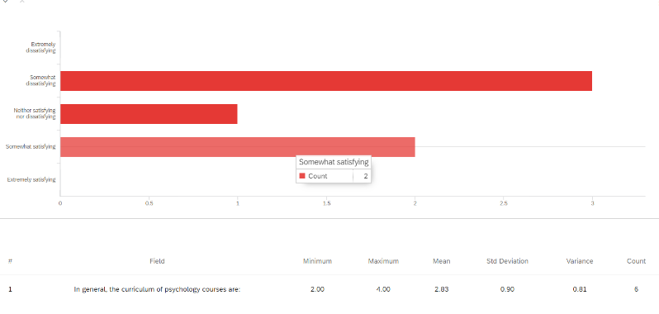

**Figure 2** Graph of data for satisfaction level of psychology courses

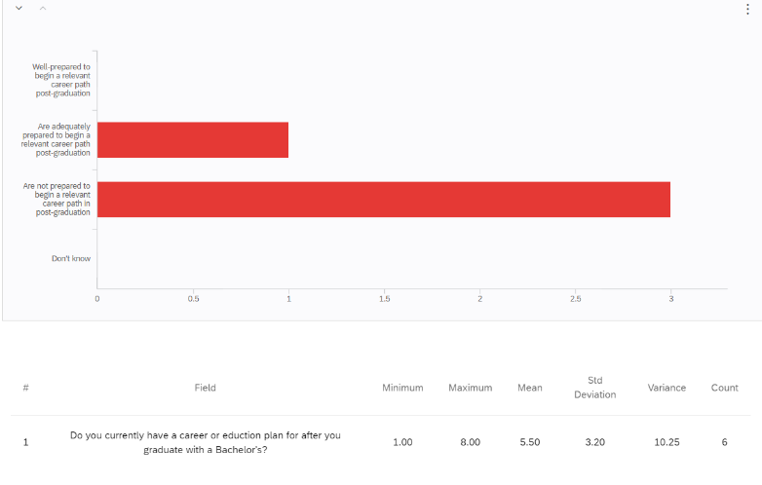

**Figure 3** Graph of data for extent of post-graduate plans

Despite the small sample size, the collected data show most participants are dissatisfied with current psychology courses and lack confidence in post-graduation career plans.

Additionally, data collected found slight to moderate interest and desire for psychology hands-on workshops.

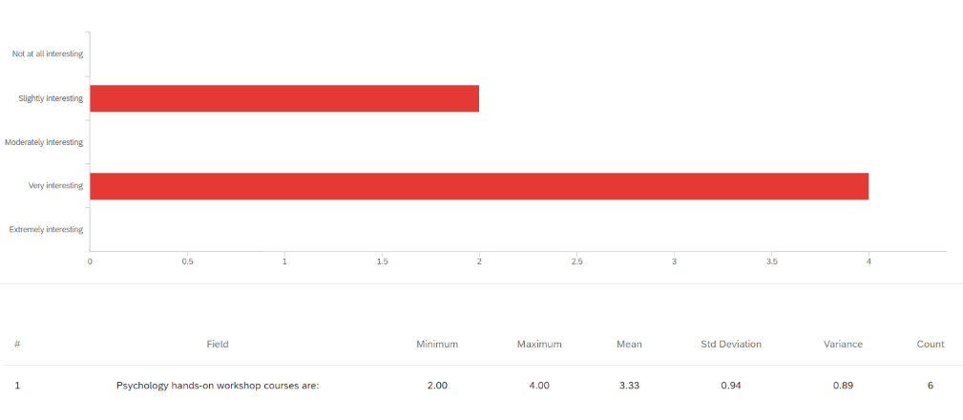

**Figure 4** Graph of data for interest in hands-on workshops

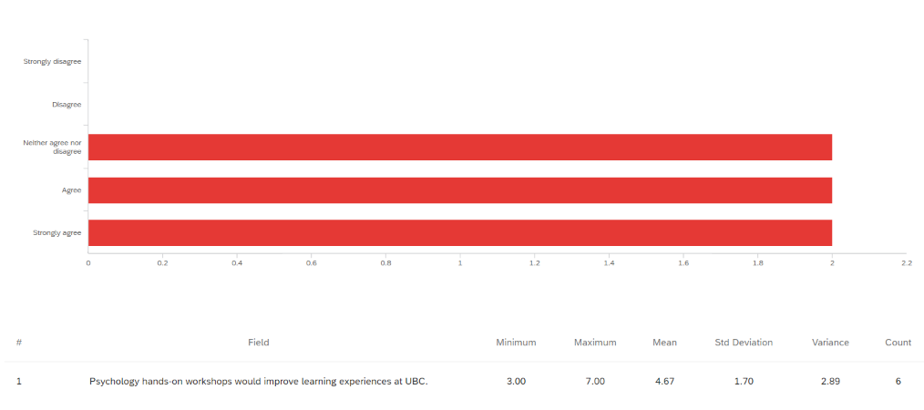

**Figure 5** Graph of data for whether or not participants believe hands-on workshops would improve learning experiences at UBC

If this data collection process were to be repeated again in the future, researchers should aim for a much larger sample size because it is more ideal for a better representation of the population. However, that was not possible for the current proposal. Nonetheless, the primary data collected confirm the feasibility of the report: students are unsatisfied with the current curriculum of UBC psychology courses and are open to hands-on courses. Based on this, we will now examine secondary sources to offer further support and insight on hands-on courses.

## Benefits

Hands-on learning is a learning style that blends visual and auditory learning with physical participation, allowing for a dynamic learning experience (Benefits of Hands-on Learning). Benefits of hands-on learning include:

* Better retainment of learned material
* In comparison to passive lecture-style learning, hands-on learning increases information retainment by 55%
* Physically practicing a concept improves memory by creating more impactful connections to the learned material

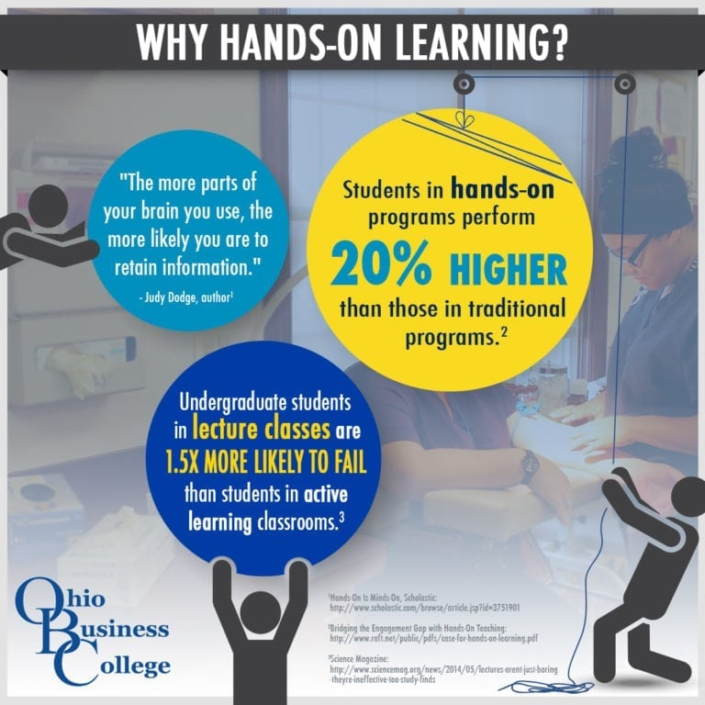

**Figure 6** Hands-on learning benefits

*Source: Image from Ohio Business College. (2016). https://ohiobusinesscollege.edu/why-a-hands-on-education-matters/*

* Increases engagement and stimulation
* Students are more enthusiastic about learning when they are able to practically demonstrate what they have learned
* Students pay more attention in class
* Results in stronger critical thinking skills
* Students must make their own decisions to demonstrate what they learn
* Extremely valuable skill to employers
* Offers real world experience guided by an instructor
* Provides opportunity to self-correct and reflect on mistakes as soon as the material is learned (Top 5 Benefits)

Workplace Transition.The reason psychology students at UBC find it difficult to transition from classroom learning to the workplace is because there are vast differences between the two environments. In the workplace, employees are not expected to write exams like in the classroom. Instead, employers are interested critical thinking and problem-solving skills in the face of various challenges. Through hands-on learning, students are familiarized with the workplace environments they will be involved in post-graduation. Hands-on learning gives students the chance to practice and solve real life problems that may arise in the workplace before students even begin their employment (Benefits of Hands-On Learning).

## Limitations

There are two major drawbacks of hands-on learning that may make both UBC’s department of psychology and psychology students hesitant to welcome hands-on workshops. The present report will examine these limitations and, with the help of secondary sources, offer solutions around them.

1. Cost and Tuition.It is costly to establish a new curriculum. Adding new sections to a course requires salary considerations for the instructor which may be out of the department’s budget. Moreover, students may be hesitant due to the possibility of tuition increases. However, the implementation of hands-on learning does not require creating new courses or sections. A possible solution to minimize cost is to make hands-on learning an addition to lectures. In other words, a section of a course will include time for both lectures and hands-on practice. The hands-on learning portion of the curriculum should be within or around the regular number of hours the course would normally be. For instance, classes normally scheduled for 3 hours per week on Monday, Wednesday and Friday can set one of these days (one hour per week) for hands-on learning, while the other two days are lectures. Additionally, tuition increase is not necessary. BCIT, a post-secondary institution built upon hands-on learning, is able to offer satisfying hands-on education at lower average tuition than UBC’s psychology program. Therefore, with proper financing, it is possible for UBC to change the current curriculum to incorporate hands-on learning at no increase to tuition.
2. Does it Work for Everyone? The second concern is whether or not hands-on learning really caters to students, especially those with severe shyness or social anxiety. In reality, institutions that currently have a well-established hands-on education system demonstrate that hands-on learning can elevate any type of learner. One of the implementation steps stated earlier proposes integration of hands-on learning with lectures, so that these different learning techniques complement each other. With hands-on learning, every student is offered the chance to learn the way they learn best, whether it be visually, auditorily, or by physically practicing the learned material (Benefits of Hands-On Learning). UBC’s psychology department should also slowly introduce hands-on learning to each course and have lecture only sections available for students to opt out of hands-on learning.

# Conclusion

## Summary of Findings

Psychology undergraduate students struggle with dissatisfaction with the current curriculum of psychology courses and lack confidence in post-graduation career plans. Integrating hands-on learning offers a wide variety of benefits that can increase the success of classroom to workplace transition. Despite the lack of sample size, the primary data collected shows that the targeted population is interested in hands-on learning and believes it will boost their learning experience. Hands-on education facilitates stronger retainment of material, more engagement, better critical-thinking skills, and provides real world experience.

## Interpretation of Findings

Psychology students mostly deem hands-on learning to be a desirable addition to the curriculum of psychology courses. As shown throughout this proposal, hands-on learning elevates the learning experience of students, past the potential of traditional classroom learning. Possible problems of establishing hands-on learning are the cost of establishment and potential increase to tuition, and the doubt over whether it will indeed work for every student. However, there are simple solutions to these issues, such as proper financing of current department funds and implementing hands-on learning not as new courses, but to be complementary to existing lecture-style learning.

## Recommendations

If you are interested in moving forward with the integrating hands-on learning into psychology undergraduate courses, consider these suggestions:

1. Conduct larger scale surveys and interviews to acquire more information about what psychology students hope to achieve out of hands-on learning and the exact psychology courses psychology students are most interested in doing hands-on learning in order to best deliver this type of education.
2. Regularly acquire student feedback to ensure satisfaction of learning.
3. Avoid making hands-on learning course load too intensive. Hands-on learning is meant to be fun and fulfilling, not homework loaded.