Reduction of Single-Use Plastics at Lee Chong Asian Food

For Xia Ping, Owner
Lee Chong Asian Food

Jenny Zhang
English 301 99A Student

December 1, 2019

ABSTRACT 2
INTRODUCTION 3
Description of the problem 3
Definition of single-use plastics 3
Purpose of this report 3
Description of sources of data 3
DATA SECTION 4
Effects of Plastic on the Environment 4
CO2 Production 4
Land Pollution 4
Ocean and Microplastic Pollution 5
Presentation of Reports on Data Collected 5
Interview Results with Worker of Lee Chong Asian Food 5
Survey Results with Customers of Lee Chong Asian Food 6
Single-Use Plastic Provided 6
Where it Ends Up 6
Potential Cost Savings 8
Cost of Alternatives and Cost Difference 8
Suggested Alternatives 10
Biodegradable Alternatives 10
Reusable Alternatives 10
CONCLUSION 12
Summary of Findings 12
Recommendations of the Problem 12
APPENDICES 12
Works Cited 12
Survey Questions 14
Interview Questions 15

ABSTRACT

INTRODUCTION

Description of the problem
Single-use plastic is used once but it can remain on our earth forever, wreaking havoc on ecosystems. When discarded in landfills or in the environment, plastic can take up to a thousand years to decompose (Giacovelli). We produce over 300 million tons of plastic every year and about 50% of that is for single-use purpose. More than 8 million tons of plastic is dumped into our oceans every year. Studies have shown that by 2050, the ocean will contain more plastic than fish (The Facts.). The use of single-use plastic is a problem that affects everyone. Just in 2018 alone, 1.1 billion single-use plastic items were thrown out by residents in Metro Vancouver (Duran). In 2015, 8.3 billion metric tons of plastic was produced and within the same year, two-thirds of that plastic has ended up in the environment (Cross). Plastic fragments can release toxic chemicals into the environment and cause serious health risk for humans and animals (Giacovelli). Therefore, the use of single-use plastic is unsustainable, environmentally unfriendly and leads to dangerous health issues in the future.

Definition of single-use plastics
The demand for single-use plastic has been growing at a very fast pace. Since the majority of society views single-use plastics as a cheap and versatile product (Cross). Single-use plastics are commonly used for plastic packaging including items like grocery bags, food packaging, containers, straws and cutlery. These items are intended to be used only once and then thrown away or recycled. (Giacovelli).

Purpose of this report
The purpose of this report is to identify how much plastic waste is produced by Lee Chong Asian Food, a food stall located at Richmond Public Market. By using the information found from data collection, recommendations of methods to reduce plastic waste can be made.

Description of sources of data
Both primary and secondary data will be used in this report. This report will conduct surveys with the customers of the food stall, Lee Chong Asian Food regarding their interest in reducing single-use plastic and to understand customer behaviour in response to possible alternatives. Survey responses have been collected anonymously from a sample of 61 customers between two days. An interview was also conducted with a worker of Lee Chong Asian Food to collect additional information while additional data will also be collected via internet sources for estimated cost of substitute solutions.

Scope of the inquiry
The scope of inquiry will be to determine whether the proposed solution to reduce the amount of single-use plastic is viable at Lee Chong Asian Food. This report will investigate all single-use plastics products that are being used in the food stall and approximate the volumes of single-use plastic food stalls like Lee Chong Asian Food see yearly. We will explore whether the owners and current customers are open to see changes mades in order to help reduce single-use plastic and from our findings, recommendations can be given.

DATA SECTION

Effects of Plastic on the Environment

CO2 Production
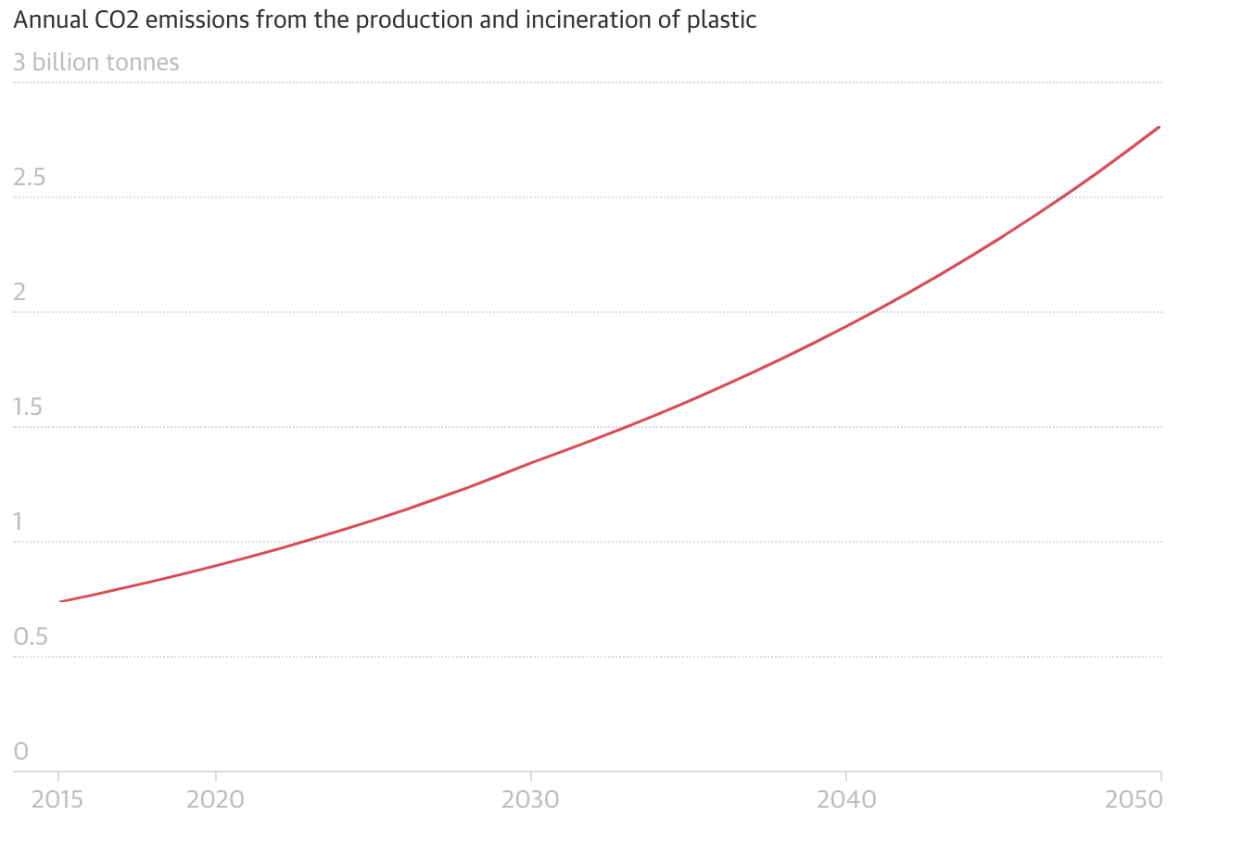
Figure 1. By 2050, the annual CO2 emissions from plastic could grow to more than 2.75 billion tonnes. (Laville)

There has been a constant increase in the manufacturing and consumption of plastic, especially single-use plastic. Almost all plastic products made in the world require the use of fossil fuel, thus driving up global emissions (Cross). With the current levels of greenhouse gas emissions from plastic, it threatens to keep global temperature rise to below 1.5 Celsius. Most plastic ends up in the landfill or ocean, but about 14 percent get incinerated which creates the most CO2 emission among any plastic waste management method. Reports have found that by 2050, plastic production and incineration is expected to emit 2.8 gigatons of C02 per year (Laville).

Land Pollution
Approximately 79 percent of our plastic waste is discarded to landfills and it takes thousands of years to decompose. There will be an estimated 12 billion tonnes of plastic in our landfills by 2050 if we continue to consume plastic at our current rate (Giacovelli). Landfilling is found to emit the least amount of greenhouse gases but it presents many other significant risks (Hamilton). Risks include contaminating our soil and water, and creating a large hazards like ingestion, choking and entanglement of plastic to wildlife on land (Giacovelli).
The production of single-use plastic requires fossil fuels and to obtain fossil fuels, it produces greenhouses due to the need to drill for oil or gas. This also means that it will cause land disturbances as forest and fields will need to be cleared (Hamilton).

Ocean and Microplastic Pollution
Figure 2. A sea turtle mistaking plastic bags for jellyfish. (Rashid)

It is estimated that by 2050, 99% of seabirds will have ingested plastic and is currently harming more than 600 marine species. The majority of the plastics we use today are not biodegradable but instead photodegrade which means they break down into small fragments we call microplastics in a very slow process. These microplastic particles are very difficult to detect and remove from oceans. Microplastics have been found in our drinking water and table salt. This is due to plastic waste and microplastic is ingested by fish and other marine life, it enters our food chain. These materials can impact our respiratory, nervous and reproductive system (Giacovelli).
Microplastic in the ocean also affects the oceans capacity to absorb CO2. Since the industrial era, the earth’s ocean has absorbed around 20-40 percent of all carbon emitted but due to microscopic plants and animals being a carbon pump that captures carbon and transports it into the deep ocean. Now, scientists have seen that these microscopic plants are being contaminated with microplastic, thus less carbon is being taken into the ocean and remaining in the atmosphere (Hamilton).

Presentation of Reports on Data Collected

Interview Results with Worker of Lee Chong Asian Food
For my report, I interviewed Kyle, who is an employee at Lee Chong Asian Food. Kyle works as the cashier who’s job is to take and pack the orders. As he works at the front of the business, he can estimate on average how many customers the food stall sees in a day. From my interview with Kyle, he stated Lee Chong Asian Food sees the most customers around noon, especially on weekends. I was provided an estimate that there are approximately 65 customers on a weekday and 90 on a weekend. It is reported that every meal, it is standard to give a plastic spoon, chopsticks, tissue, plastic bowl or aluminum container depending on what they ordered on a plastic tray or in a plastic bag if they ordered take-out. Unfortunately, Kyle did not know the amount the food stall spends on these items. The food stall goes through containers the quickest, as some orders require multiple containers and most of the items on their menu require plastic bowl containers. When asked about the idea of serving their food in reusable dishes for the customers that eat on location, he replied that he believes its viable, as there are some other food stalls in the same food court that has implemented this. Since they serve food on plastic trays that needs to be washed, adding dishes should not be too much of a problem.

Survey Results with Customers of Lee Chong Asian Food
The survey was conducted throughout two days. The survey allowed to get an insight of what can be changed to help limit the use of single-use plastic. For the customers who participated in the survey, it was found that about 68% were returning customers and visit about once a week. Of the 61 customers who took the survey, 43 of them said they were eating at the food court. From their answers, I found that a significant portion of the customers did not use every utensil they are given, specifically the spoon. When asked about using reusable dishes, 55 of the 61 customers answered that they were open to using reusable dishes. We see that the majority of the customers are open to using reusable dishes, thus we need to investigate the cost of implementing this solution.

Single-Use Plastic Provided
Figure 3. Data acquired on single use food items at Lee Chong Asian Food
 | Straws | Cups | Cutlery | Chopsticks | Plates | Bowls | Takeout bags
Plastic non-recyclable | x |  | x |  |  |  | x
Plastic recyclable |  | x |  |  |  | x
Biodegradable |  |  |  | x
N/A |  |  |  |  | x

Lee Chong Asian Food offer a mix of single-use food items. They use a mix of aluminum and plastic take-out containers. Even if eating at the food court, consumers are given their food in take-out containers but on a plastic tray instead of a plastic bag. They have plastic forks, knives and spoons but they mainly use plastic spoons which comes with every order with chopsticks that are wrapped in plastic. They only offer a small selection of drinks but they are served in plastic cups along with plastic straws.

Where it Ends Up

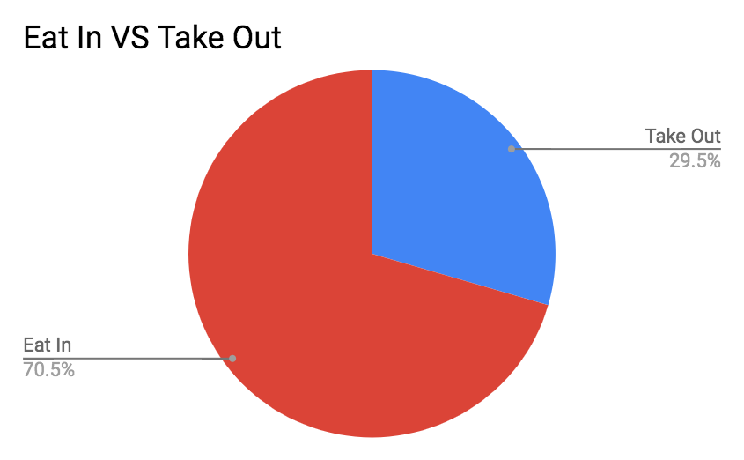
Figure 4. Evaluation of Employees Opinion on Having Adequate Training. Only 62% of employees are confident to agree that there has been adequate training provided.

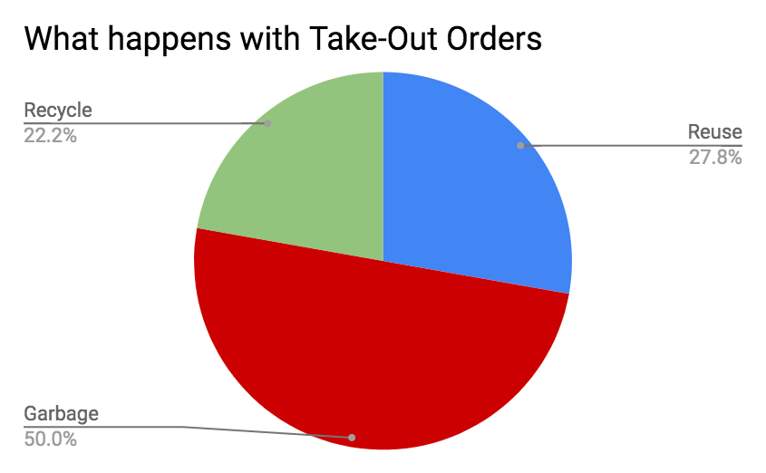
Figure 5. Evaluation of Employees Familiarity with Health Effects Associated with Needlestick Injuries. Over 90% of the employees are confident with their understanding of known health effects associated with needlestick injuries.

There was a total of 61 responses for the survey from customers of Lee Chong Asian Food. From the data collected, it was reported that about 70% of the customers ate their food at the food court (Figure 4). From the 30% of customers who ordered take out, 50% of them responded that they dispose everything including take-out containers in the garbage. About 22% properly dispose of the materials given, including take-out containers and and 28% keep the take-out containers to reuse them (Figure 5).
From our data, we see that the vast majority of customers only use the items provided once. If eating at the food court, waste is collected and properly sorted by the workers of Richmond Public market. This ensures that what can be recycled is recycled but means that the containers are only used once. If we include everyone who eats at the food court and everyone who threw away the food items in the garbage or recycling after one use, it makes up 92%.

Potential Cost Savings

Cost of Alternatives and Cost Difference
The majority of plastic waste at food stalls are from take-out containers. There are a few common materials used for take-out containers: Styrofoam, Aluminum/Foil, single-use plastic and reusable plastic. Reusable plastic differs from single-use plastic because it is made from thicker material to provide better durability. At Lee Chong Asian Food, there will be two types of take-out containers that are mainly used. Plastic containers that can be reused and aluminum/foil containers.

In the following table (Figure 6), we compare the prices of each type of take-out containers that exists. We see that the cheapest option by far is styrofoam containers and reusable plastic bowls. Currently Lee Chong Asian Food uses Aluminum/Foil containers and reusable plastic containers.

Figure 6. Comparison of costs of equal sized takeout containers made from different materials
Container material | Box quantity | Box price | Unit price
Styrofoam (bowls) | 500 | $56.47 | 0.11294
Styrofoam | 220 | $26.53 | 0.12059
Single-use plastic | 200 | $63.28 | 0.3164
Single-use plastic (bowls) | 240 | $89.66 | 0.37358
Compostable plastic | 800 | $197.12 | 0.2464
Compostable plastic (bowls) | 800 | $249.69 | 0.31211
Reusable plastic | 150 | $58.75 | 0.39233
Reusable plastic (bowls) | 500 | $55.83 | 0.11166
Single-use paper | 400 | $89.81 | 0.2245
Single-use paper (bowls) | 500 | $117.25 | 0.2345
Aluminum/Foil | 250 | $60.40 | 0.2416
(“NexDay Supply.”)

In the following table (Figure 7), we compare the prices of each type of cutlery that exists. We see that the cheapest option by far is plastic cutlery. The second cheapest would be wooden cutlery which is approximately 4 times the cost of plastic.

Figure 7. Comparison of costs of cutlery made from different materials
Material | Box quantity | Box price | Unit price
Plastic (Fork/Spoon/Knife) | 1000 | $18.91 | 0.01891
Wooden (Fork/Spoon/Knife) | 6000 | $288.91 | 0.04815
Biodegradable (Fork/Spoon/Knife) | 1000 | $40.05 | 0.4005
(Eco Gecko™ 6.5’ Wholesale Disposable Compostable Wooden Cutlery., “NexDay Supply.”)

In the following table (Figure 8), we compare the prices of each type of bags that exists. We see that the cheapest option by far is plastic bags. Biodegradable bags are a close second which differ by less than 0.02 cents per bag.

Figure 8. Comparison of costs of bags made from different materials
Material | Box quantity | Box price | Unit price
Plastic | 2000 | $94.62 | 0.04731
Paper (no handle) | 500 | $23.98 | 0.4796
Biodegradable | 2000 | $121.49 | 0.0607
(“NexDay Supply.”)
In the following table (Figure 9), we look at the prices of reusable plates and bowls. Compared to Figure 6, we see that reusable plates and bowls per unit are more expensive but we must take into account that reusable plates and bowls can be used multiple times.
Comparing it to reusable plastic containers and aluminum containers that Lee Chong Asian Food currently uses, a reusable plate only needs to be used 4.5 times in order to be cheaper than a reusable plastic container and 7 times to be cheaper than an aluminum/foil container. A reusable bowl needs to be used 11.5 times to be cheaper than a reusable plastic container.

Figure 9. Price of buying reusable plates/bowls
 | Box quantity | Box price | Unit price
Plates | 48 | $84.48 | 1.76
Bowls | 48 | $61.78 | 1.2870
(White Polycarbonate Dinnerware and Mugs.)

Suggested Alternatives
From the interviewer with Kyle, a worker at Lee Chong Asian Food, he gave an estimate of 65 customers per weekday and 90 customers a day on weekends. This equates to about 26,260 customers a year. Lee Chong Asian Food currently uses reusable plastic containers and aluminum/foil containers. There are two types of reusable plastic containers available, one that is shaped like a bowl and another that is more shallow. From the interview, it was found that the reusable plastic bowls were most often used. So if we assume that each customer only gets one container, half of it are the reusable plastic bowls, a quarter are the other reusable plastic containers and a quarter are the aluminum/foil containers. Lee Chong Asian Food, must spend at least $5628 on containers in a year.

Biodegradable Alternatives
It is important to find alternatives to single-use plastic because the need of plastic will never disappear. We are largely dependent on plastic in our day to day lives. Using recyclable materials should be a must but alternatives that are biodegradable would be better as they can break down naturally. Currently, many restaurants and food stalls are switching to recyclable take-out containers but when over 90% of plastic waste is not recycled, this is not a viable solution (Parker).
There are two main types of biodegradable containers: paper and compostable. Containers that are biodegradable can break down naturally over time and have less harm on animals who ingest them (Spec’s Waste Committee.).
From Figure 6. we see that single-use paper containers are less expensive than single-use plastics, thus there is no reason to be using a non-compostable material. Some compostable plastic containers are actually cheaper than the reusable plastic containers that the food stall offers currently. As mentioned previously, Lee Chong Asian Food currently uses reusable plastic containers and aluminum/foil containers. Reusable plastic bowls is the cheapest compared to the biodegradable options of bowls. We see that single-use paper containers is cheaper than aluminum/foil containers and compostable plastic is only more expensive by 0.005 cents per unit. Both compostable plastic and single-use paper containers are cheaper than the reusable plastic containers. So the cost cannot be a factor to not switch to an alternate container that would help the environment.
If the owner was to continue using reusable plastic bowls but switch to compostable plastic and single-use paper containers instead of reusable plastic and aluminium/foil containers. Using the same distribution of half reusable plastic bowls and a quarter of each compostable plastic and single-use paper, Lee Chong Asian Food will have to spend at least $4558 on their take-out containers. Compared to their current estimate, they will save $1070 which is approximately 20%.

Reusable Alternatives
Even if all recyclable plastic is properly recycled, our current technology is not not good enough to meet 100% efficiency. To stop plastic waste, the best option would be to not produce any more plastic but this is not a viable solution. Instead a solution is to implement reusable dishes like how most grocery stores offer reusable grocery bags (Spec’s Waste Committee.).
A solutions other than offering environmentally friendly single-use alternatives is to offer reusable materials. As the mall has a system where you return the tray and is then the waste is sorted out by workers, food stalls can have a distinct plate or bowl that can be returned back to the food stall. Since the majority of the customers are in fact eating there and not bringing the food somewhere else, the use of real dishes will help reduce the amount of single-use plastic significantly.
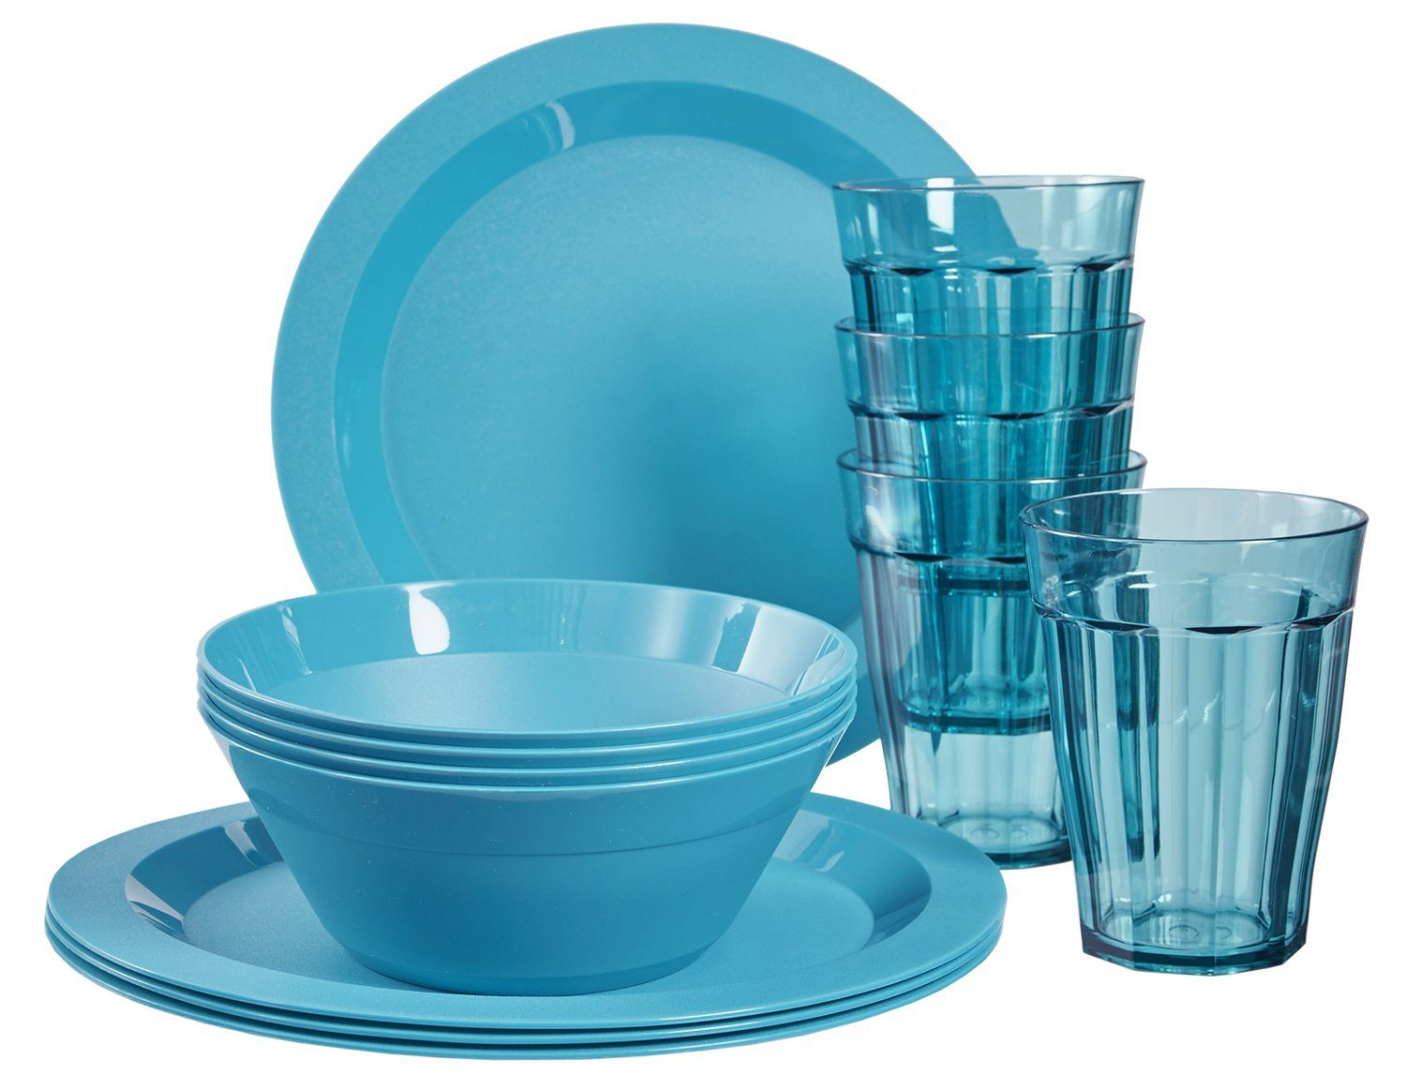

Figure 10. Plastic Reusable Dishes and Cups (“The Ultimate Plastic Dinnerware Shopping Guide”)
There are a portion of customers who order take-out, so we must account for this. From our survey, we found that approximately 70 percent of the customers ate at the food court. So assuming that 70 percent customers eat in and 30 percent order take out then of the 26,260 customers a year, it means we need at least 7,878 take out containers which will cost approximately $1688. Thus we see a significant less amount of plastic being used once. Given that approximately no more than 100 customers a day and assuming every customer only uses one container, then buying 3 packs of reusable plates and bowls each is more than enough. The cost of the reusable plates come out to be approximately $440. Thus we see that by using reusable dishes when customers are eating at the food court will result in saving money for the owner and help reduce the amount of plastic waste. The vast majority of the surveyed customers saw no problem with reusable dishes. Making this a viable solution and beneficial to all parties.

CONCLUSION

Summary of Findings
We must reduce the amount of single-use plastic items from consumption as it is found to be polluting our land and ocean. Reducing the waste produced from the use of single-use plastic will help contribute to reducing our carbon footprint and C02 emissions, thus ensuring a greener future for future generations. From the collected data and through analysis, it was found that there are some viable solutions to help this problem at Lee Chong Asian Foods. By implementing the recommended solutions, it will reduce the negative environmental impact that food stalls like Lee Chong Asian Foods have and establish a model for others to follow.

Recommendations of the Problem
Based on the findings, in order to reduce the amount of single-use plastic at Lee Chong Asian Food, it is suggested to follow the following recommendations.
- Switch to biodegradable alternatives instead of recyclable but reusable plastic containers when possible because consumers still treat it as a single-use product. Through an analysis of cost, it was found that some biodegradable alternatives are cheaper than current containers being used.
- Switch to reusable plastic dishes for customers who dine at the food court. A vast majority is found to dine in, so there is no need to serve their food in take-out containers.

APPENDICES

Works Cited
Cross, Daniel T. “Single-Use Plastics Leave a Large Carbon Footprint.” Sustainability Times,
Sustainability Times, 19 May 2019,
www.sustainability-times.com/sustainable-business/single-use-plastics-leave-a-large-
carbon-footprint/.
Duran, Estefania. “Metro Vancouverites Threw out 1.1 Billion Single-Use Items Last Year,
Study Finds.” CBCnews, CBC/Radio Canada, 12 July 2019,
www.cbc.ca/news/canada/british-columbia/metro-vancouver-single-use-items-landfill
s-study-1.5209792.
“Eco Gecko™ 6.5’ Wholesale Disposable Compostable Wooden Cutlery.” Wholesale
Eco-Gecko Compostable Disposable Sustainable Wooden Utensils Knives Forks
Spoons Wrapped Sets, www.greenstaurant.com/pages/utensils/gecko-utensils.html.
“The Facts.” Plastic Oceans International, PLASTIC OCEANS INTERNATIONAL,
plasticoceans.org/the-facts/.
Giacovelli, Claudia. "Single-Use Plastics: A Roadmap for Sustainability." (2018).
Hamilton, Lisa Anne, and Steven Feit. “Plastic & Climate: The Hidden Costs of a Plastic
Planet.” Center for International Environmental Law, 2019,
www.ciel.org/wp-content/uploads/2019/05/Plastic-and-Climate-FINAL-2019.pdf.
Laville, Sandra. “Single-Use Plastics a Serious Climate Change Hazard, Study Warns.” The
Guardian, Guardian News and Media, 15 May 2019,
www.theguardian.com/environment/2019/may/15/single-use-plastics-a-serious-climat
e-change-hazard-study-warns.
“NexDay Supply.” NexDay Supply,
www.nexdaysupply.ca/Products/Foodservice-Restaurant-Grocery-Retail-Supplies.
Parker, Laura. Plastic or Planet? National Geographic, June 2018,
www.nationalgeographic.com/magazine/2018/06/plastic-planet-waste-pollution-trash-
crisis/
Rashid, Saeed. “FROM THE FIELD: Plastic Pollution Choking World’s Oceans.” United
Nations News, United Nations, 7 June 2018, news.un.org/en/story/2018/06/1011671.
“Salaries.” Jobs, ca.indeed.com/salaries/dishwasher-Salaries,-Richmond-BC.
Spec's Waste Committee. Sustainable To-Go Food Containers. Vancouver: Society
Promoting Environmental Conservation. 2014.
http://www.spec.bc.ca/Resources/Documents/Waste/G2G/Green%202%20Go%20Re
port%20FINALFINAL.pdf
“The Ultimate Plastic Dinnerware Shopping Guide.” Simply Smart Living,
simplysmartliving.com/plastic-tableware-fyi/the-ultimate-plastic-tableware-shopping-g
uide/.
“White Polycarbonate Dinnerware and Mugs.” WebstaurantStore,
www.webstaurantstore.com/30929/polycarbonate-dinnerware-and-mugs.html?filter=c
olor%3Awhite.

Survey Questions
Hello, my name is Jenny Zhang and I am an undergraduate student at UBC engaged in a technical writing project. The purpose of this survey is to obtain primary data for an analysis and investigation that aims to provide recommendations for reducing the amount of single-use plastic that is used at Lee Chong Asian Food. The primary data obtained from this survey would greatly help towards this process and I am grateful for your time and effort in the matter. Using the answers here and other data, I will draft a final report and present it to Xia Ping, the owner of Lee Chong Asian Food for their perusal and potential implementation of the recommended solutions that take into account the perspectives and wants of the community. The survey contains 6 questions and should take about 5-10 minutes of your time. You responses are voluntary and anonymous. Thank you.

1. How often do you visit Lee Chong Asian Food?
- First time
- Once a week
- Once a month
- Other ________
2. Did you order to eat here or for take out? (circle)

For Here / Take Out

3. If you chose Take Out, Do you dispose of the plastic properly or reuse it?

4. Do you use every utensil you are given? (Straw/ Spoon/ Chopstick, etc. )

Yes / No

If not, which ones do you not use?

5. Would you be open to using reusable dishes? (circle)

Yes / No

6. Do you have any suggestions to help reduce the amount of single-use plastic?

Interview Questions
Hello, my name is Jenny Zhang and I am an undergraduate student at UBC engaged in a technical writing project. The purpose of this interview is to obtain primary data for an analysis and investigation that aims to provide recommendations for reducing the amount of single-use plastic that is used at Lee Chong Asian Food. The primary data obtained from this interview would greatly help towards this process and I am grateful for your time and effort in the matter. Using the answers here and other data, I will draft a final report and present it to Xia Ping, the owner of Lee Chong Asian Food for their perusal and potential implementation of the recommended solutions that take into account the perspectives and wants of the community. The interview contains 6 questions and should take about 10 minutes of your time. You responses are voluntary and anonymous. Thank you.

Interview Questions

- Approximately how many customers do you see in a day?

- For each meal, what are all the materials provided? (Spoons, chopsticks, plates, bowls, cups, etc.)

- What are the costs of these materials?

- Which materials does Lee Chong Asian Food use the most?

- Have you ever thought about how much plastic is used daily?

- Would you be open to more environmentally friendly alternatives?

- Are there any concerns for using reusable dishes?

- Are there any suggestions to help reduce the amount of single-use plastic?

