Reduction of Single-Use Plastics
at UBC Geering Up

for
Jakob Manning
Manager of UBC Geering Up

by
Jenny Zhu
University of British Columbia
ENGL 301 Student
Dr. Erika Paterson

December 2, 2019

TABLE OF CONTENTS

ABSTRACT…….……………………………………………………………………………….#
INTRODUCTION……………………………………………………………………………….#
- Definition of single-use plastics…………………………………………………………………………………….#
- Breaking Down Plastics and the Environmental Impact……………………….………………………………………………………...…..#
- Description of Geering Up’s Use of Plastics……………………………………………………………...……………………..#
- Purpose of this report and Intended Audience…………………………………………..………………………….…………...#
- Description of Data Sources and Methods……………………………………………………………….…………………...#
DATA SECTION (Body)
- History of Geering Up……………………………….…………………………………………………………#
- The role of plastics at Geering Up…...…………...………………………………………….……………………………..#
  - Its presence:…………….………………….……………………………………….#
    - during workshops……...….……………………………………………….#
    - during camps…….…………….…………………………………….…….#
    - during local events.…….……………………………………….…………#
- Impact of plastics…….………….......…………………………………………………….#
  - On the environment...…………..…………………………………………………#
  - On animals.…...………………………………………………………...…………#
  - On humans.…...………………………………………………………………...…#
- Impact of plastics at Geering Up..………………….……………………………………..#
  - Data from surveys..……………………………………………..…………………………….#
  - Data from interviews………………………………………………………………………….#
- Proposed Solutions for Plastic reduction..………………………………….……………..#
  - Plastic Alternatives for the Ten Most Common Items...…………….…………….#
  - General suggestions….……………………………………………………………………..#
CONCLUSION
- Summary and overall interpretation of findings…………....…….……………………….#
- Recommendations…..……………………………………………………....…….……….#
REFERENCES…………….……………………………………………………………………...#
ABSTRACT
(to be completed later)
INTRODUCTION
- Definition of single-use plastics
The world has grown to depend on plastic products over the last three decades. Plastics are versatile, cheap, and convenient. They fall under two main categories: thermoplastics, which are most malleable and reversible, and thermosets, which undergo irreversible chemical change when heated. Conveniently, both types of plastics also have single-use applications. By definition, plastics that are intended to be discarded after one use, include a variety of packaging, bottles, bags, cutlery, and containers, are deemed “single-use plastics” (“Single-Use Plastics: A Roadmap for Sustainability”, 2018).
- Breaking Down Plastics and the Environmental Impact
One of the environment’s biggest challenges is tackling plastic waste that often ends up in over-flowing dumps, landfills, or the ocean. Though recycling plastics is one way to go, the truth is, plastics never fully go away. Instead, they photodegrade into smaller and smaller pieces called microplastics, pieces of plastic smaller than 5mm in length (“Single-Use Plastics: A Roadmap for Sustainability”, 2018). Certain products containing polystyrene foam such as plastic bags may take thousands of years to decompose, resulting in pieces of floating trash in the oceans harming marine life, or in overflowing dumps contaminating water and food sources. Even p14 biodegradable plastics made up of plants or animal byproducts usually require large amounts of heat to be broken down and likewise will not degrade naturally on their own. Over the last decade, numerous bans have been set in the effort of putting a halt to the increasing trend of single-use plastic items. But still, single-use plastics are one of the biggest contributors to plastic waste in the world.
- Introduction of Geering Up and its use of plastic products
UBC Geering Up is an engineering outreach organization that focuses on using hands-on activities to engage students in Science, Technology, Engineering, and Math (STEM). In the past two years there has been significant growth in Geering Up’s programs, with an annual reach of over 24,000 students. However, its expansion also brings on the need for more materials, in particular those containing single-use plastics.
By reversing this trend, the company may produce a smaller carbon footprint while potentially decreasing its expenditures. Currently plastic products and adhesives that are seldom recycled and broken down contribute to the majority of the waste. In the last few years the organization has delivered thousands of workshop annually and has spent hundreds of thousands of dollars on single-use materials. Most workshops involve taken-home projects that are short-lived and materials that are disposed of at the end of each session. At the end of the Summer, copious amounts of plastic products are thrown away because they cannot be used again or are damaged.
- Purpose of this report and Intended Audience
The University of British Columbia is the leading university in Canada and the third in the world for sustainable cities and communities. As part of the university, Geering Up also plays a role in upholding similar values. In April 2020 UBC will be raising the cost for single-use plastic cups, which is a great opportunity for Geering Up to make a shift to using more reusable materials. Additionally this may decrease the cost of needing replenishing single-use materials frequently.
This report is intended for Jakob Manning, manager of Geering Up for Jakob Manning, the manager of Geering Up. Mr. Manning oversees all of the organization’s programs, the budget, and coordinates with the faculty of Engineering, under which Geering Up runs. He has been involved with the company for 6 years and is always looking for ways to expand our reach. As manager, everything must be approved by him so presenting this proposal would be a good call for action.
- Description of data sources
To determine whether or not there is a need to reduce single-use plastic at Geering Up, this report considers primary sources of data which include interviews and surveys and secondary sources of data such as research papers, articles, and reviews. Interviews were conducted on current staff, including the Materials Student Assistant, Teacher Pro-D Student Assistant, Local Events Student Assistant. Also, an anonymous survey was presented to current and past staff and participants. The responses to interviews and surveys are presented in section J. Secondary sources of data include research articles on reducing carbon footprints and the sustainability of various materials.
Below are the interview questions:
- Describe your role at Geering Up.
- Do you find reducing plastic at Geering Up waste to be important?
- What measures have you personally taken to reduce single-use plastic waste?
- Which ways have been successful? Which have not?
- How can we modify some activities to eliminate single-use plastic waste?
- Do you think reducing the amount of plastic waste will make it harder for Geering Up’s curriculum planners and instructors to come up with and deliver programming?
Below are the survey questions:
- Do you think Geering Up uses sustainable materials during workshops, camps, and events?
- 1 - Not at all. Almost all of the materials are not environmentally friendly.
- 2 - Somewhat. A few materials are environmentally friendly.
- 3 - Maybe. About half of the materials are environmentally friendly.
- 4 - Yes. Many of the materials are environmentally friendly.
- 5 - Absolutely. Almost all of the materials are environmentally friendly.

- Have you observed instances where Geering Up could use single-use plastic alternatives? Please elaborate if possible.
- Yes _______________________________________________________
- No ________________________________________________________

- Estimate how much money was spent on single-use plastics in the 2018 - 19 school year.
_________________________________________________________________

- How important to you is Geering Up being an organization that cares for the environment?
  - 1 - Not important at all
  - 2 - Somewhat important
  - 3 - Fairly important
  - 4 - Mostly important
  - 5 - Very important

- Would you choose another organization over Geering Up if they were more environmentally friendly?
  - Yes
  - Maybe
  - No

- Do you have any suggestions for Geering Up on reducing plastic waste?
___________________________________________________________________

- Are you a Geering Up staff, or a participant of Geering Up’s programs?
  - Staff
  - Participant
DATA SECTION
- History and Vision of Geering Up Question for Jobina: do you think this section needs to be cited?
Geering Up started as capstone project by a mechanical engineering student in 1995 at the University of British Columbia. It introduced high school STEM programs in 1999, and shortly after, Indigenous programming in 2000. Geering Up always had a mission to make STEM accessible to kids and youth. A volunteering program was initiated in 2004 and an Integration Support role in 2005. Following these, many expansions were made in Surrey, White Rock, North Delta and North Vancouver. Geering Up’s vision is to make STEM accessible to all, regardless of who they are. Evident in its efforts to be impactful and innovative at a part of UBC, currently certain staff are considering ways they could improve on the aspect of sustainability.
- The role of plastics at Geering Up
Geering Up runs the majority of its programming in the summer, which is comprised of workshops and camps for over 20000 children and youth. From May to August the Engineering Student Center and Engineering Design Center are filled with supplies from top to bottom. Much of those supplies are made of plastic and not reusable. On top of the supplies ordered for workshops, camps, and local events, there is a large reservoir of general supplies that include ziploc bags, plastic bottles, plastic wrap, and adhesives. On the very last day of the Summer season, piled outside of the Engineering Student Center is a collection of plastic bins, plastic hangers, plastic waste and packaging. Similar heaps of trash to be thrown away are collected in two other locations.
Figure 1. Large pile of garbage to be thrown out on move-out day. The picture was taken in the morning, and represents about one sixth of the total trash thrown out. Photo taken by author.
- Workshops
Geering Up runs workshops for grades K - 12 students across the lower mainland and in northern BC. A majority of materials used for workshops are plastic-containing bottles, bags, containers, cups, straws, food wrap. Various bottles are used to make take-home projects such as mini biodomes and thermometers. Containers and bags are used to transport materials. Cups and straws are mainly used for design challenges and take-home projects as well.
- Camps
Each curriculum planner is responsible for planning a camp that will run four to eight times in the Summer and ordering the materials for each participant with a budget of $20 - $30 per participant per week. The bulk of the budget goes to single-use items, especially plastic containing ones. For example, one of the 2019 high school camps spent $1000 on PVC piping, styrofoam balls, and bubble wrap.
- Local Events
Local events is another category of programming that reaches thousands of students and teachers each year. These events are similar to workshops but run during the school year instead of the Summer and the staff are part-time instead of full-time. Similarly, the issue of single-use plastics is evident but in addition, new and part-time staff often opt for more convenient options that may not be the most sustainable ones because they are more pressed for time than the summer staff.
(H - is to be completed) Question to Jobina: Do you think section H is going to add value to my report? I’m contemplating on writing it. Thank you :)
- Impact of plastics
  - On the environment
  - On animals
  - On humans
- Impact of plastics at Geering Up
  - Data from surveys
Geering Up staff and participants were surveyed to determine the need for reducing single-use plastics. According to the data, most people would support organizations that are environmentally friendly and see room for improvement at Geering Up.
The survey found that about three quarters of people find that Geering Up uses half or less than half of sustainable materials during workshops, camps and events. Only a small portion observed otherwise (Figure 2). In fact, the majority of people believe there to be alternative materials that could replace plastics (Figure 3). To account for the quantity of single-use plastic items observed, it was estimated that on average these materials amount to $19, 563 in a year. (Figure 4). About half of the people would opt for an organization if they were more environmentally friendly than Geering Up (Figure 6) but fortunately there was a lot of support for Geering Up prioritizing sustainability (Figure 5).
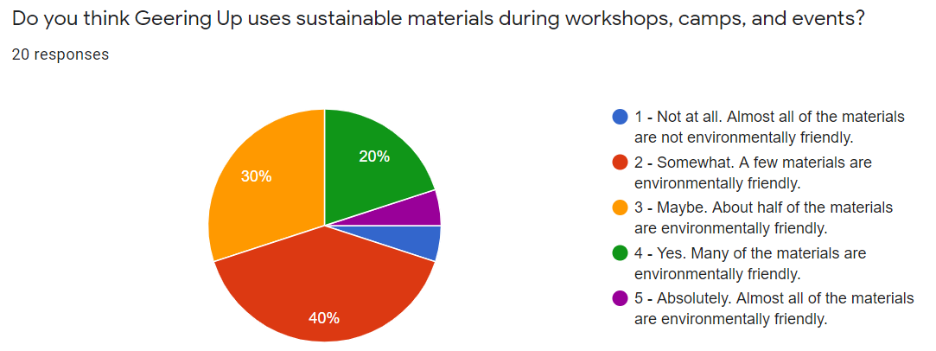
Figure 2. Survey responses for perception of sustainable materials at Geering Up.
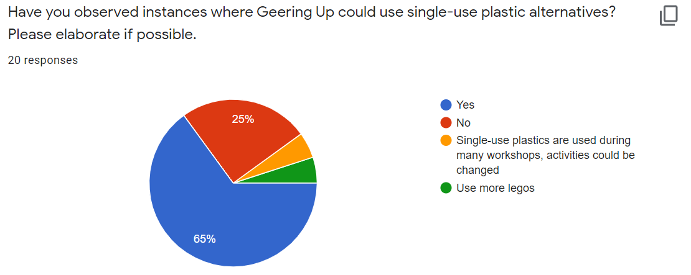
Figure 3. Survey responses for single-use plastic alternatives
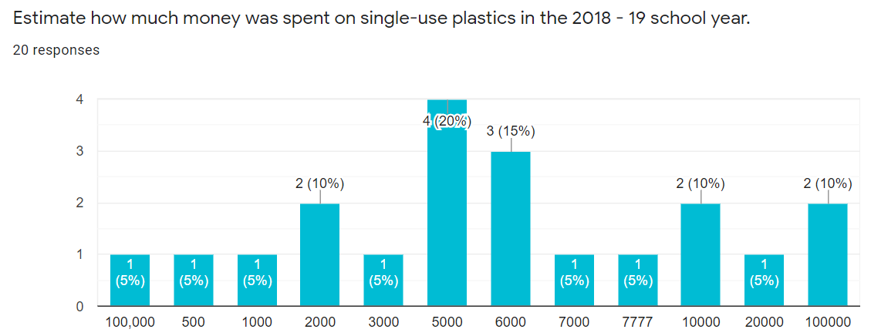
Figure 4. Survey responses for estimation of money spent on single-use plastics.
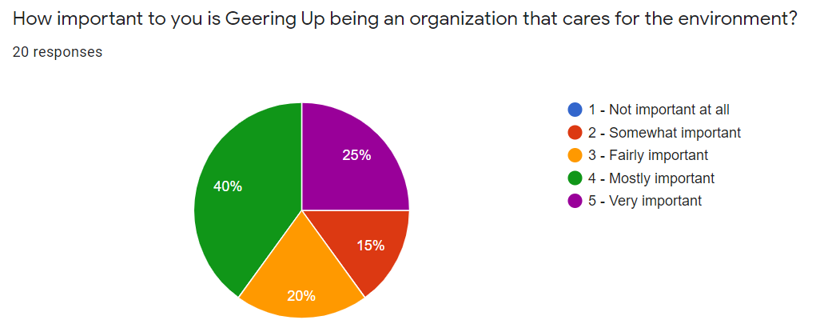
Figure 5. Survey responses for the importance of Geering Up being an environmentally-friendly organization.

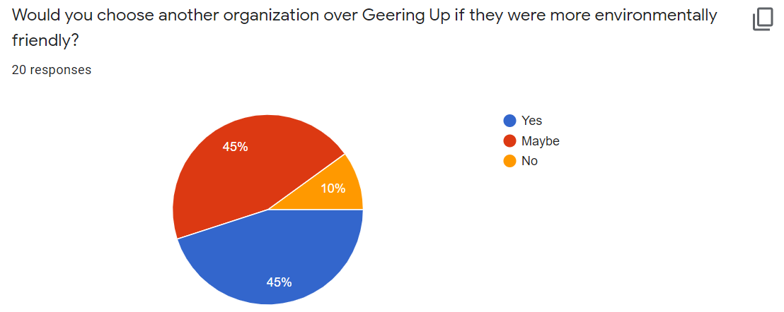
Figure 6. Survey responses for organization preferences in regards to sustainability.
  - Data from interviews
Interviews were conducted with the Materials Student Assistant (MSA), the Teacher Pro-D Student Assistant (TPSA), and the Local Events Student Assistant (LESA). The data collected helped clarify the reasons why there is still so much plastic use at Geering Up and encourages the organization to be more conscious of its actions. The main identified reason of rampant plastic use is because plastic is a very accessible resource. But once we shift to a greener mindset, replacing single-use plastics will become easier (LESA). The interviewed staff recognize the need for a shift away from plastics, and are already taking measures such as purchasing reusable items, modifying curriculum to accommodate other materials, and getting rid of certain non-essential materials all in all. One specific example given by the LESA was to implement reusable materials during an ocean cleanup activity instead of the ones used, which included plastic bags and plastic cups, because the purpose of the activity should also be reflected in the materials used. Another opportunity to reduce plastic is eliminating plastic bottles in the “Thermal Theatrics” workshop and creating another take-home activity such as a candle or a solar powered device. Lastly, the MSA who is in charge of 90% of materials ordered believes holding an hour-long session on sustainability of materials during training seasons will help drastically with reducing plastic waste.
- Proposed Solutions for Plastic reduction
  - Plastic Alternatives for the Ten Most Common Items
In 2019 over $100, 000 was spent on materials. Very little of those materials were kept for the next year because many of the items were disposed after one use. The following shows roughly how much money was spent for the most common single-use plastic-containing items. The alternatives are just suggestions and can be modified to best suit the activity(s) they are to be purchased for. Ultimately eliminating or greatly reducing these products would be best as other materials can often be used to achieve the same purpose. Though the initial cost may be higher, the cost of replacing materials will decrease in the long run.
Item | Estimated total cost from the 2019 workshops and camps season | Alternative Products
Duct tape | Will complete calculations later | Scotch tape/grafting tape/string/elastic bands
Plastic cups |  | Paper cups/mugs/reusable plastic cups
Plastic straws |  | Paper straws/Rolled-up cardstock
Plastic Salbro bottles |  | Glass milk bottles/recyclable beverage bottles
Disposable plastic containers |  | Glass containers/cardboard boxes
Ziploc bags |  | Wax paper bags/cloth pouches
Juice boxes - 200mL |  | Larger bottles of juice/juice that comes in glass containers
Plastic wrap |  | Paper + elastic band
Plastic spoons |  | Wooden spoons/metal spoons/popsicle sticks
Styrofoam balls |  | Modelling clay/playdough

  - General Suggestions
Given that Geering Up is an organization that strives to make a positive impact on education, there is also responsibility in modeling environmental sustainability to the thousands of people reached each year. To help Geering Up shift towards producing less single-use plastic waste here are some suggestions that could be implemented during the next camps season:
- Raising awareness at the management level
  - Reviewing sustainable development goals at Geering Up
  - Setting a good example for other employees by taking initiatives on reducing single-use plastics
  - During training of new employees, placing emphasis on being mindful of how much plastic is used
- Making better decisions as Curriculum Planners
  - Being environmentally-conscious while planning curriculum for workshops, camps, and local events
  - Being mindful of ordering materials and ordering materials in bulk quantities
  - Planning curriculum based off of available and sustainable material options
  - Reviewing the effectiveness of take-home activities to try to make them longer lasting
  - Capitalizing on the flexibility of design challenges to explore new and more sustainable materials
- Planning activities and events that are more technology oriented.
  - Incorporating technology in activities to increase reusability of items and decrease the need for single-use plastics
    - Examples of technology Geering Up already has: laptops, tablets, robots, microcontrollers, arduinos, circuit sets
CONCLUSION
The impact of reducing single-use plastic waste at Geering Up is a step towards being more environmentally conscious while decreasing financial expenditures. As a growing organization, this goal is something everyone can take part in.
- Summary and overall interpretation of findings
Based on data collected from staff and participants at Geering Up, there is a strong urge to shift towards using more long-lasting materials for all events. The organization could potentially gain more people and save money by shifting away from plastic. Data from research papers also outlines the harm of single-use materials on the environment and living beings, further supporting Geering Up’s move away from single-use plastics.
- Recommendations
To help Geering Up be more environmentally-friendly, this report mainly recommends changes centered around replacing currently used plastic items with options that are reusable or compostable and raising a culture of mindfulness around the choice of materials. Suggestions for alternative items for the ten most popular single-use items would decrease waste production and decrease thematerienvir amount of money spent on replacing these items frequently. Awareness at the manager and coordinator level on usage of plastic materials could lead to a cascade effect of changing the way things are done at the instructor levels.

REFERENCES
About us. Retrieved from https://geeringup.apsc.ubc.ca/sustainability-in-engineering/

Giacovelli, C .Single-use plastics: A roadmap for sustainability. ().United Nations Environment Programme. Retrieved from https://wedocs.unep.org/bitstream/handle/20.500.11822/25496/singleUsePlastic_sustainability.pdf?isAllowed=y&sequence=1
Walker, T. R., & Xanthos, D. (2018). A call for canada to move toward zero plastic waste by reducing and recycling single-use plastics. Resources Conservation and Recycling, (133:99-100) Retrieved from https://www.researchgate.net/profile/Tony_Walker/publication/323171842_A_call_for_Canada_to_move_toward_zero_plastic_waste_by_reducing_and_recycling_single-use_plastics/links/5a842752a6fdcc6f3eb3cd5e/A-call-for-Canada-to-move-toward-zero-plastic-waste-by-reducing-and-recycling-single-use-plastics.pdf

