**Assignment 1:3- Definitions**

The purpose of this assignment is to write three definitions of a term related to one’s field of study- parenthetical, sentence, and expanded, for a non-technical audience. The objective is to understand how different readers require a different form of definition, such as levels of detail and vocabulary if they are not familiar with the area of knowledge. This assignment allows the student to realize the importance of defining in technical writing.

### Calculus /ˈkalkyələs/

Parenthetical definition:

Calculus (the hardened form of dental plaque) on the tooth surfaces allows bacteria to adhere more readily, contributing to periodontal disease.

Sentence definition:

Calculus is a collection of oral microorganisms that are mineralized (or “hardened”) on the tooth surfaces from calcium and phosphate salts in the saliva.

It has a chalky consistency that may become stained by food and drinks. It is also known as *tartar. See Figure 1.*

(A microorganism is a miniscule organism such as a bacterium, virus, or fungus.)

Expanded definition:

Calculus is a collection of oral microorganisms that are mineralized (or “hardened”) on the tooth surfaces from calcium and phosphate salts in the saliva.

*Origin of the word*

Calculus comes from the Latin word meaning “small pebble”. This is a fitting connection as dental professionals are taught to detect calculus below the gum line by feeling how the instrument glides across the tooth surface. Calculus is described by clinicians as having a grainy, sand-like consistency, different than the smooth texture of a tooth.

*Calculus formation*

Calculus forms from oral plaque biofilm. Biofilm is a complex arrangement of microorganisms that thrive in moist, nutrient-rich environments. When plaque biofilm is not sufficiently removed from the oral cavity, the minerals in the saliva will calcify (harden) the deposit onto the tooth surfaces. Once this material forms, it is too tenacious to be removed with a toothbrush. A dentist or dental hygienist is qualified to remove the build-up using dental instruments.

*Importance of calculus removal*

Calculus has a rough, uneven consistency allowing bacteria to thrive in the microscopic divots. It can form both above and below the gum line, causing irritation to the tissues. If left untreated, this hard deposit can cause the gum tissue to recede, exposing the root surfaces of the teeth. Exposure of tooth roots can cause sensitivity for the individual, as they are not coated in a dense enamel layer. Blood flow to the gum tissues can also be partially inhibited if the calculus masses are large. Ultimately, dental calculus is a causative factor in periodontal infection (infection of the supporting structures of the teeth: gums, supporting tissue and bone). *See Figure 2.*

*Preventative measures to decrease calculus deposition rates*

A majority of calculus can be prevented through daily tooth-brushing, twice daily being ideal. Flossing or cleaning between the teeth with small brushes, picks, or pressurized water devices helps reduce deposits that form where a toothbrush cannot reach. Antibacterial mouthrinses are also beneficial at disrupting biofilm attachment.

*Microorganisms that make up calculus deposits*

A few of the main microorganisms that form in the oral cavity, creating the biofilm layer on the teeth are: Streptococcus spp., P. intermedia, F. nucleatum, and P. gingivalis.

Figure 1:

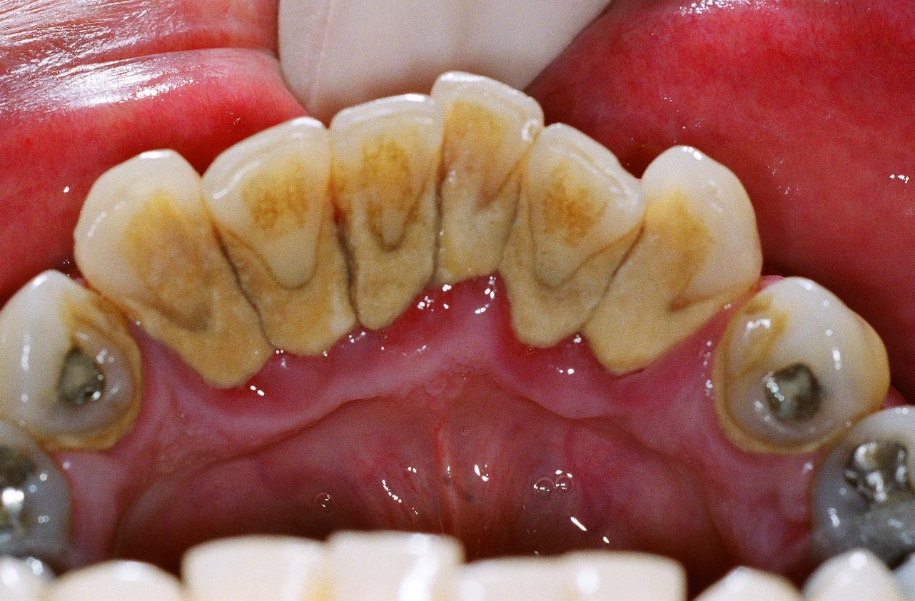

Calculus (“tartar”)- the thick, yellow mass that is shown accumulating where the tooth and gum tissue meet

Source: <https://images.search.yahoo.com/images/view>

Figure 2:

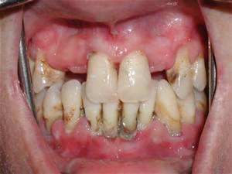

Periodontal Infection- notice the exposed root surfaces, bulbous red gum tissue, and plaque biofilm

Source: https://images.search.yahoo.com/yhs/search;_ylt=A0LEVjwtq65W9i0AiNInnIlQ?p=periodontal+disease&fr=yhs-mozilla-002&fr2=piv-web&hspart=mozilla&hsimp=yhs-002

Works Cited:

Calculus. (2016). Oxford dictionaries. (Place unknown): Oxford University Press. Retrieved January 24, 2016, from <http://www.oxforddictionaries.com/definition/english/calculus>

Darby, M.L., & Walsh, M.M. (2010). Dental hygiene theory and practice (3rd ed.). St. Louis, MO. Elsevier.

Nield-Gehrig, J.S., & Willmann, D.E. (2011). Foundations of periodontics for the dental hygienist (3rd ed.). Philadelphia, PA. Wolters Kluwer Health.