**Introduction:**

Hello fellow Wordsmiths, for this assignment I have chosen to define the word proletariat. This assignment will allow us to be more familiar with the different definitions used to describe a word in the context of technical writing. The guidelines of this assignment are to write a parenthetical definition, sentence definition, and an expanded definition of a word of our choosing. The word I chose will reflect my background as a Sociology Major.

**What is a Proletariat?**

Proletariat is a term used by theorist Karl Marx (major theorist of the class system/structure) to describe the working class in a society.

**Parenthetical Definition:**

Proletariat (Working Class)

**Sentence Definition:**

Proletariat is the lowest economic and social class in a society normally referring to the working class.

**Expanded Definitions**

**Origin:**

The “proletariat” was the lowest social class in Ancient Rome and consisted of the poor landless freemen (people who worked to produce goods). Proletariat means “producers of offspring”.

**Visual:**

This represents the capitalist system where there is a hierarchy amongst society where at the base are the proletariats who work and hold society together while the upper class takes advantage of that.

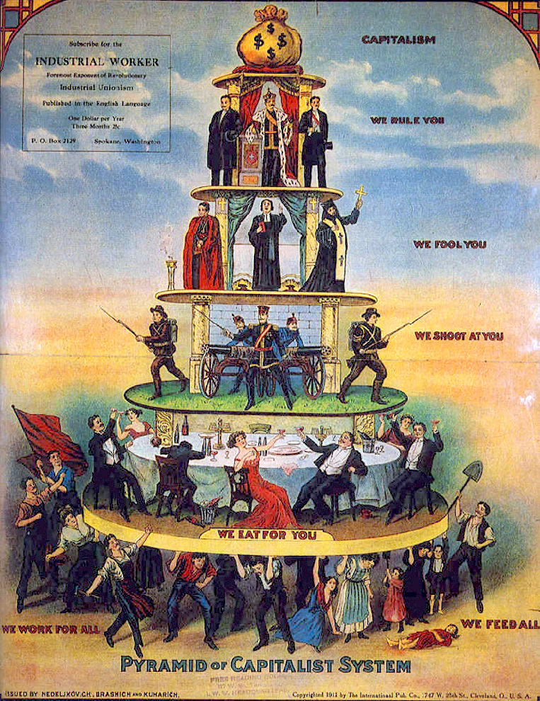

**History:**

The term proletariat dates back to Ancient Rome and most notably used by Karl Marx to describe the wage workers in a class system. While in Ancient Rome the term was designated to the lowest class in society, Marx used it to designate the working class. While in most cases the working class lived in poverty during the time Marx was writing, poverty is not what defines a proletariat.

**Negation:**

You cannot have a proletariat if the society itself does not have distinguished social classes.

**Operating principle:**

The proletariat arises in societies where production of goods is needed and the class system is set up where the lower class produces these goods for low wages.

**References:**

Britannica, The Editors of Encyclopaedia. “Proletariat.” *Encyclopædia Britannica*, Encyclopædia Britannica, Inc., 26 Sept. 2017, [www.britannica.com/topic/proletariat](http://www.britannica.com/topic/proletariat).

Proletariat.” *Wikipedia*, Wikimedia Foundation, 23 Sept. 2018, en.wikipedia.org/wiki/Proletariat.