**Proposal for Determining the Feasibility of Renovating the Rooftop Patio at Pendrell Mews Condo**

for Pamella Palmer,

the Council of Pendrell Mews

by

Jieun Kim

July 14th, 2021

Pendrell Mews

Vancouver, BC V6G 3A5

**TABLE OF CONTENTS**

**I. INTRODUCTION** --------------------------------------------------------------------------------------------- 3 A. Background of Pendrell Mews Condo ------------------------------------------------------------------------- 3  
 B. Current state of the Rooftop Patio ------------------------------------------------------------------------------ 3  
 C. Purpose of this report -------------------------------------------------------------------------------------------- 4  
  1. Audience ------------------------------------------------------------------------------------------------------- 4  
  2. Project Goals --------------------------------------------------------------------------------------------------- 4

**II. DATA SECTION** ----------------------------------------------------------------------------------------------- 5 A. Identify tenants’ requests on renovating the Rooftop Patio -------------------------------------------------- 5  
  1. survey results and interpretation ----------------------------------------------------------------------------- 5  
 B. Space Analysis --------------------------------------------------------------------------------------------------- 7  
  1. Measurement --------------------------------------------------------------------------------------------------- 7  
  2. Problems that need attention --------------------------------------------------------------------------------- 8  
 C. Anticipated Scope of Work and Estimated Cost -------------------------------------------------------------- 8  
 D. Construction Schedule ------------------------------------------------------------------------------------------ 8  
 E. Project Challenges and Limitations ---------------------------------------------------------------------------- 8  
  1. Agreement on tenants ----------------------------------------------------------------------------------------- 8  
  2. City permit on the constructions ----------------------------------------------------------------------------- 8

**III.CONCLUSION** ----------------------------------------------------------------------------------------------- 9 A. Summary and overall interpretation of findings -------------------------------------------------------------- 9  
 B. Recommendations ----------------------------------------------------------------------------------------------- 9

**IV.APPENDICES** ------------------------------------------------------------------------------------------------10 A. Work Cited ----------------------------------------------------------------------------------------------------10  
 B. Survey Question -------------------------------------------------------------------------------------------------10

**1.Introduction**

**A. Background of Pendrell Mews**

Pendrell Mews is a 4 story condo, located in the West End neighbourhood, it was built in 1979, containing 100 units. The renovation plan was put on hold as residents discussed selling the building for redevelopment, but the plan to sell has been temporarily delayed. As a result, a new discussion has occurred about whether or not the building should be remodeled to better accommodate its current owners.

Renovating the rooftop patio is a move forward plan that provides residents with social, resting, and gardening space. The patio has been growing in popularity. Especially since Covid-19, more people are using rooftop terraces. It is reasonable to assume that demand for better recreational space will continue to rise. However, the patio has not been refurbished since 1979. The structure of the patio is insufficient to accommodate the growing number of users.

**B. Current State of the Rooftop Patio**



Figure 1. Rooftop patio at Pendrell Mews

The significant implications of the patio renovation are regarding safety regulations and the up-gradation of residential amenities. First and foremost, the decayed and cracked fence and wood flooring have potential risks of leaking water and human accidents. Second, the furniture such as tables, chairs, and sunshades are old and rusted as well as short in numbers. In addition, in the long view, these aforementioned problems work together to cause degradation of the building and consequent loss in value.

**<WILL BE ADDED>**

Figure2. Furnitures at Rooftop Patio

**C. Purpose of this report**

**1. Audience**

This proposal is prepared for the council at Pendrell Mews Condo, who has the authority to evaluate and practice the proposed solutions with the data collected through the past years and based on the building assessment.

**2. Project Goals**

This report proposes renovating the rooftop patio in order to provide the tenants’ better recreational space. According to National Collaborating Centre for Environmetal Health, outdoor recreational space makes important contributions to social well-being and physical and mental health. Especially during the COVID-19 pandemic, the use of these spaces will offer the residents the opportunities for stress relief. Furthermore, in the face of city development, this suggested plan will restrain Pendrell Mews from being devalued. Therefore, this paper proposes an effective and practicable project plan to renovate the rooftop patio, which includes:

* Re-install hardwood flooring and fence
* Floor waterproofing
* Replace furniture including tables, chairs, sunshades
* Install flowerbeds
* Extend rooftop patio maximizing allowance roof area

By doing so, this proposal anticipates Pendrell Mews continuing to maintain the highest standards while ensuring the needs of its residents.

**II. Data Section**

**A. Identify tenants’ requests on renovating the Rooftop Patio  
1. Survey results**

Data was collected by the anonymous survey from the Pendrell Mews’ residents of 40. The residents were asked their experiences at the patio area regarding its condition/cleanness, garden area, furnishing, safety including overall satisfaction.

The collected data shows that the majority of survey respondents expressed the need of improvement on the rooftop patio. Figure 3 indicates that 75% of the respondents revealed their dissatisfaction on the flooring and fence. Figure 4 presents that 67% of the residents their displeasure over the patio furnishing for its quality and inadequacy for tables, chairs, and sunshades.

**Figure3. Satisfaction on patio flooring and fence**

**Figure4. Satisfaction on patio furnishing**

**Figure5. Agreement rate on the patio renovation plan**

**B. Space Analysis**

**1. Measurement**

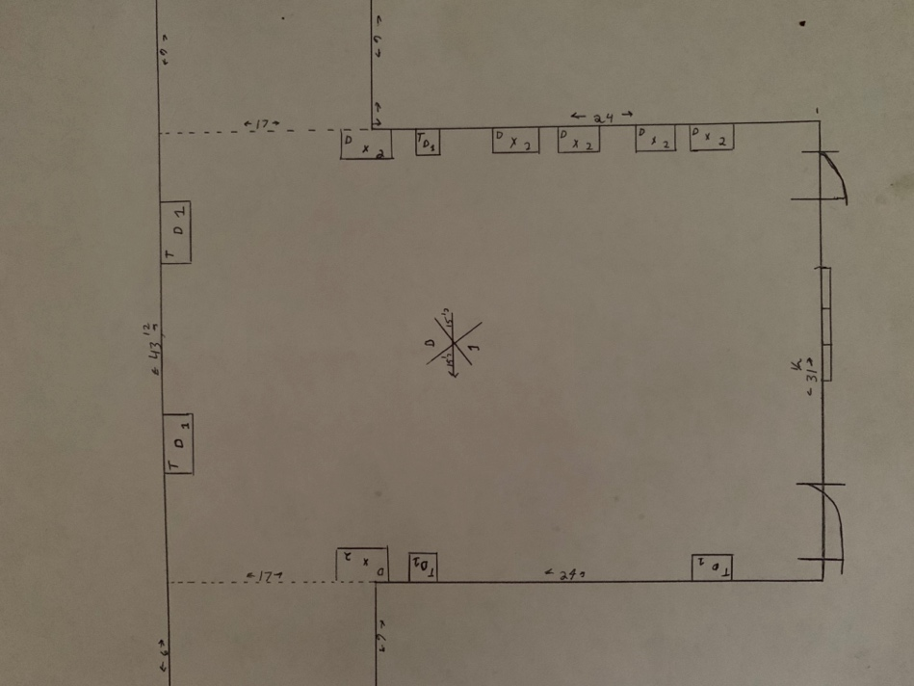

Figure. The dimensions of the patio

**<Detailed measurement will be added>**

**2. Problems that need attention**

**C. Anticipated Scope of Work and Estimated Cost**

**<Estimated cost will be added for the items below>**- Re-installing hardwood flooring and fence  
- Floor waterproofing  
- Replacement of tables, chairs, and tables  
- Install flowerbed- Extending rooftop patio

**D. Construction Schedule**

**<WILL BE ADDED>**

**E. Project Challenges and Limitations  
1. Agreement on tenants**

**<WILL BE ADDED>**

This proposed plan must be approved by at least 60% of the residents by the council policy.

**2. City permit on the constructions**

**<WILL BE ADDED>**

**III. Conclusion**

**A. Summary and overall interpretation of findings  
<WILL BE ADDED: Summary of survey results>**

List of Conclusion

* The majority of survey respondents in the Pendrell Mews expressed the need of refurbishing the rooftop patio
* The renovation plan ensures the tenant’s needs for better recreational space
* The renovated patio will contribute to tenants’ social well-being, physical and mental health as well as the value of the condo

**B. Recommendations**

**<WILL BE ADDED>**

List of recommendations

* Meeting with renovation consultants to review the provided estimated costs for each items (mainly for the flooring/fencing and anticipated construction schedule)
* Meeting with council members and tenants
* Make an announcement that there is ongoing discussion about the patio renovation.

**IV. Appendices**

**A. Work Cited**

**<WILL BE ADDED>**

COVID-19 and outdoor safety: Considerations for use of outdoor recreational spaces(2020).

Retrieved from <https://ncceh.ca/documents/guide/covid-19-and-outdoor-safety->considerations-use-outdoor-recreational-spaces

**B. Survey Questions**

* Q1~Q8. Please answer the following questions using the rating scale ranging from 1 to 5:

1 = Very Dissatisfied

5 = Very Satisfied

NA = Not Applicable

**1.How do you rate the condition and appearance of the rooftop patio exterior?**

1. 2.    3.    4.    5.   NA

**2.How do you rate the overall cleanliness of the rooftop patio?**

1. 2.    3.    4.    5.   NA

**3.How do you rate the condition and appearance of the furniture at the rooftop patio?**

1. 2.    3.    4.    5.   NA

**4.How do you rate the adequacy of furniture at the rooftop patio?**

1. 2.    3.    4.    5.   NA

**5.How do you rate the condition and appearance of the garden area at the rooftop patio?**

1. 2.    3.    4.    5.   NA

**6.How do you rate the adequacy of the garden area at the rooftop patio?**

1. 2.    3.    4.    5.   NA

**7.How do you rate the safety of the rooftop patio?**

1. 2.    3.    4.    5.   NA

**8.How do you rate your overall experience at the rooftop patio?**

1. 2.    3.    4.    5.   NA

**9.Do you agree to the rooftop patio renovation plan?**

1. Strongly disagree       2.Disagree       3.Neither agree nor disagree

 4. Agree       5.Strongly agree.

**10.Is there anything that can be improved on the rooftop patio? Comment briefly below.**