How can Urban Outfitters (UO) better adapt to the Chinese market with the existence of other similar fashion brands?

For:
Sam Aqua
URBN APAC Managing Director

By:
Jessica Lee 26931758
URBN CHINA Marketing Senior Intern
ENGL 301 99A Student

November 28th, 2020

NOT YET COMPLETED

No.301, South Jinhui Road,
Minhang District, Shanghai, China
November 30th, 2020
Sam Aqua
URBN APAC Managing Director
Jingan District, Shanghai, China

Dear Mr. Sam Aqua:
Here is my report, an analysis on how Urban Outfitters China (UO) can better adapt to the Chinese market with the existence of other fast-fashion brands. In preparing this report, I have learned a great deal about the nature of Chinese fast-fashion brands and their marketing methods, as well as what young adults are looking from fashionable brands today. I believe my information will be beneficial to you in planning next steps for UO’s entry into China. Thank you for your support and patience throughout this researching process.

Although Urban Outfitters has been a well-established and very popular brand oversees, in China it could still use some more time and traffic to build up its brand name locally. An effective yet efficient way to gain reputation is by mass engaging with local consumers. In this report, you may find out more about the “what” and “how”.

I’ve enjoyed my work on this project and would be happy to answer any questions you may have. Please feel free to email at jessicalee6688@yahoo.com at any time.

Sincerely,

Jessica Lee

Table of Contents
Introduction 4
Data Section 5
Current Situation of Urban Outfitters Attempting to Enter the Chinese Market 5
Overview of the Chinese Fast Fashion Market 6
Competitors’ Performance in China 7
Entry Difficulties 7
Understanding the Market and the Consumer’s Desires 8
Analysis of Survey Results 8
Breakdown of Interview Results 9
Possible Solution 10
Emphasizing on UO’s USP 10
Directing Other Brands’ Traffic to UO 11
Conclusion 11
Summary and Recommendations 11
Works Cited 11
Appendix A: Survey Questions 13
Appendix B: Interview Questions 14

Abstract (TO BE COMPLETED)

This section is to be completed last – after the full report had been written.

Introduction
As a major fashion brand abroad, Urban Outfitters entered the Chinese market a lot later than its fashion competitors, such as Gap or Abercrombie & Fitch (Forbes, March 2012), which is creating entry difficulties as well as bringing limited traffic to the brand. UO products are also priced above its competitors in the fast fashion industry, suggesting a drawback for consumers when comparing similar products across different brands. Considering how other major fashion brands have been established in mainland for a while, UO needs to take certain actions that will help accelerate its growth in reputation and allow it to stand out amongst its competitors.
Given the current situation, a feasible solution would be for UO to welcome local or Asian brands under its umbrella. Carrying local brand’s products will allow UO to adapt to the local culture and taste, relating itself closer to the local consumers. Furthermore, it will allow them to direct traffic of the local brands they buy from, to its own store.
With that being said, buying from local brands is only one out of the many possible solutions that Urban Outfitters China could potentially adopt. In order to determine whether this is the right decision for its entry and expansion into China, this report aims to evaluate UO’s current competitors in the market and discuss whether this decision is favored upon by its target audience (TA).

Data Section

Current Situation of Urban Outfitters Attempting to Enter the Chinese Market
As a buyer’s store, UO has a great variety of brands abroad (India Yaffe, 2019, Pop Sugar), but due to legal issues, many of them cannot be sold in mainland China (Adrian Zhou, 2020, Interview). Currently, Urban Outfitters is being closely associated to Zara and Brandy Melville amongst its TA’s conversations (survey, 2020). 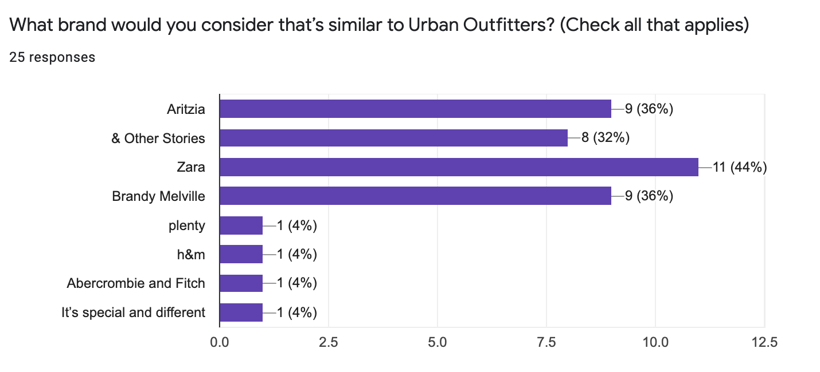
Figure 1: Brands that survey participants consider to be similar to Urban Outfitters
Yet, compared to Zara and Brandy Melville, Urban Outfitters does not have a price-point advantage that would draw consumers over from other brands. This means Urban Outfitters must have its’ own unique selling point (USP) or other features that would generate traffic to its brand or attract consumers to its store.

Overview of the Chinese Fast Fashion Market
With the largest apparel market in the world, China has the most competitive fashion industry. In addition to the innumerable foreign brands that have entered the Chinese market in early 2000s (Tang, 2019, CGTN), there are countless local fashion brands that are competing in the business. Having been in mainland for a while, most foreign fashion brands each have its own unique selling point and its own group of consumers who are familiar with them.

Well-known Swedish fast-fashion brand H&M, for instance, entered the Chinese market back in 2007 and has since become popular in the mainland for its trendy yet affordable price point (Parietti, 2019, Investopedia). Spanish brand Zara, on the other hand, strategizes on offering a higher number of available styles and products, refreshing its shelf with new styles once every two weeks (Petro, 2012, Forbes). Lastly, Brandy Melville has been one of the most popular fast-fashion brands in China this past year after numerous local celebrities has been spotted wearing the brand. All in all, it is safe to say that China already has a handful of fast-fashion brands each with its own specialty and loyal consumers.

Competitors’ Performance in China
Back in 2019, Magnus Olsson, country manager at H&M Greater China markets revealed that in addition to the company’s slowdown in growth, the rapid rise of e-commerce in China really hurt some of the foreign big brands (Tang, 2019, CGTN). More and more local businesses are now getting a chance to rise with products that are more fit to the taste of mainlanders (Tang, 2019, CGTN). These local brands also know how to tackle China’s fifth-tier cities while many foreign brands are only focused on the bigger cities.

Seeing that both British fashion brand Topshop and American fashion brand Forever 21 exited the Chinese market back in 2019 (Jun, 2019, global Times), China is actually witnessing foreign brands going on a downward trend within the country whilst local brands are on the rise. Although brands such as Gap and Hollister may be considered to be UO’s competitors abroad (Forbes, March 2012), the list of competitors may very well be entirely different and much longer here in China.

Entry Difficulties
With the existence of large reputable foreign brands that entered the Chinese market decades ago and local brands who relate closer to mainlanders, it is in Adrian Zhou’s (UO CHINA Head Buyer) belief that Urban Outfitters is currently facing difficulties in being acknowledge by the market as well as its consumers.

“There are so many other brands here already that are cheaper, have a faster rate of on-shelfing new styles, and have been in the country for so long it has a firm consumer base.” As Head Buyer, Adrian believes a wide variety of affordable brands will set UO apart from the rest of the fashion businesses. Without the brands, UO might just lose its intended audience (Petro, 2015, Forbes).

Understanding the Market and the Consumer’s Desires
To learn more about the current fashion market and Urban Outfitters’ positioning in China, interviews were held with two senior management members of URBN CHINA. Additionally, surveys were conducted to better understand consumers’ thoughts and opinions towards UO. With the collected data, a possible solution will be drawn together according to what the market is asking for and what UO can offer to the market.

Analysis of Survey Results
Of the 25 survey participants, 80% are within Urban Outfitter’s TA age range meaning that the results of this survey are relatively credible should UO want to understand its TA with this survey. When asked about how they first got to know about UO as shown in Figure 2, 72% responded with having passed by an Urban Outfitters’ physical store before, suggesting how offline stores are still a great way to gain traffic and for people to get to know the brand.
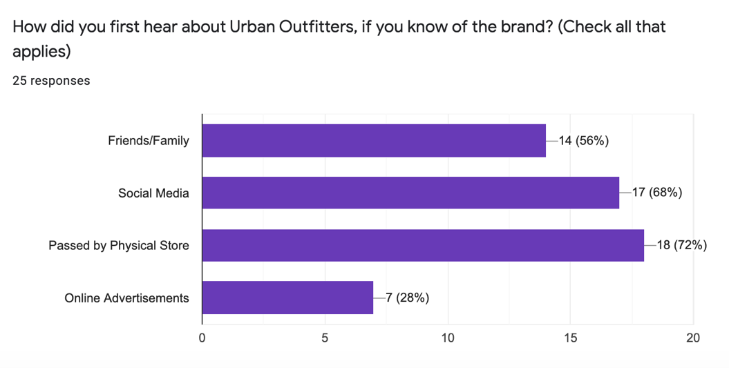
Figure 2: How participants first learnt of Urban Outfitters

Getting to know UO via social media received 68% which verifies Hayne’s belief that “digital remains the ‘largest opportunity’” in increasing “brand awareness among customers” (Burdo, 2018, Philadelphia Business Journal). A great majority, 88%, of the respondents are aware that UO carries other brands’ products and more than 90% having bought other brands’ products from UO before. From the information retrieved from the surveys, the company would ideally open a physical store to gain brand awareness and establish a strong presence within the country. However, if brick-and-mortar isn’t possible then the company should consider increasing the line of brands it carries for strengthening its USP and offering more options to its consumers.

Breakdown of Interview Results

For further insights regarding the brand and the market, two interviews were conducted with Happy Gao (URBN CHINA Marketing Director) and Adrian Zhou (Urban Outfitters CHINA Head Buyer).

Having worked in the fashion business for almost a decade, Happy is a professional who knows the fashion market very well. She joined URBN (the mother company of Urban Outfitters) right when Urban Outfitters China was first being set up back in 2019. When asked about question two and four, Happy mentioned that UO’s offline stores (abroad) are definitely a strong presence that never fails to catch consumer’s eyes. Similar to what Haynes had said in his interview (Burdo, 2018, Philadelphia Business Journal), the company originally had plans to set up stores locally in 2020 but everything has been delayed due to the outbreak of the pandemic. Having seen what other brands are doing and have been doing, Happy doesn’t necessarily believe that the company must welcome a large amount of brands in order to do well. She believes UO’s own line of products has its own story that can be told to consumers too.

On the other hand, Head Buyer of UO CHINA, Adrian Zhou is interested to see the introduction of more local brands in UO since many of the brands offered by UO North America cannot be sold in mainland China due to trademark and import complications. Having worked in the merchandising department of another big foreign brand, Adrian has valuable insights into product buying. Speaking from previous and current experience, Adrian is convinced that once UO starts selling local brands, it will have a greater pool of consumers and become a lore more accessible as well as relatable for mainlanders. “This will most likely be our best solution before our store opens” is what he ended with.

Possible Solution
According to Urban Outfitter’s Chief Executive Officer (CEO), it was UO’s intention to expand into China with a physical presence by 2020 (Burdo, 2018, Philadelphia Business Journals). However, due to COVID-19, the brick-and-mortar plans have been put on a hold (Happy Gao, 2020, Interview) so it is recommended that UO look for other methods to increase its brand awareness for the time being. A possible solution, therefore, could be to expand on the number of local brands it carries.

Emphasizing on UO’s USP
Looking at the data collected, it seems ideal for Urban Outfitters to introduce more brands to emphasize on its USP (Adrian Zhou, 2020, Interview). Evidently, UO’s TA know UO carries products of other fashion brands and is attracted to the idea of it. They buy a lot more other brands’ products than UO’s own brands’ products (Survey 2020), indicating their interest towards the brands UO carries. It is, therefore, suggestable that if UO were to increase its line of brands, it will see an increase in consumers and sales.

Directing Other Brands’ Traffic to UO
With more brands being added under Urban Outfitters, more traffic will be directed from the brands to UO. With a current concern being UO’s lack of brand awareness in the mainland as aforementioned, the company could consider interacting or even collaborating with other brands as a way to exchange consumer pools. This way, the UO name can be learnt and spread by more people.

Conclusion

Summary and Recommendations
Whilst UO prepares for its first store opening in China, it should first build up its reputation in the mainland. To do so, it may consider introducing more local or foreign well-known brands under the UO umbrella. At the moment, it appears a concern lies with the trademark issue where brands may not be allowed to enter or be sold in China with its brand name. Without their brand name, they may lose their most valuable factor of being a brand sold under the UO umbrella. The increase in number of brands, however, can attract consumers with product diversity and brand variety – something that UO’s TA are looking for and spend their money on. In conclusion, Urban Outfitters China should gain brand awareness by adding more brands into the family which then strengthens its USP and sets it apart from the rest of the fashion brands that have been established for longer in China.

Works Cited (NOT YET COMPLETED)
https://www.forbes.com/sites/narrativescience/2012/03/07/forbes-earnings-preview-urban-outfitters-2/?sh=3175c8591daa

https://www.refinery29.com/en-us/urban-outfitters-beauty-products

https://www.popsugar.com/fashion/best-brands-products-to-shop-at-urban-outfitters-46889411
Tang, https://news.cgtn.com/news/2019-07-25/Foreign-fast-fashion-brands-in-China-are-the-heydays-over--IBPlg5CAfK/index.html

Greg Petro, https://www.forbes.com/sites/gregpetro/2012/10/25/the-future-of-fashion-retailing-the-zara-approach-part-2-of-3/?sh=4c8481907aa4

Melissa Parietti, https://www.investopedia.com/articles/markets/120215/hm-vs-zara-vs-uniqlo-comparing-business-models.asp

Xie Jun, https://www.globaltimes.cn/content/1149687.shtml

Alison Burdo, https://www.bizjournals.com/philadelphia/news/2018/11/20/urbn-anthro-free-people-tmall-china-israel-stores.html

Greg Petro, https://www.forbes.com/sites/gregpetro/2015/09/22/urban-outfitters-finds-its-identity-what-it-means-for-investors/?sh=350b71f55b28

Appendix A: Survey Questions
https://forms.gle/n5xHq4XDgcfe8tSe6
I am a third-year Sociology student at UBC engaged in a technical writing course. The purpose of this survey is to collect primary data for an investigation that aims to understand the Chinese fast fashion market so recommendations can be made for how Urban Outfitters can better adapt to this fast-paced market. The final formal report will be presented to the General Manager of Urban Outfitters China as well as the Buying and Marketing Directors. Ultimately, the data gathered from this survey will provide valuable insights for UO in understanding what are the trends and preferences in the market right now. This voluntary survey contains 10 multiple-choice and short-answer questions and should take no longer than 5 minutes of your time. Your responses will remain anonymous and I would greatly appreciate it if you could participate. Thank you.

- What is your age?
- Which city in China do you currently reside in?
- Have you ever heard of the brand Urban Outfitters?
- How did you first hear about Urban Outfitters, if you know of the brand?
- Use three words to describe Urban Outfitters:
- Are you aware that Urban Outfitters carries other brands’ products?
- If so, what brand(s) have you purchased from Urban Outfitters before?
- Which fast-fashion brands do you usually shop at?
- What brand would you consider that’s similar to Urban Outfitters?
- Are there any local from-China brands that you like or shop from? (Please name if any)

Appendix B: Interview Questions

- What is your job title and how long have you been on-board with Urban Outfitters China?
- What do you think is Urban Outfitter’s unique selling point?
- How do you think Urban Outfitters is currently adapting to the Chinese market?
- What are some practices you think Urban Outfitters can adopt to increase its awareness in the Chinese fast fashion market?
- What are some solutions you think are appropriate for helping Urban Outfitters’ slow growth?
- What do you think about Urban Outfitters buying from local brands and carrying their items? Any advantages and/or disadvantages?

