Jennifer Luu

English 301 Assignment 1.3

Introduction:

Definitions are useful for explaining terms that are unfamiliar to an audience. In this assignment, the goal was to explain a specialized term from my discipline to a non-technical audience. I chose the term “polymerase chain reaction” and designed three definitions in parenthetical, sentence, and expanded form.

Parenthetical definition:

Polymerase chain reaction (PCR; DNA amplification) is a common molecular biology technique.

Sentence definition:

Polymerase chain reaction (PCR) is a molecular biology technique where specific pieces of DNA are made in high quantity.

Expanded definition:

**What is PCR?**

Polymerase chain reaction (PCR) is a molecular biology technique. It is used to amplify specific DNA sequences in high quantities.

**How was PCR developed?**

The technique was developed in the early 1980’s by Kary Mullis (Bartlett and Stirling, 2003). At that time, DNA amplification was a highly-sought technique for scientists who routinely used DNA. While small pieces of DNA could be amplified, large-scale amplification was difficult. (Templeton, 1992). Mullis’ solution was to place two primer sequences (short DNA sequences which complement the target DNA) on opposite DNA strands and amplify the region between them repetitively (Bartlett and Stirling, 2003). In this way, a specific piece of DNA could be copied billions of times.

**What does PCR require?**

PCR requires the following ingredients: template DNA, primers, DNA polymerase, and nucleotides (Garibyan and Avashia, 2013). Template DNA is double-stranded DNA from cells or tissues, from which the target sequence is amplified (Ishmael and Stellato, 2008). Primers are short, complementary DNA sequences that bind to the target sequence. They form the starting points for DNA polymerase action. DNA polymerase is a protein that joins nucleotides to create a copy of the target sequence. Finally, nucleotides are molecules which form the building blocks of DNA (Garibyan and Avashia, 2013).

**How does PCR work?**

The PCR reaction consists of three repeated steps. The first step is heating a solution with template DNA, primers, DNA polymerase, and nucleotides until the template DNA separates into two complementary strands (Garibyan and Avashia, 2013). This is the “denaturation” step. After heating the solution, the temperature is lowered to allow primer binding to the separated DNA strands. This is the “annealing” step. Finally, the solution is reheated to the optimal temperature for DNA polymerase function, and the target sequence is copied. This is the “elongation” step. The process is repeated, until ingredients are depleted (Ishmael and Stellato, 2008).

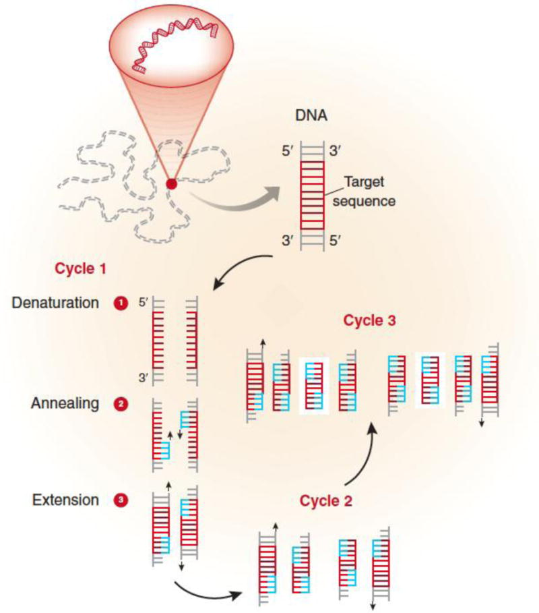

Figure 1: Diagram of the steps involved in PCR. The denaturation, annealing, and extension steps are repeated until ingredients are consumed.

Source: Garibyan, L. and Avashia, N. (2013). Research Techniques Made Simple: Polymerase Chain Reaction (PCR). *Journal of Investigative Dermatology* *133*(3): e6.

**What are some applications of PCR?**

There are various applications of PCR, including biomedical research, diagnostic medicine, and forensic genetics (Ishmael and Stellato, 2008 and Morling, 2009). In biomedical research, PCR has facilitated the study of many genes involved in diseases. It has similar applications in diagnostic medicine, such as assessing fetal health (Ishmael and Stellato, 2008). Finally, PCR is used in forensic genetics to identify and characterize biological samples from crime scenes (Morling, 2009).

**Works Cited:**

Bartlett, J.M.S., and Stirling, D. (2003). A Short History of the Polymerase Chain Reaction. In Bartlett, J.M.S. and Stirling, D. (Eds.), *PCR Protocols* (2nd ed., pp. 3 - 6). Totowa, NJ: Humana Press.

Garibyan, L. and Avashia, N. (2013). Research Techniques Made Simple: Polymerase Chain Reaction (PCR). *Journal of Investigative Dermatology* *133*(3): e6.

Morling, H. (2009). PCR In Forensic Genetics. *Biochemical Transactions* *37*(2): 438-440.

Ishmael, F.T. and Stellato, C. (2008). Principles and Applications of Polymerase Chain Reaction: Basic Science for the Practicing Physician. *Annals of Allergy, Asthma and Immunology* *101*(4): 437-443.

Templeton, N.S. (1992). The Polymerase Chain Reaction: History Methods, and Applications. *Diagnostic Molecular Pathology* *1*(1): 58-72.