To: “Thoth”
From: Joanna Yu
Date: June 5, 2020
Subject: Assignment 1:3 - Definitions

Objective
This assignment outlines the parenthetical, sentence, and expanded definitions of a GIC (guaranteed investment certificate). The objective of this assignment is to show the difference between the levels of detail among the three types of definitions. Understanding the differences and importance of definitions in technical writing would allow the writer to write more effectively by choosing an appropriate level of detail depending on the audience.
Situation
A customer at a bank wants to know where she can invest her money safely and earn interest (profit). The bank’s financial advisor introduces a GIC to the client. Since the client has a limited knowledge in investment products, the financial advisor explains GIC in plain English using appropriate details for the client to comprehend.
Communicating technical information with clarity and precision using simple terms is important as a financial advisor because the banking industry is highly regulated by the government and financial regulators.
Audience
The different definitions are intended for a non-technical audience that have limited knowledge in investment products.
Parenthetical Definition
A GIC (interest-paying investment) can be purchased by the public through different banks and trust companies.
Sentence Definition
A GIC is a contract between an investor and the bank or trust company which enables the latter to borrow money for a specified number of months or for up to five years by promising its holders the repayment of their original investment and interest payments.
Expanded Definition
A GIC is a contract between an investor and the bank or trust company which enables the latter to borrow money for a specified number of months or for up to five years by promising its holders the repayment of their original investment and interest payments. A GIC (interest-paying investment) can be purchased by the public through different banks and trust companies.

Operating Principle - Purchase Process of GICs
GICs represent one of the simplest forms of borrowing. The bank or trust company raises money by selling GICs to the public. A GIC works like a savings account where the bank pays an amount of interest to an investor in exchange for depositing money and maintaining a balance in the account. (Study Abroad, 2020). When an investor buys a GIC, he/she is agreeing to lend the bank or financial institution his/her money for a specified number of months or for up to 5 years. In exchange, the money earns interest. GICs are a guaranteed investment product. The guarantee for GICs is provided by the Canada Deposit Insurance Corporation (CDIC) up to a maximum of $100,000 (principal and interest combined), as long as the issuing financial institution is a CDIC member and the original term to maturity is five years or less (Wikipedia contributors, 2020).
Required Conditions for Investors of GICs
- GICs can be purchased with a minimum of $500 (Western Financial Group, 2020). Investors cannot purchase a GIC below $500.
- Investors of GICs can choose different maturities, from 6 months, 1 year, 2 years or up to 5 years. The term ends on the maturity date where typically the longer the term, the higher the interest rate.
Example- How Investors Earn a Profit from Investing in GICs
If an investor decides to purchase $1,000 worth of GICs that matures in one year with an interest rate of three percent per year, the seller of the GIC will pay the investor $1,030 at the end of one year. The $1,030 payment consists of the investor’s initial investment of $1,000 and the interest of $30, which is the investor’s profit.

Visual
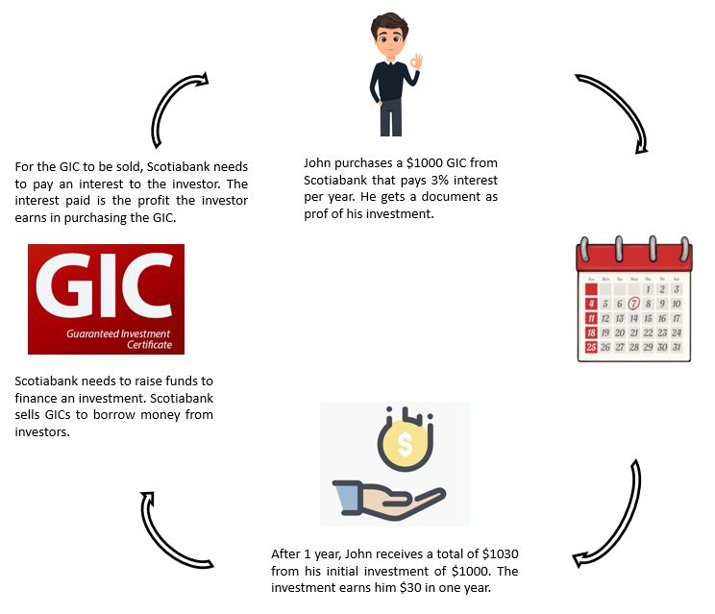

References
Study Abroad. (2020, May 5). HOME. Retrieved from https://www.studyabroadlife.org/how-do-gics-work-in-canada/
Western Financial Group. (2020, May 5). Guaranteed investment certificate. Retrieved from https://westernfinancialgroup.ca/What-are-GICs-and-how-do-they-work
Wikipedia contributors. (2020, January 4). Guaranteed investment certificate. Retrieved from https://en.wikipedia.org/wiki/Guaranteed_investment_certificate

