**To**: Ms. Darla Lee, Volunteer Coordinator

**From**: Joanne Ho, Volunteer

**Date**: June 30, 2016

**Subject**: *Proposal for Determining the Feasibility of Increasing Volunteer Recruitment into the Rehabilitation Recreation Program at Minoru Residence*

**Introduction**

In many senior residential care facilities, recreational activities are provided for residents as a form of therapy. According to the Nova Scotia Health Authority and many other health professionals, recreation therapy provides a number of benefits to people of all ages (Capital Health, 2016). This includes elevating one’s emotional wellbeing and confidence, while reducing one’s feeling of isolation. Such benefits are especially valuable to the dependent elderly who are adapting to a new living environment. Disengagement from recreation activities and social relationships may be linked to the development of depression and anxiety (Hutchinson, 2011).

As many recreational activities in the program require a larger staff for smooth operation, Minoru Residence relies heavily on the help of volunteers to run a number of activities throughout the week. However, for the past few months, the recreation staff often found themselves struggling to carry out certain activities due to the declining number of volunteers in the rehabilitation recreation program. A number of reasons account for this situation, with the main one being the general decline in the total number of volunteers at the facility.

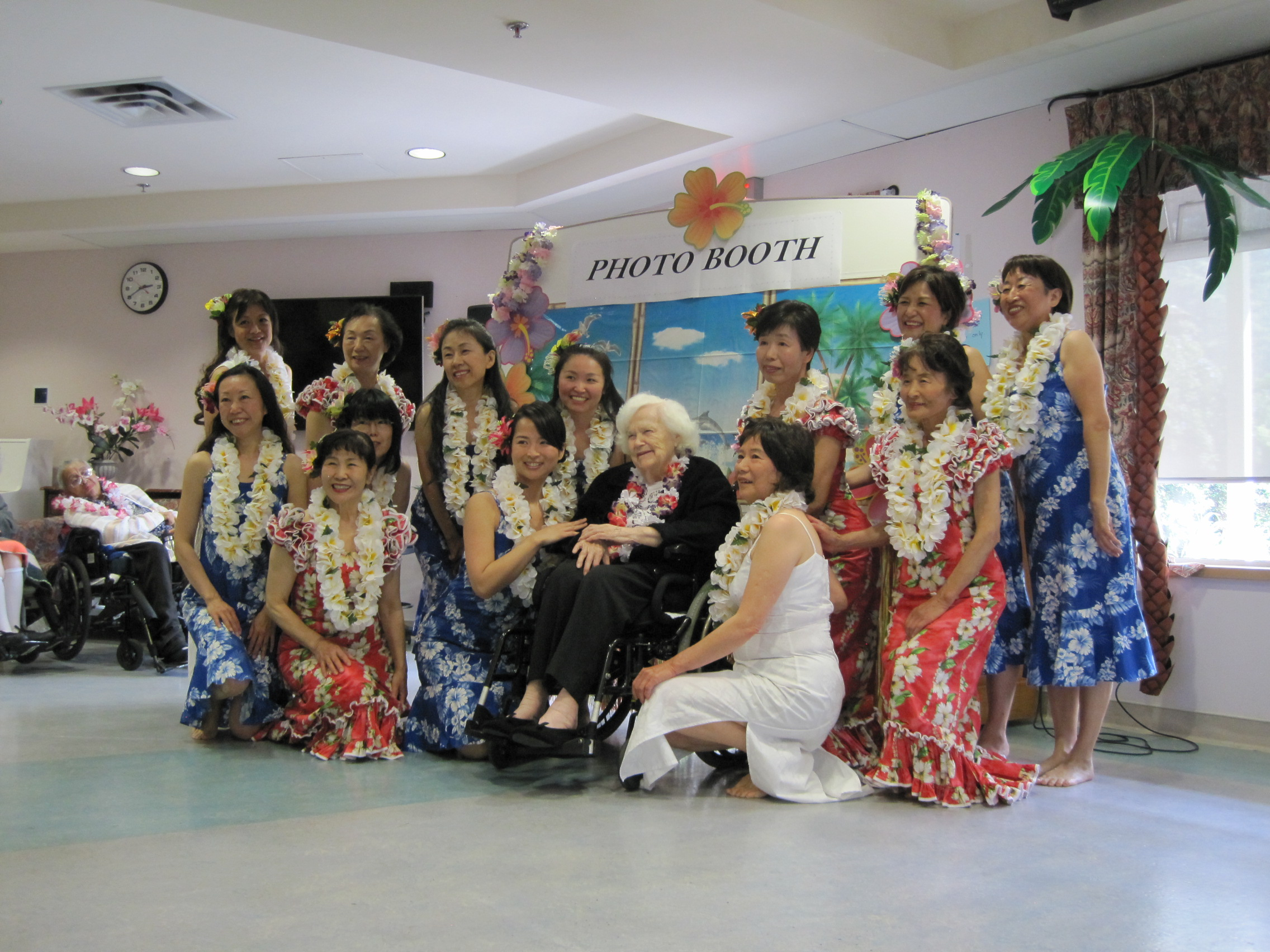

Figure 1: A resident from Minoru Residence having photo sessions with Hawaiian Hula Dance performers, organized by the Rehabilitation Recreation program.

*Source:* From Wailele Wai Wai Hawaiian Hula Dance in Vancouver,

<http://wailelewaiwai.com/2014/05/19/minoru-residence/>

**Statement of Problem**

With the decreased number of volunteers, the recreation staff are no longer able to conduct certain activities for the senior residents as well as they used to. Such activities may involve a group of individuals, such as in bowling competitions and nail care parties, or may be based on one-on-one visits between a volunteer and a resident, such as in coffee talks and personal outings. Because the operations of certain activities are negatively affected, the quality of life of certain residents is also hindered. Without their favourite activities to look forward to throughout the week, seniors may begin to develop mental health problems, such as depression, or lose their sense of connection to the community as they become socially excluded. Even in a younger population, those with poor social connectedness are 2-3 times more likely to experience depressive symptoms compared to those who report stronger social networks (Hutchinson, 2011).

**Proposed Solution**

One of the more reliable solutions is to increase the number of general volunteers at the residential care facility. With a larger pool of volunteers, the recreation staff can ask for extra help whenever they need. As a result, a wider variety of recreational activities can be provided to the seniors. In order to promote the recruitment of volunteers at this facility, the volunteer coordinator can consider reaching out to certain post secondary schools in an attempt to evoke interest in students curious about a career in health care facilities.

**Scope**

To assess the feasibility of recruitment of volunteers through post secondary schools, I plan to pursue the following areas of inquiry:

1. What proportion of post-secondary students are curious about a career in health care?
2. What is the best way to attract volunteers interested in residential care?
3. What proportion of such students has trouble seeking volunteer positions at a residential care facility even though they are interested?
4. Which sector (i.e. recreation rehabilitation, physical rehabilitation, one-on-one visits) of the senior resident care facility are such students most interested in volunteering for?
5. For what reason do current volunteers resign their positions?
6. Which post-secondary schools appear to have the most promising volunteer candidates?

**Methods**

My primary data sources will include interviews with the current staff members and volunteers at Minoru Residence regarding the areas of inquiry. In addition to people who are currently involved at the facility, I can also gather information from potential volunteers from post-secondary schools by implementing online surveys or interviews. The collected information is cost-free and simple to obtain. The data can be compiled and analyzed in order to identify the possible problems in the current volunteer recruitment system, which may be the cause of the declining numbers of interested participants.

Secondary sources will include statistics provided by the Canadian government, which provides reliable numbers regarding the demographics of the volunteering population. This will help us determine the best place to seek for potential volunteer candidates.

**My Qualifications**

Being a volunteer at Minoru Residence for the past two years, I have familiarized myself with the recruitment process. Because I am familiar with how the volunteer team operates, I am able to answer many questions that my respondents may have. As a fourth year science student and a full-time research assistant, I am aware of the research process and the proper interaction required with study participants. My experiences will allow me to carry out this feasibility study smoothly and effortlessly.

**Conclusion**

We should take action on this situation before the residents’ quality of life declines any further. By taking steps to learn about the root of the problem through the areas of inquiry addressed in this proposal, we will be able to determine the feasibility of the recruitment of volunteers from post-secondary schools. With more volunteers in the residential care facility, the recreation program will finally have enough help to operate larger activities to improve the wellbeing of the seniors. With your approval, I will begin research at once.

**Source:**

Capital health, 2016. Retrieved from <http://www.cdha.nshealth.ca/recreation-therapy-mental-health>

Hutchinson, S.L. “Physical Activity, Recreation, Leisure, and Sport: Essential Pieces of the Mental Health and Well-being Puzzle”. *Recreation Nova Scotia*. n.p. 1 June 2011. Web. 29 June 2016. <[www.recreationns.ns.ca/wp-content/uploadhere/2012/05/MentalHealthLit.pdf](http://www.recreationns.ns.ca/wp-content/uploadhere/2012/05/MentalHealthLit.pdf)>.

Statistics Canada, 2015. Retrieved from <http://www.statcan.gc.ca/pub/89-652-x/89-652-x2015001-eng.pdf>

Statistics Canada, 2012. Retrieved from <http://www.statcan.gc.ca/pub/11-008-x/2012001/article/11638-eng.pdf>