Determining the Feasibility of Increasing Security measures at Condominium

For
Mr. Jason Chen
President of Condominium Strata Council
&
Mrs. Mary Chen
Strata Agent, Rancho Management Services

By
Johnathan Tam
ENGL 301 Student

November 16, 2021
TABLE OF CONTENTS
INTRODUCTION………………………………………………………………………………………………….……………………………….3
  - Background…………………………………………………………………………………………………………………….3

  - Overview of Problem and Purpose of Report………………………………………………………………….3
  - Research Methods………………………………………………………………………………………………………….4
  - Summary of Conclusions………………………………………………………………………………………………..4

DATA COLLECTION…………………………………………………………………………………………………………….………………..5
- Concern of Property Crime in Condominium…………………………….……………………………………5
- Rating of Condominium Security Measure………………..……………………………………………………5
- Costs of increasing security measures…….……………………………………………………………………..6
- Review of Secondary Sources…………………………………………………………………………………………7
- Proposed Solutions
  - Install security cameras in mail area and courtyard
  - Hire a security team to act as a patrol unit

CONCLUSION…………………………………………………………………………………….………………………………………………..8
- Summary of Findings…………………………………………………………………………………………8
- Overview and Interpretation of Findings……………………………………………………………8
- Final Comments and Further Research………………………………………………………………8

WORKS CITED…………………………………………………………………………………………………………,………………………….9
- References to collected data……………………………………………………………………………..9
- Citation of literature and sources………………………………………………………………………9

Introduction
Background
A surprising fact: burglary is the most common threat to households. Home invasions are rarely planned but can take place in less than 10 minutes. In Canada, there are an average of 161,000 home burglaries per year.
Due to the COVID-19 pandemic, crime rates have spiked upwards with property crimes following this same trend. Shortly after the pandemic hit Canada in around March 2020, there was an increase of about 15% in residential breaking and entering incidents, compared to the previous year. For my own condominium building, in the past two months, there were 3 reported incidents of robberies and breaking and entering. This rise in residential crime is very concerning and if it continues, will lead to increased danger for all residents in the strata lot.
Overview of Problem and Purpose of Report
One of the most common targets for burglars are condominiums, especially for ground-floor units where the foot traffic is high. There are also instances where burglars are accidentally let into the lobby, unbeknownst to residents who think they are holding the door open for a resident in the building.
As outlined above, there have been 3 reported incidents of crime in the past two months: 1) theft from breaking and entering the mail/package room; 2) breaking, entering, and attempted robbery of a ground floor unit; and 3) theft from breaking and entering a storage locker. Unfortunately, in all 3 cases, the culprits were never caught, and no significant changes were made to security measures. Being proactive is key to ensuring the safety of all residents so it is crucial that security measures are increased to prevent future crimes.
The purpose of this report is to bring attention to security concerns around the condominium. In addition, it will investigate the feasibility of increasing security measures by installing security cameras in key areas and hiring a third-party security team to patrol the building grounds.

Research Methods
Data will be collecting from a survey that canvasses all residents of in the strata lot, gathering information about their concerns on security and outline areas of improvement. Research will also be conducted on the current strata budget and security measures, assessing the costs and barriers of the proposed solutions (such as the model type, amount, and installation costs of security cameras), and investigating security measures in other condominiums. Secondary sources will include publications that highlight crime in residential units and how this can be prevented.

Summary of Conclusions
(Summary of conclusion and listed recommendations of solutions)

Data Section
Level of Concern Regarding Property Crimes in Condominium

Figure 1. Residents concern regarding property crime in condominium
Rating of Current Security Measures
Figure 2. Residents rating of current security measures in condominium
Amount of increase to strata fee that residents are comfortable with to fund more security measures
(DATA)

Investigation on costs of security cameras
(DATA)

Investigation on costs of security patrol
(DATA)

Review of Secondary Sources
Times and days of most common theft
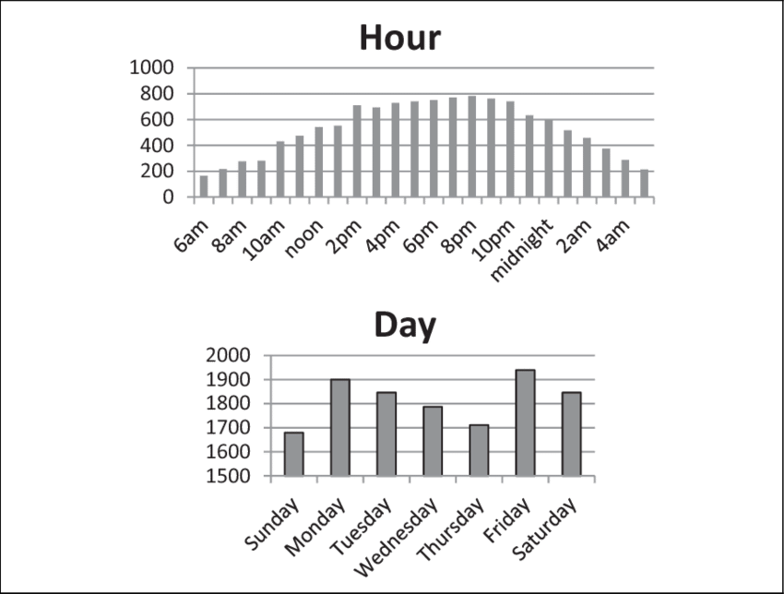
Figure 3. Research data on times and days when theft occurred most often

Proposed Solutions
- Install security cameras in mail area and courtyard
- Hire a security team to act as a patrol unit
Conclusion
Summary of Findings
(Summary of survey results and research findings)

Overview of Interpretations and Findings
(Explanation of the results and research findings)

Final Recommendations and Further Applications
List of conclusions and recommendations
- Majority of residents are concerned about the increase in property crimes
- Majority of residents do not feel confident with the current security measures
- Improvements are needed to the security measures
  - It is feasible to implement security cameras and costs can be offset with a one-time special levy payment
  - Security team can be hired, and these costs can be offset with an increase to the monthly strata budget

Works Cited
Bernasco, Wim & Ruiter, Stijn & Block, Richard. “Do Street Robbery Location Choices Vary Over Time of Day or Day of Week? A Test in Chicago.” Journal of Research in Crime and Delinquency (2016).

"Improving Condo Security | Property Management Tips - Condo Control". Condo Control, 2018, https://www.condocontrolcentral.com/blog/improving-condo-security-property-management-tips/#:~:text=Proper%20use%20of%20lights%20and,that%20are%20unsafe%20without%20supervision.

Clare, Joseph, John Fernandez, and Frank Morgan. 2009. ‘‘Formal Evaluation of the
Impact of Barriers and Connectors on Residential Burglars’ Macro-level Offend-
ing Location Choices.’’ Australian and New Zealand Journal of Criminology 42:
139-58
Clare, Joseph, Fernandez, John, & Morgan, Frank. “Formal Evaluation of the Impact of Barriers and Connectors on Residential Burglars’ Macro-level Offending Location Choices.” Australian and New Zealand Journal of Criminology (2009).
Clare, Joseph, John Fernandez, and Frank Morgan. 2009. ‘‘Formal Evaluation of the
Impact of Barriers and Connectors on Residential Burglars’ Macro-level Offend-
ing Location Choices.’’ Australian and New Zealand Journal of Criminology 42:
139-58

