Extending Customer Bases for the Futian Dumpling Restaurant

For Ms. Alan Song, Restaurant Owner
Futian Dumpling Restaurant
Vancouver, BC

By Jojo (Syau-Jing) Huang
English 301 student

December 4, 2019
Table of Contents
Introduction 3
Background 3
Problem 3
Vegetarian Culture 3
Purpose 3
Approach 4
Data Collection and Analysis 5
Survey 5
Overview 5
Importance of Providing Vegan Foods 6
Evaluation for Providing Vegan Dumplings Regularly 7
Evaluation of Providing Supplemental Vegan Foods 8
Interview 9
Overview 9
Offline Ordering 9
Online Ordering 10
Analysis 10
Conclusion 11
Summary 11
Recommendation 11
Expected Outcome 11
Reference 11
Appendix I. Meat-eater’s Responses to Other Survey Questions 12
Appendix II. Vegetarian/Vegan’s Responses to Other Survey Questions 13

Introduction

Background
Boundary Road and Kingsway area are famous for the delicious Asian foods provided by local restaurants, while the Futian Dumpling Restaurant is one of the youngest restaurants among them. Opened in December 2018, Futian Dumpling Restaurant primarily serves hand-made dumplings in the northeast Chinese style. Managing a new and small business near those well-known restaurants is challenging, and one of the main goals of the dumpling restaurant is to gain more revenue and attract more new customers, especially those customers who are not from China.

Problem
Currently, the Futian Dumpling Restaurant has got many positive feedbacks from its existing customers. For example, it had an average score of 4.3/5.0 with 27 reviews in Google map [1], while it got around 4.5/5.0 stars with 9 reviews in yelp [2]. However, the number of new customers grows slowly. Meanwhile, the main portion of the existing customers is origin from China, and it seldom has customers from other countries.
They are many factors that may affect the customer structure and the growth of the new customers, while this report will focus on a possible problem related to the food menu constitution. Currently, the Futian Dumpling Restaurant only provides “Chives, egg, & shrimp dumplings” and “Edge melon & eggs dumplings” as vegetable dumplings, which means all of the vegetarian (or vegan) foods it provides contain either eggs or shrimps. However, the vegetarian cultures are different for people with different origination, and whether eggs and shrimps are vegan foods has always been a controversial question. As a result, not providing suitable vegan foods may be a problem that prevents the Futian Dumpling Restaurant from extending its customer bases.

Vegetarian Culture
Based on the research conducted in 2018, there are around 9.4% of adults in Canada consider themselves vegetarian, in which 2.3 million people are vegetarians while 850,000 people identify themselves as a vegan [3]. At the same time, the rate of vegetarianism is expected to rise. As a result, providing vegan foods may be important to every restaurant in Canada.
As for the difference between “vegetarian” and “vegan”, based on [4], neither of them consumes meat or meat-related products. Meanwhile, people in a vegetarian diet can consume dairy products and eggs, while a vegan avoids all animal products including eggs and dairy. However, in real words, the difference between them may be much complex and confusing since we might also need to take the cultural difference of different countries into account. So, in the related survey, interview questions and this report and, I do not emphases the difference between vegetarian and vegan stated in [4], and I will use the two words interchangeably when they will not cause confusion.

Purpose
The purpose of this report is to investigate whether adding vegan foods can help the Futian Dumpling Restaurant extend their customer base and gain profit. At the same time, this report will also explore a suitable strategy for the restaurant to provide vegan foods for different kinds of customers, including regular customers and nearby companies who want to order group meals for their employees.

Approach
Based on the observation, for the restaurants near Boundary Road and Kingsway area, there are mainly two sources of food orders. The one comes from regular customers who eat inside the restaurant or take away. This kind of customer mainly consists of local residents and employees from nearby companies. Also, some other people who do not work or live nearby may come to this area for dinners because of the good reputations of the restaurants. At the same time, the order of group meals from nearby companies is the other source of food orders. There are many well-known companies, including Telus, Best Buy and Arista Network have offices near this area, each of which has more than 50 or even 100 employees. Many companies tend to order foods from nearby restaurants regularly to provide free foods for their employees. Providing foods for those companies can not only help the restaurants gain decent profits but also help them get good reputations among the employees. Based on the constitution of the customers, providing vegans foods may be very important. For example, when multiple people have lunch together, they will usually not choose restaurants without vegan foods if one of them is vegetarian. Moreover, if some companies want to provide group meals for their employees, they may always need to order some vegan foods for their vegetarian employees.

Meanwhile, based on the feedback from the Futian Dumpling Restaurant, currently, they assumed that the two kinds of vegetable dumplings they provided are vegetarian foods. Also, they claim that they have the capacity for providing dumplings for more than 50 people as long as the customers can make appointments one week in advance, while they haven’t got many large group orders until now. As for the possibility of providing new vegan dumplings without shrimps and eggs, they mainly have two concerns. The first concern is about the difficulty of developing new receipts. As they are providing handmade dumplings in the northeast Chinese style, they have never made any vegan dumplings without shrimps and eggs before. If they want to provide those kinds of vegan dumplings, they need to develop new receipts, and it is hard for them to make sure the new receipts are delicious to all customers. Meanwhile, the second concern is about the remaining dumplings. To make sure the dumplings they provided are delicious, they always provide fresh dumplings that have been made for at most one day for in-store customers, and they will not keep the frozen dumplings for more than 7 days. If they prepare those vegan dumplings daily, it is likely that those dumplings will not be ordered by any customers for a serval amount of time, and they have to find some other ways to consume those remaining vegan dumplings.

Base on the current situation, there are some possible ways that they can provide vegan foods:
- For regular customers, the restaurant may:
  - Providing vegans dumplings regularly and assuming that those vegan dumplings will be ordered every day.
  - Providing supplement vegan main foods (such as vegan noodles) regularly.
- For group orders from companies, the restaurant may:
  - Developing general vegan dumpling receipts and providing them to group meal order for companies if they can order one week in advances.

And my investigation approaches for this report mainly included two parts:
- Conducting survey for both vegetarian and meat-eater people in my network for their opinions about the vegetarian cultures, which helps to understand the importance of providing vegan dumplings in the Futian Dumpling Restaurants. At the same time, the survey also contains questions about the restaurant choice for both vegetarian and meat-eater, which helps to determine whether the two possible solutions above for regular customers are feasible.
- Conducting interviews with facilities coordinators from some companies in Vancouver about their group meal ordering process and their factors of choosing restaurants. Their feedback can help to understand whether the Futian Dumplings is qualified for providing foods for their company and whether providing vegan dumplings can make it more competitive.

Data Collection and Analysis

Survey

Overview
During my investigation, I sent out surveys to my vegetarian and meat-eater friends in Vancouver via Google form and get 34 responses in total by December 1st, 2019. The majority of the responders are the current students or recently graduated students from UBC and SFU. 32.4% of those responses came from vegetarian/vegan, and 18.2% of those vegetarian/vegan responders identify themselves as a vegan.

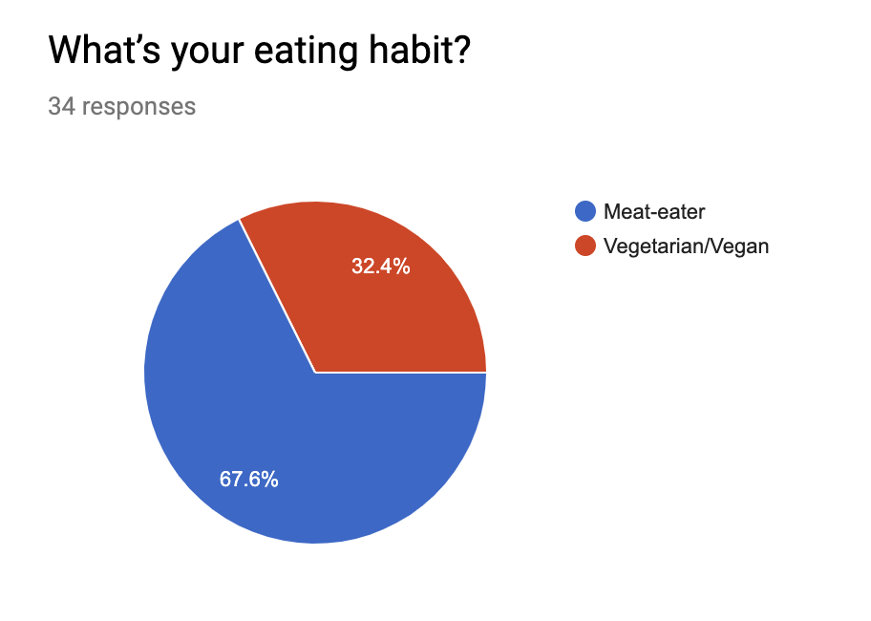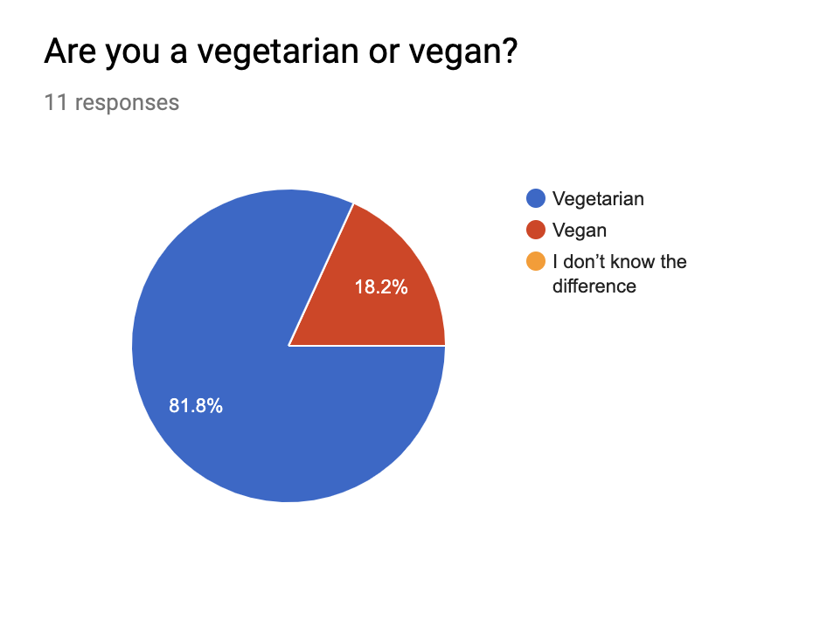
Besides, all of the 34 responders have experience of attending lunch/dinner with the presence of both vegetarians and meat-eaters, while in all of the cases from the survey responses, vegetarians take less than half of the amount of the people who attended the lunch/dinner.

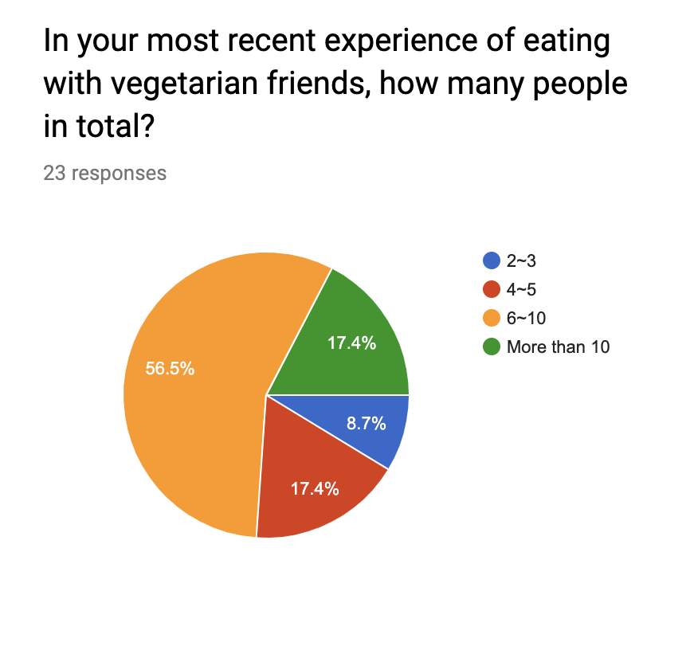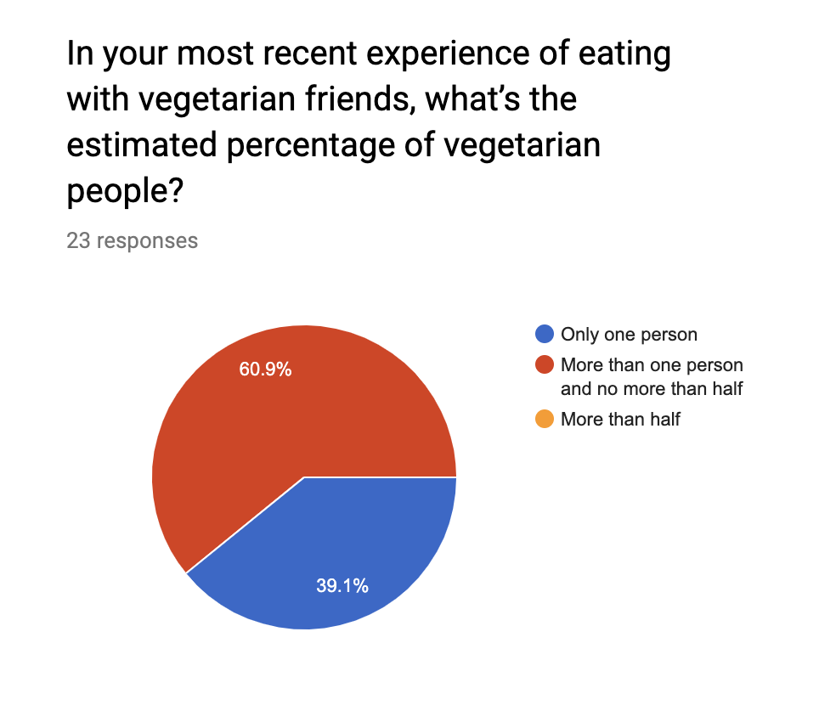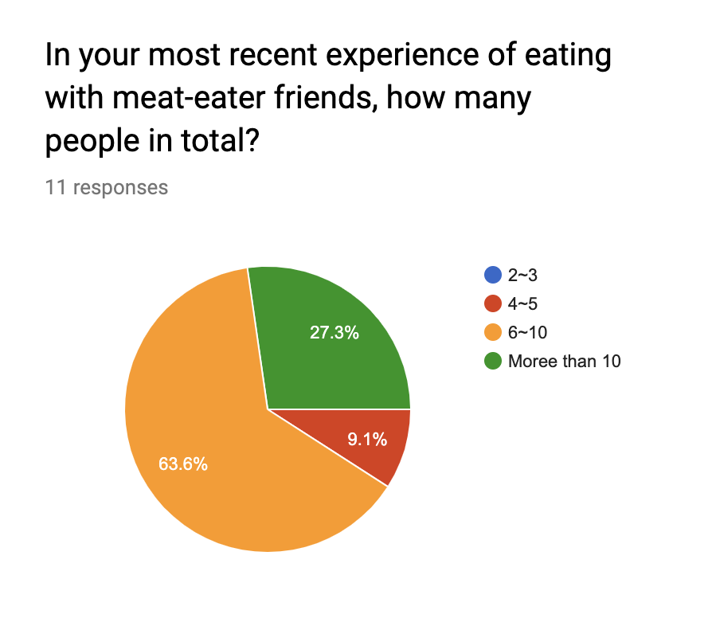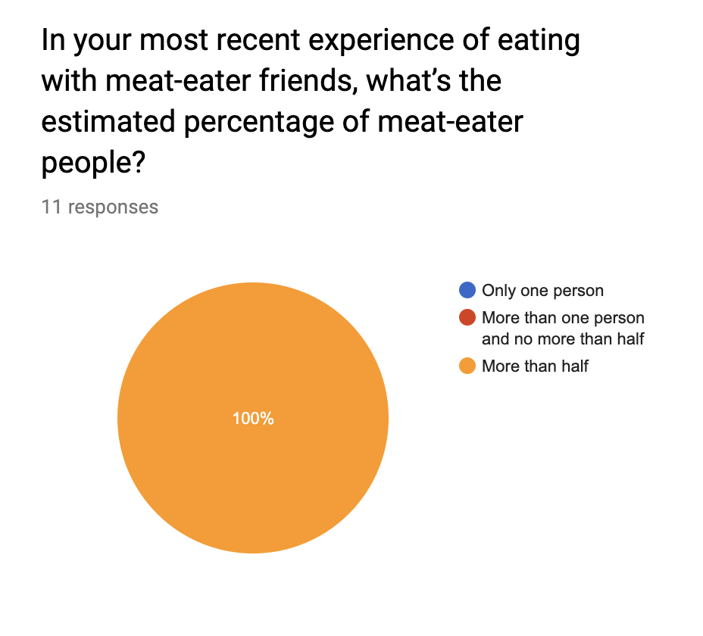

Importance of Providing Vegan Foods
Although [4] mentions vegetarians can consume eggs in general, the survey showed a different result. As described in the previous section, there are 18.2% of those vegetarian/vegan responders identifying themselves as a vegan, while based on the results shown in figure below, around 81.8% of them cannot eat food with eggs, which means that there are still many vegetarian people who cannot consume eggs. At the same time, all of the vegetarian/vegan responders cannot consume shrimps. Based on these results, we can conclude that in most cases, vegetable dumplings with eggs or shrimps cannot be considered as vegan foods.
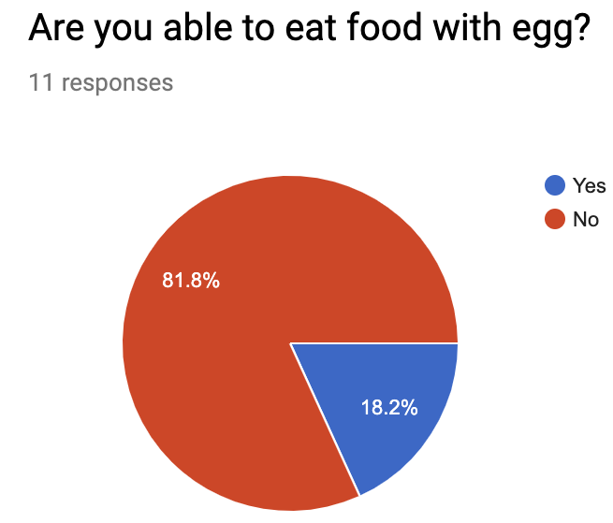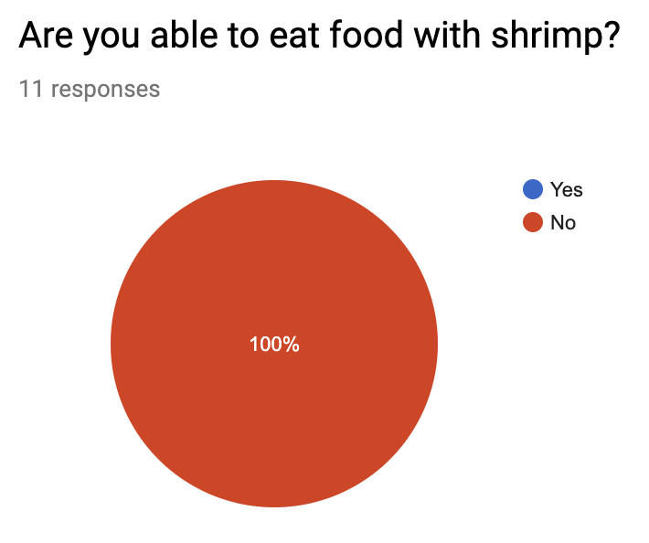
Meanwhile, in most of the situations from the survey, people tend to choose non-vegetarian restaurants that provide vegan foods when having lunch/dinner with both vegetarians and meat-eaters, and they never choose non-vegetarian restaurants without vegan foods (as shown in figure below). As a result, the Futian Dumpling Restaurant is less competitive in this situation.
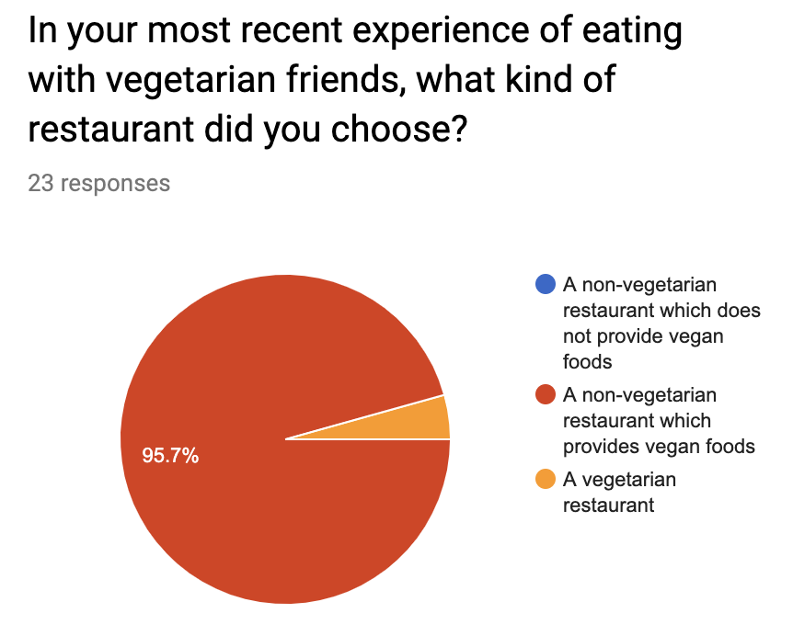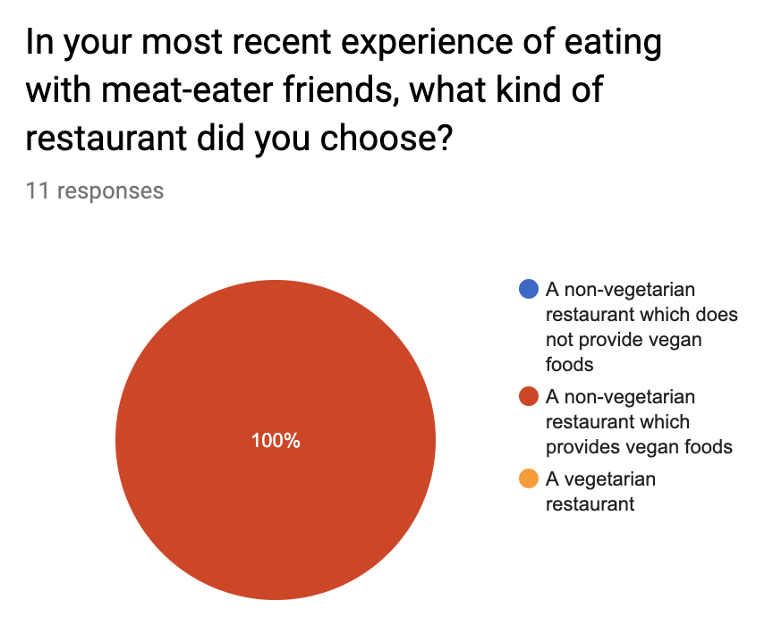

Evaluation for Providing Vegan Dumplings Regularly
As one concern of the restaurant for providing vegan dumplings regularly is about food remaining, we include questions about vegan foods ordering for both meat-eaters and vegetarians. Besides, we assume that it will be more often for people to eat alone or eat with friends with the same eating habits, so the related survey questions in this section will focus on this situation.

The related questions and the responses for meat-eaters are shown in figure below. Unluckily, none of the meat-eater responders consider providing vegan foods as a factor for choosing restaurants. Even if they are in a non-vegetarian restaurant that provides vegan foods, none of them have a strong interest in trying vegan foods, and most people may choose vegan foods only when the foods are delicious. Since the Futian Dumpling restaurant has not tried to make vegan dumplings without eggs or shrimps before, it will be a great challenge for them to make this kind of vegan dumplings delicious enough to attract meat-eater customers

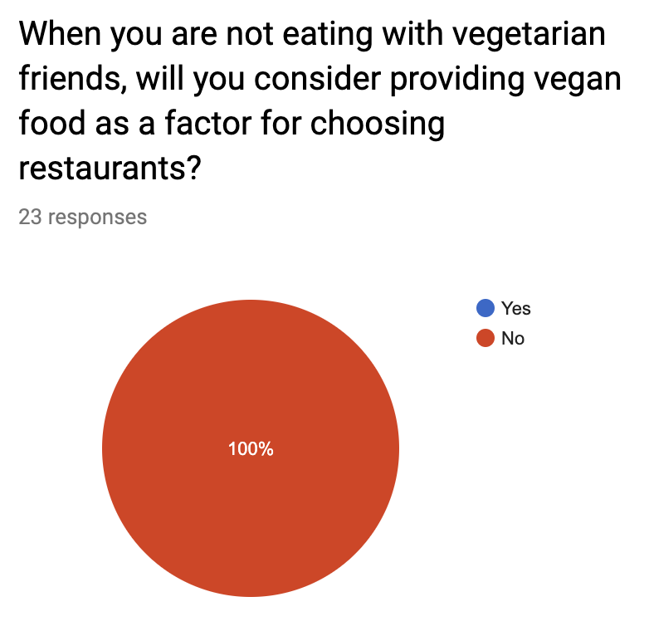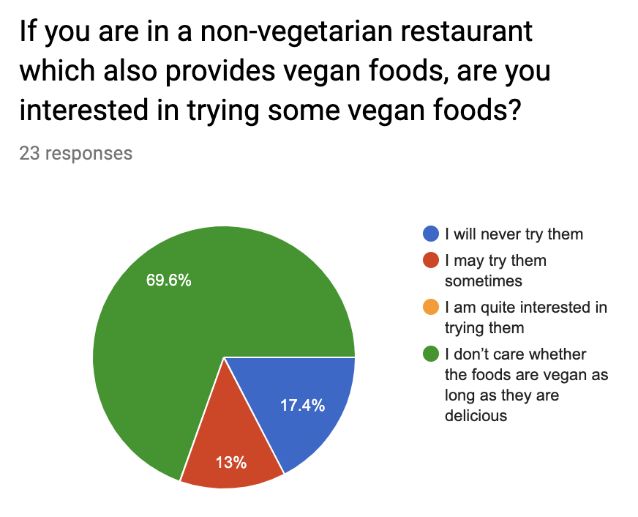
At the same time, the related question and responses for vegetarians are shown in the figure below. In general, most vegetarian responders in the survey tend to eat in vegetarian restaurants when they are not eating with meat-eaters, while none of them have strong opinions to choose non-vegetarian restaurants with vegan foods.
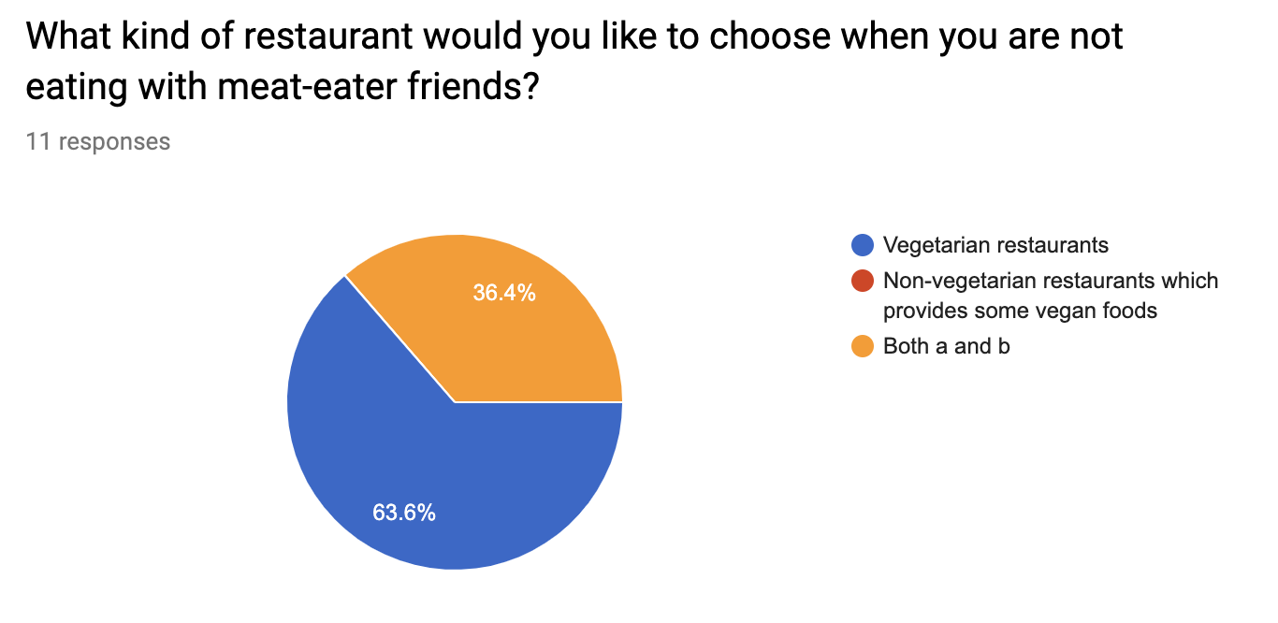
Based on these results, providing vegan dumplings regularly may not be a good solution in the case of the Futian Dumpling restaurant, as it is likely that those prepared vegan dumplings will become remaining foods quite often.

Evaluation of Providing Supplemental Vegan Foods
To understand whether providing supplemental food is a feasible solution, I included a survey question about it for vegetarian people, and their responses to the questions are shown in the figure below. Basically, all of the responders can take supplemental vegan foods in some conditions, and none of them thought it is unacceptable. Since in most cases vegetarians will go to non-vegetarian restaurants when they are eating with meat-eater friends, supplemental vegan foods may be a good candidate solution for the Futian Dumpling Restaurant if preparing vegan dumplings is too difficult.
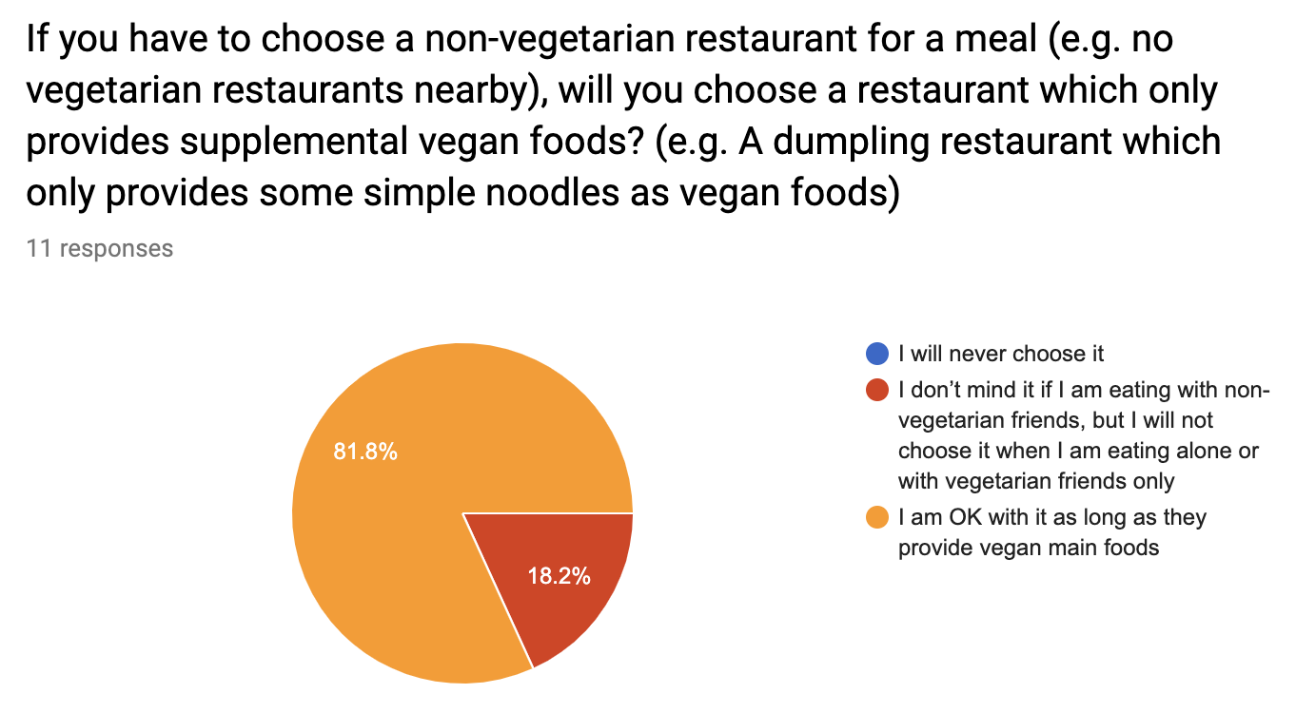

Interview

Overview
For my investigation, my original plan is to interview the facilities coordinators from two companies in Vancouver about their group meal ordering process. However, in both of the two companies in my plan, the group meal ordering is mainly handled by some other employees, such as the engineers, instead of facilities coordinators. As a result, I conducted interviews with two engineers VH (initial) and SW (initial) from Arista Network and Splunk Service Canada who have experienced in group meal ordering, and the two companies tend to use offline ordering and online ordering respectively.

Offline Ordering
The Arista Network has more than 100 employees in its office located near Glenlyon Parkway in Burnaby. Each Friday afternoon, it will host a regular party called “Beer Bash” in which the employees eat foods and have fun together. The food in the beer bash is usually ordered from the restaurants nearby with a total budget of around 500 CAD, and the food order is handled by some of their engineers in rotation. Based on the experience from VH, most of the engineers tend to make the food ordering offline by visiting the restaurants or making phone calls.

As for the factors of choosing a restaurant, providing vegan foods is always an important factor, since many engineers in the company are vegetarians. Besides vegan foods, whether the restaurant can offer a special discount for their group ordering is also an important factor, as their budget is a little limited if all of the employees attend the party. And the food delivery service may also be a factor for those engineers in the rotation who take public transportation to the office.

Meanwhile, VH mentioned that the Futian Dumpling Restaurant had once been his candidate restaurant when he took the responsibility of food orders in April 2019. At that time, Ms. Song, the owner of the restaurant, was quite interested in their group order and had promised him a decent discount. However, the dumpling restaurant could not provide suitable vegan foods, and Ms. Song suggested him to order the vegetarian part of the foods from another restaurant. Because of that, VH did not choose the dumpling restaurant since it is troublesome to arrange foods from two different restaurants at the same time.

Online Ordering
The food ordering process of Splunk Service Canada a little different from that of Arista Network. The company has around 100 employees in its Vancouver office, and they usually have two kinds of group meals. Basically, the company offers free lunch for every employee every Thursday, and their employees usually call it “Splunch”. Besides it, most departments in Vancouver organize lunch meetings often, in which the department orders free lunch for their employees who need to attend meetings during lunchtime, and usually the number of attendees in each lunch meeting is between 10 and 20.

As for the lunch ordering process, usually the lunch admin will choose restaurants first in food order websites including FoodEE or Doordash, and then each engineer orders their foods in one of the chosen restaurants under the budget of around 20 CAD per employee. When choosing the restaurant, providing vegan foods is always an important factor, while other factors also include the rotation of different restaurants and the capability of food delivery of the target restaurants.

However, SW also mentioned that the restaurant choosing process for Splunch and lunch meeting are slightly different. The restaurants choosing for Splunch is mainly handled by some third-party agency based on FoodEE. Since each Splunch needs to serve around 100 employees, the agency usually chooses three restaurants in FoodEE each week, and the employees can order food from any of the three restaurants. Usually, the three restaurants are in different food styles, so it is OK if one of them does not provide vegan food. As for the team lunch, usually the restaurant is chosen by some employees inside the department, and they can only choose one restaurant each time. As a result, the restaurant for team lunch has to provide vegan food.

Analysis
The characteristics of the group meal orders from companies are different from regular customers, while both of the companies I interviewed consider providing vegan foods as an important factor in choosing a restaurant. As a result, the Futian Dumpling Restaurant needs to provide vegan foods if it wants to be qualified as a food provider for local companies. Meanwhile, online food ordering websites like FoodEE also provides a new possibility to the restaurants who cannot provide vegan foods. Currently, the Futian Dumpling Restaurant is not available in both FoodEE and doordash, it may be a good idea for them to join those websites before they develop new vegan dumplings without eggs or shrimps.

Conclusion

Summary
There are around 9.4% of adults in Canada consider themselves vegetarian, however, it does not mean that a restaurant may only lose around 10% of the potential customers if they do not provide vegan foods. As many vegetarians in my survey are not able to eat eggs or shrimps, we may not be able to classify the Futian Dumpling Restaurant as a restaurant that provides vegan foods, and the restaurant may need to take action to improve this situation.

Recommendation
Based on the result of the surveys and interviews, when considering vegan foods, the Futian Dumpling Restaurant can focus more on the situations with the presence of both meat-eaters and vegetarians for both regular customers and the group meal orders from the company. In general, for group meal ordering, the dumpling restaurant needs to develop some new vegan dumplings receipts without eggs and shrimp and provide those vegan options to the local companies. At the same time, it may consider joining the food order websites similar to FoodEE so that it can get some opportunity before finishing the new receipts. Meanwhile, because of the food remaining issue, it may not be feasible for the restaurant to provide vegan dumplings regularly for regular customers even if they have developed the new vegan receipt. In this situation, providing some simple vegan supplemental foods, such as vegan noodles, may be a good candidate solution, although this solution might break the original strategy of the dumpling restaurants. Moreover, having some new vegan dumpling receipts may also give some new possibilities to the restaurant for regular customers. For example, it may accept the appointment from regular customers for vegan dumplings for one day in advance.

Expected Outcome
After integrating the recommendations above, it is expected that the Futian Dumpling Restaurant can extend the customer base with more orders from both regular customers and companies’ group ordering while reducing the pressures of management and providing delicious handmade Chinese dumplings for the neighborhood.

Reference
[1] “Futian Dumpling Restaurant.” Google Map, https://www.google.ca/maps/place/Futian+Dumpling+Restaurant/@49.2316403,-123.0318673,17z/data=!3m1!4b1!4m5!3m4!1s0x5486776693903a91:0x2df2937443839a91!8m2!3d49.2316403!4d-123.0296786. Access: 12-03-2019
[2] “Futian Dumpling Restaurant.” Yelp, https://www.yelp.ca/biz/futian-dumpling-restaurant-vancouver
[3] “Vegetarianism by country.” Wikipedia, https://en.wikipedia.org/wiki/Vegetarianism_by_country
[4] “Vegan vs. Vegetarian.” Diffen, https://www.diffen.com/difference/Vegan_vs_Vegetarian

Appendix I. Meat-eater’s Responses to Other Survey Questions

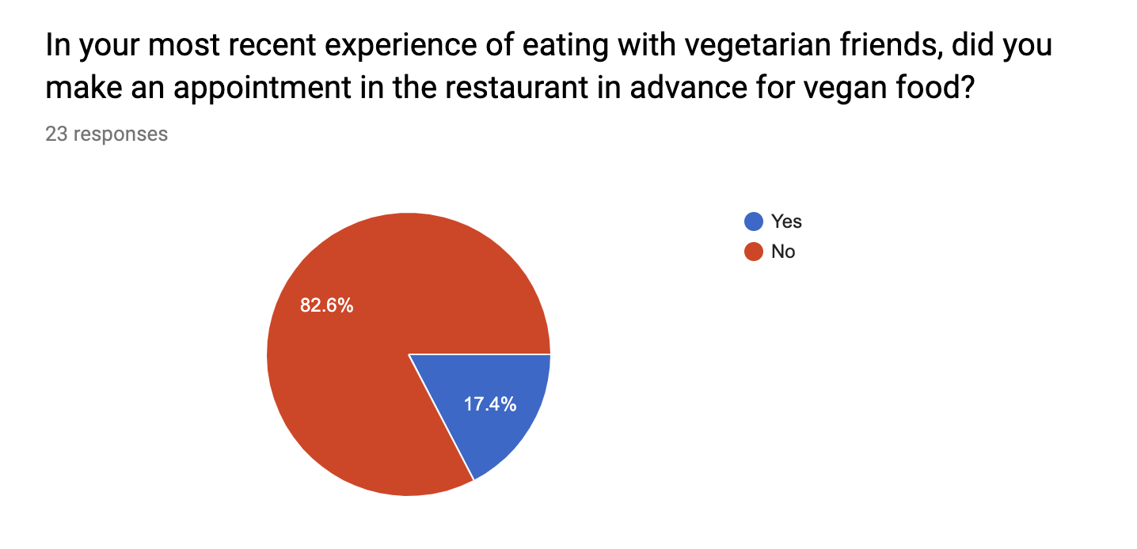
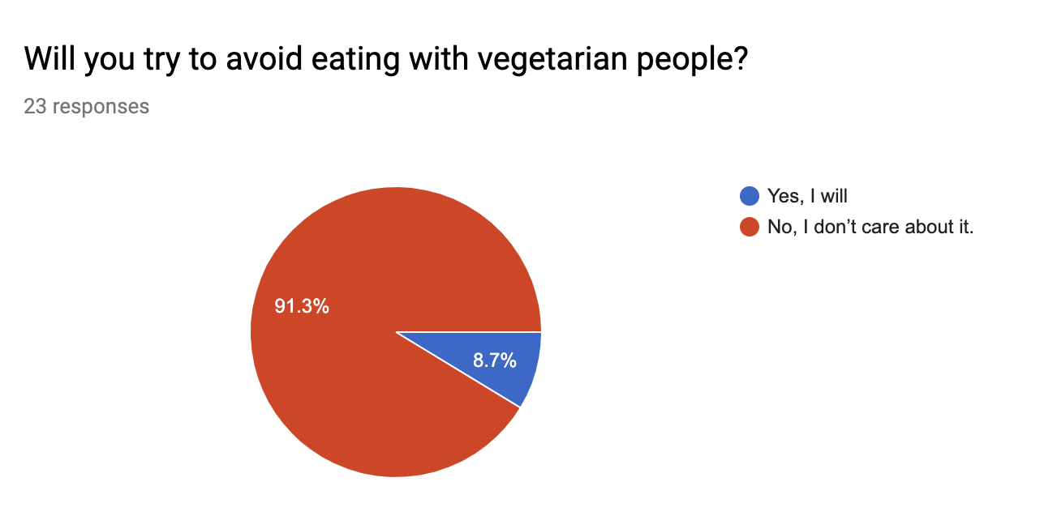

Appendix II. Vegetarian/Vegan’s Responses to Other Survey Questions

