THREE DEFINITONS EXERCISE:

This post is submitted for Assignment 1:3. My main aim is to be able to describe the term recession to anyone that has basic a knowledge of Economics. I will be describing what a recession is and it’s indicators using our most recent recession in 2007 as an example.

* Parenthetical Definition:

When the level of unemployment is high we usually refer to being in a Recession (a period of slow or negative economic growth).

* Sentence Definition:

A recession is a significant decline in activity across the economy, lasting longer than a few months. It is usually characterized by high rates of unemployment and decrease in economic investment in industrial sectors. A clear example to the outcomes of a recession can be seen when looking at what happened in the USA in 2008.

* Extended Definition

A recession is a significant decline in activity across the economy, lasting longer than a few months. It is visible in industrial production, employment, real income and wholesale-retail trade. The technical indicator of a recession is two consecutive quarters of negative economic growth as measured by a country's gross domestic product (GDP).

Aside from two consecutive quarters of GDP decline, economists assess several metrics to determine whether a recession is imminent or already taking place. These indicators are divided into two categories: leading indicators and lagging indicators.

Leading indicators are usually seen before a recession takes part. The most common leading indicator is contraction in the stock market like sever declines in broad stock indices, such as the Dow Jones Industrial Average (DJIA) and Standard & Poor's (S&P) 500 index. This was the case in 2007, when the market began declining in August, four months ahead of the official recession in December 2007.

Lagging indicators however represent factors that are seen after a recession has begun, an example is unemployment. Though the Great Recession began in December 2007, the unemployment rate only began declining in May 2008 and did not recover until several months after the recession ended in June 2009.

People usually confuse recession to a depression; a depression however is a deep and long-lasting recession like the one that happened in the 1930’s

The picture below plays a joke on the Recession, as people lose their jobs during a recession and have to confirm to downgrades in their careers if they want to keep working. As you may see on the left high-profile professionals are entering the “recession machine,” and are coming out as cooks, gas station clerks and janitors. The government official on the top however tries to claim there are new jobs for all these people with a clear sense of mockery.

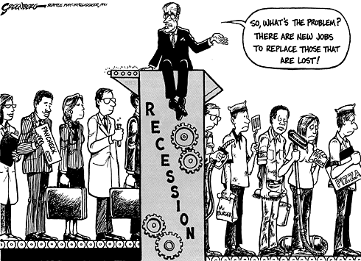

Works Cited

“Economics A-Z Terms.” *The Economist*, The Economist Newspaper, [www.economist.com/economics-a-to-z/r#node-21529883](http://www.economist.com/economics-a-to-z/r#node-21529883).

Greenberg, Steve. “Job Machine.” *Greenberg Art*, 18 Nov. 1991, [www.greenberg-art.com/.Toons/.Toons,%20social/Recessionjobs.html](http://www.greenberg-art.com/.Toons/.Toons,%20social/Recessionjobs.html).

Staff, Investopedia. “Recession.” *Investopedia*, 25 Nov. 2003, [www.investopedia.com/terms/r/recession.asp](http://www.investopedia.com/terms/r/recession.asp).