2308 Stephens St.

Vancouver BC, V6K 3W8

April 2, 2018

Cara Speakman

Operations Coordinator, Thunderbird Park & Stadium

The University of British Columbia

Vancouver, BC V6T 1Z3

Dear Cara Speakman

My name is Joao Pedro Neves and I am writing to express my interest in the position of Facility Operations Staff. I am currently a fourth-year student and intend to graduate in 2018 with a Bachelor of Arts degree in economics and minor in commerce. Due to my previous work experience where managing and approaching people was integral to the roles success, I gained plenty of first-hand experience being the face of a well-known service. I understand how to increase the attractiveness of a service for the intended target audience, while also maintaining a good academic standard. I am a highly creative, determined and confident person who works well under stress both independently and within a team.

As a volunteer for the FIFA World Cup Media Center in Brazil, I worked as a front desk operator, accommodating media members and most importantly identifying their needs and acting on them quickly. During my time working at the quality department of IB Technology in Brazil, I researched company standards across the country in order to better advise my colleagues on the company’s objectives and aims. While being part of this company I also supervised four different working stations in order to implement working standards in all of them. Through these experiences I have gained knowledge on how to maintain working stations, coworkers and customers delighted while learning of their needs and wants.

Over the past four years I have lived in two different UBC campuses that offered many student services, through this I have observed and learned the main weaknesses and strengths of the program. My main objective is to improve the system to better fit the needs of all students and community members by providing efficient customer service and rapid problem solving. I also believe that my passion for sports will allow me to take this position beyond, as I strive for the best experience possible for our athletes and fans.

I am confident that my creativity, interest in professional growth and passion to meet new people, will make me an asset a real as a Facilities Operations Staff, while allowing me to gain valuable experience in the process. I’ve attached a resume with further information about my educational and extracurricular background. I look forward to hearing from you and further discussing this great opportunity. Thank you for your time and attention.

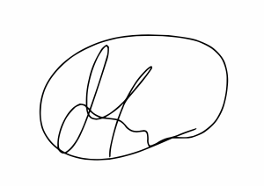Sincerely,

Joao Pedro Neves

Encl: Resume