**Tungsten in Canada:**

**A Feasibility Study for**

**Re-Opening the Cantung Mine**

For

Current Cantung Mine Manager

By

Kai Corley-Jory

English 301 Student

November 25, 2018

Table of Contents

Abstract…………………………………………………………………………………………………………………………………………………..3

Introduction…………………………………………………………………………………………………………………………………………….4

Mine History……………………………………………………………………………………………………………………………….4

Uses of Tungsten…………………………………………………………………………………………………………………………4

Economic History………………………………………………………………………………………………………………………..4

Data Collection Methods…………………………………………………………………………………………………………….5

Data Section…………………………………………………………………………………………………………………………………………….5

Mine Challenges………………………………………………………………………………………………………………………….5

New Processing Technology………………………………………………………………………………………………………..6

Further Processing of Tungsten Ore……………………………………………………………………………………………6

New Exploration Technology………………………………………………………………………………………………………6

Factors for Global Price of Tungsten……………………………………………………………………………………………7

International Trading Policy………………………………………………………………………………………………………..7

Domestic Mining Concerns………………………………………………………………………………………………………….8

Discussion………………………………………………………………………………………………………………………………………………..8

The Price of Tungsten………………………………………………………………………………………………………………….8

New Technology………………………………………………………………………………………………………………………….9

Prospective Operator Requirements…………………………………………………………………………………………..9

Conclusion……………………………………………………………………………………………………………………………………………..9

References…………………………………………………………………………………………………………………………………………….10

Figures

Figure 1 Tungsten Growth Tree………………………………………………………………………………………………………………4

Figure 2 Top 9 Tungsten Producing Countries…………………………………………………………………………………………7

Figure 3 Historical Tungsten Prices and Inflation Calculations…………………………………………………………………8

**Abstract**

Cantung has a rich history of tungsten production since the deposit was discovered in 1954. The current uses for tungsten today in many practices has increased dramatically since the second world war, and the demand for tungsten will remain steady going forward.

The feasibility of re-opening the Cantung tungsten mine located in the N.W.T. depends upon many factors, including foreign and domestic mining policy, tungsten prices, and advances in new mining technology for finding and sorting ore, and taking advantage of an opportunity to increase profits by upgrading the final tungsten product to a state more readily used in metallurgy. Additionally the feasibility of re-opening Cantung also depends on many mine-specific challenges like environmental regulations, reprocessing of existing waste tailings, and outstanding debt on the mine.

The re-opening of Cantung would be feasible for a large mining & resource company, who is able to front the necessary capital in order to keep the mine operating until it can pay off its fixed costs. The main concerns of a company hoping to operate Cantung, would be the use of new technology to both process and find ore, history of tungsten price and where it is predicted to go in the future, and any changes to domestic mining policy and environmental regulations.

There are many other factors not mentioned in this report that affect whether Cantung could be re-opened. That being said, with the data and discussion in this report it is easy to see that the re-opening of Cantung is a distinct possibility and past trends with the mine closing and subsequently opening again say that 2015 will not be the last year Cantung was in operation.

**Introduction**

**Mine History**

Cantung is a tungsten mine located on the east side of the Yukon-NWT border in the southern Mackenzie mountain range. The Cantung skarn deposit was discovered in 1954, and subsequently began development into a mine in 1959. By 1962 Cantung was in operation with a small open-pit operation. The mine closed and re-opened twice in 1963 & 1966 due to low tungsten prices and a fire that made their mill inoperable. By 1971 and underground resource had been discovered and in 1974 the mill started to run underground ore. Cantung was again shut down, and finally re-opened in 2001 after the mine switched hands, and tungsten prices increased. Cantung shut down once again in 2009, only to be opened again in 2010 until 2015 when the mine shut down and is currently housing a crew for care and maintenance incase the mine is to be re-opened or remediated in the coming future.

**Uses of Tungsten**

Tungsten (W) is a very useful metal, mainly due to the fact that it has the highest melting point of all metals at 3414°C. Tungsten is commonly used to create alloys with other metals, one of them being tungsten-carbide, which has many practical and industrial uses because of its extreme hardness. These properties allow tungsten to be vital to a wide variety of industries, such as, metal working, welding, mining, and the petroleum industry ("History of Tungsten").

**Economic History**

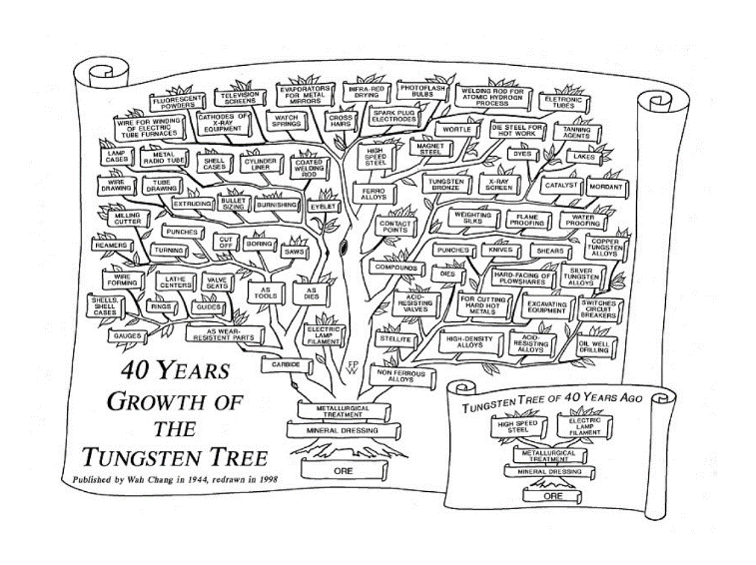Although tungsten was discovered in the 16th century, tungsten didn’t gain much significant material value until the mid-19th century. In 1858 tungsten-steel alloys were patented for “self-hardening” steels, and later shown at the world exhibition in 1900. In 1904, tungsten filaments also replaced the carbon filaments used in most lightbulbs. Not until the end of the Second World War did tungsten find a function in the industrial environment. Ever since, tungsten has been an important commodity in many industrial practices. In 1944 K C Li, compared the growth in application for tungsten to the growth of a tree, and his idea has since been expanded up (as seen in Fig. 1). This figure illustrates that with increasing technological advances, tungsten demand has steadily been increasing because of its natural properties ("History of Tungsten").

**Figure 1: Tungsten Growth Tree,** Source: Figure From [www.itia.info/history.html](http://www.itia.info/history.html)

**Data Collection Methods**

Data for this report was primarily gathered through online research, mine reports, and discussion with a former mine geologist that worked at Cantung until the closure in 2015. Additionally, I personally worked near Cantung for a month in the summer of 2018, and had the chance to meet the current mine managers and maintenance crews. Online research includes looking at tungsten history, prices, operating costs, labor laws, mining policies, and much more. Mine specific details were obtained through personal experience and working with a former mine geologist from Cantung ("Cantung Feasibility Interview" 2018).

**Data Section**

**Mine Challenges**

Cantung has a number of mine specific obstacles that need to be addressed if the mine is to be considered for operation in the future. These obstacles include environmental concerns, operational costs, mine life & ore reserves, debt owed against the mine, and the potential for reprocessing tailings waste ("Cantung Feasibility Interview" 2018).

Though Cantung had kept up its environmental duties until closure, environmental regulations governed by many federal, provincial and territorial agencies may have changed in the past few years. But even so, with Cantung’s long standing history of operation, it is likely that there would be little standing in the way of re-opening because of environmental concerns. This is vastly different than the types of regulations and bureaucracy that would have to be dealt with when opening a brand new mine.

The current price of tungsten ($19.85 USD/lb.) would not cover the operational costs of Cantung if it were to be re-opened, and would be running at a loss. There are a few newer technologies, processes and methods that could allow for the mine to be profitable at this price.

The mine itself does have enough known ore reserves to warrant going back into operation ("Cantung Feasibility Interview" 2018). The remaining ore has a cutoff grade of (0.2-0.4 weight %) tungsten with an estimated mine life of at least 15 more years. And this isn’t taking into consideration the potential reprocessing of the five tailings damns and ponds located at the mine site.

In 2015 Cantung closed because the controlling company “North American Tungsten” went bankrupt after owing $79,000,000 to over 200 companies. This debt is still owed against the mine to the Canadian government. Unlike other mine closures at Cantung, in 2015 it wasn’t directly related to the price of tungsten in the market, instead it was the fault of the parent company. That means that in order for the mine to go into operation again a new company would have to purchase it or the government would have to decide to control the operation themselves. It is assumed that if a new company were to buy the mine they would have to pay it off, but it is unlikely that a new company would have to pay off the debt in full.

Cantung has five large tailings damns, all with significant weight percentage of tungsten in them due to the processing methods that were used at the mine. If there was an investment made into new processing technology it could not only improve the efficiency of normal mining operations, but allow for the re-processing of tailings ("Cantung Feasibility Interview" 2018). This action would further increase profits to be made at Cantung and mine life, because of the ability to processes lower grade ore efficiently.

**New Processing Technology**

Wolfram Bergbau, a tungsten mining company located in Austria, has developed a new, more efficient technology for sorting ore material. To see how effective this sorting is, you can see a video of how it works here: <https://www.youtube.com/watch?v=9bpoQWgWWFE>("Cantung Feasibility Interview" 2018).

The cost of extraction (pulling material from the earth) for the tailings damns has already been sunk into them by the previous mine operators. Re-processing the tailings would require a more efficient mill showcasing technology seen in the Wolfram Bergbau mill. Initially this purchase would be more expensive than operating the existing mill at Cantung, but it would also be able to extract a higher percentage of tungsten from ore taken from the mine. This would allow for the mill to process a lower grade of ore than before, increasing the overall tonnage of tungsten that would be able to be produced from the mine in its life ("Cantung Feasibility Interview" 2018). An addition of a new mill with a lower cutoff grade wouldn’t only mean better recovery on tungsten from ore and tailings, but this would mean that the sorted waste rock would have less contaminants in them like sulfides. This means that the waste produced would effectively be much less harmful to the surrounding environment wherever they would eventually be stored.

A new mill with a sophisticated sorting mechanism could also reduce operating costs, due to the fact that it would use less energy. Since a lot more waste would be sorted from the ore before initial milling and processing, this means the bulk of the material to be processed would be less than it would have previously. This in turn reduces the overall energy consumption of the mill during the processing stages and reduces operating costs.

Another bonus of using more effective sorting and mill processes is that they could in-directly improve the infrastructure around Cantung and allow for further access into the Nahani Range and Howard’s Pass. This would be possible because of the fact that most of the waste material at Cantung has very hard and resistant physical properties making it ideal for use in road building. This 200-400km range of improved roads through the Nahani Range, reaching Cantung and further north in Howard’s Pass, could increase exploration and industry in the area ("Cantung Feasibility Interview" 2018).

**Further Processing of Tungsten Ore**

Further processing of tungsten ore past where it has been processed at Cantung previously could allow for the mine to operate at a level that would have been considered a loss, but could bring in a profit if the ore material were to be further upgraded. This is due to the fact that there are not a lot of companies that upgrade their ore directly to ammonium paratungstate, which is the direct precursor to the use of tungsten in metallurgical processes ("Cantung Feasibility Interview" 2018). The price-point on the ore before and after this upgrading is vastly different because of the lack of entities that undertake this procedure. This would also increase the revenue produced per weight unit of tungsten extracted from the mine. Meaning that if this process were to occur at Cantung then the overall profit of the mine would be greatly increased.

**New Exploration Technology**

New methods could also be considered for use in defining the extent of the underground tungsten resource. For example, new technologies for geophysical surveys could be implemented in conjunction with past drilling methods to define the localities and boundaries of mineralization in the mine. The geophysical surveys in question that would be practical for finding ore underground would be a coupled DC-Resistivity and Induced Polarization (IP) borehole survey. These surveys highlight the contrast in “chargeability” of materials, this in essence makes sulfides stick out like a sore thumb. This only works because of the tungsten’s close spatial associated with pyrrhotite (a sulfide mineral). The benefits of using borehole surveys underground is their potential for use in any orientation and direction, and the fact that you could use the same holes that are already being drilled to define the resource. The use of geophysics could reduce the overall number of drill-holes required to define the resource and therefor reduce costs for this specific function at Cantung.

**Factors of Global Price for Tungsten**

Since the global tungsten market is so small when compared to that of many other metals such as gold or iron, there are only a few factors that have a large effect on the global market.

The factors effecting the global market are to do with labor laws and wages, environmental responsibilities and concerns, and policy concerning trade with countries that practice “un-ethical” operating conditions.

In Canada, even the minimum wage earned is more than many other countries around the world for labor. In many tungsten producing countries around the world, the cost of labor for production is simply much lower in cost when compared to Canada. Since these foreign countries can warrant the lower cost of operation due to these cheaper costs of labor it allows them to sell their tungsten at a lower price, which in turn would make a similar operation in Canada inefficient. This means that these countries with cheaper labor and more lax mining policy are able to essentially control the global price of tungsten ("Cantung Feasibility Interview" 2018).

China currently has a monopoly on the tungsten market, as seen in the tungsten production Fig. 2.

**Figure 2: Top 9 Tungsten Producing Countries Worldwide.**

Source: Data From investingnews.com/daily/resource-investing/critical-metals-investing/tungsten-investing/top-tungsten-producing-countries-china-russia-canada/.

**International Trading Policy**

Europe & North America have policies banning trade with countries that practice unethical work conditions and production methods. e.g. not buying resources from a country that would in turn use the money to fund a civil war or any other unethical activities. But some other countries without these regulations will buy from the “unethical” country and act as a middle man flipping the resources and selling them to European/North-American countries for a profit. This is allowed to occur because these middle-man countries aren’t outside of the trading policy groups of many European and North American Countries. This encourages and allows these less-ethical countries to continue production while helping to keep the price of tungsten low ("Cantung Feasibility Interview" 2018). This then makes it less efficient for tungsten mining in places like Cantung.

**Domestic Mining Concerns**

Because Canada has had some bad mining negligence and policies in the past for not keeping on top of certain mining companies, their policies today regarding environmental concerns and labor laws have become quite strict. Though this shouldn’t be a problem for Cantung specifically, because it has been a shining example for Canada in terms of operating mines. Cantung has a long standing history and integration with all parties, and it has been able to be opened time and time again because of this. Because of this fact, Cantung shouldn’t have a lot of trouble with mining policy, environmental policy and land use issues.

**Discussion**

**The Price of Tungsten**

The global price of tungsten would have to increase to similar highs that have been seen in the past for a major company to be interested in purchasing Cantung. As a side note, a large enough company interested in Cantung may also be interested in the tungsten resource Mactung further to the north ("Cantung Feasibility Interview" 2018). These historical price highs can be seen in Fig. 3.

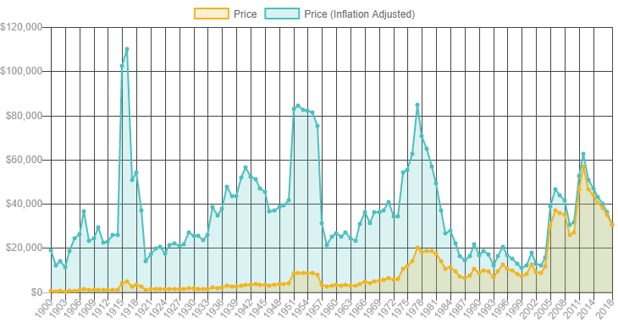

**Figure 3: Historical Tungsten Prices (per metric ton) and Inflation Calculations.**

Source: Graph From [www.metalary.com/tungsten-price/](http://www.metalary.com/tungsten-price/).

A change in the price of tungsten could come about in many different ways. One way would be to have a shift in foreign mining policy concerning labor wages and environmental regulations. For example if China were to introduce stricter environmental regulations, similar to China’s New Environmental Protection Tax Law, then that could increase production and facilitating costs for tungsten mines, driving the global price higher. Similarly, an increase in the minimum wage for laborers at these mines would increase overall prices.

**New Technology**

Increasing the price of tungsten isn’t the only factor that effects the potential for Cantung to re-open. Alternatively if the mine were to implement new technology at the mine they could reduce costs and improve operational efficiency. A new ore-sorting machine, mill, and geophysical exploration methods could all be major factors in reducing these costs. The fact that more overall profit per weight could be obtained by further processing of tungsten concentrate into ammonium paratungstate would be one of the more influential reasons to re-open the mine ("Cantung Feasibility Interview" 2018). This is simply because it would increase overall profit from the mine. Reducing operating costs would also be essential for Cantung to open in the current market because it would allow for the sale of tungsten products from the mine to be sold at a lower cost, not requiring the market price to increase for operation to begin.

**Prospective Operator Requirements**

Regardless of global tungsten price, or new technology that could be implemented to increase the revenue and profit margin at Cantung, an entity with a lot of capital would have to purchase the mine for it to go back into production ("Cantung Feasibility Interview" 2018). Currently the government owns the mine and there is an outstanding debt left by the previous owner. This coupled with the fact that a new owner that would want to implement some new processing and mining methods would have to spend a lot of money initially, wouldn’t see significant return on their investment for many years. Because of this, a small mining company wouldn’t be able to afford to keep the mine in operation long enough to make a profit. A large mining company or even the government would have to be the ones to re-open Cantung in order for it to stay open.

With Cantung’s close proximity to so many other mineral resources, and its remote nature but impressive infrastructure it could be used as a stepping stone to other resource sites in the area. A company interested in Cantung would not only get the benefit of the mine itself, but could use it to improve infrastructure and road access to a lot of the Nahani Range and Howard’s Pass ("Cantung Feasibility Interview" 2018).

**Conclusion**

Re-opening Cantung isn’t a simple matter of seeing an increase in the price of tungsten or the development of new technologies. These factors may help in enticing a larger mining company to want to buy the mine and start operations, but in reality there are a lot of other factors that go into making these decisions. That being said, I think that these technologies and methods would greatly improve production efficiency at Cantung if it were to be re-opened. It wouldn’t make much sense to re-open the mine without implementing some newer technologies and it is unlikely that none of these methods would be used in the future. The likelihood of Cantung re-opening is increasing every year with changes coming to foreign environmental and labor policies, and newer technologies being created. 2015 won’t be the last operating year for Cantung, it will be re-opened in the future.

**References**

Ehsan, and Kai Corley-Jory. “2018 Cantung Feasibility Interview.” 17 Oct. 2018.

("Cantung Feasibility Interview" 2018), (“Interview”)

*Technical Report on The Cantung Mine, Northwest Territories, Canada*. North American Tungsten Corporation Ltd., 2014, pp. 1–148, *Technical Report on The Cantung Mine, Northwest Territories, Canada*. 2014 Cantung Technical Mine Report, <http://www.natungsten.com/i/pdf/tech-report-cantung-mine-northwest.pdf>.

“Tungsten Price.” *Metalary*, [www.metalary.com/tungsten-price/](http://www.metalary.com/tungsten-price/).

“History of Tungsten.” *An Extensive Source of Information about Tungsten, Its Properties, Applications and Uses*, [www.itia.info/history.html](http://www.itia.info/history.html). ("History of Tungsten")

“Regulatory Effectiveness.” *Welcome to the Mining Association of Canada | The Mining Association of Canada*, mining.ca/our-focus/regulatory-effectiveness.

“Home ~ Wolfram.” *Wolfram*, [www.wolfram.at/en/](http://www.wolfram.at/en/).

TOMRA. “Tungsten Sorting at WOLFRAM Bergbau AG, Austria.” *YouTube*, YouTube, 13 May 2014, [www.youtube.com/watch?v=9bpoQWgWWFE](http://www.youtube.com/watch?v=9bpoQWgWWFE).

“9 Top Countries for Tungsten Production.” *Investing News Network*, 24 Apr. 2018, investingnews.com/daily/resource-investing/critical-metals-investing/tungsten-investing/top-tungsten-producing-countries-china-russia-canada/.