Improving Student Wellbeing at UBC Vancouver

Feasibility analysis of anxiety management and preventing sleep deprivation amongst students

For

Matt Dolf
Director at the UBC Wellness Office

By

Karen Okoyomon
November 16, 2021
Table of Contents
I. INTRODUCTION 2
A. Background 2
B. Statement of Problem 3
C. Purpose and Significance of the Report 3
D. Research Methods 3
II. DATA SECTION 4
A. Studies on test anxiety amongst students and its effect on academic performance 4
1. Recap of interviews - anxiety 4
2. Primary source data from surveys 4
B. Studies of the effects of sleep deprivation 6
1. Secondary source data about the impact of sleep on academic performance & nap pods 6
2. Interview recap - sleep 6
3. Sleep survey results 7
D. Studies of useful mental health resources 9
III. CONCLUSION 9
A. Summary of findings and interpretation 9
B. Recommendations 9
V. Works Cited 10
IV. APPENDIX 10
Appendix A. Survey questions 10
Appendix B. Interview Questions and Answers 12

I. INTRODUCTION

A. Background
Student wellbeing is an important part of the university experience. Students often experience high levels of stress that interfere with other areas of their life. At a highly ranked institution like UBC, it is important that students feel good so that they can continue to excel in their studies. Test anxiety affects close to 40% of students, with 16-20% experiencing high test anxiety, and 18% with moderately high anxiety (Linan). Many students experience the stressors of school on a frequent basis. There is an immense pressure to not only pass classes, but also excel in them. Many students have a fear of failure that can push their stress levels over the edge during exam season, and lead to unhealthy coping mechanisms and study methods. Some students turn to pulling all-nighters to stay up studying for their assessments. While studying is an integral part of

B. Statement of Problem
The stress of university can leave students feeling overly exerted, especially during midterm and exam season. Studying is an important part of university, but courses prioritize grades over learning, this is when students can experience feelings of hopelessness, worthlessness, or inadequacy. Students frequently lose sleep in order to study for more hours in the day, which has negative impacts on both their short-term and long-term health.

C. Purpose and Significance of the Report
The purpose of this report is to research methods that students can use to reduce their anxiety and increase their sleep. It will focus on improving the mental health and sleep health. This report will also study the impact that anxiety and sleep have on students’ academic performance.

D. Research Methods
Research on the impact of test anxiety and sleep amongst students will be conducted through a mix of primary and secondary research methods. The primary source will be a survey sent to third year UBC students of all faculties, and the next primary source will be an interview with an undergraduate student at UBC. The secondary sources will be external research on the subject.

II. DATA SECTION

A. Studies on test anxiety amongst students and its effect on academic performance
Test anxiety is the nervousness that comes before a test or exam. These nerves can cause people to have immense feelings of dread, worry, and fear. The American Test Anxieties (ATA) association studies the affect that school and testing have on students’ lives. According to the ATA, “students who struggle with test anxiety typically fall a half a letter grade below their peers” (Oxford Learning). The causes of this anxiety can be situational, such as the pressure of timed test and intimidation from the classroom setting, or mental such as the fear of poor grades, self-esteem, etc.

Recap of interviews - anxiety
In an interview conducted with a third year Psychology student at UBC, the answers to each question were as follows (see appendix B for the interview questions):
Q1: What is your Major? How many hours per week do you spend studying?
“I am a third-year psychology student, and I study every day. I spend the whole day studying, and I rarely catch a break. In one day, maybe 3-4 hours minimum, not including the time spent in class.”
Q4: Do you have test anxiety? How are some ways you deal with it?
“Yes, I do experience test anxiety from time to time. I usually try to calm my nerves during the test by doing some deep breathing when I feel stressed.”

Primary source data from surveys
See appendix A for full details of the survey questions being asked.

Figure 1: survey results of test anxiety amongst university students
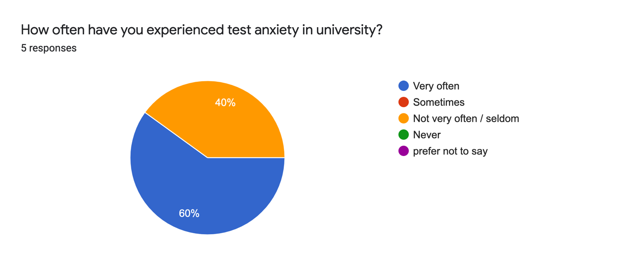
Figure 2: survey results of the effect of test anxiety on academic performance
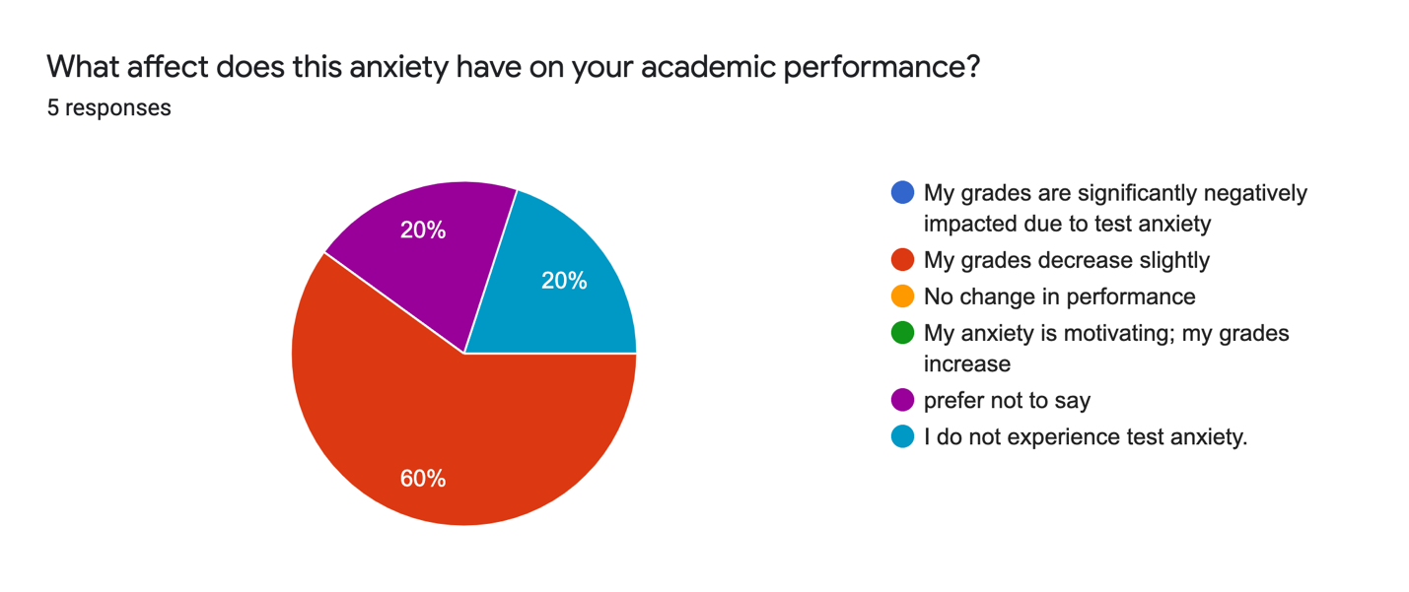
Figure 3: survey results of places on campus to find help with anxiety
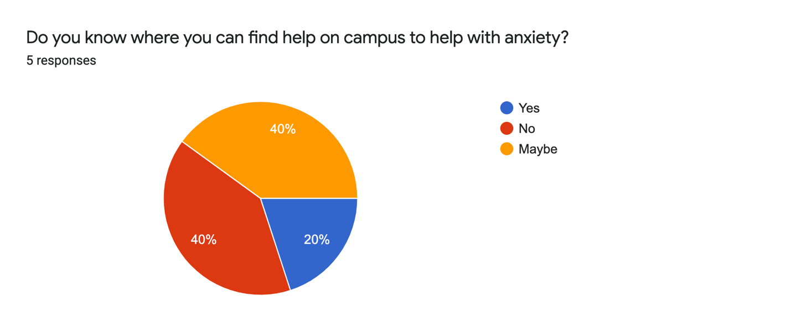

B. Studies of the effects of sleep deprivation

1. Secondary source data about the impact of sleep on academic performance & nap pods
Sleep is an important part of life. It is important for human growth, development, and recovery. Yet so many people still chose to sacrifice this vital part of living. Having enough sleep can help improve performance, concentration, and focus. The sleep foundation recommends 7-9 of sleep per night for adults (Suni), yet in the survey conducted (see figure 4), several students tend to have 6 hours or less. In a study from Kana Okano et al, it was found that “sleep measures accounted for nearly 25% of the variance in academic performance” (Okano, Kaczmarzyk and Dave).
Naps are said to help people retain more information than they were before. Some report feeling more energized after a short nap rather than a long period of time. During exam season, many students like to stay up late in the library to revise. As they study, they become increasingly tired. A nap pod implemented at UBC can help students on their study breaks so that they can relax and refresh their brains in a small yet comfortable space.

2. Interview recap - sleep
Q2: Do you think university tends to glamorize sleep deprivation?
"Yes, absolutely. I find that people tend to brag about how little sleep they get. It’s like they correlate a lack of sleep with more dedication or rigour when that is not always the case. People play it off like it’s just the culture of being in college or university, but it’s actually a huge problem because students are getting 4-5 hours of sleep per night and acting like that’s normal and healthy.”
Q3: Why do you think so many people find it difficult to get enough sleep?
“Well people have a lot of schoolwork. Sometimes there is just not enough hours in then day to get it all done. And on top of that, some people have jobs, or are trying to keep up with friends in their social life.”

3. Sleep survey results
Figure 4: survey results of average sleep per night on weekdays
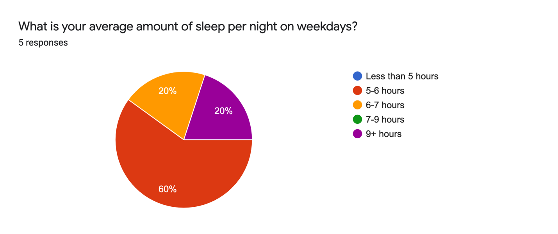
Figure 5: survey results of average sleep per night on weekends
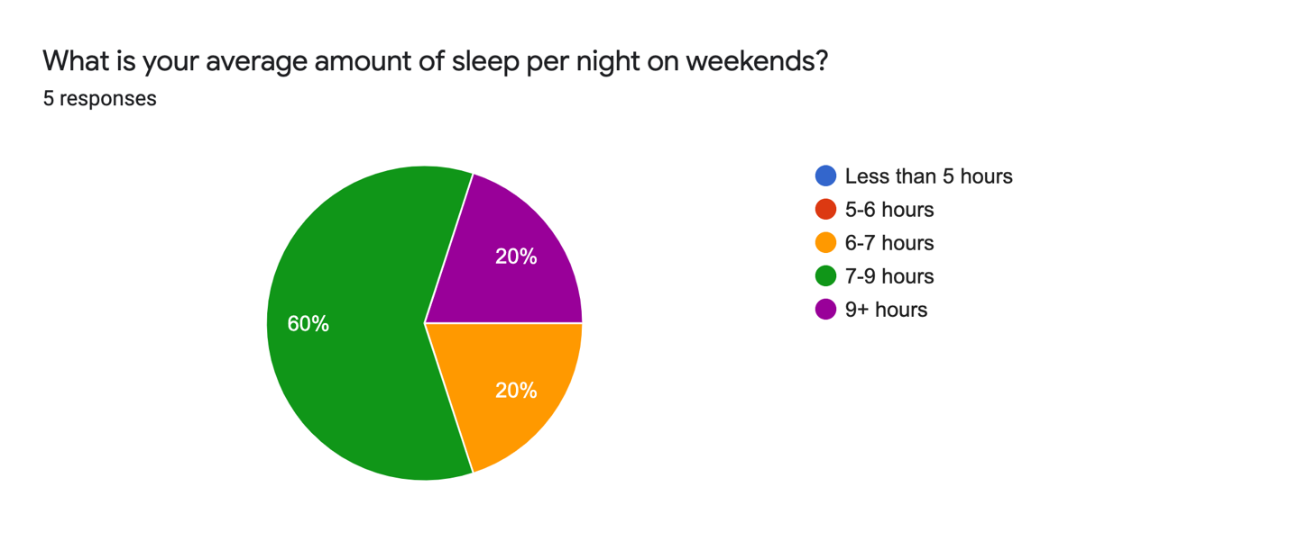
Figure 6: survey results of sleep satisfaction

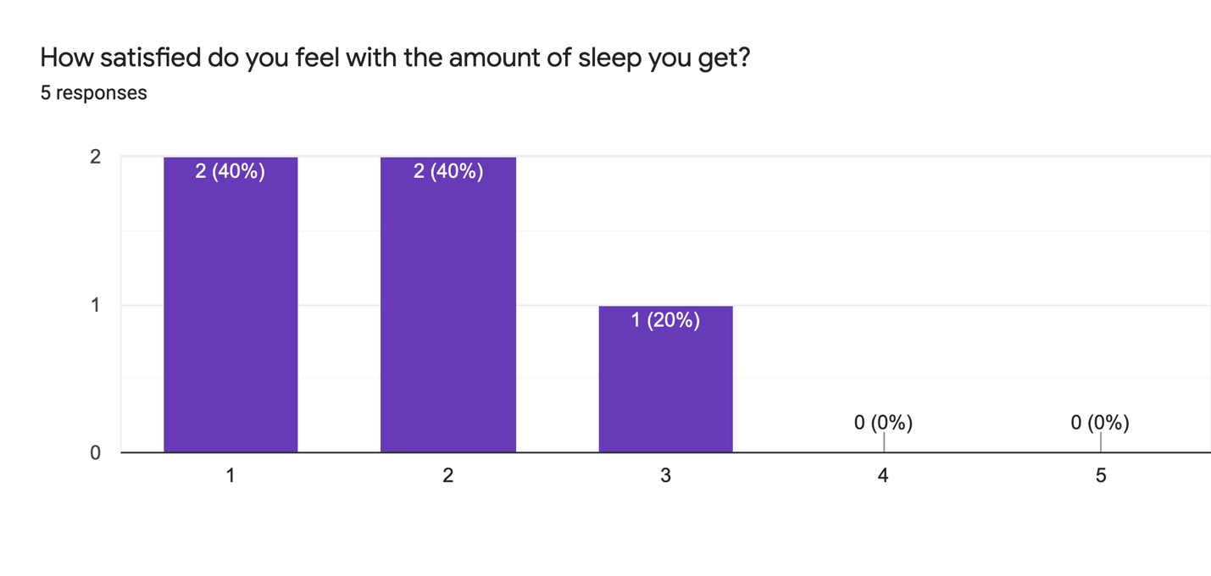
Figure 7: survey results of nap pods

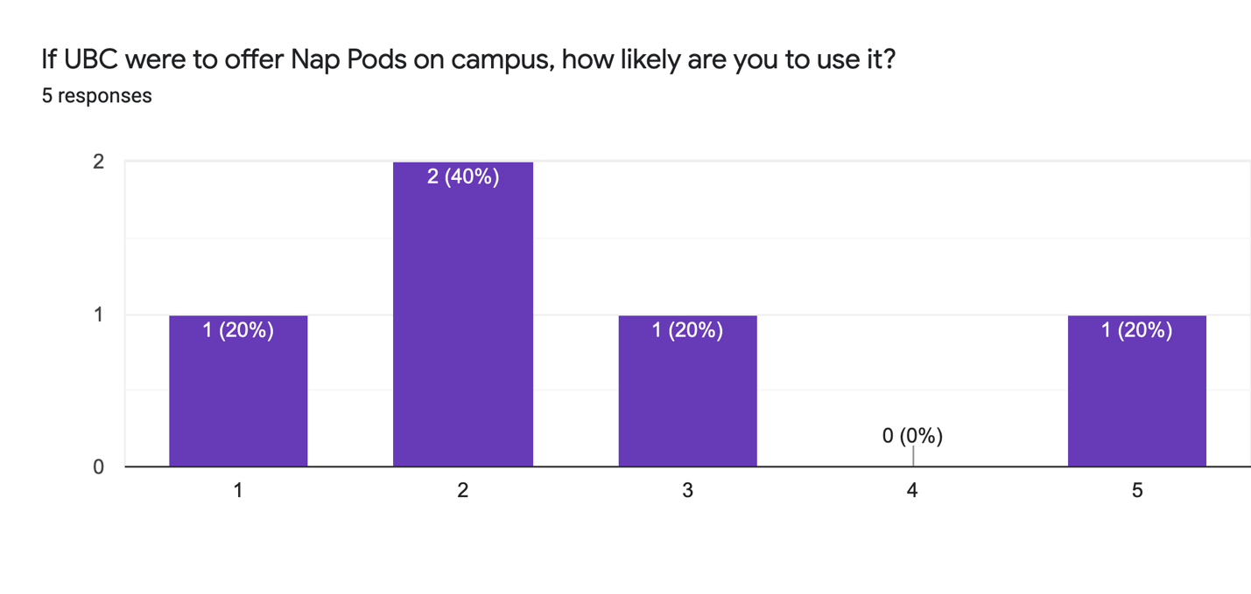
Figure 8: survey results of academic performance
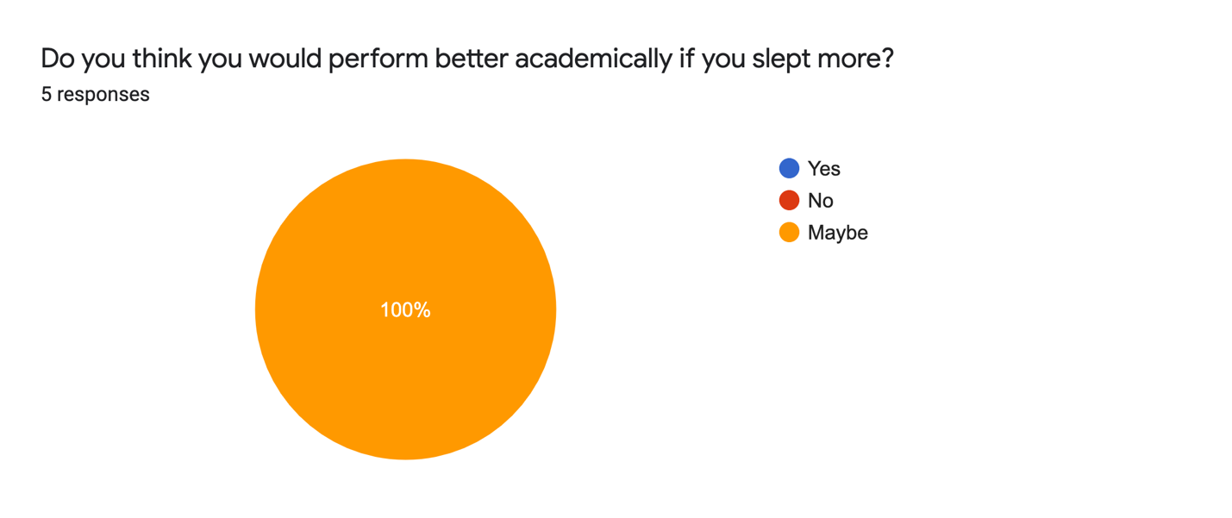

D. Studies of useful mental health resources
The survey shows that only 1 in 5 students know where they can access the resrouces the get the help that they need.

III. CONCLUSION

Summary of findings and interpretation
Overall, test anxiety and sleep deprivation remain as prevalent issues in the world of academia. Students can feel overwhelming amounts of stress on a daily basis. The main findings were that A) many students experience test anxiety but do not know where to get help; and B) many students do not get nearly enough sleep as is recommended.

Recommendations
UBC should focus more on implementing resources that students can use to reduce their anxiety and offer more accommodation to those who feel unwell in test situations. This will help students to feel better and perform at a higher level in their classes. With the right tools, any student can

V. Works Cited

Linan, Ali. “Test Anxiety May Leave Some Students Unable to Achieve on Exams.” Las Cruces Sun-News, 21 Nov. 2017, https://www.lcsun-news.com/story/life/wellness/2017/11/21/test-anxiety-performance-anxiety-students-finals/800902001/.
Okano, Kana, et al. "Sleep quality, duration, and consistency are associated with better academic performance in college students." npj Science of Learning (2019).
Suni, Eric. “How Much Sleep Do We Really Need?” Sleep Foundation, 10 Mar. 2021, https://www.sleepfoundation.org/how-sleep-works/how-much-sleep-do-we-really-need#:~:text=National%20Sleep%20Foundation%20guidelines1,to%208%20hours%20per%20night.
“What Is Test Anxiety (and How It Affects Students).” Oxford Learning, 20 Aug. 2018, https://www.oxfordlearning.com/what-is-test-anxiety/.

IV. APPENDIX

Appendix A. Survey questions

Survey on sleep and anxiety amongst students

I am an undergraduate student at UBC working on a technical writing project. This survey is intended to be used to obtain primary data to analyze how sleep deprivation and anxiety affects student's overall wellbeing and academic performance. This study focuses primarily on students at the UBC Vancouver campus. The final formal report will be addressed to The Health and Wellbeing student services office. Together with supplemental research from scholars, the data from this survey will be used to propose accessible methods for increasing the overall wellbeing of students. The survey contains 8 questions, and it should take about 5 minutes. Your responses are anonymous. Thank you for participating in my survey.

Q1: What is your average amount of sleep per night on weekdays?
- Less than 5 hours
- 5-6 hours
- 6-7 hours
- 7-9 hours
- 9+ hours

Q2: What is your average amount of sleep per night on weekends?
- Less than 5 hours
- 5-6 hours
- 6-7 hours
- 7-9 hours
- 9+ hours

Q3: How satisfied do you feel with the amount of sleep you get?
Not sufficient, I am tired all the time. Great, I feel energized.
1 2 3 4 5

Q4: If UBC were to offer Nap Pods on campus, how likely are you to use it?
Not likely at all Very Likely

1 2 3 4 5

Q5: Do you think you would perform better academically if you slept more?
- Yes
- No
- Maybe
- Other:

Q6: How often have you experienced test anxiety in university?
- Very often
- Sometimes
- Not very often / seldom
- Never
- prefer not to say

Q7: What affect does this anxiety have on your academic performance?
- My grades are significantly negatively impacted due to test anxiety
- My grades decrease slightly
- No change in performance
- My anxiety is motivating; my grades increase
- prefer not to say
- I do not experience test anxiety.
- Other:

Q8: Do you know where you can find help on campus to help with anxiety?
- Yes
- No
- Maybe
- Other:

Appendix B. Interview Questions and Answers
Elise Butcher, Interview. by Karen Okoyomon. 10 November 2021.
Interview conducted in-person.

Q1: What is your Major? How many hours per week do you spend studying?
Q2: Do you think university tends to glamorize sleep deprivation?
"Yes, absolutely. I find that people tend to brag about how little sleep they get. It’s like they correlate a lack of sleep with more dedication or rigour when that is not always the case. People play it off like it’s just the culture of being in college or university, but it’s actually a huge problem because students are getting 4-5 hours of sleep per night and acting like that’s normal and healthy.”
Q3: Why do you think so many people find it difficult to get enough sleep?
“Well people have a lot of schoolwork. Sometimes there is just not enough hours in then day to get it all done. And on top of that, some people have jobs, or are trying to keep up with friends in their social life.”
Q4: Do you have test anxiety? How are some ways you deal with it?
“Yes, I do experience test anxiety from time to time. I usually try to calm my nerves during the test by doing some deep breathing when I feel stressed.”

