Agricultural Land Reserve Analysis
Central Kootenay Region
British Columbia, Canada

David Waine
Kate Baranova
Amanda Bulmer
Adrian Cheng

Lab Section: L1B & L1C
December 07, 2015

TABLE OF CONTENTS

1 EXECUTIVE SUMMARY________________________________________________ 2
2 INTRODUCTION_______________________________________________________ 3
3 REPORT______________________________________________________________ 4
3.1 OVERVIEW_____________________________________________________ 4
3.2 BIOGEOGRAPHICAL_____________________________________________ 4
3.2a LAND COVER_______________________________________________ 4
3.2b WATERBODIES______________________________________________ 6
3.2c SOIL CLASSIFICATION TYPES________________________________ 6
3.2d RESTRICTIONS______________________________________________ 7
3.2e AGRICULTURAL CENSUS ESTIMATES_________________________ 8
3.3 SOCIAL_________________________________________________________ 9
3.3a ROADS______________________________________________________9
3.3b RECREATIONAL LAND USES_________________________________11
3.3c POPULATION_______________________________________________ 11
3.3d THREATS TO ALR___________________________________________12
3.4 SUMMARY_____________________________________________________ 13
3.4a AREAS REMOVED FROM ALR________________________________ 13
3.4b CURRENT ESTIMATES VS. RESEARCH________________________ 14
4 ERROR AND UNCERTAINTY___________________________________________ 15
5 FURTHER RESEARCH/RECOMMENDATIONS_____________________________17
6 APPENDICES_________________________________________________________ 18
6.1 REFERENCES__________________________________________________ 18
6.2 DATA SOURCES________________________________________________ 19
6.3 MAPS_________________________________________________________ 20
6.4 FLOW CHART__________________________________________________ 29
6.5 CONTRIBUTOR REVIEW_________________________________________30

EXECUTIVE SUMMARY
The purpose of this project is to determine and quantify how much of the agricultural land reserve in the Central Kootenay Region is available and suitable for agriculture. Agricultural land reserves are land set aside by the Provincial Government to be primarily used for agriculture. The definition of ALR does not automatically mean that all of the land reserves are actually used for farming. The land within the ALR could be allocated for other uses or contain land unsuitable for farming. Our goal was to determine the different characteristics of the ALR and the actual land-use. Throughout this analysis we made use of numerous data sources and GIS tools to analyze and interpret how various factors affect the application of agricultural land in the ALR. We gathered data on roads, waterbodies, landuse, landcover, slope and soil within the ALR and took out all the elements that made it unsuitable for agricultural use. Additionally, we gathered census data in the Central Kootenay area to account for possible effects that population demographics may have on the ALR. By completing this analysis we will produce a better estimate, than what the ALR offers, of the total area that is actually useful for agriculture.

INTRODUCTION

This analysis examines the Agricultural Land Reserve of the Central Kootenay Region in British Columbia, Canada. The Central Kootenay region lies along the southern border of the province in the eastern corner. This region is largely mountainous with most agricultural land lying in the river valleys alongside rivers. The population in the region is quite low. The purpose of this project is to determine the total amount of land in the ALR actually useful for agriculture. We will be taking into account various metrics during this analysis. These metrics include land cover types, water body coverage, different types of land use, slope of land preventing productive agriculture, soil capability types (determined by the Agricultural Land Commission), road types present, and parkland included in the ALR. During our analysis we will be taking various data sources and using GIS software to process the data to determine (using the above metrics) agricultural activity in the boundaries in the ALR. Data sources we will be using including, BC Trim, Open BC Data, Agricultural Land Commission, Census Canada, University of Toronto Census Data, and GeoBase Land Cover. At the completion of this project we will be able to determine the total area in the ALR that is used for agriculture compared to the official area count released by the Agricultural Land Commission.

OVERVIEW

The Central Kootenay Census Division covers a total of 2314404.73 hectares. The agricultural land reserve (ALR) in the Central Kootenay covers 63079.07 hectares. This ALR land makes up a total of 2.73% of the total land area of the entire Central Kootenay Region. The following categories indicate the restrictions that affect actual agricultural use for this set of ALR.

BIOGEOGRAPHICAL

Land Cover
The Central Kootenay Agricultural Land Reserve contains many various types of land cover. The largest amount of land cover by percentage of ALR is open coniferous forest, which covers roughly 46% of the total land area. Excluding land that is utilized for Annual Cropland 0.0105%, Perennial Cropland and Pastureland 1.706%, and Herb (hay fields potentially) 22.422%, we find that less than 50% of land in the Agricultural Land Reserve is actually used for agriculture. A detailed percentage breakdown of land cover types based off of the total ALR land in hectares is presented in the table below. The analysis regarding the data involved selecting only land cover present in the ALR and sorting the land by their attributes. Then each attribute area was calculated using the statistics tool to determine the area for each attribute. We were able to determine the landcover using GeoBase Land Cover satellite data circa 2000.

Landcover | Hectares | Percent of ALR
Agricultural Land Reserve | 63079.073 | 100
Annual Cropland | 66.365704 | 0.105
Broadleaf Open | 1354.378418 | 2.147
Coniferous Dense | 219.589646 | 0.348
Coniferous Open | 29367.367506 | 46.556
Coniferous Sparse | 343.865758 | 0.545
Developed | 344.8758 | 0.547
Exposed Land | 9253.382239 | 14.669
Grassland | 37.76977 | 0.060
Herb | 14143.727018 | 22.422
Mixed Wood Open | 71.057536 | 0.113
Perennial Cropland and Pasture | 1076.251463 | 1.706
Rock/Rubble | 17.192423 | 0.027
Shrub Low | 1749.314655 | 2.773
Wetland Herb | 1382.748707 | 2.192
Wetland Shrub | 732.711693 | 1.162
Wetland Treed | 9.717853 | 0.015

Waterbodies
By selecting water bodies inside the ALR, including rivers and other open surface water, we were able to determine the percentage of area covered by water in the ALR. All rivers and other waterbodies were buffered by ten meters to allow for riparian zones and flood areas. The TRIM data was taken and clipped to the ALR then buffered to ten meters. The data used was sourced from the government of British Columbia in the form of TRIM data.
Waterbodies hectares | Percent of ALR
5767.30 | 9.14

Soil Classification Types
The Agricultural Land Commission classifies the quality of soil based on how efficiently the soil can be used to grow food. The classes 1-4 were classified as good quality and 5-7 was low quality. We found that the most common type of soil was class 4, with classes 1-4 making up the majority of the Central Kootenay ALR. The analysis of this data involved taking the ALC data and changing the symbology to highlight each individual type. Then we were able to calculate the area of each type by selecting by attributes and using the statistics tool. This data was sourced from the Agricultural Land Commission.

Soil Type | Area Hectares | Percentage of ALR
1 | 4623.563 | 7.330
2 | 11840.522 | 18.771
3 | 8428.485 | 13.362
4 | 21471.838 | 34.040
5 | 6895.640 | 10.932
6 | 3095.464 | 4.907
7 | 2562.180 | 4.062
Total 1-7 | 58917.691 | 93.403
Non Classified Data | 1080.667 | 1.713

Restrictions: Land
The area of the Central Kootenay is quite mountainous and the agricultural land in this area generally lies in the river valleys. Of the land in the ALR we found that only 12.6% was 30 degrees in slope or less. 30 degrees or less in slope is considered ideal for agriculture. However taking this into account, some crops can grow on areas with a slope of more than 30 degrees. For example vineyards and orchards can be placed on areas with a more severe slope. The analysis method used was mainly taking the digital elevation model and reclassifying it to show slope in degrees showing manual breaks between +/- 30 degrees of slope. This data was sourced from BC OpenData.

Degrees of Slope | Area hectares | Percent of ALR
0-30 | 7960.369 | 12.620
31 + | 55109.006 | 87.365

Agricultural Census Estimates
According to the 2011 agricultural census there are 63,123 ha of land in the Central Kootenay ALR. Of this land 24,733 ha is under production, with a total of 552 farms at an average size of 49 ha. A total of 11041 ha are under production as cropland with the vast majority of this producing hay (7098 ha). Greenhouse flower production covers 16,501 ha with greenhouse vegetable production covers 6,691 ha. There are 158 poultry farms and 153 cattle farms present in the ALR along with minimal other livestock production facilities. In conclusion the major use is greenhouse production with hay crops following behind. (Government of British Columbia, 2011)

SOCIAL

Roads
There are several hundred kilometers of different types of roads in the ALR. The group with the most is rough roads at 1247 km, which makes sense considering the farming nature of the area. Gravel Roads and Paved roads are also present in the region at around 600 km each. This data was clipped from the BC TRIM data and clipped to the ALR, symbology was changed to display road by type allowing us to calculate road length by type.

Road Type | Road Length (kilometers)
Gravel Road 1 Lane | 639.13 km
Gravel Road 1 Lane One Way | 21.87 km
Gravel Road 2 Lane | 737.47 km
Overgrown Road | 36.42 km
Paved Road 1 Lane One Way | 0.94 km
Paved Road 2 Lane | 680.30 km
Paved Road 3 Lane | 0.05 km
Rough Road | 1247.00 km
TOTAL ROAD | 3343.66 km

Roads were then all buffered to 10 meters to allow for road width, shoulders, and ditches. This allowed us to calculate the rough estimate of the area of the ALR occupied by the roads. The data used was sourced from BC TRIM.

Road Type | Land Surface Coverage (hectares)
Gravel Road 1 Lane | 575.02 ha
Gravel Road 1 Lane One Way | 2.19 ha
Gravel Road 2 Lane | 666.65 ha
Overgrown Road | 33.61 ha
Paved Road 1 Lane One Way | 0.70 ha
Paved Road 2 Lane | 599.82 ha
Paved Road 3 Lane | 0.00868 ha
Rough Road | 1125.10 ha
TOTAL AREA COVERED (ha) | 3003.09 ha
TOTAL AREA COVERED (%) | 4.76 %

Recreational Land Uses
The ALR in the Central Kootenay region contains very few parks, comprising less than 2% of the total land area. The largest amount is Provincial Parks at 976 ha with other parks covering only 18.64 ha. Golf courses in the area cover 159.38 hectares. The data analysis involved taking TRIM data clipped to the ALR and selecting parks and golf courses. This data was in polyline format so it had to be converted to polygons. Once converted to polygons we could calculate the area covered. Data for this layer was sourced from BC TRIM data.
Park Type | Land Surface Coverage (hectares) | Percent of ALR
Provincial Park | 976.10 ha | 1.547
“Other” Park | 18.64 ha | 0.030
Golf Courses | 159.38 ha | 0.253
Total | 1154.12 ha | 1.83

Population
According to the latest 2011 Canadian Census Profile, the Central Kootenay region has a total population of 58,441. By taking the total population of the Central Kootenay region (58,441) and subtracting the land restricted to ALR (2.7%), we estimate that the ALR land must have 1578 people living in it and around 2.6 persons per square kilometer.

The median age for the Central Kootenay region is 47.5 years, with 85.2% of the population being over the age of 15. The area has a roughly equal gender distribution, with 28, 965 men and 29, 480 women. The average number of people in a census family is 2.7, with an average of 0.8 children per household. The majority of the population’s mother tongue is English, with French being the second majority. It is interesting to note that, according to the National Household Survey (NHS), most of the immigration into the Central Kootenay region happened prior to the 1970s. There are 6025 immigrants in the Central Kootenay region, most of who are from Europe.

Threats to ALR
Based on our research the greatest threat to ALR land is pipeline construction across its area. There are not many buildings or alternate uses on ALR land at present and those present are relatively small in area. Much of the land in the ALR is also not currently being used for agriculture in actuality. The population in the region is also quite low so development is not a very large threat. So in conclusion the greatest threat is pipelines being constructed across the ALR as well as those already currently constructed. Any leaks or spills could cause catastrophic environmental damage to potentially high quality agricultural land.

SUMMARY

The final stage of our analysis was to remove all land in the ALR that we determined to be unsuitable for agriculture. We removed all buffered roads, waterbodies, heavily sloped land, parks, golf courses, sports fields, schools, pits, buildings, yards and trailers, and sewage treatment areas. In total we removed nearly 90% of land in the ALR. 6932.147 hectares of land is suitable for agriculture based on our analyses. This totals 10.975%.
 | Area hectares | Percentage of ALR
Land Suitable for Agriculture | 6923.147 ha | 10.975

Areas Removed from ALR
Land Removed | Area hectares
Buffered Roads | 3003.085
Buffered Water Bodies | 5767.300
Slope too Steep for Agriculture | 5.511
Parks | 994.741
Golf courses | 159.380
Sports Fields | 3.453
Schools | 0.401
Pits | 28.568
Buildings | 24.844
Yards and Trailers | 2.959
Sewage Treatment | 1.083

Current Estimates vs. Research
Our research suggests that the current estimates are largely overestimated in regards to land in the ALR suitable for agriculture. According to the 2011 British Columbia Agricultural Census the ALR in the Central Kootenay Region contains 63123 hectares of land. While this number is accurate in the amount of land present in the ALR, only roughly 11% is suitable for agriculture. The census states that 23733 hectares are farmland as of 2011. This is roughly 38% of the ALR. We believe this discrepancy to exist due to errors in the data gathered that was used in our analysis. Also this discrepancy can be accounted for in the slope analysis. A slope of 30 degrees or less is considered ideal. However much of the agriculture in the region could be undertaken on slopes greater than 30 degrees. For example vineyards, orchards, and pastureland can all accommodate slopes greater than 30 degrees.

ERROR AND UNCERTAINTY

There are many possible errors and uncertainties that could crop up in the analysis process during this project. First would be errors regarding the age of the data sourced. BC TRIM data is from 1992, so over 20 years old, The GeoBase Land Cover data is circa 2000, 15 years old. The age of these data sets means that the current land cover, roads, waterbodies, etc., could all be quite different from that which is represented in the data sets. The Enhanced Resource Management zone data sets were not accessible to the public. As such we do not know how recent resource extraction projects may have affected the ALR since the time the data we used was collected. Human error must also be considered when reviewing possibilities for uncertainty, such as in census data. Another factor to consider involving census data is areas that lack information due to it being suppressed according to Census Canada regulations. There is some uncertainty in the way population demographics may affect the ALR. Also the scale at which the data was collected could affect its precision. The data could be quite precise on the scale collected, however on a different scale the data could become less precise. During our processing of the data errors could be introduced as data sets were projected. If the projections of the data do not match one to another the data could become distorted, affecting how the topography of the maps take form. This could affect calculations and assumptions made based on that data. In our analysis we converted several polylines to polygons in order to calculate areas. If the lines were not completely closed the polylines would not properly convert to polygons. So when calculating area for these polygons some areas may be absent. When making calculations using data in attribute tables rounding errors may occur thus affecting final outcomes. In conclusion there are many possible sources of error and uncertainty in geographic information systems, involving accuracy, precision, data gathering errors, as well as out of date data. We must account for these possibilities and accept that garbage in is equal to garbage out.

FURTHER RESEARCH AND RECOMMENDATIONS

After completing our analysis of the original ALR area as defined by the Agricultural Land Commission, we would like to suggest potential areas for further research and recommendations to improve future policy decisions. To increase the accuracy of the data a new round of data collection should be undertaken. For future reference, it would be helpful if the government maintained a predictable rate at which it collected and released data. Since current data sets are out of date new data needs to be collected to better reflect the reality of the situation in the ALR. We recommend the Canadian government conduct another long form census to gain better demographic data. It would benefit the discourse over the ALR land if the government opened more of its data sources to public use. We believe that if these recommendations are followed the knowledge and information relating to the Agricultural Land Reserve could be greatly improved. With this improvement policy makers and the public can make better decisions regarding the future of the Agricultural Land Reserve.

APPENDIX A REFERENCES

Government of British Columbia. (2011). Central Kootenay Region. Retrieved from Census of Agriculture: http://www2.gov.bc.ca/assets/gov/farming-natural-resources-and-industry/agriculture-and-seafood/about-agriculture-and-seafood/statistics-agriculture-and-seafood/census/aginbrief_central_kootenay.pdf
Statistics Canada. (2011). Central Kootenay Census Profile. Retrieved from:
http://www12.statcan.gc.ca/census-recensement/2011/dp-pd/prof/details/page.cfm?Lang=E&Geo1=CD&Code1=5903&Geo2=PR&Code2=59&Data=Count&SearchText=Central%20Kootenay&SearchType=Begins&SearchPR=01&B1=All&Custom=&TABID=1
Statistics Canada. (2011). NHS Profile, Central Kootenay. Retrieved from:
http://www.census2011.gc.ca/nhs-enm/2011/dp-pd/prof/details/page.cfm?Lang=E&Geo1=CD&Code1=5903&Data=Count&SearchText=central%20kootenay&SearchType=Begins&SearchPR=01&A1=All&B1=All&Custom=&TABID=1

APPENDIX B DATA SOURCES

Agricultural Land Commission. (2015). Agricultural Land. Retrieved from: http://www.alc.gov.bc.ca/alc/content/alr-maps/agricultural-landhttp://www.alc.gov.bc.ca/alc/content/alr-maps/agricultural-land
Natural Resources Canada. (2012). Canadian Digital Elevation Model Mosaid (CDEM), [Data set]. Retrieved from:
http://geogratis.gc.ca/api/en/nrcan-rncan/ess-sst/C40ACFBA-C722-4BE1-862E-146B80BE738E.html
Natural Resources Canada. (2009). Geobase, [Data set]. Retrieved from:
http://ftp2.cits.rncan.gc.ca/pub/geobase/official/lcc2000v_csc2000v/
Ministry of Environment. (2015). Soil Data, [Data set]. Retrieved from: http://www.env.gov.bc.ca/esd/distdata/ecosystems/Soil_Data/AgricultureCapability/?C=M;
“Terrain Resource Information Management Program – (TRIM)”, http://hdl.handle.net/11272/10166 BCGOV ILMB Crown Registry and Geographic Base Branch [Distributor] V3 [Version]

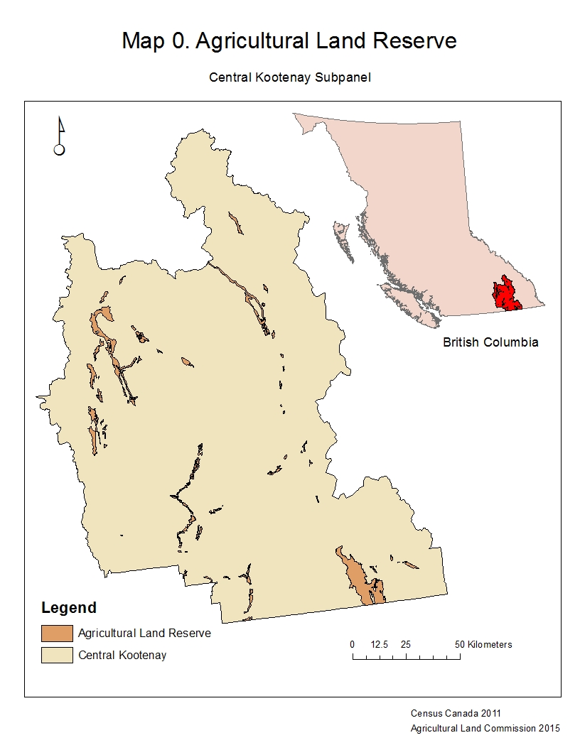
APPENDIX C MAPS
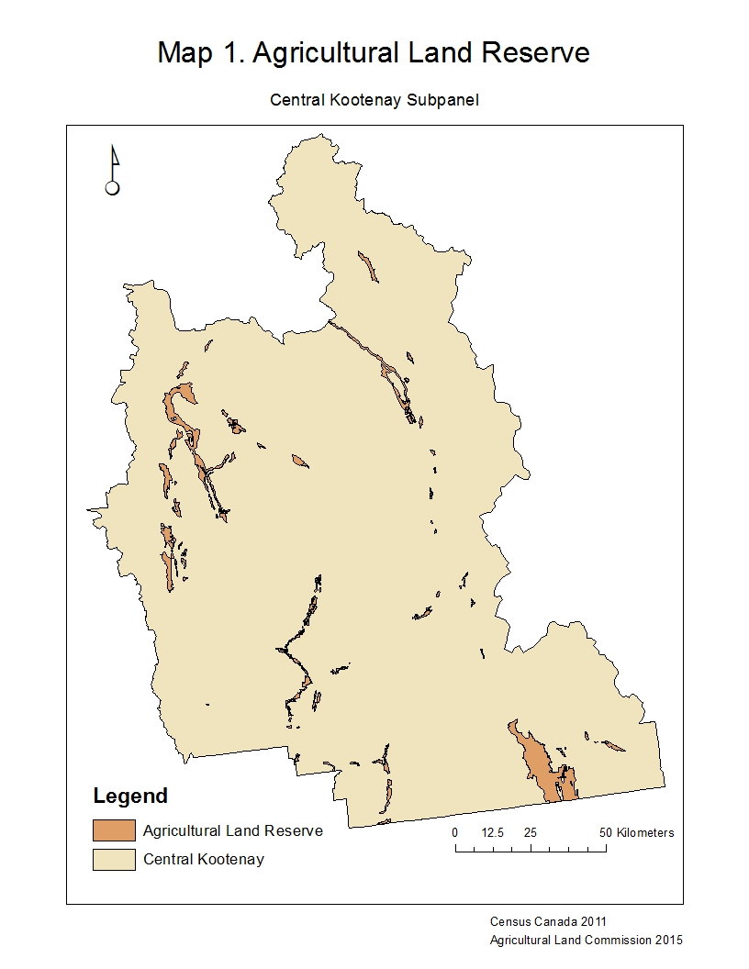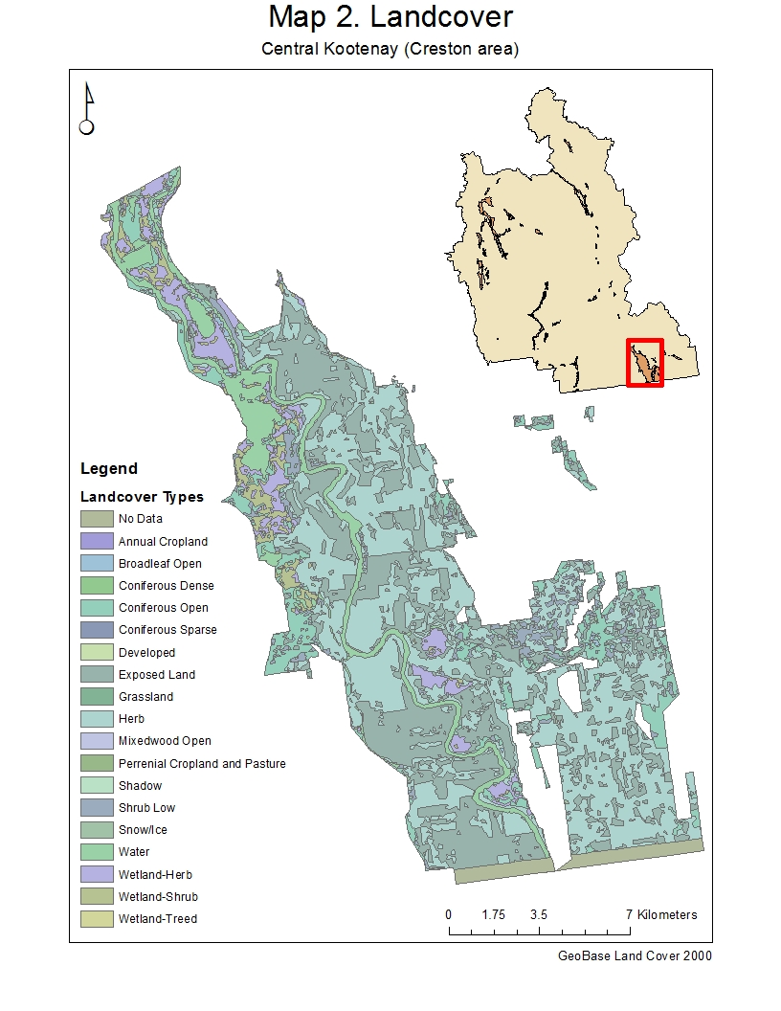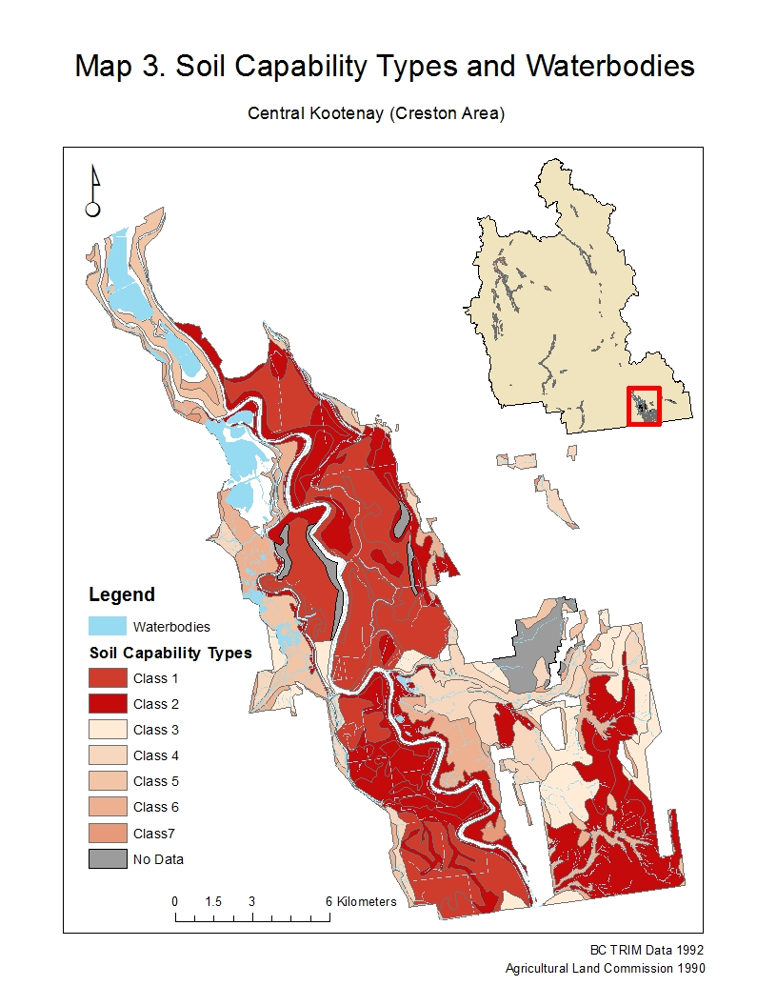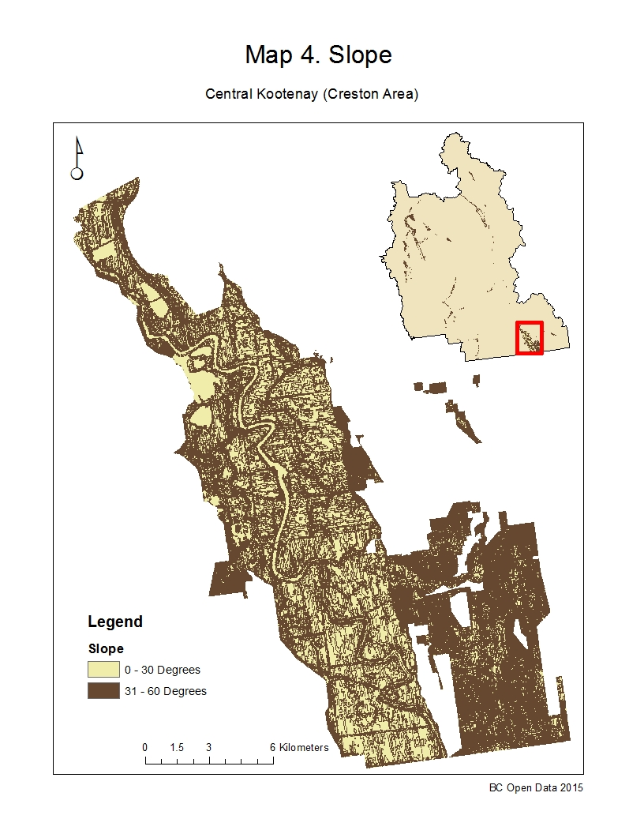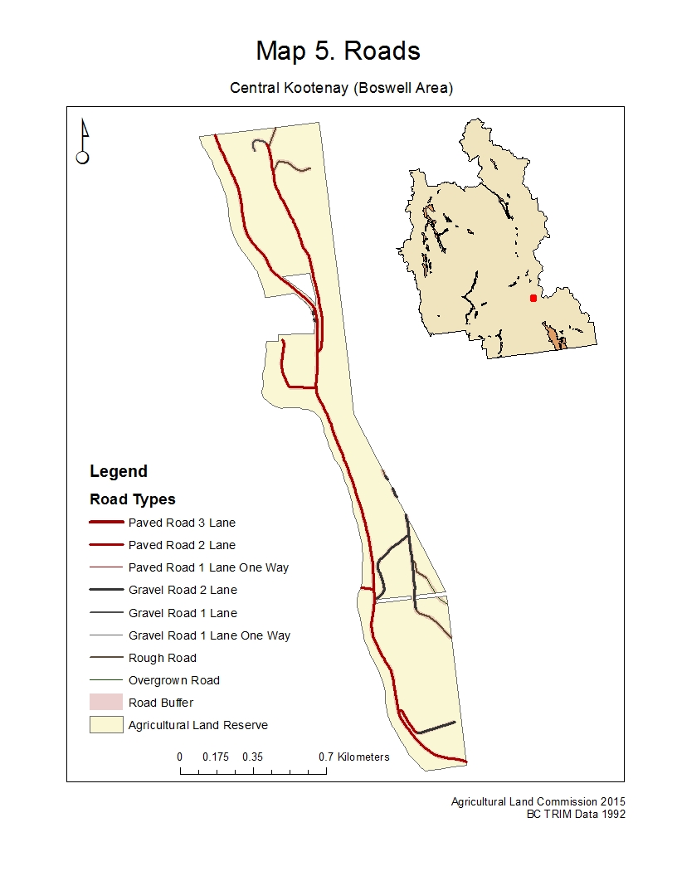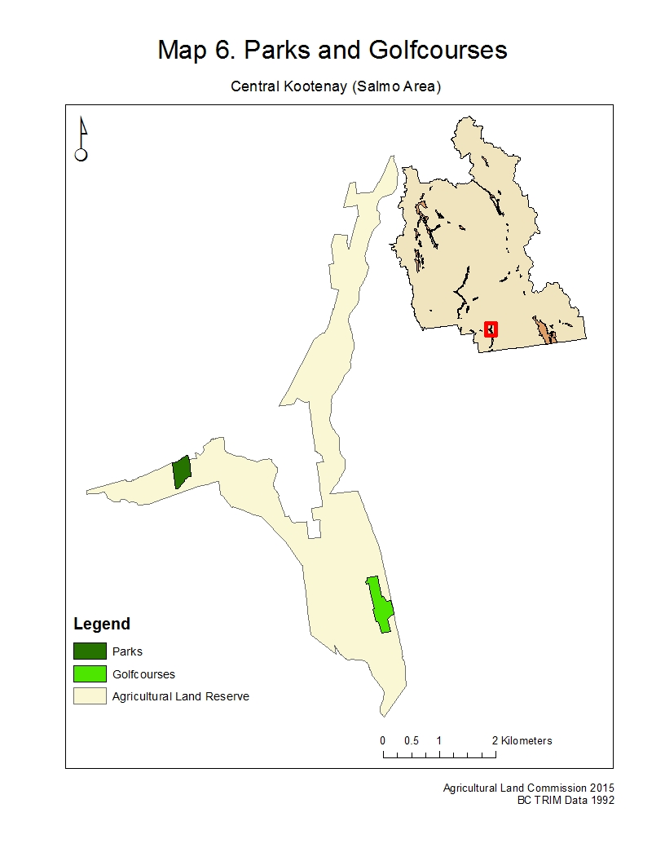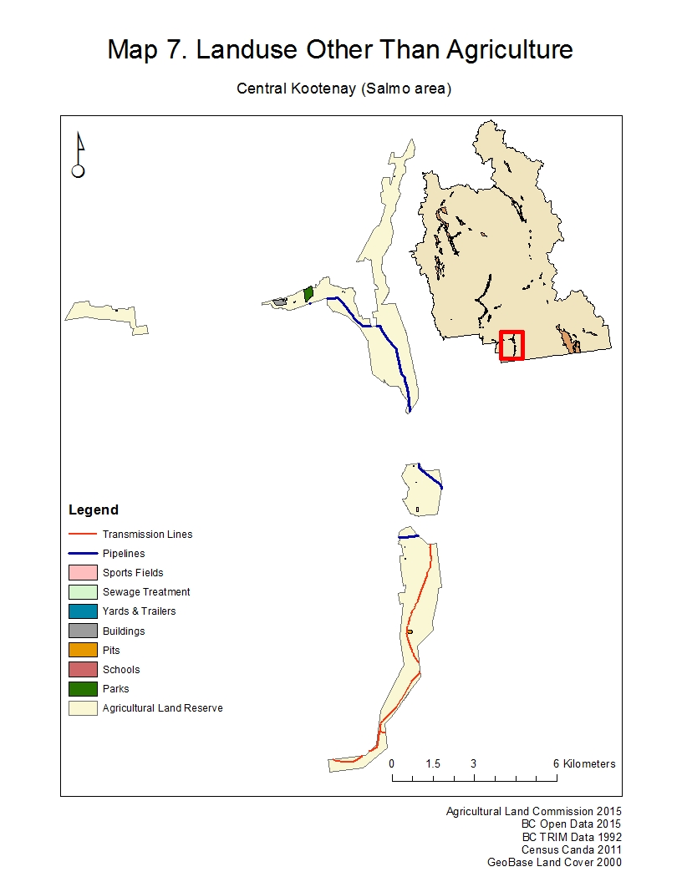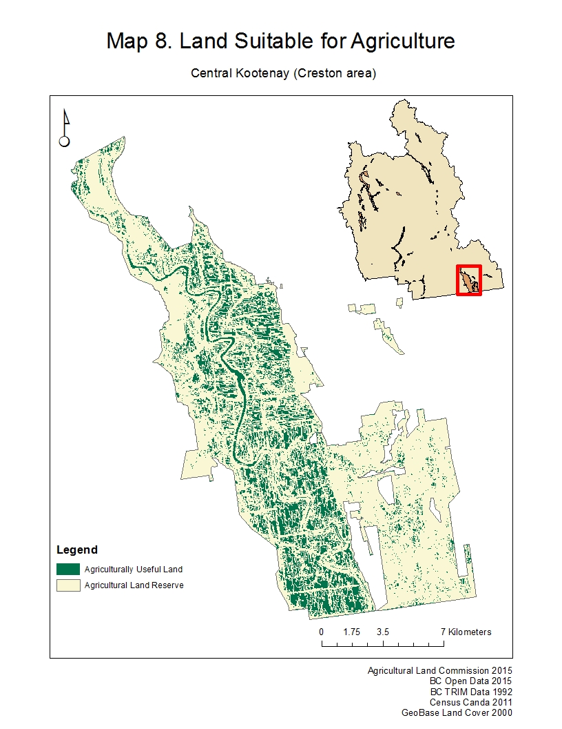

APPENDIX D FLOW CHART
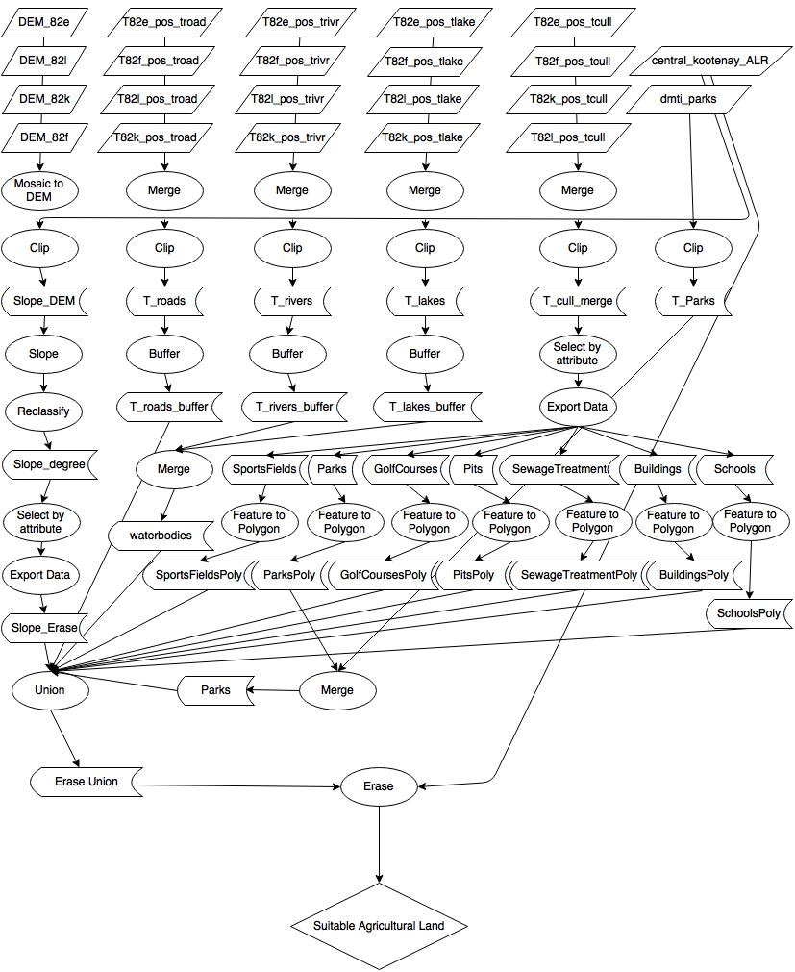

APPENDIX E CONTRIBUTOR REVIEW
Each of the group members was responsible for gathering data and completing analysis for specific problems in the project.
David Waine worked on finding, processing and analyzing the following data and creating maps for said data
- The digital elevation model data to determine the elevations suitable for agriculture
- The soil capabilities classification types data, used to develop a map highlighting the various classifications
David extracted the TRIM data for the others to process
Kateryna Baranova and Amanda Bulmer processed and analysed the extracted TRIM data to create maps of the waterbodies and roadways present in the ALR. They created Maps 0-4
Adrian Cheng did the analysis of the census data as well as helped gather and analyse the landuse data used.
Amanda completed the citations and references in the report.
Adrian and David completed the Error and Uncertainty report as well as the Further Research Recommendations.
Amanda completed the analysis of the parks and golf courses data and helped develop Map 6 along with Kate.
Amanda completed the analysis of the roads and helped develop Map 5 along with Kate.
Kate and David completed the flowchart in Appendix D
David created the final Map 8 and shapefile.
The entire group combined worked on the final report write up, both compiling and editing.

