## In-class collaborative assignment:

## Loh et al (2015)

1. How did the authors reprogram somatic cells for the experiments presented in the article? What was the source of cells (the cells that underwent reprogramming?

Somatic cells were reprogrammed by transfecting the cells with plasmids containing genes that encode Oct3/4, Sox2, and Klf4 to allow temporary expression of pluripotency factors. The cells used were originally mouse embryonic fibroblasts.

1. How did the authors demonstrate that their initial cells had successfully been reprogrammed into PSCs? What figures show the relevant data?

The relevant data is shown in Figures 1A-1C. The authors observed changes in fibroblast cell morphology, spontaneous self-renewal and formation of embryoid bodies in anti-differentiation suspension medium, and performed alkaline phosphatase staining to show that the cells had been reprogrammed into PSCs.

1. What does Figure 3 show? What was the experiment? What question does this experiment address? What are the results? What can we conclude?

Figure 3 shows the five toe spread analysis of normal mice, mice which had undergone sciatic nerve transection, and mice which had undergone sciatic nerve transection but also received topical application of either EiPSCs, 129 ESCs, or B6 ESCs. The experiment addresses if treatment by EiPSCs is sufficient to improve the functional recovery of transected sciatic nerves. The results indicate that mice which received EiPSCs show improved five toe spread after transection compared to mice that received no stem cell treatment. In addition, mice which received EiPSC treatment showed a similar level of five toe spread compared to mice that received 129 ESC or B6 ESC treatment. We can conclude that treatment by EiPSCs is sufficient to improve the functional recovery of transected sciatic nerves in mice, and that EiPSC treatment results in similar recovery levels compared to 129 ESC and B6 ESC treatment.

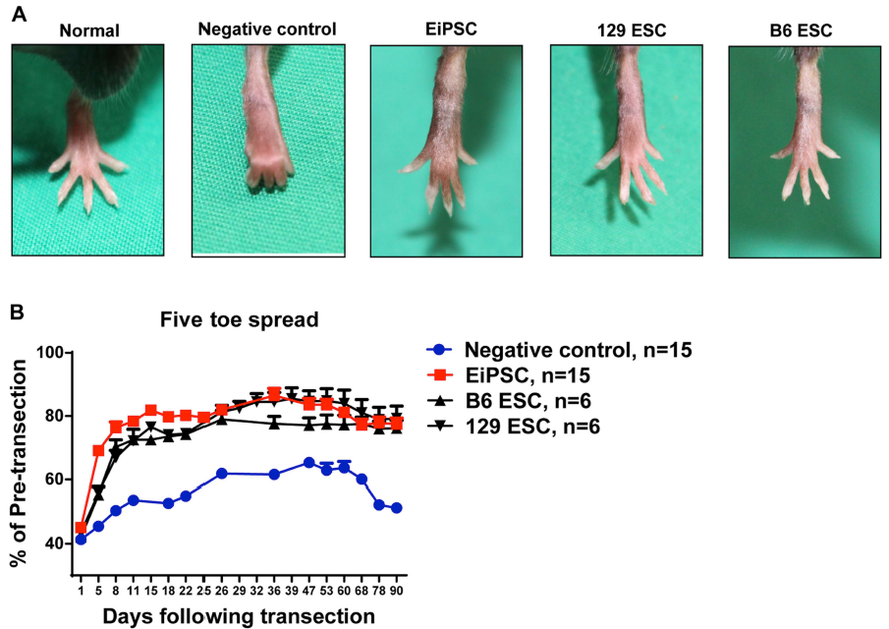

5. What other measurements did the authors perform in order to assess the effects and effectiveness of their treatments?

The authors also performed video gait analysis to measure functional recovery by measuring the ankle angles, where larger ankle angles indicate better muscle recovery, and mid-swing phase angles, where smaller mid-swing phase angles indicate greater muscle power and thus increased recovery.

6. What do the authors measure in Figure 7? What are the results? What is the purpose of those measurements?

Figure 7 shows measurements of five toe spread, examination of the surrounding tissues where stem cell treatments were applied, and H&E examination of various organs in mice from each experimental group, one year after receiving stem cell treatment. The results show that mice which received EiPSCs show improved five toe spread even after one year of receiving the treatment compared to mice that received no stem cell treatment, and mice which received EiPSC treatment showed a similar level of five toe spread compared to mice that received 129 ESC or B6 ESC treatment. Furthermore, normal tissue architecture was observed in all mice that received any of the three stem cell treatments compared to the negative control. The purpose of these measurements are to assess the long-term effects of EiPSC treatment in terms of whether recovery is maintained and whether adverse secondary effects occur, to further show that EiPSC treatment is viable.

7. What is the relevance of being able to enhance peripheral nerve regeneration and recovery? What are the potential applications of the data obtained? What do you think are the next steps in this field?

Showing that enhancement peripheral nerve regeneration and recovery is possible through PSC treatment is innovative because peripheral nerve regeneration and recovery is not normally possible. A potential application of the data obtained could be to use PSCs as therapy for patients who have suffered nerve damage to allow functional recovery. The next steps in this field could be to test the feasibility of using EiPSCs to assess nerve regeneration and recovery in other parts of the body and eventually conducting clinical trials in humans.