Geography 442 | University of British Columbia  December 12, 2010
The Landscape Impact of Power Supply Systems, and the Implications for the Development of a Smart Grid
Adam Cassady

Abstract
To understand the many challenges the North American power grid faces, it is important to acknowledge the interconnected and interdependent nature of the system, as well as understand the engineering constraints that must be overcome to transition the present system of power supply, to a “smart-system” for which it was not designed. Future demand for increasing power flows with higher reliability, security, and protection will undoubtedly stretch the current supply system to its limits and due to the interdependence of the system, the potential ramifications of grid failure could precipitate throughout the economic, social, and environmental regimes of which all are connected. To understand the magnitude of this dilemma, one must first understand the many facets that make up the current power supply system, and the structure that the smart-grid necessitates. This paper will focus on the topic of power delivery through transmission and distribution systems: its present effects on the landscape, and the requirements needed for the transition to a smart grid.

TABLE OF CONTENTS

Introduction 3
1.1 Overview of the Power Grid 3
1.2 Defining the Smart-Grid 6
Present Power Distribution Issues 8
2.1 Environmental Issues 8
2.1.a Bird Mortality 8
2.1.b Corridors 9
2.1.c Edge Effect 10
2.2 Social Issues 11
2.2.a Visual Impact 11
2.2.b Property Value 11
2.2.c Electromagnetic Fields (EMF) 12
2.2.d Social Safety 13
2.3 Economic Issues 13
2.3.a Repair and Maintenance 13
2.3.b Vegetation Management 14
Supply under the Smart Grid 14
3.1 Transmission Systems 14
3.1.a Power Flows and Phase Monitoring 14
3.1.b Flexible AC Transmission System Devices (FACTS) 15
3.2 Distribution Systems 15
3.2.a Power Line Carrier Systems (PLC) 15
3.2.b Selective Load Control 16
3.2.c DG Management and “Islanding” 17
3.3 Smart Metering 17
3.3.a TOD vs. TOU Readings 17
3.3.b Preferential Load Control 18
3.3.c Automatic Meter Reading Through PLC 18
3.4 System Limitations 19
3.4.a Wireless Vulnerabilities 19
3.3.b Appliance Limitations 19
3.3.c System Cost 19
Conclusion 20
Appendix 1 21
Literature Cited 22

Introduction:

This paper will focus on the topic of power delivery: its present effects on the environmental and social landscape, and the requirements needed for the transition to a smart grid. I will first review the current power delivery system as it exists today and outline some important environmental and social issues it raises. I will then explore the future of the energy system and the role that distribution will play. Although the implementation of a smart grid will involve changing many factors of the current energy system, I will focus on the transmission and distribution systems that will be needed to satisfy the spatial arrangement of energy sources, including upcoming distributed generation (DG) systems. This paper will stand to illustrate the problems associated with the current system of energy delivery and why it won’t work for a smart design, and review potential steps that will be needed to facilitate this transition with regard to the delivery process.
1.1 Overview of the Power Grid:
To illustrate the structure of the present power supply system, Peter Fox-Penner’s book “Smart Power”, compares the power grid to a network of ponds of water over a large area. These ponds are all connected to each other through a system of water channels which keep the level of the water the same across the system. When water is added to any of the ponds the channels balance the system by draining the excess, adding it evenly over the system. In this sense the ponds are the power generators, and the channels are the transmission system that connects them together. If the ponds move out of balance, then the system overflows; but if the power grid falls out of balance it will trigger an immediate blackout (Fox-Penner 2010). Consumers can extract water from any pond depending on the size of pipe used, but the sum total of water withdrawals from all users must balance the amount of water added to the pools. The balance of the power system is calculated on a split-second basis, by the power system operators (a balancing authority such as BC Hydro) that monitor and control generation of each “pond”, as it cannot move out of equilibrium. The interconnected grid (i.e. the transmission network) creates the reliable system that we depend on, but also exposes itself to limitations.
To understand the limitations of the present power supply system, it is important to understand the benefits the grid system offers. When the power industry began, each “pond” or community had an individual generator to supply their own power. This created localized community microgrids that were independent from each neighbouring community. To increase system reliability, each microgrid has been connected into a nation-wide grid which provides reliability with regard to system disturbances such as generator malfunction or breakdown. Going back to the pond metaphor, a system disturbance would be analogous to a creek that fills one of the pools - suddenly stopping. If not for the grid, the system would fall out of balance; but because the system is connected via the transmission system, the load demanded by the consumers is distributed evenly over the remaining generators on the grid, and the balance is sustained. “Large power generators trip off roughly 2-10% of the time” (Fox-Penner 2010: 28), but these outages don’t affect the balance for two reasons: because of the interconnected grid, and because system operators are required to keep reserve generators ready at all times; “fully operational and ready to start instantly, much like keeping a idling car at the curb” (Fox-Penner 2010: 28).
There are some proponents that argue for a return to the microgrid model, but this design would require each community to have a generator running all the time as well as a backup generator of the same size ready when needed. With the present grid system, however, each community or region must have a generator running, but can share the cost of the reserve generator with several other communities, drastically reducing the cost of power generation across the grid system (Fox-Penner 2010).
This discussion so far, has summarized power delivery as a single entity, but in reality there are two very different stages of power supply. They are the transmission system and the distribution system (see Figure 1; and Appendix 1).
Transmission lines are the large, high voltage power lines ranging from 33kV to 500kV or more; but within this group there are three sub-categories of lines, (see Table 1). Transmission lines are most commonly seen in rural areas, though there are many areas of urban interface. They are usually located overhead and according to the (Canadian Standards Association. 2001) are required to be a minimum height above the ground (typically 5.8 to 13.3 m depending on voltage class). Transmission lines carry electricity from generating stations (coal, gas, hydro-dams, wind farms, etc.) over long distances; and certain characteristics of the line are employed to reduce energy loss. The resistance in the lines is reduced by stepping the voltage up which in turn reduces the current, and also increasing the diameter of the line which further reduces the resistance. From the transmission lines the energy travels to distribution points called substations where the current is stepped down to a lower voltage (AESO 2007).
 |  | Transmission |  |  |  |  | Distribution
 | Generation | Extra High Voltage (EHV)Transmission |  | Typical Transmission |  | Sub-Transmission | Distribution |  | Consumption
Voltage Range | 2.3-30 kV | +230 kV |  | 230-66 kV |  | 66-33 kV | 33-11 kV |  | 415-240 V
Table 1: Typical voltage ranges of each phase of the power distribution process.
From those substations, the lower voltage distribution lines (typically 11kV) provide electricity to homes, farms, and businesses (see Figure 1). It is these lines that are associated with urban power distribution and is what the majority of the population understands to be a “power line”. It is also these lines which will see the largest change in the future.
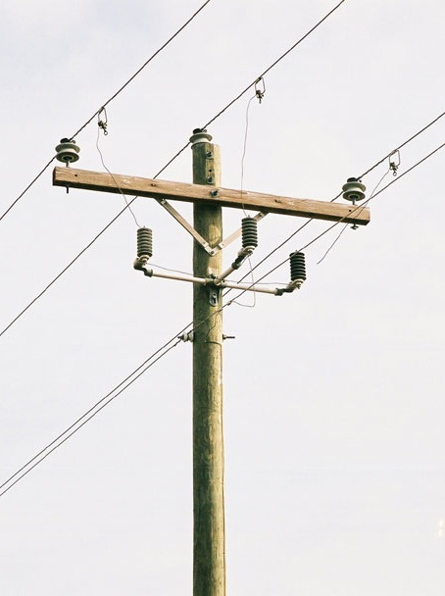
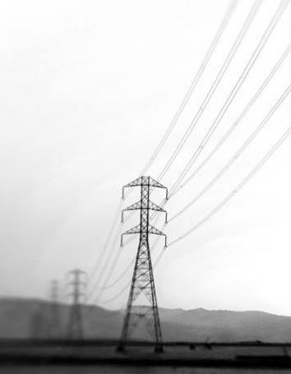

Figure 1. Images of transmission and distribution lines. Left: 345 kV transmission line (Photo source: http://www.dailyyonder.com/power-line-frenzy-hits-rural-america/2009/06/29/2202); Right: 25kV distribution line (Photo source: http://www.electrical-forensics.com/Transformers/Transformers.html).

1.2 Defining the Smart Grid:
The smart grid is an ever-changing concept with undefined boundaries, and as such, a true and comprehensive definition must accommodate the changing technologies and nature of the model. The overarching theme of the smart grid is the idea of increased efficiency at all levels. Smart grid technology can be divided into up-stream and down-stream sectors; where up-stream includes generation, transmission, and some aspects of distribution, and the down-stream sector includes the remaining aspects of distribution, and consumption. The defining features of the smart grid will be broken down and explored in the section titled Supply under the Smart Grid, on page 14.
One of the major advantages the smart grid offers is the facilitation of individual load shifting from on-peak to off-peak-load periods. This action takes place in the down-stream sector, wherein customers can observe price signals (sent to them by the utility company), and arrange their consumption patterns in accordance with the price of energy, at real-time pricing. This will involve three major system changes including: Distributed Generation (DG) technologies, electric vehicles and energy storage, and Demand Response (DR).
Distributed Generation (DG) is a fundamental part of the smart system, and can be defined as generation of electricity either within the distribution system, or on the customer side of the power meter (Ackermann et al. 2000). This differs from traditional power generation which employs large generators that supply power to the transmission system. Distributed generation is of significance because it takes some of the load off large scale generators and reduces the need for building more transmission lines. It is usually associated with renewable energy systems such as wind or solar sources, and allows individual homes to reduce their dependence on the grid while providing a clean and renewable contribution to the system.
A second change that the smart grid will offer is the ability to store energy both within buildings and vehicles. The ability to store energy reduces the requirement to balance the system, because with enough storage devices, a majority of the micro-balancing could be done in this way. Energy storage can reduce the cost of energy by reducing peak-load-periods. The storage devices can be recharged during off-peak periods, and then relied on during on-peak times. Plug-in-hybrid-electric-vehicles (PHEV) offer a similar benefit, given that they can be plugged into a building and, depending on the price/kWh at that moment, can either discharge power to the building or draw power to recharge their own batteries (Fox-Penner 2010).
Demand Response (DR) is the ability of consumers to tailor energy consumption based on price signals sent from the distributor, which allows load shifting from on-peak to off-peak periods. While there have been many dynamic pricing models created, they are not created equally. Some models react to weekly/daily changes, or 12 hour periods, some to hourly changes, and some react to changes in pricing per minute; obviously the more accurate or dynamic the model is, the more efficient (and complicated) it is. One thing all dynamic pricing rates have in common is that they are “designed to be profit neutral to the utility…the utilities short-term profits don’t change when these rates are implemented – the changes in customer payments induced by these rates equal the utilities cost savings (Fox-Penner 2010: 41). This means that DR offers large cost savings that are provided entirely to the consumer.
Under the smart grid, the up-stream sector will experience a much less drastic change in technologies and function than the down-stream sector, because many of the tools that are to be implemented have already been used for some years (although their use so far has been limited). The up-stream changes will allow more accurate monitoring and control of power flows, will seek to increase efficiency by reducing system losses through resistance, and will lessen the likelihood of power failures or blackouts (Fox-Penner 2010).
Present Power Distribution Issues:
  - Environmental Issues:
2.1 a. Bird Mortality
Although both transmission and distribution lines cause significant bird mortality, the ways in which this occurs is quite different. Generally transmission lines are associated with bird collision and distribution lines are associated with electrocutions.
Transmission lines rarely cause electrocution as their energized parts are held far enough apart that contact with more than one part is unlikely. The majority of avian mortality associated with transmission lines is therefore caused by collision with the lines or towers, and more often than not it can be attributed to the overhead shield wire. The shield wire is located above the energized wires and protects the system from lightning damage. This wire is smaller in diameter than the energized wires which makes it harder to see. Birds will often swerve away from the main lines, only to strike the shield wire. Although bird strikes are more common than electrocution, they are rarely seen or recorded because it hardly ever causes damage to the infrastructure (Heck 2007).
Distribution lines have energized parts close together which increase to chance of animal electrocution, especially larger raptors as they tend to use distribution lines for nesting, roosting and hunting (Heck 2007). The frequency of bird and bat electrocutions is well documented in some areas and is an ever-present public concern.
2.1 b. Corridors
Power lines create linear corridors which affect the movement and distribution of many wildlife species. In Alberta, woodland caribou populations have declined significantly in response to anthropogenic development of wild areas, especially the creation of corridors for infrastructure development (roads, seismic lines, pipelines and power lines). These linear corridors are extremely long and straight strips of open land with long sight-lines which is changing the predator-prey relationship between wolves and woodland caribou. Wolves naturally prey on woodland caribou, but the frequency and magnitude of predation along with the extent of wolf range is increasing due to infrastructure development. Wolves avoid open areas and roads; however, corridors that see little human activity become easy travel routes and areas for hunting (James et al. 2000). The long sight lines allow prey detection over long distances, but predation is also aided by the winter snow pack. Snow drifts into the corridors creating a hard crust on top of the softer snow below. Wolves are light enough to be able to move on top of this hard crust while their larger prey breaks through and is significantly slowed down. Caribou, like many wild species, generally avoid clearings but with the increasing frequency of infrastructure corridors fragmenting natural habitat, many species are forced to cross more open clearings that they would otherwise have avoided. “Caribou that have had previous encounters along corridors may avoid them as a learned anti-predator strategy” (James et al. 2000: 157). Humans also use anthropogenic corridors to hunt and as a route for off-road travel which again, will significantly increase wildlife avoidance of corridors and open areas entirely.
2.1 c. Edge Effect
The creation of corridors through forested areas dramatically increases the interface zone of open and closed canopies, a phenomenon known as “the edge effect”. This effect has negative implications with regard to natural species diversity (especially shade tolerant vegetation), and the consequences of edge can radiate up to 15 meters into the standing natural forest. This means a power line corridor 30 meters wide can have an influence field up to 60 meters in width (Luken et al. 1991).
“In forests already fragmented by development activities, the presence of a single power-line corridor may render forest patches unsuitable for plant and animal species requiring large forest interior habitats” (Luken et al. 1991: 315). Depending on the aspect of the clearing, the edge area will experience an increase in solar radiation which will dry soils and create different growing conditions that may not reflect natural conditions (Luken et al. 1991), and may facilitate the establishment of invasive species that are associated with anthropogenic disturbances. Linear corridors also increase wind velocities by funnelling airflow through the straight, narrow clearing. Forest edges are consequently prone to wind damage because the trees along the newly created edge have developed a rooting structure that relies on surrounding vegetation to buffer the effects of wind. Trees can increase their wind-firmness with time, but this involves a transition to increases in wind velocity. Once a clearing is created, the remaining trees are subjected to an instantaneous increase in velocity and will eventually blow down.
  - Social Issues:
2.2 a. Visual Impact
The visual impact of power lines is a major concern of the public, more so with transmission lines as the towers are taller which increases the width (varying from 10-100m) of the right-of-way (ROW), making the power line visible for a greater distance and altering the scenery of the visible landscape (Luken et al. 1991). In urban areas the visual impact is also important as distribution lines create visual clutter and reduce the visual quality of city landscapes.
2.2 b. Property Values
Residential property value is related to both the proximity to the transmission line easement (ROW), and the proximity to the towers on the line. Generally, property value increases as the distance from the line increases, but at a decreasing rate. This means that the economic impact related to property values decreases as the distance from the line increases (Elliott et al. 2002). The impact of transmission lines on property values is also lessened through time, meaning that as time progresses this impact on property values decreases. The impacts of transmission corridors on property values also vary with regard to the voltage and height of the lines. In some cases there is actually a positive effect on property values adjacent to transmission line easements. In these cases the corridor is viewed as an area with use potential for community gardens, playgrounds, green belts, etc. (Elliott et al. 2002).

2.2 c. Electromagnetic Fields (EMF)
Transmission and distribution lines transmit energy at different voltages and currents, but all lines create electric and magnetic fields around them. These two types of fields are usually combined to determine their effects and are referred to as Electromagnetic Fields (EMF). For the purpose of this paper the two fields will first be identified separately, and then combined to examine the total effect of EMF fields on the landscape.
Electric fields are a result of the voltage gradient on the surface of the conducting line. These electric fields are strongest at the line but dissipate as the distance from the line increases, and are influenced by obstacles such as vegetation or structures which shield much of the electric field. Higher electric fields are associated with larger voltage lines which means transmission lines are more likely to create electric fields that influence their environment (Gill 2002).
Magnetic fields occur as a result of the current in the line, and change depending on the electrical load on the line. The magnitude of these fields decay as the distance from the line increases, but unlike electric fields, magnetic fields are not influenced by shielding obstacles.
Despite large amounts of research on the topic of Electromagnetic Fields (EMF), the resulting biological effects are still unclear. Some biological systems are incredibly sensitive to electric and magnetic fields, especially aquatic systems. Both terrestrial and aquatic organisms use these fields for navigation, and in 1992 Kirschvink et al. discovered magnetite (an element reactive to magnetic influences) in human tissue within the brain. “Strands of magnetite function like compass needles to help one-celled bacteria navigate. Magnetite has been found in homing pigeons, salmon, dolphins, tuna, bats, and honeybees, and may be part of their navigational systems” (Rabinowitz 2002: 4). At present there has been significant research and scientific publications that argue everything from adverse to positive effects of EMF, and everything in between. As such, there is no scientific consensus on the topic. Despite these discrepancies, it is not wise for electric utilities to ignore the possible effects and as such, much of the research has been done in association with utility companies.
2.2 d. Social Safety
There is, and always has been, a level of social trepidation surrounding transmission and distribution lines regarding personal and community level safety issues. Due to public advertisements and educational programs in the schooling system, most citizens are aware of the dangers of overhead power lines and avoid them at all costs. In recent times there has been an increase in public awareness with regard to underground or buried lines, but when compared to the United States, Canada falls short of preventative measures to safeguard its public. In the US there is a national “one call” program to request a certified technician to locate and mark buried lines. Canada has similar programs in 5 of its provinces that work like the American system, but the number to dial changes with each province, enforcement regulations within Canada have a low conviction rate with regard to buried power or gas-line strikes, and Canadian utility companies are not required to participate. A buried line strike in the United States is considered very serious and requires a mandatory court appearance. This severe outlook regarding public safety has reduced the number of buried line strikes dramatically.
2.3 Economic Issues:
2.3 a. Repair and Maintenance
At present, there is no method of fault detection or way to identify potential problems with transmission or distribution lines. Repairs are made after the system has failed which creates inefficiencies in the supply system, reduces equipment life, increases waste, and adds to landfill accumulation (Pratt 2010).

2.3 b. Vegetation Management
Utility companies treat right-of-way (ROW) areas to allow access for maintenance of lines and to prevent vegetation from growing up and contacting the overhead lines. Vegetation management costs for treatments such as brush clearing, danger tree removal, and herbicide applications can cost as much as $260/acre/year (Johnstone 1990). Russel et al. suggest that power line ROWs should be managed as habitat rather than waste-land, and the vegetation management practices should be changed to increase biodiversity with respect to native bee species. They further suggest that these areas should be managed in a way that reduces pesticide use and periodic mowing, and encourages floral and nesting resources for bee populations (Russel et al. 2004).
Supply under the Smart-Grid:
3.1 Transmission Systems:
3.1 a. Power Flows and Phase Monitoring
In their current state, transmission systems measure power flows and relay the data back to a power systems operator in a regional control center to keep the system in equilibrium. Both Canada and the United States use a power system wherein the current and voltage oscillate at a frequency of 60 Hz, but they don’t oscillate in phase (synchronization). In order to transmit energy from point A to point B the line needs to have different phases at each end, but the line will not transmit power if the difference in phase becomes too great. At present there are very few measurements of phase taken, but new technologies are now making the monitoring and measurement of these lines more feasible which will increase the efficiency and stability of the whole power system (Morgan et al. 2009).

3.1 b. Flexible AC Transmission System Devices (FACTS)
“Power flows through transmission grids in accordance with the laws of physics, not the laws of economics. This means that often it will flow in parts of the network where it is not wanted, and not flow in places that would be more economically desirable” (Morgan et al. 2009). New technologies are emerging to overcome this obstacle by changing the electrical properties of the lines which facilitate bi-directional flow where it is needed. In a sense the energy becomes more like a fluid under pressure and flows from areas of high concentration to those of lower concentrations, from generation to consumption. The mechanisms used to control the properties are known as Flexible AC Transmission System devices or (FACTS), and at present their feasibility is highly dependent on the location within the system, but if correctly placed, they offer considerable cost savings and effective power allocation (Morgan et al. 2009). Large scale implementation of FACTS has the potential to offset the construction of new transmission lines which will reduce the economic, social, and environmental strain on the transmission system (de Oliveira et al. 1999). While these devices appear to be an easy and effective strategy to implement, they are expensive and require advanced system communication and control technology which offset the cost savings they create (Morgan et al. 2009).
3.2 Distribution Systems:
3.2 a. Power Line Carrier (PLC) Systems
A power line carrier (PLC) system is a way of transmitting information through existing power lines at different frequencies, much like radio transmissions; however the information is transmitted through controlled wires. This technology has been around since the 1920’s and has many applications, but stands to offer many benefits for the smart grid system. PLC can be used for detecting system disturbances, load forecasting, power quality improvements, increasing information security, sending price signals to customers, and creating efficient meter reading and billing operations (Cupp. 2008). Information security will be discussed in section 3.4.a, and meter reading operations will be discussed in section 3.3.c.
Transmission systems use high voltage lines between substations as a communication channel for data transfer. This system uses PLC as a communication system for linking the sub-stations and as a backup system for transmitting protection signals to detect system failures (Morgan et al 2009).
Most distribution systems are arranged in a branch-like pattern called ‘distribution feeders’. In a typical feeder the power enters at ‘the root’ and then flows out along the branches to each customer. If the root is damaged by lightning, snow/ice, or a vehicle collision, circuit breakers within the system trip and automatically disconnect the entire feeder system. A smart grid system will connect these distribution feeders together in a grid pattern, so that if one of the roots is damaged, it will be identified immediately through the (PLC) system, isolated and cut off, and the power can be re-routed through an alternative system to reduce power loss to the entire feeder.
3.2 b. Selective Load Control
If a supply failure occurs, such as a generator breakdown by weather or terrorist attack, there will be more demand than supply and the system will fall out of balance. All systems downstream from the failure will black out until either the supply is increased, or the demand is lessened. Under the present system of power supply the only way to reduce demand is to disconnect entire feeders, as was done in California with the rolling blackouts of May 2000 (Fox-Penner 2010). Under the smart-grid scenario, individual loads could be controlled along the feeders so that critical services (such as police and hospitals) may remain in operation. Eventually, the loads within each home could also be controlled to limit the consumption so that power to vital appliances within each home remains intact. Overall this technology is not new, but utility distributors have been slow to utilize it because it provides most of the benefits to the customer with all of the cost resting on the individual utilities (Morgan et al. 2009).
3.2 c. DG management and “Islanding”
Distributed Generation (DG) systems have many advantages over large central-station power plants. They make electricity and produce usable heat, relieve stress on transmission and distribution systems, increase the reliability of the power supply to customers, and they are usually clean energy supply sources. During a power failure up-stream these DG’s would allow for a partial system disconnect, which would create isolated “islands” or micro-grids that serve only the vital loads in each community. As of right now this is not attainable due to legal, regulatory, and technical reasons (Morgan et al. 2009).
3.3 Smart Metering:
3.3 a. TOD vs RTP readings:
Utility companies have traditionally billed customers based on monthly or seasonal periods, averaging total consumption over this time onto each bill. One of the main functions of this monthly rate schedule was to encourage consumption by gradually reducing the average price per kWh, as monthly use increased. This method was the best case scenario in a time when wireless technology and the internet didn’t exist; but now that these and other technologies are available, there is a great opportunity to update the system which will drastically increase the reliability and efficiency per customer, and across the system (Fox-Penner 2010).
Time of Day (TOD) reading has been implemented in some areas, particularly in the United States, as a trial run or step toward the real-time-pricing system. The TOD system is based on two settings, “on-peak” and “off-peak”, calculated each day. “These meters bill at a higher price at a time of day when the demand for power is typically high, regardless of actual demand on that particular day” (Morgan et al. 2009: 1).
Real-time-pricing (RTP) meters will receive information from the distributor at a selected time step, usually every 1-5 minutes, this will allow users to arrange their consumption patterns based on the up-to-the-minute price per kWh. This technology is available now; however the high cost, complexity, and volatility of pricing, along with the uncertain security of this system have created high barriers to transition (Morgan et al. 2009; Fox-Penner 2010).
3.3 b. Preferential Load Control
With dynamic pricing, customers will be able to control their loads, spreading consumption more evenly throughout the day. Large draws like AC and heating can be “cycled” on or off depending on price signals from the distributor, and other appliance such as washing machines can be given price parameters so that they only turn on when the price per kWh is below a specified threshold. This involves minor discomfort to the user but provides them with cost savings, and energy savings to the system (Fox-Penner 2010).
3.3 c. Automatic meter reading through (PLC)
PLC systems, as discussed in section 3.2a, involve the transmission of data through power lines in either direction. Price signals can be sent to the meters (via PLC) to provide accurate and dynamic pricing, but data can also be sent from the meters to the transformer or sub-station, to provide the utility with individual load demands for billing purposes and for accurate load requirements, a bi-directional transmission of data. This will reduce the overall cost because energy supply can be tailored directly to energy demand, utility disconnects and connections can be done immediately and remotely, and the cost of meter reading will be reduced as it will be done remotely as well (Morgan et al. 2009; Fox-Penner 2010).

3.4 System Limitations:
3.4 a. Wireless Vulnerabilities
A large portion of the new technologies proposed for the smart-grid systems rely on communication between various components, and much of this will involve wireless communication that relies on the internet to data transfer. This introduces a serious vulnerability with regard to unauthorized access or tampering, be it foreign or domestic. For example a burglar could hack into the system and monitor the domestic energy consumption of a particular home to determine when it is occupied or empty, or hackers could get into the main system from around the world to cause system wide failures or blackouts. While the PLC system reduces this weakness, the threat must still be acknowledged.
3.4 b. Appliance Limitations
Appliances must be able to receive the price signals sent from the meter, and must be equipped with automatic switches to turn the unit on or off. “At the moment there are only a few commercially available household devices that can be programmed to take hourly price signals and adjust automatically” (Fox-Penner 2010: 42).
3.4 c. System Cost
The total estimated cost to transition the present system of power delivery to a smart system ranges from $100 billion to over $1.5 trillion, depending on the time-frame, for the United States alone (ASCE 2010). While these numbers are substantial, it should be recognized that this won’t be a one-time payment. The majority of investment will likely come from private investment and utility companies seeking to profit from the benefits of lower production costs and higher demand for cleaner energy. Some of this cost will be passed on to consumers in the form of higher peak rates, and the households that can’t afford to purchase smart grid equipped appliances or meters will undoubtedly experience these added costs. It will take careful planning and sequential installation to make the transition possible, but more importantly it will also take time to implement.
Conclusion:
It is clear that the future of power generation will be vastly different than the system we see today. It will need to be an industry that provides the highest level of reliability, security, and protection, within the limits of social and environmental sustainability. Most of the changes required will create regulatory conflict, especially with regard to the allocation of costs and benefits. It is also clear that the present system of power supply is, and always has been, flawed in many ways and any change in the way power is allocated needs to address not only the new issues related to the smart grid and climate change, but also the problems that have been and still are present today.
The smart grid offers a solution to many of today’s problems, but it should not be viewed as “the answer” to all of the problems our society faces. Like all technological fixes, the smart grid is only a piece of the puzzle; the remaining pieces are in each of our hands. It is up to us as a collective society to work together and construct a viable solution. As Albert Einstein said, “We cannot solve the problems that we have created with the same thinking that created them.” The changes that the smart grid necessitates must accompany changes in society, with regard to lifestyle changes and community cooperation.

Appendix 1: The 4 Stages of Energy Supply

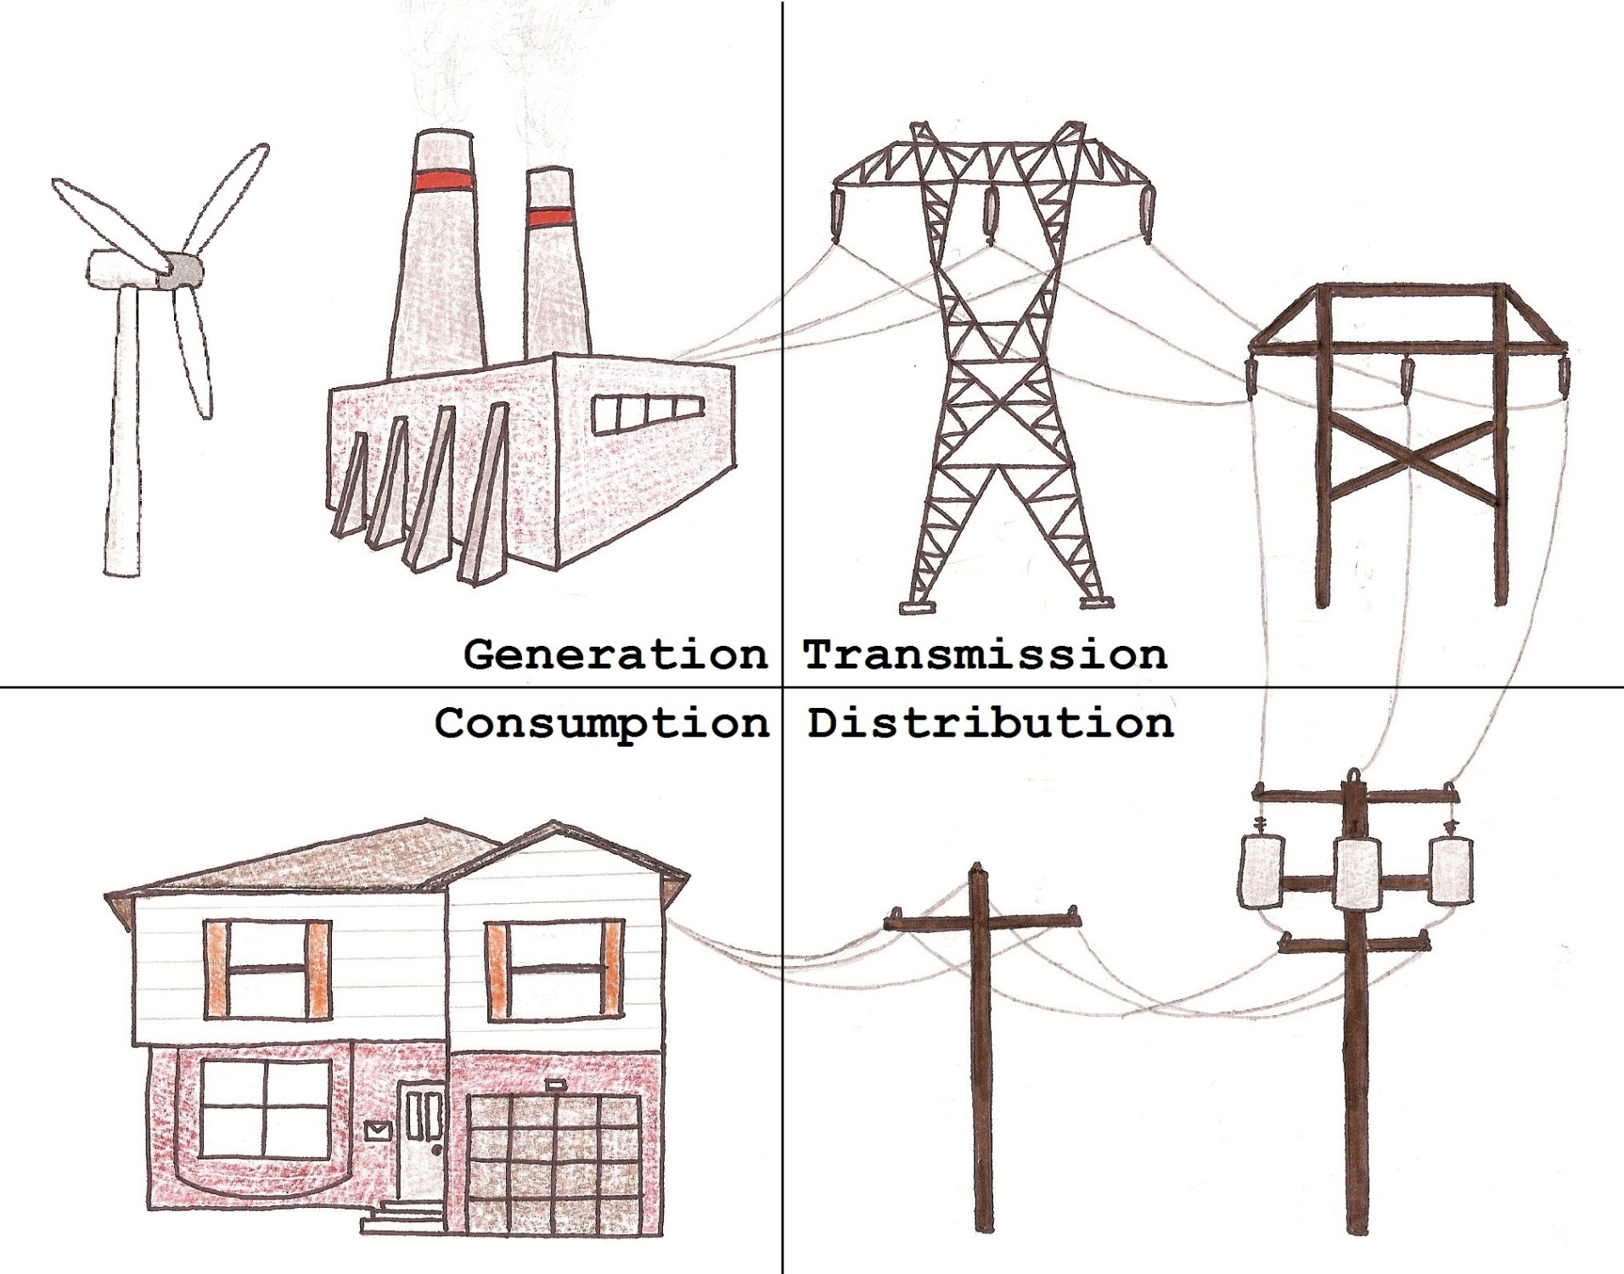

Literature Cited:
Ackermann, Thomas., Goran Andersson, Lennart Soder. “Distributed Generation, a definition.” Electric Power Systems Research vol. 57 (2001): 195–204

AESO (Alberta Electric System Operator). “Electricity at work, Powering Alberta.” 1.1 (2007): 2 –3.

ASCE (American Society of Civil Engineers). “Policy Statement 484 - Electricity Generation and Transmission Infrastructure.” http://www.asce.org/Content.aspx?id=8387. Accessed December 12, 2010

Canadian Standards Association. “Overhead Systems.” CSA Standard C22.3-1-01 (2001): 174.

Cupp, James. Mike Beehler. “Implementing Smart Grid Communications.” Burns & McDonnell Marketing, Communications, 2008.

Elliott, Peter., David Wadley. “The Impact of Transmission Lines on Property Values: Coming to Terms with Stigma.” Property Management 20.2 (2002): 137-152.

Fox-Penner, Peter. Smart Power. Washington, DC. Island Press, 2010. Print.

Gill,Ramandeep. Electric Transmission Line Routing Using a Decision Landscape Based Methodology. Diss. Punjab Technical University, Jalandhar, 2002. Print.

Heck, Nicole. “A Landscape-Scale Model to Predict the Risk of Bird Collisions with Electric Power Transmission Lines in Alberta.” Diss. University of Calgary, Alberta. 2007.

Industry Canada. 2003. “Electric Power: A Canadian Specialty.” http://www.dfait-maeci.gc.ca/trade/ner/electric-en.asp, Accessed November 27, 2010.

James, Adam., Kari Stuart Smith. “Distribution of Caribou and Wolves in Relation to Linear Corridors.”
The Journal of Wildlife Management, 64.1 (2000): 154-159.

Johnstone, R. “Vegetation management: mowing to spraying.” J. Arboric, 16.0 (1990): I86- 189.

Kirschvink, Joseph., et al. “Magnetite in Human Tissues: A Mechanism for the Biological Effects of Weak ELF Magnetic Fields.” Bioelectromagnetics Supplement 1 (1992): 101-113.

Luken, James., Andrew Hinton, Douglas Baker. “Forest edges associated with power-line corridors and implications for corridor Siting.” Landscape and Urban Planning 20.0 (1991): 315-324.

Morgan, M., et al. “The many meanings of ‘Smart Grid’.” Department of Engineering and Public Policy, Carnegie Mellon University, July 2009: 1-5. Print.

de Oliveira, E., J. Marangon Lima, J. Pereira. “Flexible AC transmission system devices: allocation and transmission pricing.” International Journal of Electrical Power & Energy Systems 21.2 (1999): 111-118.

Pratt, R.G., et al. “The Smart Grid: an Estimation of the Energy and CO2 Benefits.” Study commissioned by the US Dept of Energy, PCNNL-19112, Revision 1 (2010): 21-143. Print.

Rabinowitz, Mario. “Power Systems of the Future.” IEEE power engineering review 20.8 (2002): 1-4.

Russel. K.N., H. Ikerd, S. Droege, “The potential conservation value of unmowed powerline strips for native bees” Biological Conservation 124 (2005): 133–148

