Reviewed definition

In this assignment, I will define the term Positron Emission Tomography (PET) scan. The following paragraphs will include three definitions of Positron Emission Tomography (PET) scan, as the goal of this assignment is to appreciate the importance of definitions in technical writing and to be able to differentiate between levels of detail.

Term: Positron Emission Tomography (PET)

**Parenthetical**

Positron emission tomography scan (a medical test)

**Sentence**

A positron emission tomography (PET) scan is a neuroimaging technique which shows the structure and functioning of the brain by observing blood flow in areas of the brain that are more involved in a specific cognitive process.

**Expanded**

What is a positron emission tomography (PET) scan?

Positron emission tomography is one of the most used methods of neuroimaging. The goal of a PET scan is to reveal the structure and functioning of the brain during a cognitive process.

How does a PET scan work?

Glucose is injected into the blood stream, which then travels to the brain. By performing a specific cognitive process, doctors will be able to observe areas of the brain that help to regulate that function. These regions will appear as bright spots on the PET scan because the glucose will travel to areas of higher activity.

When/why is a PET scan used?

Your doctor may order a PET scan to inspect blood flow, oxygen intake, or the functioning of your organs and tissues. PET scans are commonly used to detect cancer, heart problems, brain disorders, as well as problems with the central nervous system which can include Alzheimer’s disease, depression, epilepsy, and Parkinson’s disease. PET scans may also be administered to both healthy infants and children, as well as children who have experienced brain damage. Children who suffer brain injuries allow doctors and scientists to examine powerful information regarding brain structure and function by using PET scans.

How does a PET scan compare to other tests?

PET scans show changes which happen at the cellular level, as opposed to CT scans and MRIs which are not capable of showing problems at such levels. PET scans can detect very early changes in your cells, while CT scans and MRIs can only detect changes later on.

Do PET scans have any risks?

PET scans use very little radiation and a small amount of glucose which does not affect the normal processes of the body. However, pregnant women should consult with their doctor before going through with a PET scan because the fetus may be exposed to the radiation which may cause complications.

**Visual:**

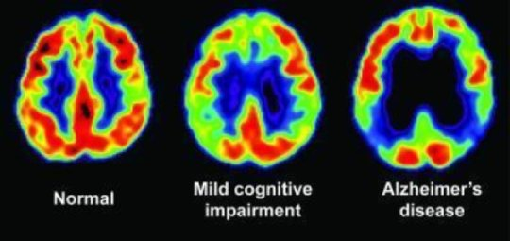

Pictured: PET scan showing normal levels of glucose metabolism, indicated in yellow and red. Patients with mild cognitive impairment (middle) and with Alzheimer's disease (right). Image taken from: https://www.sciencedaily.com/releases/2009/07/090714085812.htm

**References**

B. K., & M. A. (2018, August 27). PET Scan: Definition, Purpose, Procedure, and Results.

Retrieved September 25, 2018, from <https://www.healthline.com/health/pet-scan#purpose>

Kail, R. V., & Zolner, T. (2012). *Children: a Chronological Approach.* Don Mills, ON: Pearson.

PET Scan Test Details. (2017, September 21). Retrieved September 25, 2018, from

https://my.clevelandclinic.org/health/diagnostics/10123-pet-scan/test-details