**How to Cite your Photo**

When you use information that is not your own, you need to record where you got the information.

**For a photo from Flickr, you need the following:**

1. The name of the photographer.
2. The name of the photo.
3. The date the photo was taken.
4. The name of the collection.
5. Flickr.
6. Web.
7. The day the photo was looked at.

**Look at the image below to see where to find this information.**

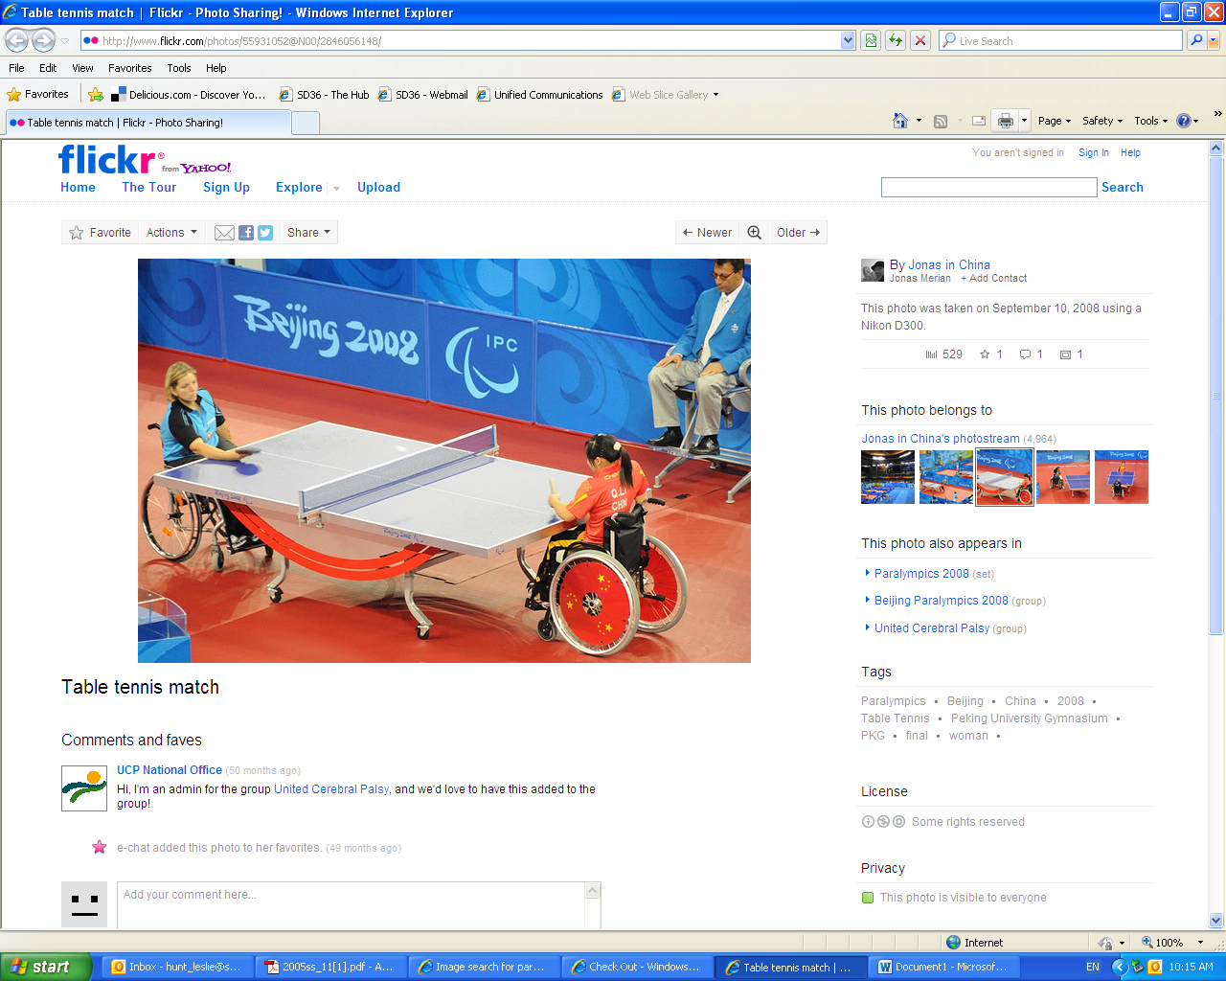

Name of the photo

Date of photo

Name of the collection

Photographer’s name

**This is what your citation will look like once you have all of the information:**

Jonas. Table Tennis Match. 10 September 2008. Jonas in China’s Photostream, Flickr. Web. 17 October 2012.

Name of photographer Date the photo was taken The day the photo was looked at

Jonas. Table Tennis Match. 10 September 2008. Jonas in China’s Photostream, Flickr. Web. 17 October 2012.

Name of the photo Name of the collection

**Record your information here so you can create your citation**

1. The name of the photographer. _____________________________
2. The name of the photo.____________________________________
3. The date the photo was taken. ______________________________
4. The name of the collection. ________________________________
5. Flickr.
6. Web.
7. 29 November 2012.