For this assignment, we must write three definitions of a term we choose: parenthetical definition, sentence definition, and expanded definition. The objective of this assignment is for students to be able to differentiate between different types of definitions, as well as knowing the proper use of them given different type of situation and different audience.
I will be using the term: Calculus. The audience are mostly high-school students or university students with some pre-calculus background but have not taken the actual calculus class yet, thus are still unaware of the term. The objective is to give the audience a little bit of overview of what is meant by calculus and some exposure to the theory used in the field.
Parenthetical definition:
Calculus (a method of calculating continuous change) is an advanced branch of mathematics.
Sentence Definition:
Calculus is a branch of mathematics that deals with calculation of continuous change by working with infinitely small numbers.
Expanded Definition:
Calculus is a branch of mathematics that deals with calculation of continuous change by working with infinitely small numbers. The word calculus origins from Latin word, calculus, which means small pebbles used for counting on a counting frame. Although in general calculus means methods of calculation, in mathematics calculus is often referred as the study of calculation of continuous change by working with infinitely small non-zero numbers. The idea of calculus had been developed in several countries, but it was popularized in the 17th century by Isaac Newton and Gottfried Wilhem Leibniz. These approaches were later known as the two major branches that defines calculus: differential calculus and integral calculus. Although there are other fields in mathematics such as vector calculus, matrix calculus, calculus of variations, etc., when people say calculus, they should be referring to integral and differential calculus.
Differential calculus is the study of derivative of a function. The process of finding the derivative is called differentiation. The idea of differentiation is to measure the rate of change of a function, where you measure the change in the response variable over the change in the explanatory variable. For simple function, such as linear, the rate of change is often defined as slope, and can be calculated in simple steps because the rate of change of a linear is constant.
$$\frac{dy}{dx}=\frac{∆y}{∆x}=\frac{y_{2}-y_{1}}{x_{2}-x_{1}}$$
Equation 1. The differentiation of linear function
However, for more complicated functions, such as quadratic or exponential function, differentiation process involves small measurement by taking limits approaching the arbitrary point because the rate of change at every point is different.
$$\frac{dy}{dx}=\lim_{x→a}{\frac{f\left(x\right)-f(a)}{x-a}=\lim_{h→0}{\frac{f\left(x+h\right)-f(x)}{h}}}$$
Equation 2. The differentiation of functions other than linear
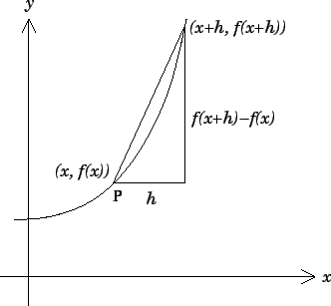

Figure 1. The illustration of derivative

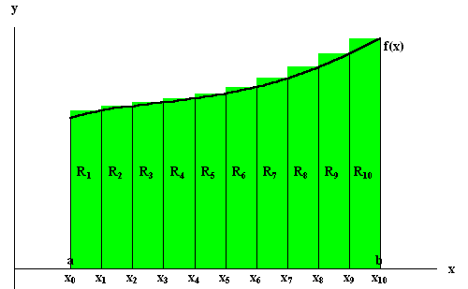
The notation commonly used in differential calculus is $d$ , which means a little bit of. Differential calculus is often used to measure slope, velocity and acceleration of an moving object, as well as optimization, for example to maximize or minimize profit in finance.
Integral calculus is the study of integration of a function. Compared to differential calculus, integral calculus uses method of integration or anti-derivative to calculate the area under the function. The idea of integration is to divide the area under graph into many rectangles of different dimensions and sum them. To avoid overestimation or underestimation of the area calculation, the width of the rectangles is minimized into a very small, but non-zero value, while the length is the corresponding y-value.

Figure 2. The illustration of integration

The notation commonly used in integral calculus is , which means the sum of. Integral calculus is often used in calculating area, volume, and arc length of a function, as well as center of mass, work, and pressure of a system. It’s also widely used in computing probability, power series, and Fourier series.
References:
“Calculus”.Wikipedia.n.d.Web.May 31st 2017. https://en.wikipedia.org/wiki/Calculus
“calchistory”.The History of Calculus.Department of Mathematics of University of Houston.n.d.Web.May 31st 2017. https://www.math.uh.edu/~tomforde/calchistory.html
“Differential Calculus”.Encyclopedia of Mathematics.n.d.Web.May 31st 2017. https://www.encyclopediaofmath.org/index.php/Differential_calculus
Thompson, Silvanus P. Calculus Made Easy. 2nd edition. New York: The Macmillan Company, 1914. 1. Print.
Image Sources:
Figure 1: http://www.pgtc2007.org/maths/calculus/node2.html
Figure 2: http://www.sosmath.com/calculus/integ/integ01/integ01.html

