**Recommendations on Using Visual Notes as Additional Learning Aid for Langara College’s MATH 1150**

(DRAFT)

**For:**

Rebecca Friesen

MATH 1150 instructor

Langara College

Vancouver, BC

**By:**

Lani Diana

UBC ENGL 301 student

July 10th ,2017

**TABLE OF CONTENTS**

Abstract…………………………………………………………………………………….......................iii

Introduction

Overview & Background…………………………………………………………………...……01

Purpose of Study…………………………………………………………………………………01

Methods of Data Collection……………………………………………………………………...01

Scope of Study…………………………………………………………………………………...02

Limitations……………………………………………………………………………………….02

Data Collection

Visual Notetaking vs Normal Notetaking……...………………………………………………..03

Visual Notetaking Technique……….…………………………………………………………...03

Survey Result – Issues in Learning Math……………………………………………………….04

Survey Result – Improvement in Academic Performance After Using Visual Notes…….….....04

Survey Result – Improvement in Study Progress After Using Visual Notes……………………04

Interpretation of Findings………………………………………………………………………..04

Conclusion

Recommendation…………………………………………………………………………….......05

Appendix

References…………………………………………………………………………………….....01

Figures and Tables………………………………………………………………………………01

Survey……………………………………………………………………………………...........01

**ABSTRACT**

**INTRODUCTION**

**Overview & Background**

The objective of MATH 1150 is to prepare students with weak mathematical background the necessary basic algebraic skill required for college/university level. During my time as a tutor in MSAC, students from MATH 1150 whom I tutored sometimes consulted me about how stressful studying math for them. Most of the students who attend MATH 1150 are working adults who had to balance their full-time work and school. Langara College’s Mathematics and Statistics Department offered several accessible learning aids such as instructor’s office hours and Math and Stats Activity Center (MSAC), however some students were still unable to utilize those aids due to their busy schedule.

**Purpose of Study**

As a result, studying math became even more frustrating and often led students to use the wrong method to learn, where they either memorize the steps or do several trial-and-error until their answer match the solution, without understanding the nature of the problem. Unsurprisingly, many students who resort to these methods often fail their tests, and this adds on more to their stress.

Given the issue, one possible solution is to provide students with a new learning aid that is flexible of their schedule, such as online visual notes. Visual notetaking is a process of visualising ideas artistically using doodles and colors. According to an article by a molecular biologist, John Medina, humans learn and remember better using visual rather than audio. Pictures work better than texts since human’s brain “sees words as lots of tiny pictures, and we have to identify certain features in the letters to be able to read them” (Medina,” Brain Rule Rundown”). A NY times article written by Pam Belluck also mentions the usage of color generally improves performance. The main goal of the usage of visual note is not only limited to improve memorization time and understanding, but also to improve student’s mood when learning using doodles and color. This study is intended to assess the effectiveness of using visual notes as additional learning aid for MATH 1150 students.

**Methods of Data Collection**

To assess the effectiveness of Visual Notes as learning aid, sample of Visual Notes relating to the subject students have studied over the past week will be provided as a mean of review or summary for their weekly quizzes. At their last quiz, students are asked to fill out a survey about their opinion of the Visual Notes. To compare the effectiveness, students were not provided any notes for the first four quizzes, while for the rest of the quizzes, visual notes are provided for them weekly.

**Scope of Study**

This study will assess the effectiveness of the components of visual notes:

* How does color help in highlighting different type of information?
* What kind of visual is appropriate to help digesting difficult terms more easily?
* What kind of sketch noting technique is appropriate?
* Do the visual notes help students illustrating the problem more easily?
* Do visual notes make studying math less stressful?

**Limitations**

Since this study is intended to only MATH 1150 students, the sample size for the survey would be relatively small. In addition, math is a subject that requires a lot of sequential steps that can’t be graphically displayed, thus the nature of visual notes can’t be optimized. Unless they were important terms to remember or some graphs students need to know, doodles can’t be used as frequently as it could’ve been in other subjects such as history or physics. To compromise with the lack of graphical usage, colors are often used to emphasize important information and combination of note-taking technique are used depending on the content of the note (for example, if the note was mainly about important terms to remember, the notes will be arranged using mapping method, whereas when the note is mainly about steps to solve the question, the notes will be arranged using outlining method).

**DATA COLLECTION**

**Visual Notetaking vs Normal Notetaking**

Visual Notetaking is an interactive way of implementing ideas in a non-linguistic way. Over the years, visual notetaking has been accredited by educators to be an effective way of learning. It implements several theories such as dual coding theory (a theory suggesting that humans’ mind stores verbal representations and mental images that are both required to retain and retrieve knowledge) and picture superiority effect (a theory suggesting that combination of visual and text is better than text alone). The breakdown of the advantages of components of visual notes are as follows:

|  |  |
| --- | --- |
| ***DOODLES*** | ***COLOR*** |
| * Ease tension and boredom * According to a journal “What Does Doodling Do?” by Jackie Andrade, doodling improves concentration * Stimulate ideas for improvement * Alternative to express complex emotions that helps relieving stress | * Color has stronger attention effect than shape, and is effective in increasing memory performance * Helps guiding students to locate, compare, understand and recall information faster * Increases motivation to read by 80% (InkFactory, 2017) |

Overall, visual helps improves audience attentiveness, memory retention, ideas and creativity by a huge margin compared to text and audio.

**Visual Notetaking Techniques**

In visual notes, elements such as doodles, typography, lines/arrows and color are often used to enhance student’s attention. These are the breakdowns of the visual notetaking techniques used in MATH 1150 visual sample notes:

* The use of doodles/pictures to help students remembering important term/techniques. It is also important to use consistent doodles for repetitive sign such as example sign, or warning sign.
* Use non-linear notetaking technique and try to write in an unconfined way by combining Cornell, mapping and outlining method for the note’s layout, with the use of arrows to help pointing out the flow of the note. This is intended to distract students from boredom from repetitive layout.
* The use of different colors to highlight different type of information
  + Warm colours (to stimulate) are often used to highlight common mistake students make, things students should not do.

Ex: Red, Orange, Yellow.

* + Cool Colours (to calm) are often used as a guidance during the steps sequence so students are not confused on the origin of the numbers and helps students to follow the sequential flow easier. Cool colours are also used to highlight suggestions and additional information that is not required, but might help improving their understanding.

Ex: Blue, Purple, Green

* + The use of contrast color to emphasize two completely different method to solve the problem.
  + 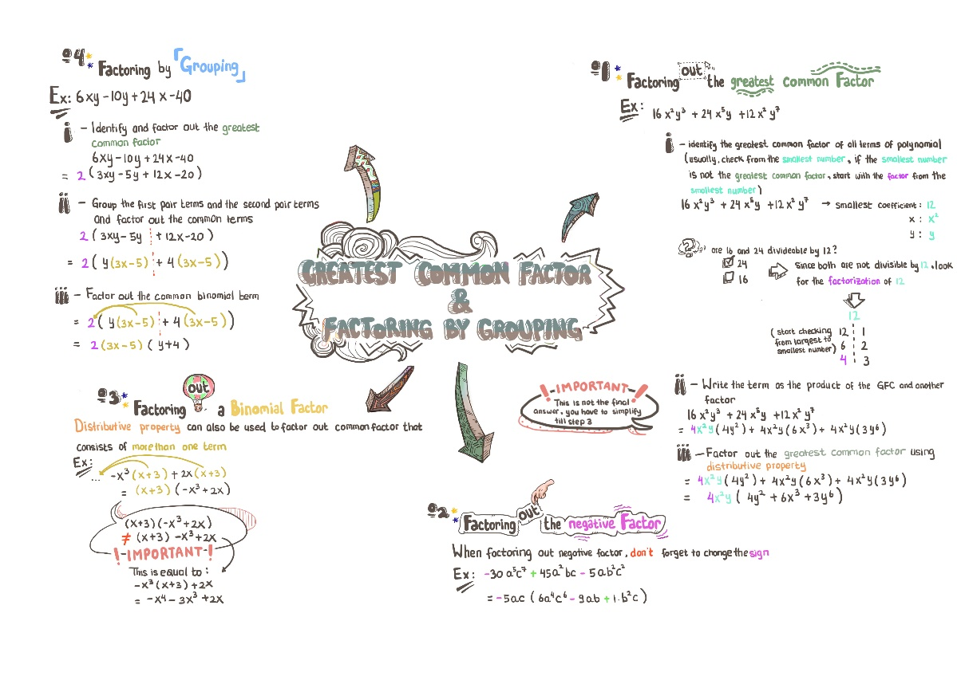The use of monochromatic colour scheme for flow chart/instruction text to help digesting information faster.

Figure 1. The sample of visual note provided for MATH 1150 students

Source: Author’s Library

(The survey is scheduled to be distributed after MATH 1150 students finish their last quiz, which is on July 12th 2017, until then this subsection will be empty. For the graphical use, I’m intending to use bar chart to visualize the percentage of students who find visual note, as a whole, is effective, and pie chart to visualize the percentage of students who find some elements of visual ntoes to be effective)

**Survey Result – Issues in Learning Math**

**Survey Result – Improvement in Academic Performance After Using Visual Notes**

**Survey Result – Improvement in Study Progress After Using Visual Notes**

**Interpretation of Findings**

**CONCLUSION**

**Conclusion**

* (To be determined from the survey)

**Recommendation**

* Aside from using Visual Notes to help improving students’ performance, the usage of interactive visual presentation during lectures will also help
* Instead of using Visual Note as a review material, it might be more effective to use it as a pre-reading material for students before the class, so students are familiarized with the basic concept, and instructor can spend more time discussing more complicated concept during class time.

**REFERENCES**

“Notetaking Systems”. *Cal Poly*, n.d. http://sas.calpoly.edu/ASC/ssl/notetakingsystems.html. Accessed 10 July 2017.

“The Powerful Science Behind Visual Note-Taking”. *Ink Factory*, 26 January 2017 http://inkfactorystudio.com/powerful-science-behind-visual-note-taking/. Accessed 10 July 2017

Andrande, Jackie. ” What Does Doodling do?”. *U of Plymouth: Applied Cognitive Psychology*, 10.1002/acp.1561, 27 February 2009. <http://pignottia.faculty.mjc.edu/math134/homework/doodlingCaseStudy.pdf>. Accessed 10 July 2017.

Belluck, Pam.”Colors might affect performance, study suggests”. *The New York Times*, 6 February 2009. <http://www.nytimes.com/2009/02/06/health/06iht-color.1.19983382.html>. Accessed 7 June 2017.

Dzulkifli, Mariam Adawiah and Muhammad Faiz Mustafar. ”The Influence of Colour on Memory Performance: A Review”. *The Malaysian Journal of Medical Sciences : MJMS*, Penerbit Universiti Sains Malaysia, March 2013. <https://www.ncbi.nlm.nih.gov/pmc/articles/PMC3743993/>. Accessed 10 July 2017.

Jan, Jana.” How colors can enhance memory performance?”. *Edynco*, 13 January 2014. <https://blog.edynco.com/instructional-design/how-colors-can-enhance-memory-performance/>. Accessed 10 July 2017.

Medina, John.”Brain Rule Rundown”.*vision-brain rules*, n.d. <http://brainrules.net/vision>. Accessed 7 June 2017.

Scammell, Margaret, and Holli Semetko. SAGE Handbook of Political Communication. London: SAGE Publications, 2012. Print.

Shellenbarger, Sue. ”The Power of the Doodle: Improve Your Focus & Memory”. *The Wall Street Journal*, 29 July 2014. <https://www.wsj.com/articles/the-power-of-the-doodle-improve-your-focus-and-memory-1406675744>. Accessed 10 July 2017.