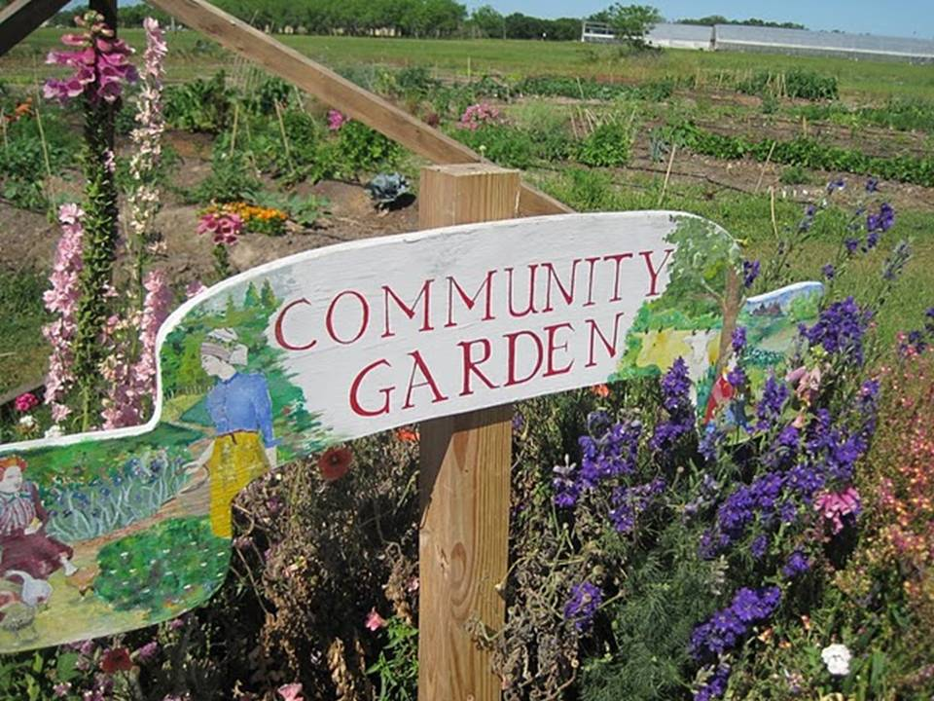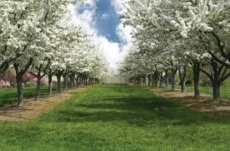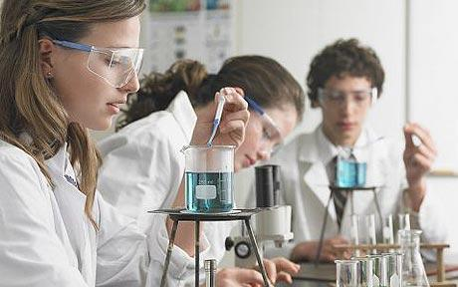

At Orchard View we focus on establishing teacher- student relationships. There are 2-3 formal teacher-student conversations that report on student progress, ways to improve and goal setting. Additionally we have 2 parent-teacher interviews each semester.

### **By: Rum M. Leona O.**

**Rayman D. Dalyce F. Lucy L. Trevor R.**

Orchard View

**…We Embrace & Uphold The Importance Of Multiculturalism..**

**Social Justice**

**About Me Square:** Together as a school we will each make a square to be displayed throughout the school. The squares represent the self as an individual, as a group, collaboration, equal space, voice and freedom of creativity. Each year will have a different theme. Please feel free to come by and check it out!  
**Community Garden**Serves as a project that each of the different disciplines of the school can use as part of their lessons. Student’s can carry the skills they learn working in the garden into the community and their homes. Student’s will host a monthly famers market and the Home Economics Department will also use the food produced in the garden within their lessons

## **Assessment**

### **Orchard View Secondary**

**Diversity**Our school is located in the 3rd most ethnically and culturally diverse community in Canada and we embrace and uphold the importance of multiculturalism here at Orchard View. One example of this is our weekly culture based meals made by our very own Home Economics Department.

**We strive to foster an environment that facilitates well-rounded citizens who work towards their passions through curiosity, being creative, achieving personal success, and a sense of social responsibility**

**Pedagogy**  
  
Our school has a wonderful volunteer program that allows students to experience the workforce or the benefits of giving back to the community. Students in grades 11 & 12 are expected to complete 50 hours of paid or non-paid work experience to meet graduation requirements.

**Classes Offered**  
English, Math, Science, Home Economics, Art, Band, Tech. Ed., Physical Education, Drama, Socials, History, Law, French, Spanish, Mandarin, Punjabi, Agricultural Studies, Business

**Diversity•Responsibilty•Community** 

**Social Responsibility**

Our school praises Social Responsibility and encourages our staff and students to practice it. Our senior students can earn credits by spending a block peer tutoring juniors. The whole school also has an opportunity to experience Social Responsibility with a weekly student presentation on a social aspect of their choice.

…….