**Big Ideas**

* Generalizations, Principles, *real-world connections*
* What students ***will understand***

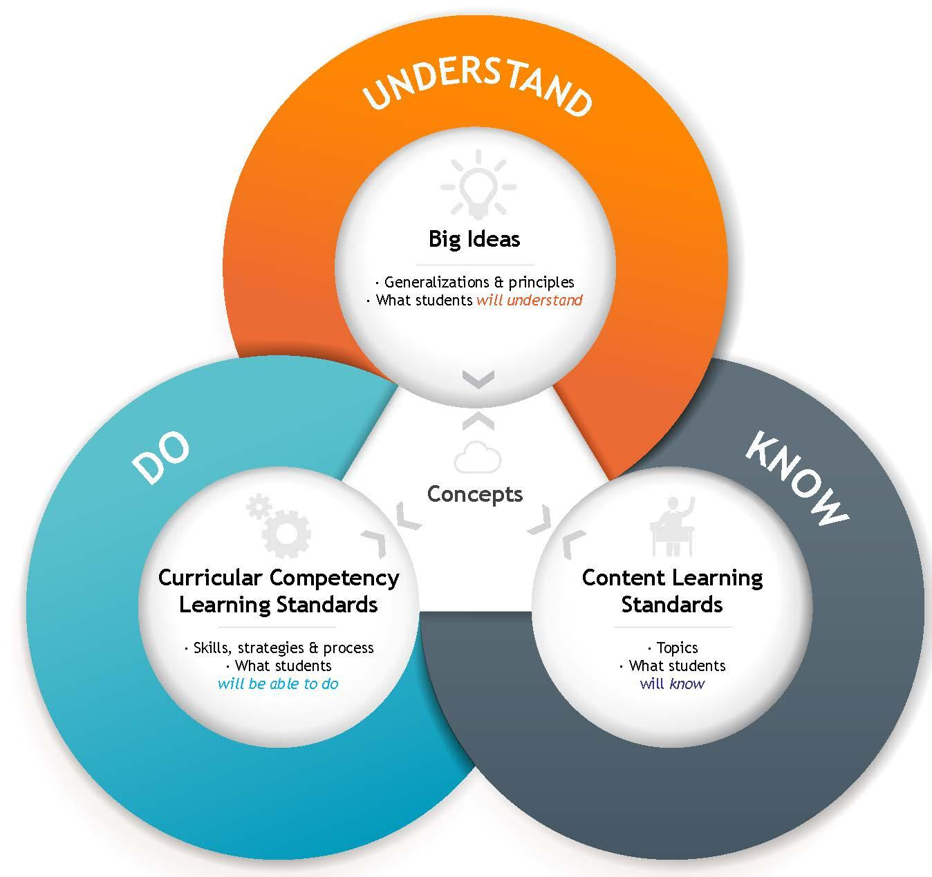

**Curricular Content**  (Learning Standards)

* Topics
* What students ***will know***

**Curricular Competencies** (Learning Standards)

* Skills, strategies & processes
* What students ***will be able to do***