Invertebrates in the Soil

The objectives of the module were for students to:
Learn the difference between insects and arachnids
Identify the diversity of shapes and sizes in soil arthropods
Identify the components of a soil extractor
Explain how a soil extractor uses heat to extract arthropods
Use a glass slide and pipette to place a soil arthropod under the microscope
Extrapolate how many insects were found in small amounts of soil, to how many would be found in the size of their backyard
Recognize the presence/prevalence of soil arthropods everywhere in their surroundings

Purpose/Interest:
This module is a great way for students to have a first glimpse at what is literally going on around them everyday. It allows for students to get an in-depth perspective on the ecology of soil arthropods, and really emphasizes how small these organisms are. For many students, seeing soil mites will be the first time they have ever seen an organism which has those characteristics (and is this small).

References:
Most of my references for this module come from my own research experience. One excellent guide for this is:

Walter, D.E., S. Latonas, and K. Byers. 2011. Almanac of Alberta Oribatida. Part 1. Ver. 2.3. The Royal Alberta Museum, Edmonton, AB. http://www.royalalbertamuseum.ca/research/lifeSciences/invertebrateZoology/research.cfm

Another reference which shows how a Berlese soil extractor is made can be found:
http://www.ecoplexity.org/files/Berlese%20teacher%20and%20student%20directions.pdf

Secondary Sources:

Krantz, G. W., and Walter, D. E. (EDS.) 2009. A Manual of Acarology. Third Edition. Texas Tech University Press; Lubbock, Texas, 807 p

Walter, D.E. and H.C. Proctor. 1999. Mites: Ecology, Evolution and Behaviour. University of New South Wales Press and CAB International.

Materials:

Pop bottles empty (x3)
Metal mesh (1 sheet cut into three pieces)
Three collection containers (glass cups)
Plaster of Paris (~ 4 tablespoons to put in the bottom of the glass cups)
Cheesecloth (1 sheet)
1 lamp
Dissecting microscopes (1 per two children)
Glass dishes for observing mites (1 per two children)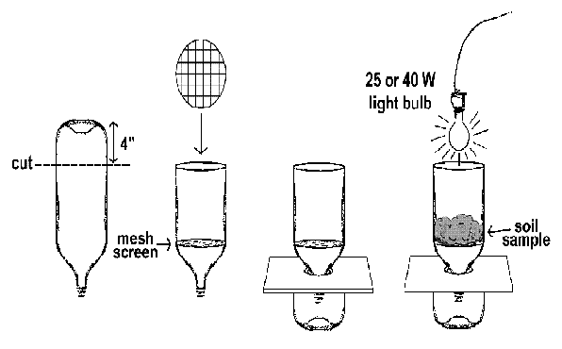

Pre-Assessment:

Introductory class talk. In the first 10-15 minutes, I introduced myself to the class and asked them some questions about how to tell the difference between spiders and insects. I used questions centered around slideshow images of different soil arthropods. I then also took them through the construction of the soil extractor and had them use their knowledge about how arthropods like soil moisture to hypothesize how the extractor works to extract arthropods.

Participatory Learning:

In another scenario, I would arrange two meetings. One where the students learn about critters in the soil and actually go out and collect soil. They could then have the extractor in their classroom throughout the week and make observations on what comes out of the soil extractor each day. On the second meeting, students would actually look through their samples. Due to time restrictions, we were unable to do this this year (though I have done it this way in other classes). Students were asked to look at extracted soil and see if they could find any arthropods. I then prepared slides for them (the classroom did not have dissecting scopes as they thought they did) and students looked at the mites under the scopes. I went around the room and interacted with each pair of students to: 1. Make sure they had an arthropod to look at; 2. Tell them what their arthropod was. I also had students go around to different microscopes so they could see as many different arthropods as possible. I left the extractor with the class so they could do the activity again and watch the extraction.

Post-Test:
At the end of the microscope activity, we had students discuss the sorts of organisms they found underneath the microscope. We emphasized that the organisms were all very different and had different lifestyles, we discussed how some of the organisms they saw ate others that they saw, and we also discussed just how “small” these organisms are. Students were asked to think about other places they might see soil arthropods. This question was used to assess whether students took what they learned about soil arthropod habitat and were able to extrapolate that knowledge to their everyday surroundings. Another good post test would be to provide students with a handout of the soil and to draw the different organisms they saw.

Summary:

Soil arthropods are a very interesting field for a few reasons. First, soil arthropods are everywhere. EVERYWHERE. And that’s just really stinkin’ cool. It really gives students an appreciation for all of the things they can’t see with their naked eye. The second is that soil arthropods play a really crucial role as indicators of soil health. The more arthropods, and greater diversity of species, the healthier the soil. The government of Alberta uses soil arthropods in its surveys to determine the impact on soil health over time through resampling. Third, most species of soil mites are still undescribed. That means that if you ever wanted to name a species, mites are a great group to work with.

Make it your own;

To advance the module, it would be great to have students involved in all steps of the soil extraction – re. making the extractors, collecting the soil, learning about how to label samples correctly, and have students form hypotheses about the types/amounts of arthropods they will see based on the samples they take.

For younger students, you can have them stake what they learn about soil mites, and have them “make their own mites” out of foam, pipe-cleaners etc. to allow them to take what they have learned and make a physical model. I have done this activity with grade 2 and grade 3 classes and it went swimmingly both times.

