May 29, 2022

Subject: English 301 Writing Team Application
Dear colleagues,
Do you want a writing team member with well-rounded writing experience who is friendly, hard-working, and plans ahead? If so, please consider reading further. I am a third-year composition major who has written classical music, electronic music, and soundtracks for student films and video games, and I am looking to join a writing team as advertised on our course’s website.
Concerning my writing experience, I have successfully taken courses on academic writing, creative writing, music history, and analysis of plays. Because of my work ethic and ability to plan ahead in these courses, I have received Dean’s List sessional standing for the past 3 years and multiple scholarships. Outside of school, I have enjoyed volunteering as an Imagine Day Orientation Leader for 2 years, as well as participating in the UBC Game Development Club, having developed my teamwork skills during both those experiences.
Regarding my writing specifically, my strongest area is formal academic writing. However, I am looking to develop my ability to write in a plain, but professional tone, and being able to adapt my writing to my intended audience. As for my learning philosophy, I love diagrams, visual aids, and re-reading a passage until I understand it, but when I am really stuck on a topic, I like talking it over with others.
As for my general work habits, I am meticulous, and great at editing, but am working on accepting that my first drafts will be imperfect, and that I need to start somewhere if I want to make them perfect. I like starting my projects as early as possible and having goals, so when working with others, I enjoy having an assigned role and a clear project timeline.
I am excited to get working on a writing team and start collaborating on projects. If you have any questions, or feel I would fit in with your writing team, please email me at leifjack395@gmail.com.
Looking forward to hearing from you.
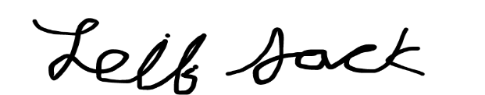
Sincerely,
Leif Jack

