Water Pumps or Higher Walkways:
Comparing Their Financial Feasibility and Effectiveness in Managing Mission Creek’s Water Level

Recipient: Colin Basran, Mayor of Kelowna

Author: Leif Jack, UBC Student

University of British Columbia

July 22, 2022

CONTENTS
INTRODUCTION 2
Kelowna’s Recent Climate History 2
Report Purpose 2
Scope 2
Report Method 3
Summary of Findings 3
DATA 4
Likeliness of Drought vs. Mission Creek Flooding 4
Survey of Citizens’ Climate Concerns 5
Controlling Mission Creek’s water levels 9
CONCLUSION 10
Summary and Interpretation 10
Recommendations 10
WORKS CITED 11

INTRODUCTION

Kelowna’s Recent Climate History
Due to climate change, Kelowna’s precipitation increasingly deviates from monthly averages, with some months receiving much less than average, and others much more. Moreover, summer months are seeing higher than average temperatures more frequently. June-August 2021, for example, saw record-breaking heat, and unexpected dryness, while contrastingly, this June’s rainfall and melting snow pushed Mission Creek, approximately within a metre of overflowing. Unexpected, dangerously hot and dry temperatures, and Mission Creek potentially overflowing create two dangers respectively: drought, and damage to private properties.

Report Purpose
However, two potential solution exists for these problems: installing water pumps along Mission Creek and heightening its walkways. This report compares these solutions’ feasibility in order to recommend which the city should implement in the near future. Installing water pumping stations along the creek that are connected to water storage tanks would allow using the creek as a water source, helping mitigate future droughts, while reducing the water level when the creek has a high water level. Meanwhile, heightening the walkways allows the creek to reach higher levels without causing flooding or endangering those who use the walkways

Scope
To compare theses solutions’ feasibility, this report explores five topics: is drought or flooding more likely, which weather event concerns residents more, how expensive is each solution, including maintenance costs, would the solutions bring the desired outcomes, and do citizens approve of either of these solutions.

Report Method
This report’s data was collected in two ways: research and through an anonymous survey. The research component examined recent studies on Kelowna’s climate history and projections to assess the likeliness of serious flood and drought in the coming years. The research also investigated the construction costs of installing water pumps along Mission Creek compared with heightening its walkways by (commercial websites?). Meanwhile, the survey’s purpose was to determine which weather event the public perceives as more likely and concerning, and their preference for the proposed solutions. 8 participants were asked to answer seven multiple-choice questions, with questions like “In your opinion, how likely is it that Kelowna experiences challenging levels of drought in the near future?” and how concerning that event would be for them. Questions 1 through 6 let participants answer with five options ranging from “Highly Likely” or “Highly Concerning” to “Highly Unlikely” or “Not at all concerning”, while in Question 7, participants chose which solution they preferred if only one could be implemented, with the option to propose alternative solutions if none appealed to them.

Summary of Findings
As a brief overview, climate studies showed Kelowna was becoming hotter and drier, and will likely continue to over the century. Regarding survey results, Kelowna residents felt drought was likelier and showed greater concern if it were to occur, compared with Mission Creek flooding. As for the cost-effectiveness of installing water pumps on Mission Creek compared with higher walkways, (more effective solution), and/yet this solution was favoured/less by residents.

DATA

Likeliness of Drought vs. Mission Creek Flooding
- Climate projections
In a 2021 article from the journal Climate Risk Management, Hewer and Gough assessed climate change’s impact on Kelowna’s wine industry using the city’s climate change history as well as projections. Much of the data and interpretations from that article are highly relevant to this report. While the article examined multiple metrics relevant to winemaking, the most pertinent were changes in annual average maximum temperature and total average precipitation.
- Interpretation
Turning to this report’s first question: Is drought or Mission Creek flooding more likely? With the data presented, this question is hard to answer at first glance. This mainly comes from the fact that 5 months of the year will be increasingly wetter than average, while 7 months of the year will be increasing drier. Nonetheless examining the year as whole, if more months will be drier, it can likely be said that the years will be drier as a whole.
Considering this climate data and projections, installing water pumps along Mission Creek seems like the more pressing solution, not because Mission Creek will be experiencing water levels close to flooding, but because excess water will likely become scarcer. Thus, unexpected extra water in Mission Creek should be taken advantage as soon as possible and put into reserve, to prepare for potential water scarcity. It should be noted too that with increasing temperatures, water demand will likely increase, as dehydration from the heat will occur faster. Consequently, heightening the Creek’s walkways does not seem a logical solution with average precipitation decreasing, and thus the likeliness of the river overflowing. While the science indicates drought is likelier, the next question is which event concerns residents more? As the survey results will show, it seems to be drought.

Survey of Citizens’ Climate Concerns
- Survey Results
Concerning the possibility Mission Creek could flood in the near future, most (5 in 8) survey participants felt such an event was likely (See Figure 1 below). 1 in 4 were unsure, and 1 in 8 felt the event was unlikely. Importantly, none considered it highly unlikely or highly likely, thus making the responses not very spread out over the five possible options.
This contrasts with the possibility of challenging drought in Kelowna. While survey participants were divided over how likely they felt a challenging drought was (Figure 2), combined, an overwhelming 75% thought it was likely or highly likely, compared to the 62.5% feeling flooding was likely (a 12.5% difference). Intriguingly, the remaining participants were either unsure about the likeliness of challenging drought, or felt it was highly unlikely, with none thinking it unlikely. This makes Figure 1’s data much more spread out than Figure 2’s.
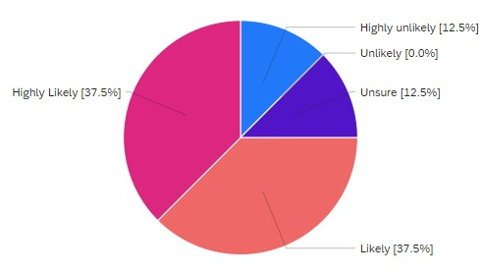
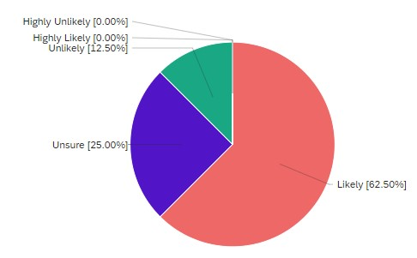
Figure 2: Perceived likeliness of drought in Kelowna in near future
Figure 1: Perceived likeliness of Mission Creek flooding in near future
A pattern emerges when the previous responses are compared with participants’ level of concern if flooding or drought were to occur (see Figure 3). Like Figure 1, in Figure 3, 5 in 8 participants would be concerned by Mission Creek flooding. Slightly different from Figure 1 however, none were unsure about their concern, with 1 in 4 instead feeling unconcerned if flooding occurred. Likewise, 1 in 8 were not at all concerned if flooding occurred. For concerns about drought (Figure 4), while divided in their level of concern, an overwhelming 7 in 8 participants (82.5%) were concerned or very concerned by the possibility of challenging drought. 1 in 8 were unconcerned, and none were unsure. Interesting too, data from these figures was limited to 3 of the possible options, like Figure 1, but unlike Figure 2.
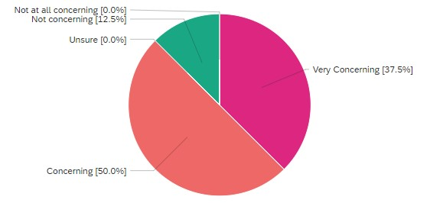
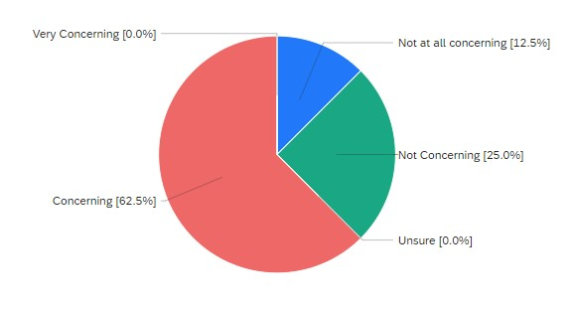
Figure 4: Resident’s level of concern if drought occurred
Figure 3: Resident’s level of concern if Mission Creek flooded
As might be expected based on the previous figures, the solution which greater support from participants was installing water pumps along Mission Creek (compare Figure 5 and 6). In Figure 5, participants were divided in their level of support for heightening Mission Creek’s walkways, with only 3 in 8 participants supporting or strongly supporting the proposal. 1 in 8 were unsure, with the remaining 1 in 2 (50%) somewhat opposing the proposal. This makes Figure 5 as spread out as Figure 2 in data, and different from Figures 1, 3, and 4.
Figure 5: Level of support for heightening Mission Creek’s walkways
This contrasts starkly with support for installing water pumps along Mission Creek. In Figure 6, 7 in 8 participants (82.5%) supported or strongly supported the proposal, with only 1 in 8 unsure, and none opposing. Like Figures 1, 3, and 4, responses in Figure 6 are limited to 3 of the possible options.
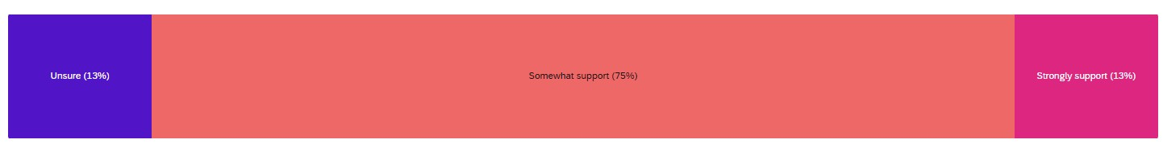
Figure 6: Level of support for installing water pumps along Mission Creek
Yet, Figure 7 complicates the data. When asked which solution participants preferred if only one could be implemented in the near future, there was no consensus, despite a majority of participants supporting installing water pumps in the previous question. For participants who chose “None of these”, they could propose an alternative solution, and one participant did, suggesting to “regulate the flow rate and volume of water into the creek from upstream.” 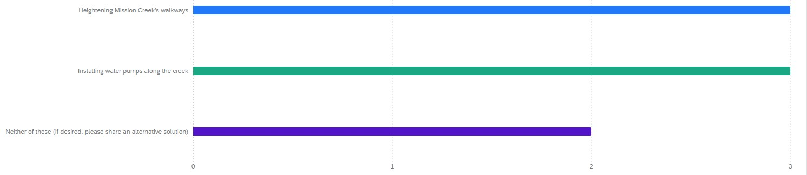
Figure 7: Preferred solution if only one could be implemented
- Interpretation
Comparing the survey’s results with the previously discussed climate study, the most significant detail is how residents’ perception that drought is more likely aligns with the findings of the climate study. This means any effort to address potential drought in Kelowna based on the climate study will likely be popular, and require less resources to convince residents of their urgency and need. This contrasts with if the climate study found Kelowna was becoming wetter, but the survey participants felt Kelowna was becoming drier, or vice versa. In that case, additional work educating residents would need to be done, lest such projects seem pointless, and thus unpopular.
However, even though residents’ perception align with climate studies, the fact Figure 2’s data is more spread out than other figures should be taken into account. The data is somewhat spread to the extremes, with few participants unsure, and half of participants feeling drought is either highly likely or highly unlikely. This means perceptions about drought likeliness could be a polarizing issue, so while a majority might not need convincing of the drought’s likeliness, there is potential for a vocal minority to question the urgency of drought-relief measures. This is somewhat further demonstrated by Figure 5, where while 50% somewhat oppose heightening the creek’s walkways, a majority of those who support the proposal, strongly support it. This potential polarization can also be seen in Figure 7, with its lack of consensus on which solution participants preferred if only one solution could be implemented, and one participant offering an alternative solution. Very briefly considering the alterative solution that one participant proposed, it can be agreed it would be effective at controlling the creek’s water levels, but it seems inefficient in face of the possibility of drought. Properly examining this participant’s proposal exceeds this report’s scope, but it nonetheless should be kept in mind, as it could prove an intriguing topic of further research if installing water pumps proves to costly.
Concluding this section, to answer this report’s questions, “which weather event concerns residents more?” and “which solution do they prefer?”, the survey shows more consider drought likely, have far greater concern if it occurred, and support installing water pumps as a way to prevent it. So, while there is potential for polarization, and some effort would be required to convince the most skeptical, the survey results concur with the climate study, and support installing water pumps on Mission Creek over heightening its walkways.

Controlling Mission Creek’s water levels
The last remaining questions for this report are whether the proposed solutions are cost-effective: how expensive are the solutions, and do they achieve their intended goal?

CONCLUSION

Summary and Interpretation
In conclusion, this report investigated multiple questions, and found mostly unequivocal answers. A climate study showed Kelowna was becoming hotter and drier and will likely continue to do so in the following century. These conditions would likely increase water usage, while reducing water availability, making drought more likely. Likewise, survey participants’ concerns matched climate history and projections, with drought thought of as more likely and concerning. Stemming from this, participants supported installing water pumps more than heightening Mission Creek’s walkways, with some offering intriguing alternatives that could be further explored. Despite this, the issues seemed somewhat polarized, meaning installing water pumps could require some public education efforts. Lastly, it was found that while water pumps would be a more expensive project, they would be worth the investment.

Recommendations
Considering the presented data, this report recommends the Kelowna City Council pursue the following actions as soon as possible:
- Prepare a detailed plan and timeline for constructing the water pumps on Mission Creek, and connecting them to water reservoirs
- Prepare educational material concerning the need for, and benefits of installing water pumps on Mission Creek
- Integrate data and arguments from the climate study cited in this report (Hewer and Gough, 2021) into such educational material
- As needed, research the feasibility of regulating Mission Creek’s flow and volume from upstream

WORKS CITED
Hewer, Micah J., and William A. Gough. "Climate Change Impact Assessment on Grape Growth and Wine Production in the Okanagan Valley (Canada)." Climate Risk Management, vol. 33, 2021, pp. 100343.

