The recorder fills in the blank with everyone’s response.

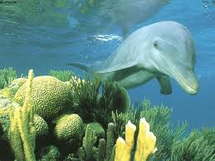

**A Mammal is...**

1._________________

2._________________

3._________________

4._________________

5__________________

6.__________________