Sustainability Challenge Messaging Toolkit

Overview (could be used in emails, newsletters, blog posts)
Headline:
Option 1 - Student teams compete in the Sustainability Challenge
Option 2 - Compete in the Sustainability Challenge for your chance to win!

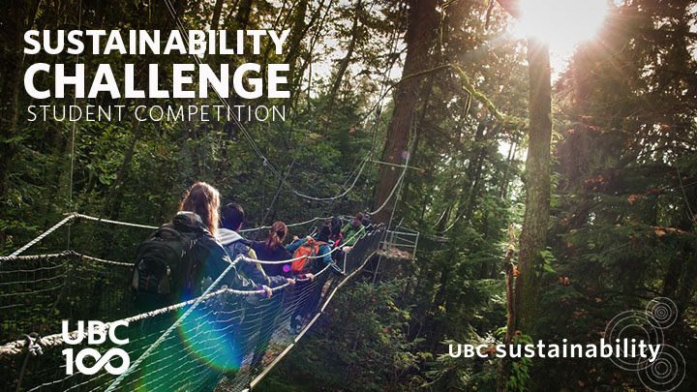

In celebration of UBC’s centennial, UBC Sustainability Initiative is excited to launch an innovative student competition that's focused on creating opportunities to advance UBC's commitment to campus sustainability by simultaneously promoting human and environmental wellbeing.

Working in interdisciplinary teams, students will develop solutions for a challenge associated with one of four themes: climate action, waste, food and physical activity.

Gain professional development skills and compete for a chance to win cash prizes totalling $5000!

Learn more and apply by September 30 online: sustain.ubc.ca/sustainabilitychallenge

Please share widely!

Twitter

September 10 - 12

#UBCSustainChallenge invites Vancouver & Okanagan students to compete for prizes totalling $5000. Apply by Sept 30 http://bit.ly/1EMN8oT

Think you have what it takes to win #UBCSustainChallenge? Win prizes, develop skills, & advance campus sustainability http://bit.ly/1EMN8oT

September 13 - 19

Student teams are invited to compete in the #ubcsustainchallenge - advance campus sustainability for a chance to win! http://bit.ly/1EMN8oT

Student teams from Vancouver & Okanagan will compete to advance campus sustainability in the #ubcsustainchallenge http://bit.ly/1EMN8oT

September 20 - 29

Think you know a thing or two about sustainability? Prove it. #UBC SustainChallenge puts you & your peers to the test! http://bit.ly/1EMN8oT

Want to advance sustainability at #UBC, work with friends, staff, & compete for cash prizes? Apply by Sept 30 http://bit.ly/1EMN8oT

#UBCSustainChallenge invites students from Vancouver & Okanagan to compete for a chance to win up to $5000, apply by Sept 30 http://bit.ly/1EMN8oT

Facebook

Advance campus sustainability and simultaneously advance human and environmental wellbeing. Student groups are invited to compete in the Sustainability Challenge for a chance to win prizes totalling $5000! Learn more and apply online by September 30th http://bit.ly/ubcsustainchallenge

