

**2019**

**Seminar Series**

# *The One Planet Fellowship:* Using a Gender Lens to Invest in the Next Generation of Climate Adaptation Scientists for Africa

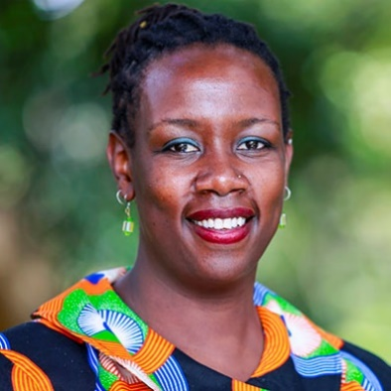

**Bio:** Dr. Wanjiru Kamau-Rutenberg is Director of African Women in Agricultural Research and Development (AWARD). AWARD manages the One Planet Fellowship, a climate change initiative sponsored by the Bill & Melinda Gates Foundation and BNP Paribas Foundation and which enjoys the official patronage of the President of France.

Prior to joining AWARD, Wanjiru was Founder & Executive Director of Akili Dada, an award-winning leadership incubator that invests in high-achieving young women from under-resourced families driving change in their communities. Wanjiru also served as an assistant professor of Politics at the University of San Francisco. Her academic research and teaching interests centered on African politics, gender, international relations, ethnicity, democratization, and the role of technology in social activism.

Born in Kenya, Wanjiru holds a PhD and a master's degree in Political Science from the University of Minnesota, & a Politics BA from Whitman College, Washington, U.S.A.

**Abstract:** Africa is one of the most vulnerable continents to climate change with the agricultural sector heavily impacted. Reductions in yield are projected to reach 50% by 2050 with agricultural production providing only 13% of the population’s needs.

By building a vibrant, intergenerational network of African, European (and other!) scientists, the One Planet Fellowship hopes to catalyze delivery of gender responsive climate adaptation solutions for African smallholder farmers.

Dr. Kamau-Rutenberg is seeking expressions of interest to expand the network of collaborators within the One Planet Fellowship and across the broad spectrum of AWARD’s activities across Africa.

By strengthening the ability of African agricultural researchers, institutions, & agribusinesses to conduct and disseminate gender responsive agricultural innovation, AWARD is working towards more inclusive, agriculture-driven prosperity for the African continent.

 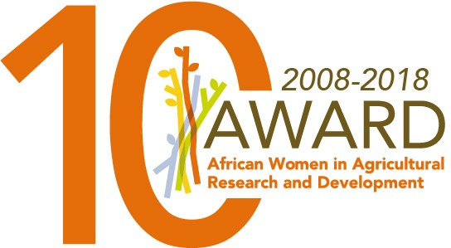

**Dr. Wanjiru Kamau-Rutenberg**

Director,

African Women in Agricultural Research and Development

**When:**

**June 5th 10.30-12.00**

**Where:**

**UBC Centre for Advanced Wood Processing**

**2424 Main Mall**

**rm. 2916 (caseroom)**

**Light lunch and refreshments for participants after the seminar**