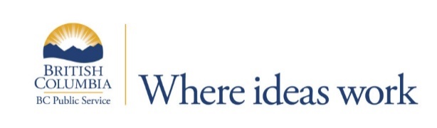
Ministry of Environment & Climate Change Strategy
Victoria
Soils Analyst
$66,557.72 - $75,884.38 annually
An eligibility list may be established.
Contribute your flair for organization and prioritization
The Analytical Chemistry Laboratory (the Laboratory) provides innovative, high-quality analytical chemistry support to the natural resource sector on a cost recovery basis. The Laboratory conducts routine chemical, physical, and biological tests on soil, water, and vegetation to support environmental monitoring. It also completes customized or specialized analyses and method development to support emerging research.

Working under the general direction of the unit supervisor, the Soils Analyst analyses a variety of environmental, agricultural and forestry soil, plant, and water samples. This position is the primary operator for the combustion, colorimetric autoanalyzer’s and UV-vis spectrophotometer instruments and the secondary operator of the instruments primarily operated by the Metals Analyst and the Organic Analyst. The Soils Analyst works independently to plan, prioritize, schedule and conduct a high volume of complex scientific chemical, physical, and biological analyses, using a variety of testing methodologies, sophisticated computer applications/systems, sensitive laboratory equipment and complicated diagnostics. This position is responsible for reviewing datasets to ensure all quality control specifications have been met prior to reporting results to the unit supervisor. The Soils Analyst also provides the lab and clients with the theoretical knowledge pertaining to soil chemistry, physics, and preparation.

The BC Public Service is an award-winning employer and offers employees competitive benefits, amazing learning opportunities and a chance to engage in rewarding work with exciting career development opportunities. For more information, please see What We Offer.

The BC Public Service is committed to creating a diverse workplace to represent the population we serve and to better meet the needs of our citizens. Consider joining our team and being part of an innovative, inclusive and rewarding workplace.
Qualifications for this role include:

- Bachelor’s Degree in Soil Chemistry, Environmental Chemistry, or related field, plus three (3) years of related experience; OR
- Master’s Degree in related field plus one (1) year of related experience.
- Specialized courses or experience related to environmental, forestry, and/or agricultural type of chemical and physical soil analyses.

For more information and to apply online by July 30, 2021, please go to:
https://bcpublicservice.hua.hrsmart.com/hr/ats/Posting/view/77238

