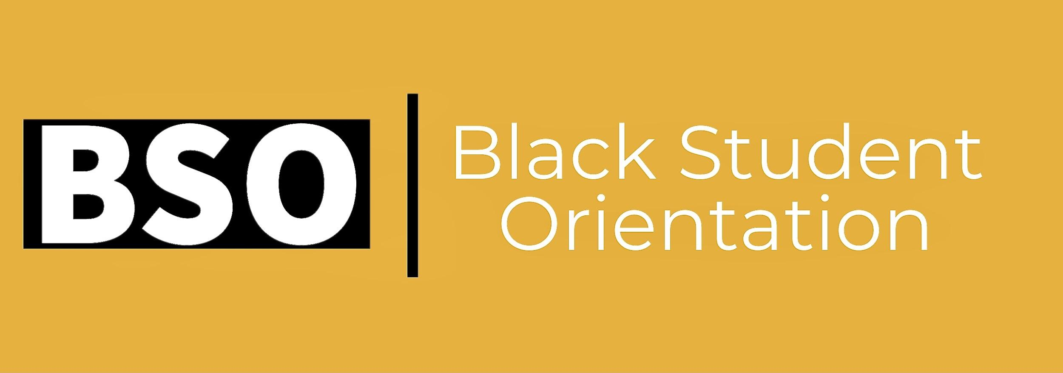
PROMOTIONAL PACKAGE
Orientation landing page/registration link: https://blackcaucus.ubc.ca/black-student-orientation/
Date: Thursday, September 2nd, 2021
Time: 10am - 2:30 pm
Mode of delivery: Online (Zoom)
Primary Audience: Incoming UBC-V and UBC-O graduate and undergraduate Black students
Secondary Audience: Current UBC-V and UBC-O graduate and undergraduate Black students
Key message: The purpose of this orientation is to create a space for new undergraduate and graduate Black students at the Vancouver and Okanagan campuses to start to build community with each other, receive tips for transitioning to UBC, and connect with Black-identifying student groups. Current UBC Black students are welcome to join the session.

Email Newsletter
Dear [Insert Name],

EXCITING NEWS!
The UBC Black Caucus, Mastercard Foundation Scholars Program, and Beyond Tomorrow Scholars Program have come together to jointly organize and offer a pilot initiative, a Black Student Orientation for the Fall 2021 term.

The purpose of this orientation is to create a space for new undergraduate and graduate Black students to start building a community with each other, receive tips for transitioning to UBC, and connect with Black-identifying student groups. Current Black students are welcome to join the session.

This free session will be held virtually on Thursday, September 2nd, 2021 from 10 am - 2.30 pm.
Interested in attending? Register using this link: https://blackcaucus.ubc.ca/black-student-orientation/

Thank you,
[Insert name]

Facebook
Excited to share that the UBC Black Caucus, Mastercard Foundation Scholars Program, and Beyond Tomorrow Scholars Program are offering a pilot initiative, the Black Student Orientation (BSO) for the Fall 2021 term. Calling on all new UBC-V and UBC-O Black undergraduate and graduate students to sign up. This free session is also open to current Black students. Register and find more details here: https://blackcaucus.ubc.ca/black-student-orientation/
For more updates on the orientation, follow @ubcblackcaucus

Instagram
Excited to share that the UBC Black Caucus, Mastercard Foundation Scholars Program, and Beyond Tomorrow Scholars Program are offering a pilot initiative, the Black Student Orientation (BSO) for the Fall 2021 term. Calling on all new UBC-V and UBC-O Black undergraduate and graduate students to sign up. This free session is also open to current Black students. Register and find more details here: https://blackcaucus.ubc.ca/black-student-orientation/
For more updates on the orientation, follow @ubcblackcaucus

Twitter
Excited to share that the UBC Black Caucus, Mastercard Foundation Scholars Program, and Beyond Tomorrow Scholars Program are offering a pilot initiative, the Black Student Orientation (BSO) for the Fall 2021 term. Calling on all new UBC-V and UBC-O Black undergraduate and graduate students to sign up. This free session is also open to current Black students. Register and find more details here: https://blackcaucus.ubc.ca/black-student-orientation/
For more updates on the orientation, follow @ubcblackcaucus

