**Teacher Librarianship**

**LIBE 477B 951 (3.0): Media and Technologies in the School Library Program**

**Course Resources**

**E-books available through Amazon.ca**

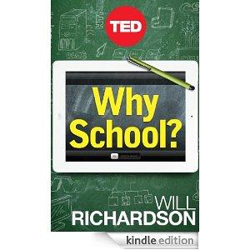

[Why School? Will Richardson](http://www.amazon.ca/dp/B00998J5YQ)

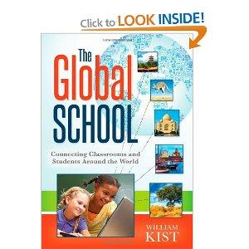

[The Global School, William Kist](http://www.amazon.ca/Global-School-Connecting-Classrooms-ebook/dp/B008NU3Y6G/ref=sr_1_2?s=digital-text&ie=UTF8&qid=1372363845&sr=1-2&keywords=the+global+school)