**Mi comida favorita**

*Draw and label a favorite meal. Tell which meal it is and what foods it includes. Use at least* ***three*** *vocab words.*

*Note: Leave some space in the plate, we will add more to it later.*

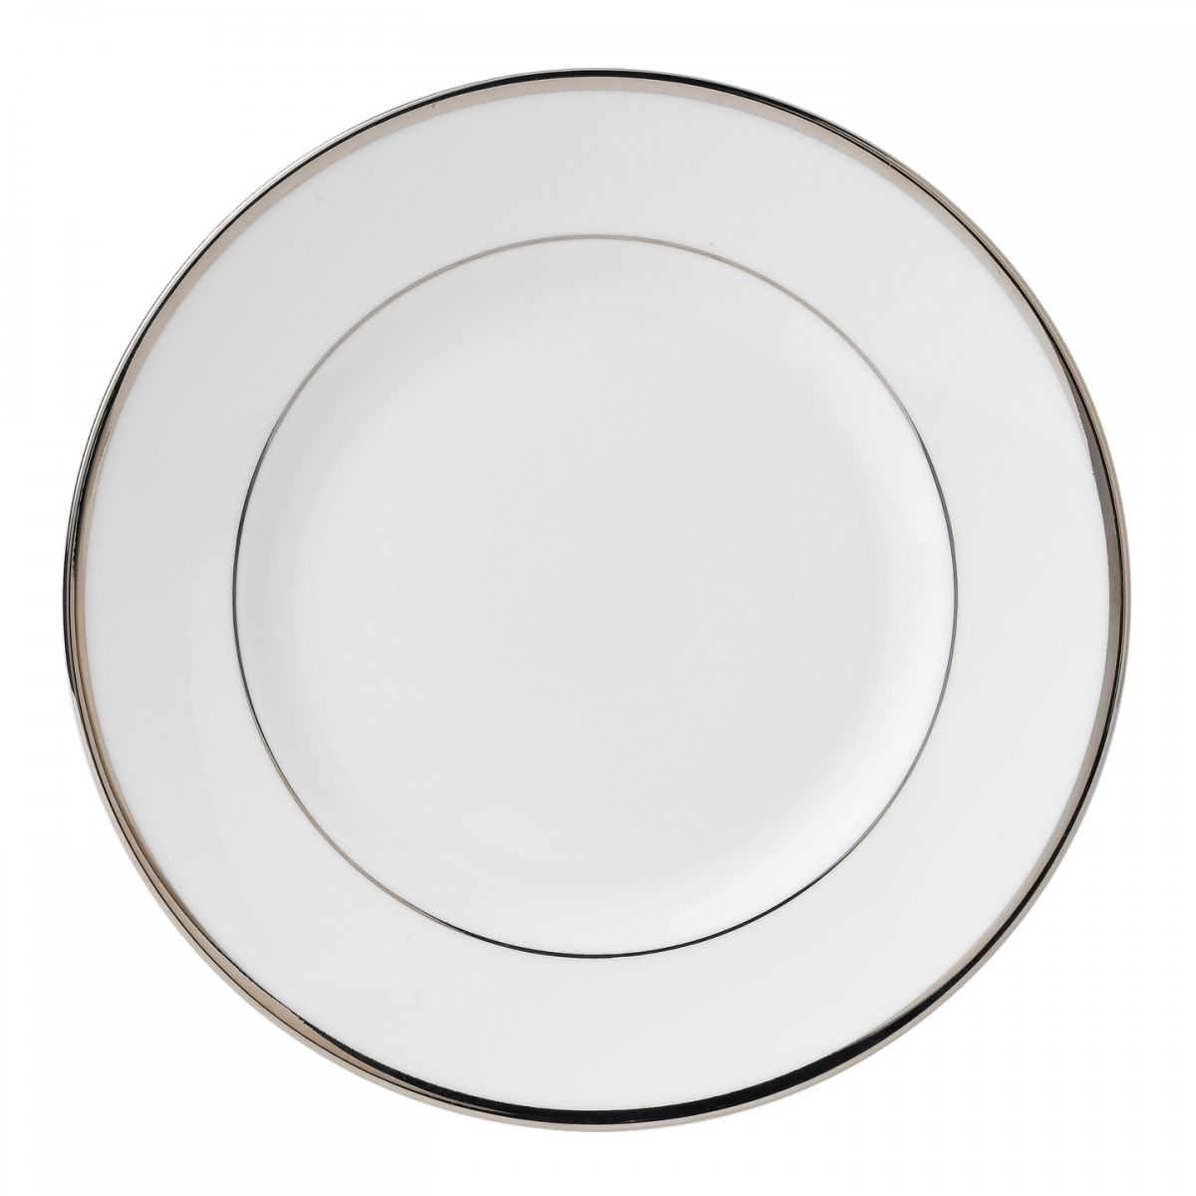Mi comida favorita es (my favourite meal is): __________________________.