**Anatomy of the Atom**

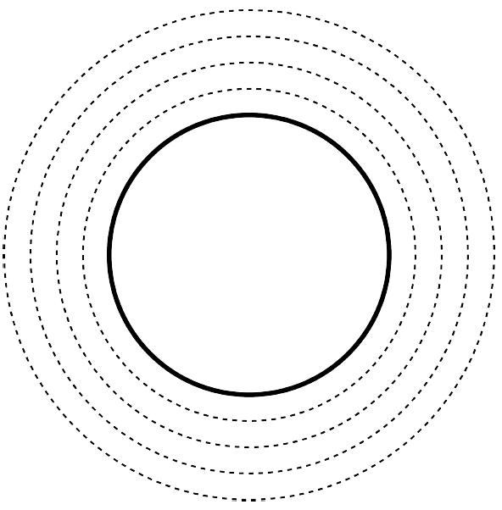

Electron

Neutron

Proton